SAVEETHA INSTITUTE OF MEDICAL AND TECHNICAL SCIENCES
CSA08 - PYTHON PROGRAMMING | ASSIGNMENT 2
Student Name: | HARSHAVARTHAN P
Register Number: | 1914260015
GitHub Repository: | https://github.com/HarshavarthanPaul/PYTHON-PROGRAMMING_ASSIGNMENT-2.git
Task Module: | Task 03: Engineer a Vehicle Registration Number Validator

Task 03: Engineer a Vehicle Registration Number Validator

Problem Context: Vehicle Registration Number Validator
Toll plaza operators enter registration numbers in varied formats ('tn 09 ab 1234', 'TN-09-AB-1234', 'Tn09Ab1234'). Valid vehicle numbers follow the pattern: 2 letters (state) + 2 digits (district) + 1 or 2 letters (series) + 4 digits (unique number). Total clean length is either 9 or 10 characters.

Inquiry: String Immutability and Slicing Mechanics
1. Strings in Python are immutable sequence objects; memory buffers cannot be altered in-place. 2. text.upper() returns a newly allocated string object without modifying the original text reference. 3. Slicing evaluation: s[-4:] extracts the last 4 characters ('1234'). For a 9-char string, s[4:-4] extracts 1 character (s[4:5]); for a 10-char string, s[4:-4] extracts 2 characters (s[4:6]).

Native String Validation & Receipt Formatting
Inputs are normalized using strip(), replace(' ', ''), replace('-', ''), and upper(). Validation checks length in (9, 10), state_code.isalpha(), district_code.isdigit(), series_code.isalpha(), and number.isdigit() without using regular expressions. Valid receipts format output cleanly as 'TN 09 AB 1234'.

Alternative Concept & Complexity Analysis
Comparing pure string slicing against Regular Expressions (re.fullmatch(r'[A-Z]{2}[0-9]{2}[A-Z]{1,2}[0-9]{4}', reg)):
- String Slicing: Time Complexity = O(L), Space Complexity = O(L). Pinpoints specific segment validation errors but requires manual branch logic.
- Regular Expression: Time Complexity = O(L), Space Complexity = O(1). Highly readable declarative pattern matching, but introduces engine compile overhead.

Program Execution Screenshot
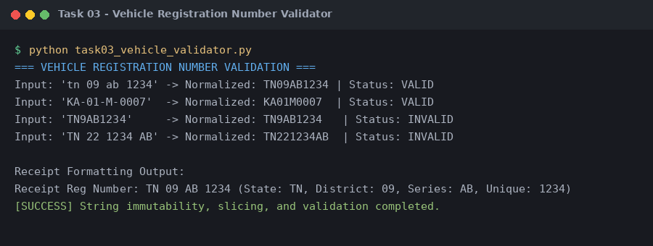
Figure 3.1: Execution output verification for Task 3 (Vehicle Registration Number Validator).

