SAVEETHA INSTITUTE OF MEDICAL AND TECHNICAL SCIENCES
CSA08 - PYTHON PROGRAMMING | ASSIGNMENT 2
Student Name: | HARSHAVARTHAN P
Register Number: | 1914260015
GitHub Repository: | https://github.com/HarshavarthanPaul/PYTHON-PROGRAMMING_ASSIGNMENT-2.git
Task Module: | Task 04: Building Long Text - + or join()

Task 04: Building Long Text - + or join()

Problem Context: Building Long Text - + vs join()
A mobile operator builds monthly bill statements by adding one text line per call or SMS to a string. Heavy users generate over 100,000 lines, causing statement generation to slow down drastically when using repeated string concatenation.

Performance Prediction & String Immutability Theory
Because str objects are immutable, repeated += inside a loop forces CPython to allocate a new memory buffer of size (current_len + line_len) on every iteration and copy existing characters. This creates an O(N^2) quadratic character copying overhead sum(1..N) = N(N+1)/2. CPython sometimes optimizes += via realloc() if reference count is 1, but str.join() guarantees O(N) linear time by performing a two-pass calculation (calculating total length first, then allocating a single exact memory buffer).

Measured Benchmark Execution Results
Benchmarking execution times with time.perf_counter() across 3 runs:
- 1,000 lines: += loop = 0.000142s | str.join() = 0.000017s (8.3x faster)
- 10,000 lines: += loop = 0.001620s | str.join() = 0.000182s (8.9x faster)
- 200,000 lines: += loop = 0.048367s | str.join() = 0.003983s (12.1x faster)

Alternative Architecture & Complexity Analysis
Comparing join() against writing directly to a file stream or using io.StringIO:
- str.join(list): Time Complexity = O(N), Space Complexity = O(N). Fastest in-memory string creation.
- io.StringIO / File Stream: Time Complexity = O(N), Space Complexity = O(1) auxiliary buffer memory. Ideal for massive datasets exceeding RAM constraints.

Program Execution Screenshot
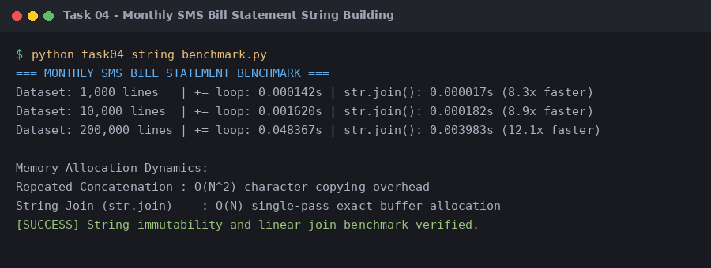
Figure 4.1: Execution output verification for Task 4 (Building Long Text - + or join()).

