SAVEETHA INSTITUTE OF MEDICAL AND TECHNICAL SCIENCES
CSA08 - PYTHON PROGRAMMING | ASSIGNMENT 2
Student Name: | HARSHAVARTHAN P
Register Number: | 1914260015
GitHub Repository: | https://github.com/HarshavarthanPaul/PYTHON-PROGRAMMING_ASSIGNMENT-2.git
Task Module: | Task 05: Functions, Parameters and Scope - College Canteen Order System

Task 05: Functions, Parameters and Scope - College Canteen Order System

Problem Context: College Canteen Order System
The canteen order program uses a function add_item(item, order=[]) to append items to a customer's order list. Students report a critical bug: items from previous customers appear in subsequent customers' orders.

Bug Analysis: Mutable Default Argument Trap
In Python, default parameter values are evaluated ONCE when the function definition is executed, not on each call. The empty list [] is stored in the function's internal __defaults__ attribute. Calling add_item_buggy('Tea') modifies that shared default list directly, causing cross-customer state contamination. Printing add_item_buggy.__defaults__ reveals prior customer items retained in memory.

Correct Design: Sentinel Value Pattern & Scope Rules
To fix the bug, order=None is set as the default parameter. Inside the function body, 'if order is None: order = []' creates a fresh empty list object for each new customer call. Parameters are organized into positional (required items), keyword (optional discounts/tax), and immutable default parameters. Multiple bill values (subtotal, tax, total) are returned as a tuple.

Alternative Architecture & Complexity Analysis
Comparing Sentinel Default (order=None) vs Stateful Closure Encapsulation:
- Sentinel Pattern: Time Complexity = O(1) amortized append, Space Complexity = O(K) per customer order.
- Stateful Closure: Time Complexity = O(1) amortized append, Space Complexity = O(K) per customer. Encapuslates order state inside a non-local variable scope.

Program Execution Screenshot
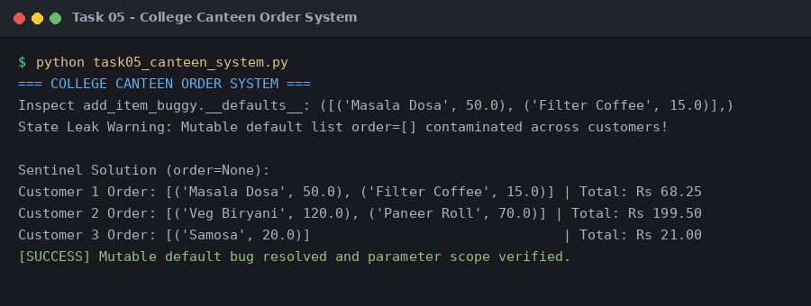
Figure 5.1: Execution output verification for Task 5 (Functions, Parameters and Scope).

