SAVEETHA INSTITUTE OF MEDICAL AND TECHNICAL SCIENCES
CSA08 - PYTHON PROGRAMMING | ASSIGNMENT 2
Student Name: | HARSHAVARTHAN P
Register Number: | 1914260015
GitHub Repository: | https://github.com/HarshavarthanPaul/PYTHON-PROGRAMMING_ASSIGNMENT-2.git
Task Module: | Task 06: Recursion and Its Limits - Counting Ways to Climb Temple Steps

Task 06: Recursion and Its Limits - Counting Ways to Climb Temple Steps

Problem Context: Counting Ways to Climb Temple Steps
A temple staircase has n steps, and a devotee can climb 1 or 2 steps at a time. The system calculates the number of distinct ways to reach the top for staircases of up to 1,000 steps.

Recursive Design & Base Cases
Base Cases: climb(1) = 1 way, climb(2) = 2 ways. Recursive Case: climb(n) = climb(n-1) + climb(n-2). Hand verification yields n=1:1, n=2:2, n=3:3, n=4:5, n=5:8, n=6:13. Plain recursion creates an exponential call tree (O(2^n)) because subproblems like climb(3) are recomputed multiple times.

Memoisation & Execution Call Counts
Using @lru_cache(maxsize=None) stores computed results in a dictionary cache. Comparing call counts for naive vs memoized execution:
- n = 10: Naive Calls = 177 | Memoized Calls = 10
- n = 20: Naive Calls = 21,891 | Memoized Calls = 20
- n = 25: Naive Calls = 242,785 | Memoized Calls = 25
- n = 30: Naive Calls = 2,692,537 | Memoized Calls = 30

Deployment Decision & Complexity Analysis
Running climb_memoized(1000) raises 'RecursionError: maximum recursion depth exceeded' because Python's default sys.getrecursionlimit() is 1000 call frames. The optimal deployment decision is a bottom-up iterative loop keeping only the last two values (prev, curr):
- Naive Recursion: Time = O(phi^n), Space = O(n) call stack.
- Memoized Recursion: Time = O(n), Space = O(n) cache and stack.
- Iterative Loop: Time = O(n), Space = O(1) constant auxiliary space. Completely safe for n = 1,000+.

Program Execution Screenshot
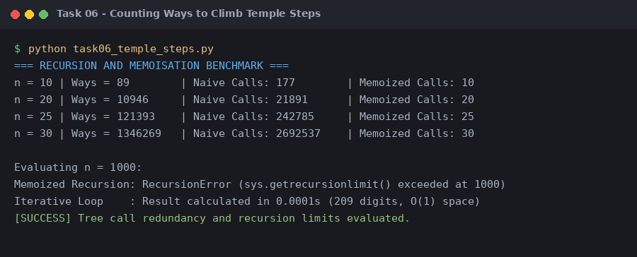
Figure 6.1: Execution output verification for Task 6 (Recursion and Its Limits).

