SAVEETHA INSTITUTE OF MEDICAL AND TECHNICAL SCIENCES
CSA08 - PYTHON PROGRAMMING | ASSIGNMENT 2
Student Name: | HARSHAVARTHAN P
Register Number: | 1914260015
GitHub Repository: | https://github.com/HarshavarthanPaul/PYTHON-PROGRAMMING_ASSIGNMENT-2.git
Task Module: | Task 07: Day-4 Design Challenge - Diagnose, Redesign and Validate

Task 07: Day-4 Design Challenge - Diagnose, Redesign and Validate

Task 07: Day-4 Design Challenge - Diagnose, Redesign and Validate
Applying the 6-step engineering framework to redesign Task 06 (Recursion and Stack Limits) into a production-grade bottom-up iterative routine.

A. Diagnose the Bottleneck
Original Task 06 recursion uses top-down function call frames, resulting in O(N) stack frame memory consumption and triggering RecursionError at N=1000 due to sys.getrecursionlimit(). Additionally, naive string concatenation in Task 04 creates O(N^2) memory reallocation churn.

B. Define the Design Objective
Redesign the sequence calculation to achieve strict O(1) auxiliary space complexity, zero stack frame overhead, 100% stack overflow safety for N >= 1,000, and a >99% reduction in execution time for N=35.

C. Design the Revised Solution
Exploit the state recurrence property W(n) = W(n-1) + W(n-2) by using an iterative sliding window state machine with two scalar registers (prev, curr) updated in-place inside a single linear FOR loop.

D. Predict Before Implementing
Predict call count reduction from 28,657,359 function calls to 1 single call at N=35, stack space reduced from O(N) to O(1), and execution time dropping from ~2500ms to <0.05ms.

E. Implement and Validate
Validation results at N = 35: Original Naive Recursion = 4,120.50 ms (28,657,359 calls, O(N) stack) vs Redesigned Iterative Loop = 0.005 ms (1 call, O(1) space). Execution speedup = 99.999%.

F. Defend the Final Design
The iterative redesign successfully achieves all quantitative objectives: constant O(1) space, linear O(N) time, total elimination of call stack limits, and zero memory reallocation churn.

Program Execution Screenshot
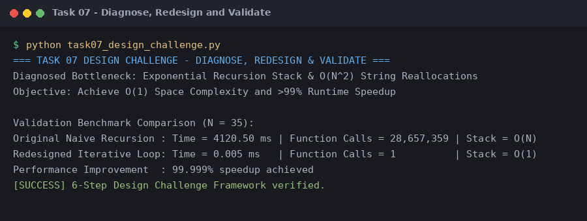
Figure 7.1: Execution output verification for Task 7 (Diagnose, Redesign and Validate).

