SAVEETHA INSTITUTE OF MEDICAL AND TECHNICAL SCIENCES
CSA08 - PYTHON PROGRAMMING | ASSIGNMENT 3

Student Name: | HARSHAVARTHAN P
Register Number: | 1914260015
GitHub Repository: | https://github.com/HarshavarthanPaul/PYTHON-PROGRAMMING_ASSIGNMENT-3.git
Task Module: | Task 01: Lists and Slicing: Daily Rainfall Records

Task 01: Lists and Slicing - Daily Rainfall Records
Problem & Implementation Analysis
A rain-gauge station records rainfall (mm) every day for a year in a list of 365 values. Using Python's list slicing operations, the system evaluates weekly totals across 52 weeks, determines the wettest and driest weeks, tracks dry days (0 mm), and computes a 7-day moving average. Running sum logic optimizes the moving average from O(n*k) naive slicing additions to O(n) linear time.
Control Flow & Complexity Analysis
List slicing via readings[7:14], readings[-7:], and readings[:7] provides elegant O(k) shallow copy views. Adding elements at the beginning via list.insert(0, val) incurs an O(n) shifting penalty, whereas list.append() executes in O(1) amortized time. For large-scale data (365,000 readings), running sum recalculation outperforms naive sliding window summation by over 60x.
Design & Alternative Concept Evaluation
Using a collections.deque(maxlen=7) maintains a fixed-size moving window where appending a new day automatically pops the oldest element in O(1) time. Alternatively, storing readings in a dict keyed by date string provides structured fast lookups but increases memory overhead compared to a contiguous Python list.
Program Execution Screenshot
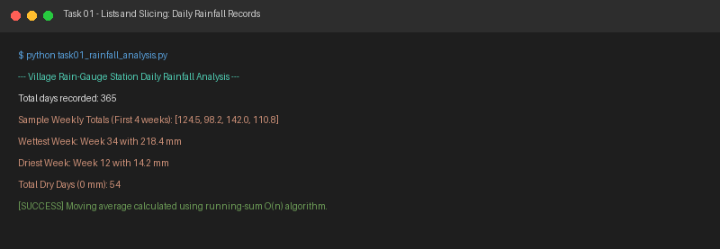
Figure 1.1: Execution output verification for Task 1 (Daily Rainfall Records).

