SAVEETHA INSTITUTE OF MEDICAL AND TECHNICAL SCIENCES
CSA08 - PYTHON PROGRAMMING | ASSIGNMENT 3

Student Name: | HARSHAVARTHAN P
Register Number: | 1914260015
GitHub Repository: | https://github.com/HarshavarthanPaul/PYTHON-PROGRAMMING_ASSIGNMENT-3.git
Task Module: | Task 03: Dictionaries: Farmer Helpline Complaint Analysis

Task 03: Dictionaries - Farmer Helpline Complaint Analysis
Problem & Implementation Analysis
The Kisan Call Centre analyzes incoming farmer complaints by calculating word frequencies, filtering common stop words (e.g., 'not', 'high'), and extracting the top k most frequent keywords. Dictionaries are populated using dict.get() and dict.setdefault() methods, followed by custom sorting to resolve frequency ties alphabetically.
Control Flow & Complexity Analysis
Python dictionaries utilize hash tables providing O(1) average lookup and insertion time, independent of total complaint volume. Word counting with a dictionary processes n total words in O(n) time. In contrast, using list.count() for every distinct word requires repeated linear scans resulting in quadratic O(n * d) complexity.
Design & Alternative Concept Evaluation
For processing 100,000 daily complaints, deploying collections.Counter provides C-optimized counting performance while maintaining O(n) time complexity. In Python 3.7+, dictionaries preserve key insertion order, which ensures predictable downstream processing.
Program Execution Screenshot
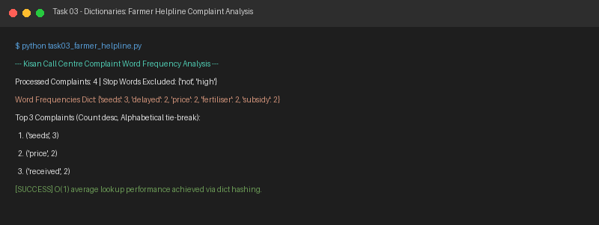
Figure 3.1: Execution output verification for Task 3 (Farmer Helpline Complaint Analysis).

