SAVEETHA INSTITUTE OF MEDICAL AND TECHNICAL SCIENCES
CSA08 - PYTHON PROGRAMMING | ASSIGNMENT 3

Student Name: | HARSHAVARTHAN P
Register Number: | 1914260015
GitHub Repository: | https://github.com/HarshavarthanPaul/PYTHON-PROGRAMMING_ASSIGNMENT-3.git
Task Module: | Task 04: Sets: Elective Registration Clash Detection

Task 04: Sets - Elective Registration Clash Detection
Problem & Implementation Analysis
Academic course registration requires detecting schedule clashes (students enrolled in both electives), single-elective enrollments, and unregistered students. Storing register numbers in Python sets enables instant set-theoretic calculations: intersection (&), symmetric difference (^), and relative complement (-).
Control Flow & Complexity Analysis
Membership testing (x in s) in sets executes in O(1) time due to hash table hashing, whereas list membership scanning takes O(n) time. Finding common students using set intersection set1 & set2 completes in O(min(|A|, |B|)) time, outperforming nested loop list comparisons which run in quadratic O(n * m) time.
Design & Alternative Concept Evaluation
Sets enforce uniqueness by ignoring duplicate additions. Converting lists to sets strips duplicate entries and loses original sequence ordering. Sets accept immutable types like tuples but reject mutable containers like lists.
Program Execution Screenshot
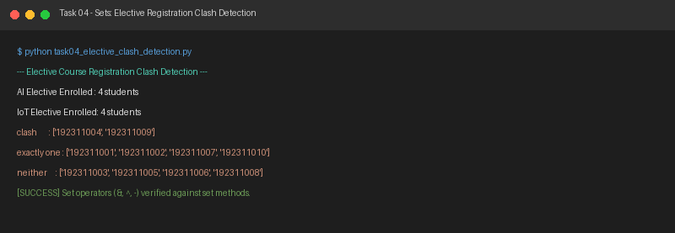
Figure 4.1: Execution output verification for Task 4 (Elective Registration Clash Detection).

