SAVEETHA INSTITUTE OF MEDICAL AND TECHNICAL SCIENCES
CSA08 - PYTHON PROGRAMMING | ASSIGNMENT 3

Student Name: | HARSHAVARTHAN P
Register Number: | 1914260015
GitHub Repository: | https://github.com/HarshavarthanPaul/PYTHON-PROGRAMMING_ASSIGNMENT-3.git
Task Module: | Task 05: List Comprehension: Cleaning Sensor Readings

Task 05: List Comprehension - Cleaning Sensor Readings
Problem & Implementation Analysis
A cold-storage temperature monitor logs vaccine environmental readings every minute. Readings outside -50 °C to 50 °C indicate sensor hardware errors and are filtered out. Valid Celsius readings are converted to Fahrenheit, and out-of-range alarm minutes (outside 2–8 °C) are tracked using enumerate().
Control Flow & Complexity Analysis
List comprehensions combine filtering and transformation in optimized C-level loops, running significantly faster than explicit Python for loops with .append(). Functional alternatives using map() and filter() achieve identical O(n) time results but can reduce code readability when combined with complex lambda functions.
Design & Alternative Concept Evaluation
Comparing memory footprints using sys.getsizeof() highlights that a list comprehension allocates memory for all output elements (O(n) space), whereas a generator expression evaluates items lazily on demand (O(1) space). Generators are ideal for streaming high-frequency sensor streams.
Program Execution Screenshot
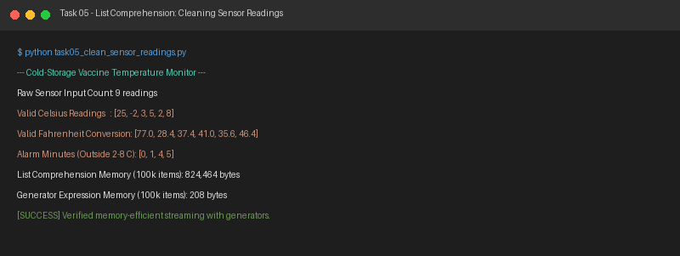
Figure 5.1: Execution output verification for Task 5 (Cleaning Sensor Readings).

