SAVEETHA INSTITUTE OF MEDICAL AND TECHNICAL SCIENCES
CSA08 - PYTHON PROGRAMMING | ASSIGNMENT 3

Student Name: | HARSHAVARTHAN P
Register Number: | 1914260015
GitHub Repository: | https://github.com/HarshavarthanPaul/PYTHON-PROGRAMMING_ASSIGNMENT-3.git
Task Module: | Task 06: Nested Data: A Railway Timetable

Task 06: Nested Data - A Railway Timetable
Problem & Implementation Analysis
A station enquiry system structures timetable data using nested data structures: a dictionary mapping train numbers to inner dictionaries containing train names, route stop tuples (station, arrival, departure), and running day sets. Queries find matching trains stopping at a specific station on a target day sorted by departure time.
Control Flow & Complexity Analysis
Accessing nested fields relies on chained indexing like timetable[train_id]['schedule'][station_idx][2]. Unindexed queries iterate through all trains and stops, taking O(trains * stops) time. Constructing an auxiliary station index (station -> list of train IDs) speeds up query resolution to O(trains at station) time.
Design & Alternative Concept Evaluation
Each data structure is selected for specific capabilities: Dictionaries enable O(1) key lookups; Lists maintain ordered sequence of stops; Tuples enforce immutable stop attributes; Sets allow fast day availability checks. The auxiliary index requires extra O(N) memory but provides drastic query latency reductions.
Program Execution Screenshot
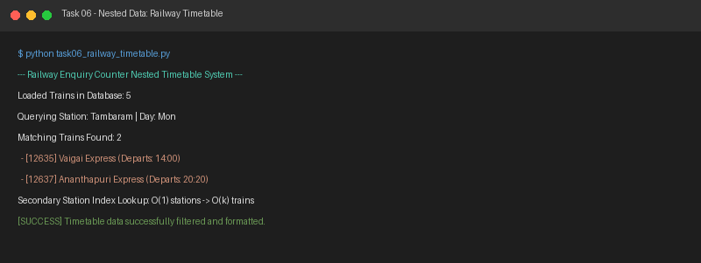
Figure 6.1: Execution output verification for Task 6 (Railway Timetable).

