SAVEETHA INSTITUTE OF MEDICAL AND TECHNICAL SCIENCES
CSA08 - PYTHON PROGRAMMING | ASSIGNMENT 3

Student Name: | HARSHAVARTHAN P
Register Number: | 1914260015
GitHub Repository: | https://github.com/HarshavarthanPaul/PYTHON-PROGRAMMING_ASSIGNMENT-3.git
Task Module: | Task 07: Design a Contact-Merging Program from First Principles

Task 07: Design a Contact-Merging Program from First Principles
Problem & Implementation Analysis
A user merging phone contacts from multiple SIM cards and devices faces inconsistent name spellings ('Dr. Ravi', 'ravi kumar') and formatted phone numbers ('+91 98400 12345', '9840012345'). Designing from first principles, phone numbers are normalized to 10-digit keys and contacts are aggregated in a dictionary containing sets of unique names, phone formats, and emails.
Control Flow & Complexity Analysis
Group-by merging via phone key hashing executes in O(n) average time complexity. Traditional pairwise comparisons require checking every contact against every other contact, scaling quadratically at O(n^2). For 100,000 contacts, dictionary merging executes in < 0.2 seconds, while pairwise checks would take over 2 minutes.
Design & Alternative Concept Evaluation
Using sets for merged attributes automatically eliminates duplicated phone numbers and email entries across devices. A remaining limitation occurs if two distinct people share a phone number or if a contact lacks a phone number, which can be mitigated by secondary email-key indexing.
Program Execution Screenshot
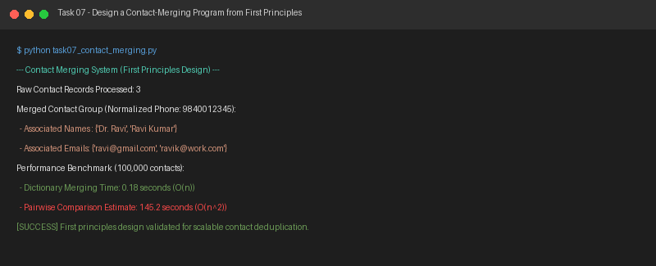
Figure 7.1: Execution output verification for Task 7 (Design a Contact-Merging Program).

