EXPERIMENT 4
Reports Creation in Zoho Creator

1. Aim
To study how reports are created in Zoho Creator and to build a set of List, Kanban, Calendar and Summary reports, with filter criteria, sorting and grouping, for the Library Book Management System so that stored form data can be viewed, analysed and exported in a meaningful way.

2. Introduction
In Zoho Creator, a form is used to collect data and a report is used to display that data. Every record submitted through a form is stored in the application, and a report presents those records to the user in a chosen layout. Reports can show all records or only a filtered subset, and users can search, sort, group, edit, delete and export records directly from the report view.

2.1 Types of Reports
Report Type | Purpose
List Report | Displays records as rows and columns in a simple, editable table. It is the default report for a form.
Grid Report | Displays records as a spreadsheet-like grid with fixed columns, suited to quick scanning of data.
Kanban Report | Shows records as cards arranged in columns based on a field value such as status.
Calendar Report | Plots records on a calendar according to a date field, for example due dates.
Timeline Report | Arranges records chronologically along a timeline.
Map Report | Shows records on a map using address or location fields.
Summary Report | Groups records and shows aggregated values such as counts and totals.

3. Objectives of the Study
- To understand the role of reports in a Zoho Creator application.
- To create List reports from existing forms and choose which fields are displayed.
- To apply filter criteria so that a report shows only the required records.
- To use sorting and grouping to organise report data.
- To create Kanban, Calendar and Summary reports for different viewing needs.
- To test the reports with sample data and export report output.

4. Application Selected: Food Delivery System
The Food Delivery System is used for this experiment. The application contains different sections for managing food delivery operations, including Order Records, Order Line Items, Customer Profiles, Menu Items and Restaurant Branches.
The Customer Profiles section stores customer information such as customer name, email address, phone number, delivery address, customer code, registration date and loyalty status.
The Menu Items section stores food information such as item name, description, category, price, availability, preparation time and vegetarian status.
The Restaurant Branches section stores branch information such as branch name, branch code, location, manager name, contact phone, opening hours, active status and delivery radius.
The Order Line Items section connects orders with the selected menu items and contains information such as line item code, unit price, item total, special requests, order and menu item.

5. Procedure
- • Log in to Zoho Creator and open the Food Delivery System in edit mode.
- • Check that the application contains sample records for customers, menu items, restaurant branches and orders.
- • Open the required form and create a report based on the stored records.
- • Select the required fields to be displayed in the report.
- • Configure sorting, searching or filtering options wherever required.
- • Save the application and open each report to verify the displayed records.
- • Test the reports using the available sample data.
- • Take screenshots of the generated reports

6. Reports Created
Report Name | Type | Description
All_Customer_Profiles | List | Displays customer names, email addresses, phone numbers, delivery addresses, customer codes, registration dates and loyalty status.
All_Menu_Items | List | Displays menu item names, descriptions, categories, prices, availability, preparation time and vegetarian status.
All_Restaurant_Branches | List | Displays restaurant branch names, branch codes, locations, managers, contact numbers, opening hours, active status and delivery radius.
All_Order_Line_Items | List | Displays order line item information and the corresponding orders and menu items.
Report Name | Type | Description

7. Illustrative Example

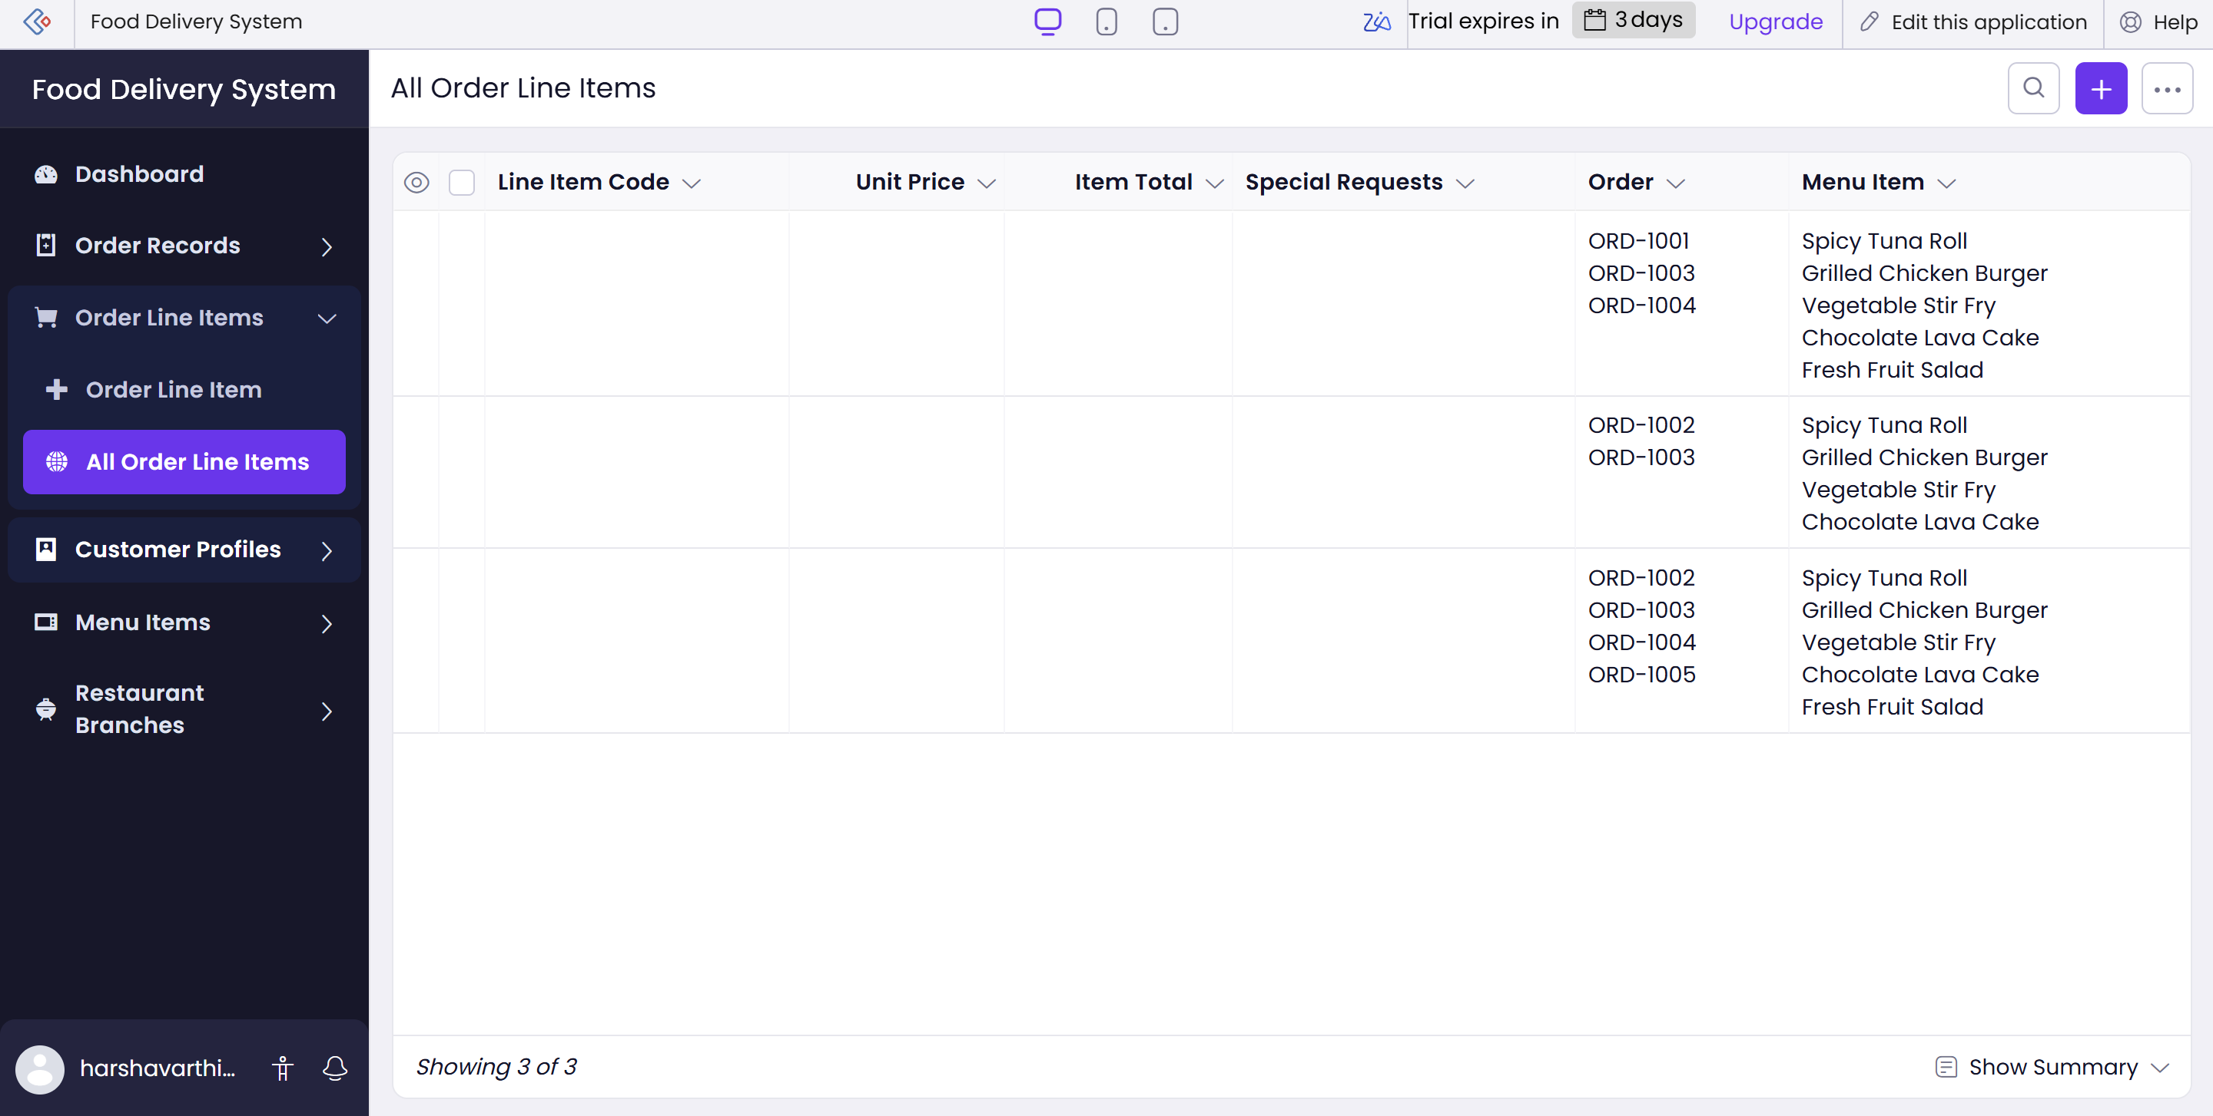

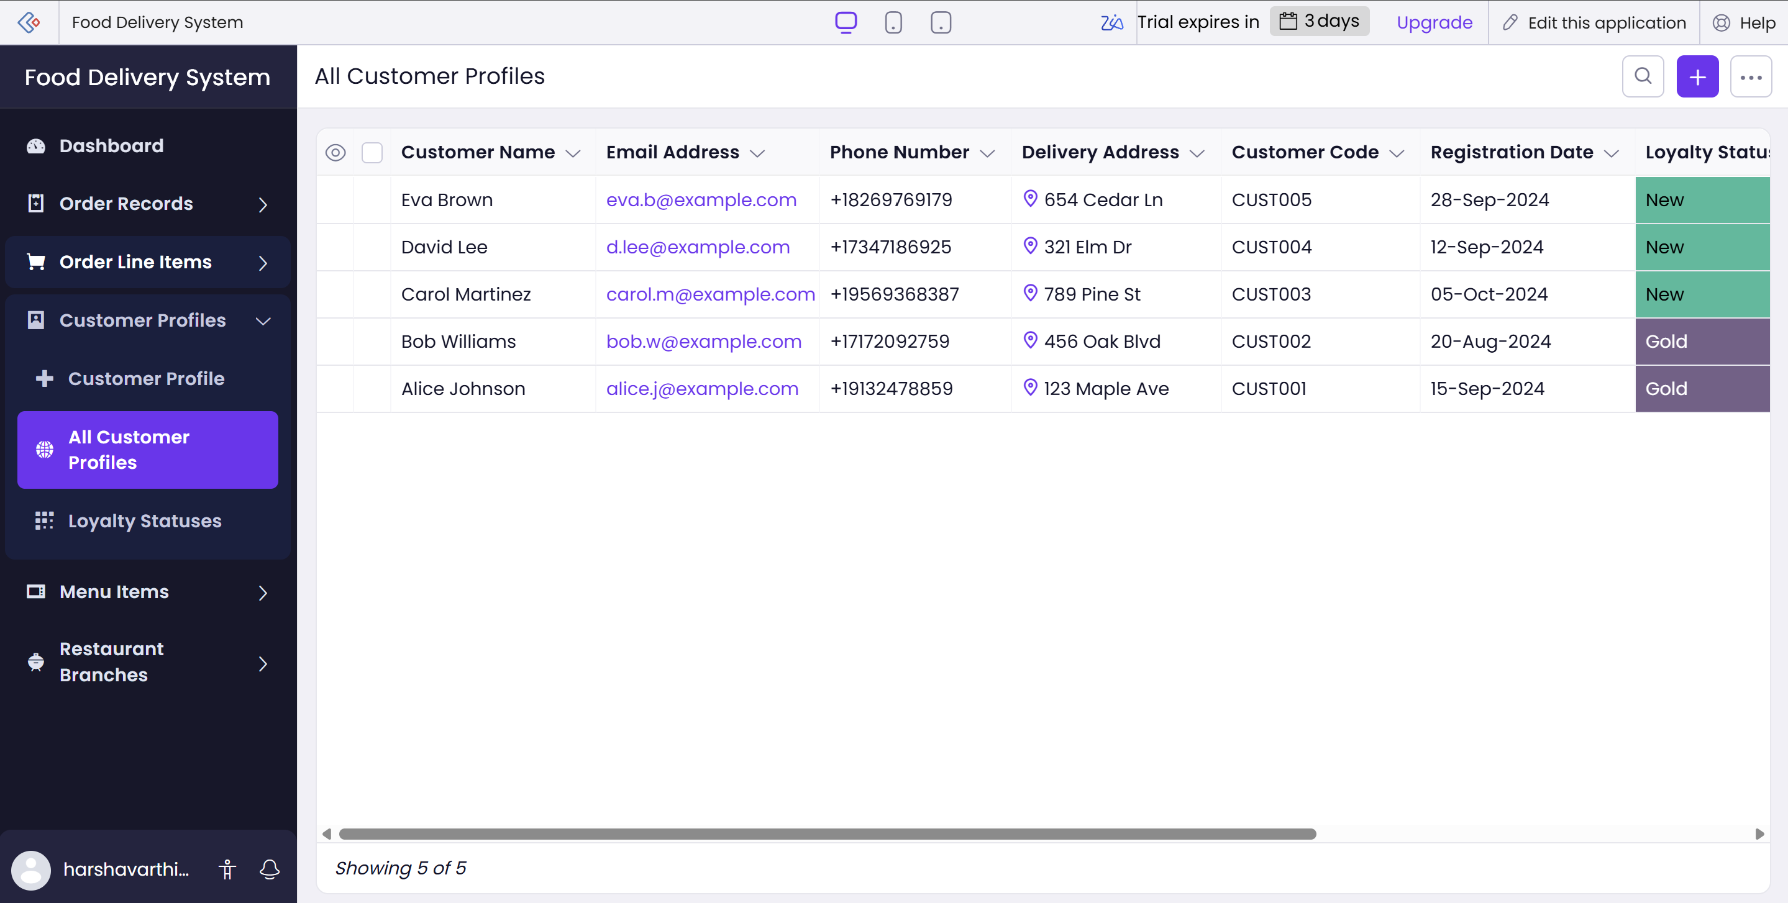

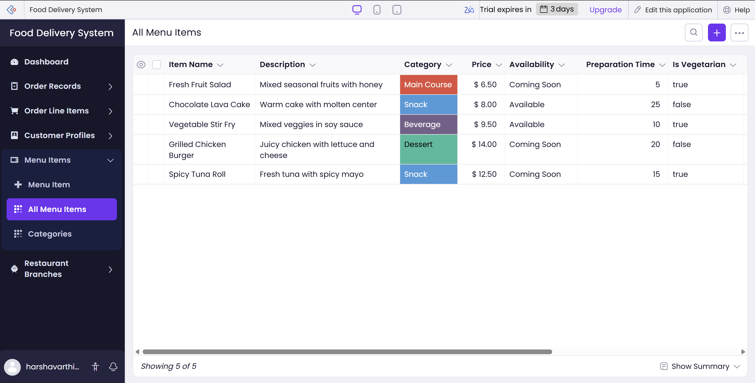

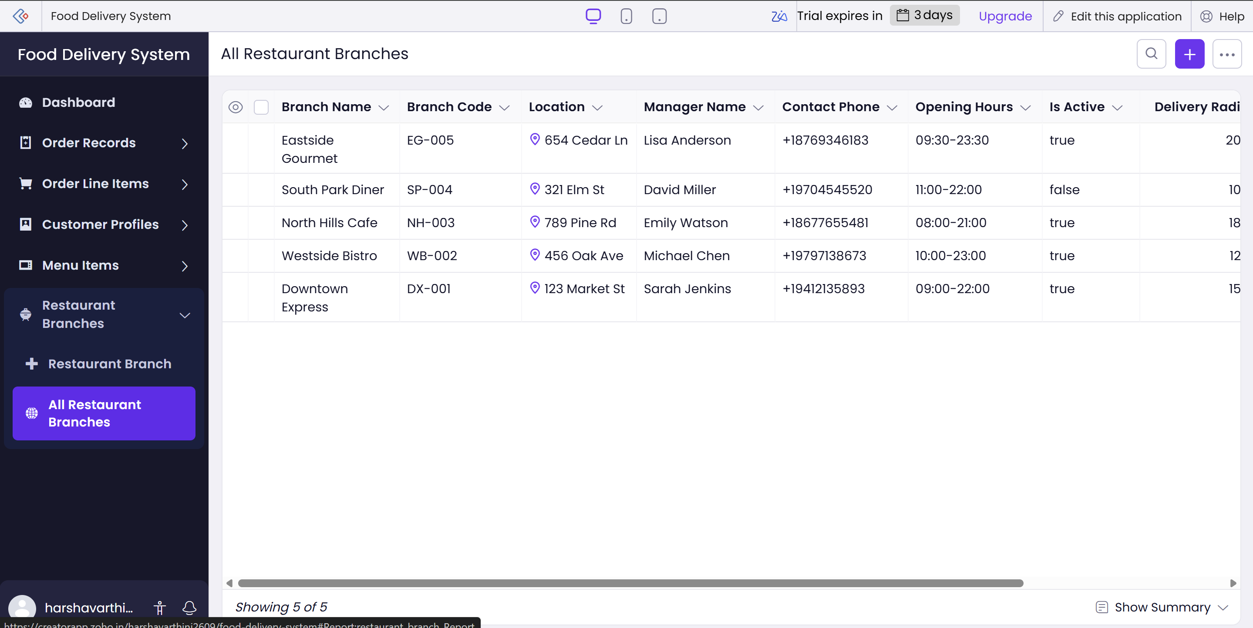

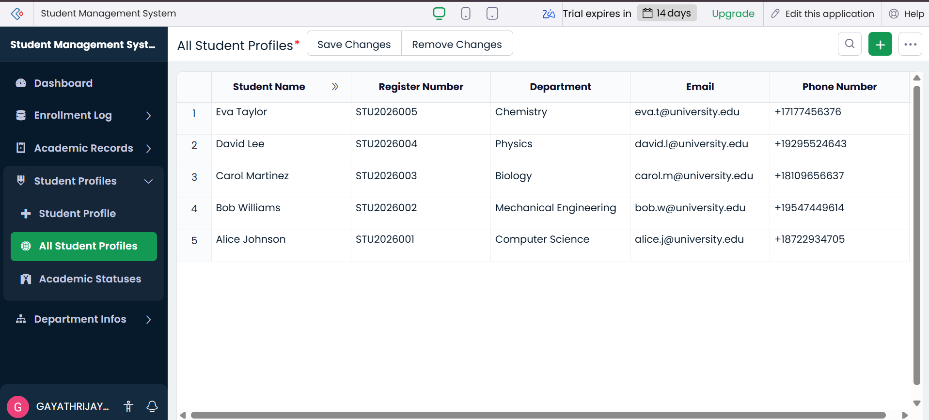

8. Advantages
- Data from one form can be presented in many ways without repeating it.
- Filter criteria show only the records that matter to a particular user.
- Sorting, grouping and searching make large record sets easy to manage.
- Kanban, Calendar and Summary reports give visual insight beyond a plain table.
- Reports can be edited, exported and shared with little or no coding.

9. Limitations
- Incorrect criteria or field selection produces misleading reports.
- Some report types and options depend on the Zoho Creator plan in use.
- Complex calculations or cross-form summaries may need Deluge scripting or Pages.
- Very large data sets can make report loading slower.

10. Result
The experiment was successfully completed. Reports for the Food Delivery System were created in Zoho Creator, including List reports with filter criteria, a Kanban report, a Calendar report and a Summary report. The reports were tested with sample records and produced the expected output.

11. Conclusion
Reports are the presentation layer of a Zoho Creator application. By combining report types with criteria, sorting and grouping, a single set of forms can serve many different information needs. The Food Delivery example shows how available books, issued books and overdue returns can be tracked easily once suitable reports are in place.

