Ex. No. : 02 Date : 27/08/2026

Register No. : 240701181 Name : Harshavarthini Annamalai

Comparative Study of Low-Code Development

1. Aim
To carry out a comparative study of low-code application development on the Zoho Creator platform against conventional hand-coded software development, examining how the two approaches differ in build time, cost, adaptability, growth capacity, security posture, and the categories of business applications each one serves best.

2. Introduction

2.1 Low-Code Application Development
Low-code development is a model-driven way of producing software in which most of the application is assembled through configuration rather than typed out line by line. Zoho Creator, the platform used in this study, exposes form designers, ready-made interface blocks, rule-based workflow builders, and a compact scripting language called Deluge. Because the platform already supplies the database, hosting layer, and user-management plumbing, a domain expert with limited programming background — often called a citizen developer — can produce a working business application, while professional developers use the same environment to cut delivery time on routine projects.

2.2 Traditional Application Development

Traditional development follows the classical Software Development Life Cycle. Each tier of the system is authored explicitly: the presentation layer, the business rules, the persistence schema, and every external integration are written by engineers using languages and frameworks such as Java, Python, .NET, or a JavaScript stack. The result is maximum control, paid for in effort and elapsed time.

3. Objectives of the Study

- To examine how the stages of the development lifecycle differ between a low-code platform and a conventionally coded project.
- To assess both approaches against measurable criteria such as delivery time, expenditure, required skill level, and capacity to scale.
- To determine the problem domains in which each approach delivers the better outcome.
- To record the benefits and constraints of committing to a low-code platform such as Zoho Creator.

4. Development Lifecycle Comparison
The figure below illustrates the key stages involved in building an application using the traditional approach versus the Zoho Creator low-code approach. The low-code pipeline compresses design, scripting, testing, and deployment into fewer, faster, more integrated stages.
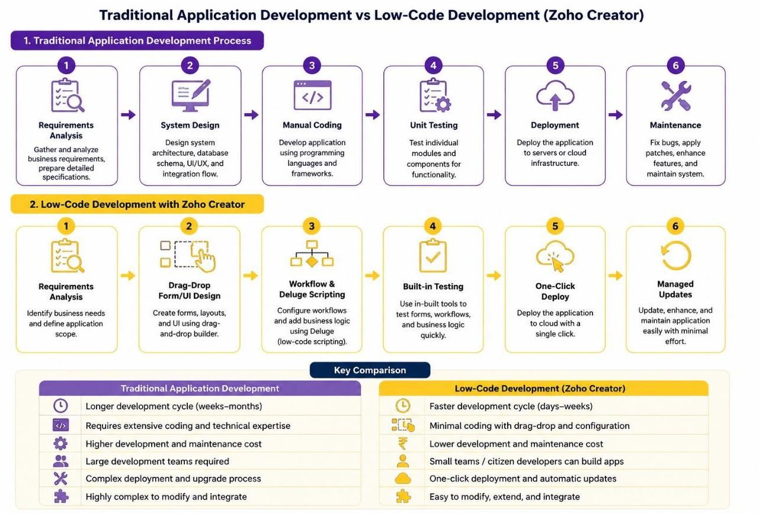
Figure 1: Development lifecycle — Traditional Development vs. Low-Code Development
(Zoho Creator)

5. Detailed Comparative Analysis

Parameter | Low-Code Development (Zoho Creator) | Traditional Application Development
Development Speed | Rapid — applications built in days/weeks using visual builders and pre-built components. | Slower — every screen, workflow, and logic module is hand-coded, typically taking weeks to months.
Skill Requirement | Minimal coding; citizen developers with basic Deluge scripting knowledge can build apps. | Requires trained software engineers skilled in languages such as Java, Python, or .NET.
Cost of  Development | Lower upfront cost; subscriptionbased licensing (e.g., Zoho Creator plans) reduces manpower cost. | Higher cost due to large development teams, longer timelines, and infrastructure needs.
Customization & Flexibility | Good for standard business logic; complex, highly specialized logic may hit platform limits. | Highly flexible — any custom logic, architecture, or integration can be implemented from scratch.

Parameter | Low-Code Development (Zoho Creator) | Traditional Application Development
Scalability | Scales well for departmental or mid-size applications; enterprise scale depends on platform limits. | Can be architected for any scale, including large distributed, hightraffic systems.
Maintenance & Updates | Platform vendor (Zoho) manages infrastructure, security patches, and platform upgrades. | Development team is fully responsible for maintenance, bug fixes, and version upgrades.
Integration Capability | Built-in connectors and REST APIs for integrating with Zoho and third-party services. | Full control over integration design, but requires custom API development and testing.
Security & Governance | Role-based access control and platform-level security are built-in and configurable. | Security must be designed and implemented manually at every layer of the application.
Learning Curve | Shallow — visual, drag-and-drop interface is easy for beginners to adopt quickly. | Steep — requires strong foundation in programming, frameworks, and system design.
Deployment Time | One-click deployment from development to production environment. | Deployment involves build pipelines, servers, and manual configuration steps.
Vendor Lock-in | The application depends on Zoho Creator's runtime, making migration non-trivial. | None — the organisation holds the source code and can host or port it freely.
Ideal Use Case | Internal tools, approval and tracking workflows, data-collection apps, and prototypes. | Miss Mission-critical platforms and large-scale systems where performance and control are decisive.

Table 1: Parameter-wise comparison of Low-Code Development vs.
Traditional Application Development

6. Illustrative Example

Consider an organisation that needs an internal Asset Request and Issue Tracking application, through which employees raise requests for equipment and the IT department approves, allocates, and records the issue.

6.1 Using Zoho Creator (Low-Code)

- A request form capturing employee details, asset category, quantity, and justification is assembled in the drag-and-drop builder, with validation set through field properties.
- A workflow rule routes each submission to the department head, then onward to the IT stores team once approved.
- A short Deluge snippet updates the available-stock count and mails a confirmation carrying the allotted asset tag.
- Build, test, and deployment are realistically completed inside a single working day.

6.2 Using Traditional Development

- A backend developer models the asset, employee, and request entities and exposes REST endpoints for creation, approval, and stock adjustment.
- A frontend developer constructs the form, listing screens, and dashboard in a framework such as React or Angular.
- Approval routing, stock decrement, mail dispatch, and role-based permissions are each coded and unit-tested individually.
- Delivering the same functionality conventionally typically consumes one to two weeks of dedicated developer effort.

7 Advantages and Limitations

7.1 Low-Code Development — Advantages

- Compresses time-to-market dramatically for process-driven and departmental applications.
- Allows people closest to the business problem to build the solution, reducing requirement loss in handoffs.
- Removes infrastructure, hosting, and patching work from the organisation's plate.

7.2 Low-Code Development — Limitations
- Limited support for highly specialized or performance-critical logic.
- Possible vendor lock-in to the platform's ecosystem and pricing model.
- May not scale efficiently for very large, high-traffic enterprise systems.

7.3 Traditional Development — Advantages

- Total authority over architecture, data design, performance tuning, and user experience.
- The organisation owns the codebase outright and can host, modify, or migrate it freely.
- The only viable route for systems with demanding scale or regulatory obligations.

7.4 Traditional Development — Limitations

- Long build and verification cycles delay the point at which the business sees value.
- Requires sustained investment in skilled engineers and supporting infrastructure.
- Ongoing ownership is expensive, as every patch and enhancement is manual work.

8. Result
The comparative study was completed successfully. The analysis shows that low-code development on Zoho Creator delivers clear advantages in delivery speed, cost predictability, and accessibility for conventional business applications, whereas traditional development remains necessary wherever an application demands deep customisation or enterprise-scale architecture.

9. Conclusion.

The study indicates that low-code and traditional development are complementary tools rather than rivals. Zoho Creator is the efficient choice for internal automation, approval systems, and prototypes that must reach users quickly, while conventionally engineered systems remain correct for products whose scale or control requirements exceed what a platform can accommodate. Understanding where that boundary lies allows a developer to match the right method to the right business problem.

10. References
- Rosam, W. and Kalnichevski, O., Low-Code Development: A Practical Guide, BPB Publications.
- Zoho Creator Official Documentation — https://www.zoho.com/creator/help/
- Deluge Script Reference Guide — https://www.zoho.com/deluge/
- Gartner Research — Magic Quadrant for Enterprise Low-Code Application Platforms.

