OPERATIONAL RISK ANALYTICS
& EXECUTIVE REPORTING DASHBOARD
Portfolio Project Documentation
BY – HARSH BHARTI

Dataset records | 2,147 | Total loss | 239,544.50 kUSD
Average loss | 111.57 kUSD | Maximum loss | 382.01 kUSD
Actual-date records | 858 | Potential loss outliers | 5

Tools: Excel • SQL • Python • Pandas • NumPy • Power BI • DAX • Generative AI

1. Executive Summary
This project demonstrates an end-to-end analytical workflow for operational risk event data. The objective was to validate and transform the dataset, analyze loss and risk patterns using SQL and Python, and communicate the results through an interactive Power BI executive dashboard.
The analysis covers 2,147 scenarios with a combined recorded loss of 239,544.50 kUSD. The workflow includes data-quality validation, event-type and process-area analysis, loss concentration, severity/frequency analysis, ALE/OLE comparison, risk-band segmentation, temporal analysis for records with actual dates, correlation analysis, outlier review, and executive reporting.
The dataset is treated as a portfolio-analysis dataset. Analytical thresholds used for risk bands are project-defined thresholds for demonstration and are not presented as regulatory, industry, or company-specific limits.

Project Objectives
- Validate data completeness, uniqueness, date quality, and potential outliers.
- Use SQL to produce repeatable KPI, segmentation, concentration, ranking, and trend analyses.
- Use Python/Pandas/NumPy to independently validate and extend the analysis.
- Develop a Power BI dashboard with executive KPIs, risk analysis, and data-quality monitoring.
- Use DAX for reusable KPI calculations and interactive reporting.
- Use Generative AI tools as analyst-assistance tools while validating outputs against the underlying data.

2. Business Problem
Operational risk datasets can contain many event records across business processes, event types, severity levels, and external indicators. A decision-maker needs a concise way to understand where loss is concentrated, which scenarios require review, how risk measures relate to recorded loss, and whether data-quality limitations could affect interpretation.
This project addresses that need by converting a row-level operational risk dataset into validated analytical outputs and an executive dashboard.

3. Dataset Overview
Item | Value
Rows | 2,147
Original columns | 12
Clean/derived columns used | 17
Scenario ID pattern | ALE-#### / OLE-####
ALE records | 1,289
OLE records | 858
Actual dates | 858
Synthetic date label | 1,289 records marked Synth-2022
Missing values in original fields | 0
Exact duplicate rows | 0
Duplicate Scenario IDs | 0
Loss range | 5.00–382.01 kUSD
Frequency range | 1–5
Severity range | 0.30–3.00
OpVar range | 0.50–3.50%
ML range | 0.82–4.30
GDP range | 2.50–4.00%
VIX range | 14–29
Potential loss outliers | 5

Dataset Fields
Field | Type / Role | Business / analytical use | Quality note
Scenario_ID | Identifier | Unique scenario reference | No duplicates identified
Scenario_Type | Category | ALE/OLE classification | Consistent with scenario IDs
Date | Original field | Original date/synthetic date representation | Includes Synth-2022
Event_date | Date | Actual event-date analysis | Valid actual dates used for trends
Date_type | Category | Actual vs synthetic date classification | Used for monitoring
Event_Type | Category | Event classification | 5 categories
Process_Area | Category | Business/process classification | 5 categories
Loss_Amount_(kUSD) | Numeric | Recorded loss amount | No negatives; 5 IQR flags
Frequency_(Nk) | Numeric | Scenario frequency measure | Range 1–5
Severity_(Xi) | Numeric | Scenario severity measure | Range 0.30–3.00
OpVar_(%) | Numeric | Operational variable in source dataset | Definition should be source-validated
ML | Numeric | Source dataset variable | Definition should be source-validated; structural pattern observed
GDP_(%) | Numeric | Macro indicator | Used for association analysis only
VIX | Numeric | Market-volatility indicator | Used for association analysis only
Target | Numeric/category | Source target variable | Meaning should be source-validated before interpretation
Loss_Outlier_Flag | Derived category | Flags potential high-loss observations | IQR-based analytical flag
Data_Quality_Flag | Derived category | Monitoring/review status | Used for QA dashboard

4. Data Cleaning & Validation
The cleaning stage focused on validation and traceability rather than deleting unusual records. Potential outliers were retained and flagged because a high-loss operational risk event may be analytically important.
- Checked missing/null values across the dataset.
- Checked exact duplicate rows.
- Checked duplicate Scenario_ID values.
- Validated Scenario_ID structure and ALE/OLE classification.
- Separated actual event dates from the synthetic 'Synth-2022' representation.
- Checked numeric ranges and negative-loss conditions.
- Applied an IQR-based flag to potential loss outliers.
- Reviewed the relationship between data-quality flags and outlier flags.
- Retained unusual values for review instead of automatically deleting them.

Observed data-quality considerations
- 1,289 records use the 'Synth-2022' date representation, while 858 records contain actual dates.
- The actual-date records span 2022-01-01 to 2023-12-31 and were used for monthly trend analysis.
- All 858 OLE records have ML = 1.00 in the supplied dataset, while ALE records show variation. This is treated as a dataset-specific structural pattern, not a reason to overwrite values.
- Five loss observations were identified as potential IQR outliers. They were retained and flagged.
- The definitions of ML, OpVar, Xi, Nk, and Target should be confirmed from the source documentation before making domain-specific claims.

5. SQL Analysis
SQL was used to create a reproducible analytical layer over the cleaned operational-risk table. The analysis included validation, KPI calculations, categorical aggregation, concentration analysis, ranking, risk-band segmentation, correlation/association checks, and data-quality review.
- Data validation: record count, duplicate Scenario IDs, missing values, scenario type, and date type.
- Core KPIs: total scenarios, total loss, average loss, maximum loss, average severity/frequency/OpVar/VIX.
- Event-type analysis: counts, total loss, average loss, severity, frequency, and loss contribution.
- Process-area analysis: counts, total loss, average loss, severity, frequency, and loss contribution.
- Event Type × Process Area concentration.
- Severity and frequency analysis.
- ALE versus OLE comparison.
- Outlier and data-quality review.
- Actual-date monthly trend analysis.
- Top-loss event identification.
- CTE/ranking/window-function analysis for ranked and top-N results.
- Analytical risk bands using project-defined thresholds.
- Association analysis for VIX/GDP and other numeric variables.

6. Python Analysis
Python was used as an independent analytical and validation layer. Pandas was used for data manipulation and aggregation, NumPy for numerical operations, and Matplotlib for visual exploration.
- Loaded and inspected the clean dataset.
- Validated missing values and duplicates.
- Generated descriptive statistics.
- Compared mean and median loss to assess distribution shape.
- Visualized loss distribution and boxplot-based outlier candidates.
- Analyzed event types and process areas.
- Compared severity/frequency with loss.
- Calculated a correlation matrix for loss, frequency, severity, OpVar, ML, GDP, and VIX.
- Created actual-date monthly analysis for 858 records.
- Compared ALE and OLE scenarios.
- Created analytical risk bands.
- Exported reusable analysis tables to Excel.

7. Key Analytical Findings

7.1 Overall portfolio
- The dataset contains 2,147 scenarios with total recorded loss of 239,544.50 kUSD.
- Average recorded loss is 111.57 kUSD per scenario, while the maximum recorded loss is 382.01 kUSD.
- Average severity is approximately 1.50.
- No duplicate Scenario IDs or missing values were identified in the supplied clean dataset.

7.2 Event-type loss concentration
Event Type | Scenarios | Total Loss (kUSD) | Avg Loss (kUSD) | Avg Severity | Loss Share
System Failure | 497 | 53,811.56 | 108.27 | 1.48 | 22.46%
Data Breach | 494 | 52,632.86 | 106.54 | 1.44 | 21.97%
Tech Failure | 454 | 47,561.68 | 104.76 | 1.42 | 19.86%
Cyber-Fraud | 450 | 44,748.60 | 99.44 | 1.47 | 18.68%
Phishing | 252 | 40,789.80 | 161.86 | 1.90 | 17.03%
System Failure has the largest total recorded loss at 53,811.56 kUSD (22.46% of total loss). Phishing has the highest average loss per scenario at 161.86 kUSD and also has the highest average severity among event types at 1.90. These are descriptive patterns in the supplied dataset.

7.3 Process-area loss concentration
Process Area | Scenarios | Total Loss (kUSD) | Avg Loss (kUSD) | Avg Severity | Avg Frequency
Retail Banking | 507 | 53,743.59 | 106.00 | 1.46 | 3.05
ATM Network | 478 | 52,011.41 | 108.81 | 1.43 | 2.97
E-Banking | 474 | 51,838.15 | 109.36 | 1.51 | 3.03
Payments | 465 | 48,341.26 | 103.96 | 1.43 | 2.89
Online Services | 223 | 33,610.09 | 150.72 | 1.91 | 3.00
Retail Banking has the largest total recorded loss among process areas at 53,743.59 kUSD. Online Services has the highest average loss per scenario at 150.72 kUSD and the highest average severity at 1.91.

7.4 ALE versus OLE
Scenario Type | Scenarios | Total Loss (kUSD) | Average Loss (kUSD) | Avg Severity | Avg Frequency
ALE | 1289 | 195,897.18 | 151.98 | 1.90 | 2.96
OLE | 858 | 43,647.32 | 50.87 | 0.90 | 3.03
ALE scenarios account for 1,289 records and 195,897.18 kUSD in recorded loss, while OLE scenarios account for 858 records and 43,647.32 kUSD. The average recorded loss is 151.98 kUSD for ALE versus 50.87 kUSD for OLE.

7.5 Analytical risk bands
Risk Band | Scenarios | Total Loss (kUSD) | Average Loss (kUSD)
Medium Risk | 1078 | 171,044.76 | 158.67
Lower Risk | 1043 | 61,103.69 | 58.58
High Risk | 26 | 7,396.05 | 284.46
The project-defined rules were: High Risk = Severity ≥ 2.5 AND Loss ≥ 250 kUSD; Medium Risk = Severity ≥ 1.5 OR Loss ≥ 150 kUSD; Lower Risk = all remaining records. These thresholds are analytical rules created for this portfolio project and are not presented as official regulatory/company thresholds.
Under these rules, Python reports 26 High Risk, 1078 Medium Risk, and 1043 Lower Risk scenarios.

7.6 Actual-date monthly trend
Monthly trend analysis was restricted to the 858 records with actual Event_date values. The highest monthly recorded loss was 2,429.16 kUSD in March 2022; the lowest was 1,113.63 kUSD in August 2022.
The synthetic-date records were excluded from chronological trend analysis because 'Synth-2022' does not identify a specific event date.

7.7 Correlation and association
Variable vs Loss | Pearson correlation
Frequency_(Nk) | -0.06
Severity_(Xi) | 0.45
OpVar_(%) | 0.49
ML | 0.44
GDP_(%) | -0.03
VIX | 0.23
The strongest observed linear associations with recorded loss in the supplied dataset are Severity (0.45), OpVar (0.49), ML (0.44), and VIX (0.23). Frequency is approximately uncorrelated with loss (-0.06), while GDP is near zero (-0.03). Correlation indicates association, not causation, and these relationships should not be interpreted as causal effects.

8. Power BI Executive Dashboard
The Power BI report contains three pages: Executive Risk Overview, Risk Analysis, and Data Quality & Monitoring. The dashboard is designed to demonstrate KPI reporting, segmentation, interactive filtering, DAX measures, and data-quality monitoring.

Page 1 — Executive Risk Overview
- KPI cards: High-Risk Scenarios, Total Scenarios, Total Loss, Average Loss, Maximum Loss, Average Severity.
- Total Loss by Event Type.
- Total Loss by Process Area.
- Risk Scenario Distribution.
- Total Loss by Month.
- Top 10 Operational Risk Loss Events.
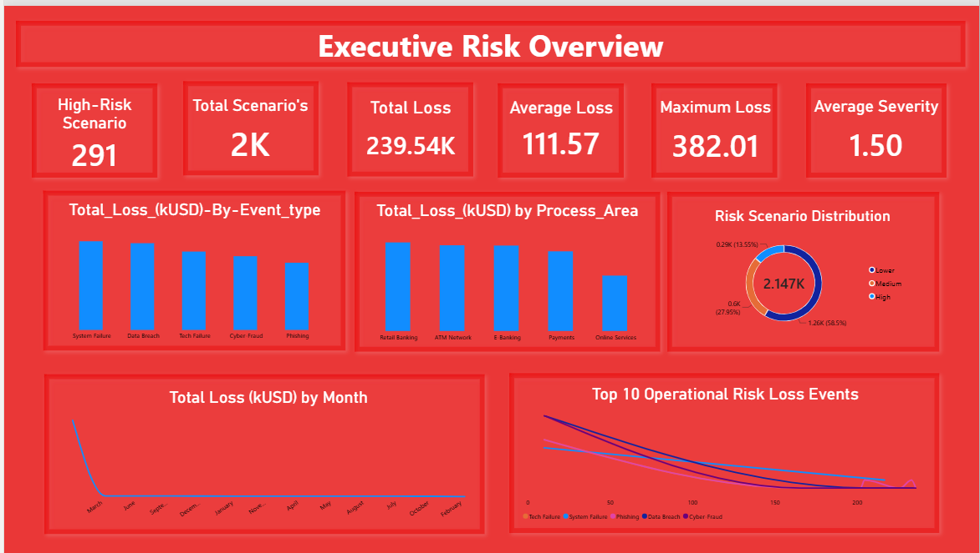
Dashboard screenshot supplied by the project owner.

Page 2 — Risk Analysis
- Event Type, Process Area, Scenario Type, Risk Band, and Event Year slicers.
- Risk Band Distribution.
- Process Area by Event Type.
- ALE versus OLE.
- Total Loss by Frequency.
- Total Loss by VIX.
- Total Loss by Severity.
- Total Loss by GDP.
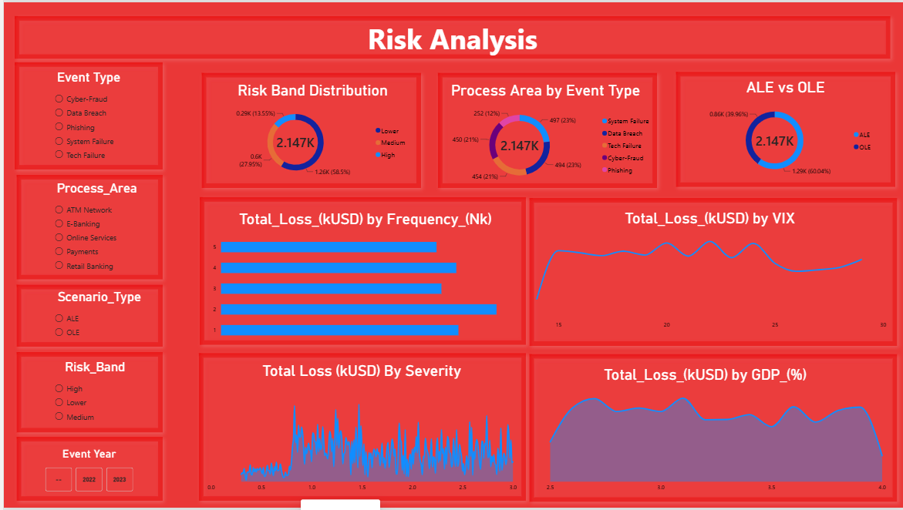

Page 3 — Data Quality & Monitoring
- KPI cards: Total Records, Missing Values, Duplicate IDs, Outlier Count, Data Quality Review, Actual Dates.
- Data Quality Flag Distribution.
- Date Type Distribution.
- Loss Outlier Analysis.
- Records Requiring Review table.
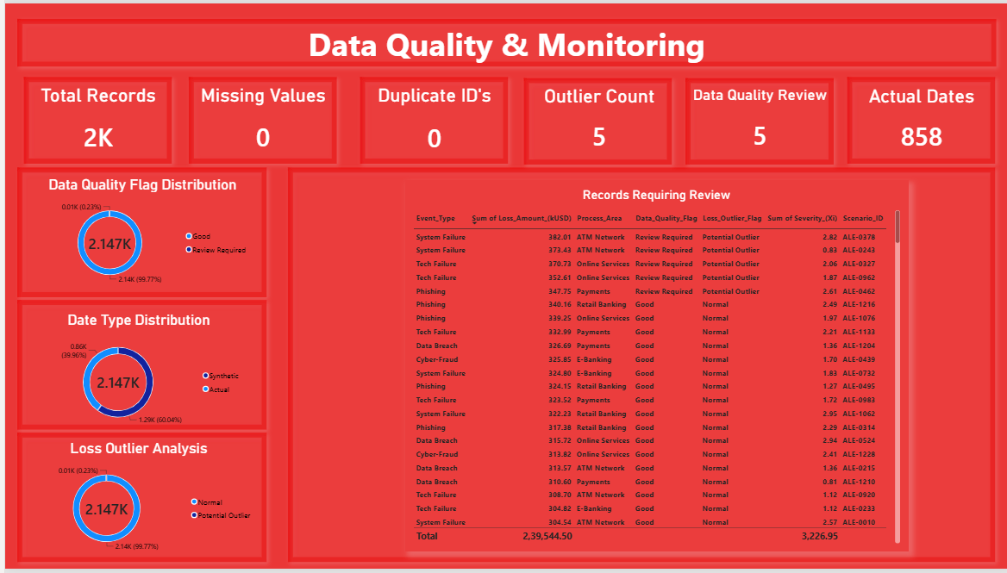

9. DAX Measures Used / Recommended
The following measures form the core reusable KPI layer. Table and column names should match the final Power BI model exactly.
Total Records
COUNTROWS('Operational Risk Events')
Total Loss (kUSD)
SUM('Operational Risk Events'[Loss_Amount_(kUSD)])
Average Loss (kUSD)
AVERAGE('Operational Risk Events'[Loss_Amount_(kUSD)])
Maximum Loss (kUSD)
MAX('Operational Risk Events'[Loss_Amount_(kUSD)])
High Risk Scenarios
CALCULATE(
COUNTROWS('Operational Risk Events'),
'Operational Risk Events'[Risk Band] = "High"
)
Duplicate Scenario IDs
COUNTROWS('Operational Risk Events')
-
DISTINCTCOUNT('Operational Risk Events'[Scenario_ID])
Actual Date Records
CALCULATE(
COUNTROWS('Operational Risk Events'),
'Operational Risk Events'[Date_type] = "Actual"
)
Synthetic Date Records
CALCULATE(
COUNTROWS('Operational Risk Events'),
'Operational Risk Events'[Date_type] = "Synthetic"
)

10. Generative AI Integration
Generative AI was used as an analyst-assistance layer rather than as an unverified source of conclusions.
Tool | Use in project | Validation approach
ChatGPT | Data-quality framework, SQL/Python assistance, KPI/KRI design, analytical wording, documentation, dashboard planning | Outputs reviewed against dataset and calculations
Microsoft Copilot | Excel exploration, formula/Pivot support, Power BI exploration/narrative assistance where available | Results checked against underlying data and dashboard calculations
Suggested resume wording: 'Leveraged ChatGPT and Microsoft Copilot for AI-assisted data exploration, SQL/Python development, KPI design, analytical summarization, and executive insight generation, with outputs validated against underlying data.'

11. Analytical Recommendations
- Prioritize review of event types and process areas with high total loss contribution, while also examining categories with high average loss.
- Use the largest individual-loss scenarios as a focused review list for root-cause and control assessment.
- Monitor severity and loss together rather than relying on frequency alone, given the weak observed correlation between frequency and loss in this dataset.
- Maintain an explicit data-quality monitoring layer so synthetic dates, potential outliers, and review flags remain visible to dashboard users.
- Validate source definitions for ML, OpVar, Xi, Nk, and Target before using them for domain-specific business claims.
- Treat VIX/GDP relationships as descriptive associations and avoid causal conclusions without additional methodology and data.

12. Dashboard QA & Reconciliation Notes
Before publishing the dashboard as a final portfolio artifact, the following reconciliation items should be checked.
- High-Risk KPI mismatch: the supplied Power BI screenshot shows 291 High-Risk scenarios, while the exported Python Risk_Bands analysis reports 26 High Risk scenarios under the documented rule (Severity ≥ 2.5 AND Loss ≥ 250). Reconcile the Power BI Risk Band field/measure with the Python/SQL definition before final submission.
- Risk-band distribution should therefore be rechecked after the above reconciliation.
- Page 1 'Total Scenarios' displays approximately 2K due to card formatting; use 2,147 or an explicit integer format if exact reporting is preferred.
- The Page 1 monthly chart should use a Year-Month field for chronological ordering across 2022–2023; avoid sorting month names alphabetically or combining two years into the same month label.
- The Page 1 'Top 10 Operational Risk Loss Events' visual should be verified to use Scenario_ID on the category axis and Loss_Amount_(kUSD) as the value, with a Top N = 10 filter. A horizontal bar chart is clearer for this purpose.
- Page 3 review table should clearly identify the rows that require review and avoid implying that every high-loss row is automatically a confirmed operational-risk issue.

13. Limitations & Assumptions
- The dataset is treated as a portfolio/project dataset; conclusions describe the supplied data rather than a real company's full operational-risk environment.
- Synthetic dates are not used for precise time-series interpretation.
- Potential outliers are flags for review, not automatically erroneous observations.
- Project-defined risk-band thresholds are illustrative analytical rules, not regulatory or company policy thresholds.
- Correlation results do not establish causation.
- Source definitions for ML, OpVar, Xi, Nk, and Target should be validated before domain-specific interpretation.
- Dashboard values should be reconciled against SQL/Python outputs before publication.

14. Technology Stack & Skills Demonstrated
Technology / skill | Application in project
Excel | Data review, exported analysis, tabular validation and reporting
SQL / MySQL | Data validation, aggregation, KPI analysis, ranking, CTEs, window functions, risk segmentation
Python | Data loading, validation, descriptive statistics, analytical aggregation and export
Pandas / NumPy | Data manipulation and numerical analysis
Matplotlib | Distribution, outlier and relationship visualizations
Power BI | Interactive executive dashboard, slicers, KPI cards and analytical visuals
DAX | Reusable KPI and monitoring measures
Data Quality | Missing-value, duplicate, date-quality and outlier monitoring
Risk Analytics | Loss, severity, frequency, concentration, ALE/OLE and analytical risk-band analysis
Generative AI | ChatGPT and Microsoft Copilot for analyst assistance with validation

15. Interview-Ready Project Explanation
I built an end-to-end operational risk analytics project using a 2,147-record scenario dataset. I first validated and cleaned the data, including duplicate checks, date-quality checks, and outlier flagging. I then used SQL to perform KPI, event-type, process-area, concentration, ranking, ALE/OLE, and risk-band analysis. In Python, I independently validated the results, explored loss distributions, correlations, and actual-date trends, and exported analytical outputs to Excel. Finally, I built a three-page Power BI dashboard with DAX-based KPIs, risk analysis, and data-quality monitoring. I also used ChatGPT and Microsoft Copilot as analyst-assistance tools, while validating AI-supported outputs against the underlying data.

16. Resume-Ready Project Entry
Operational Risk Analytics & Executive Reporting Dashboard
- Cleaned and validated 2,147 operational-risk scenarios using Excel/Python, performing missing-value, duplicate, date-quality, and outlier checks.
- Used SQL and Python to analyze loss concentration across event types/process areas, severity, frequency, ALE/OLE scenarios, risk bands, correlations, and actual-date trends.
- Developed a 3-page Power BI executive dashboard with DAX KPIs, interactive risk analysis, loss monitoring, and data-quality reporting.

17. Project Deliverables
Artifact | Purpose
Operational_Risk_Events_Raw.csv | Original source dataset
Operational_Risk_Events_Clean.csv | Cleaned/derived row-level dataset
risk_analysis.sql | SQL validation and analytical queries
risk_analysis.py | Python analytical workflow
Operational_Risk_Python_Analysis.xlsx | Exported Python analytical results
Operational_Risk_Dashboard.pbix | Interactive Power BI report
Data_Dictionary.xlsx | Field definitions and quality rules
Project_Documentation.docx | This project report
Dashboard screenshots | Portfolio/GitHub/README presentation assets

18. Final Quality Checklist
- SQL queries run successfully and results are saved.
- Python analysis completed and exported.
- Power BI dashboard contains three pages.
- DAX measures are present and validated.
- Power BI High-Risk count reconciled with Python/SQL definition.
- Monthly trend uses a correctly sorted Year-Month field.
- Top-10 loss visual uses Scenario_ID and Loss_Amount with a Top-N filter.
- Data dictionary definitions are source-validated where necessary.
- Final screenshots are readable and consistent.
- Resume bullets use factual project language and do not imply real operational-risk employment experience.

