

**Intro:**

Modern dance originated in Europe and America in the late 19th and early 20th centuries. It was seen as combining the physical and emotional, to express the human spirit.

Dance Academy website offers you the all the knowledge about the classes and Dance forms that students can learn at Dance Academy.

**Purpose:**

The purpose is of making the online availability of the Dance Studio. So that customers can view from the website about the Classes timing, Dance forms and their prices.

**Minimum Requirements:**

If you are using a custom named instance of Microsoft SQL Server Express, you will need to browse the **web.config** files in the demos for **connectionString** parameter entries, and replace any occurrence of the default instance name ("SQLEXPRESS") with your custom instance name.

Starting with version 13.2, for most popular database engines, the DevExpress .NET Demo Center automatically recognizes available database engines on the machine. When launching a particular demo that requires SQL Server from the Demo Center, it automatically locates available DBMS instances in the following order:

1. .\SQLEXPRESS
2. (localdb)\vX
3. (local)

**ASP.net Features**

ASP.NET MVC provides the following features −

* Ideal for developing complex but lightweight applications.
* Provides an extensible and pluggable framework, which can be easily replaced and customized. For example, if you do not wish to use the in-built Razor or ASPX View Engine, then you can use any other third-party view engines or even customize the existing ones.
* Utilizes the component-based design of the application by logically dividing it into Model, View, and Controller components. This enables the developers to manage the complexity of large-scale projects and work on individual components.
* MVC structure enhances the test-driven development and testability of the application, since all the components can be designed interface-based and tested using mock objects. Hence, ASP.NET MVC Framework is ideal for projects with large team of web developers.
* Supports all the existing vast ASP.NET functionalities, such as Authorization and Authentication, Master Pages, Data Binding, User Controls, Memberships, ASP.NET Routing, etc.
* Does not use the concept of View State (which is present in ASP.NET). This helps in building applications, which are lightweight and gives full control to the developers.

Admin:

After logging in successfully admin can add, delete, and update new staff and student

Username: admin

Password: admin

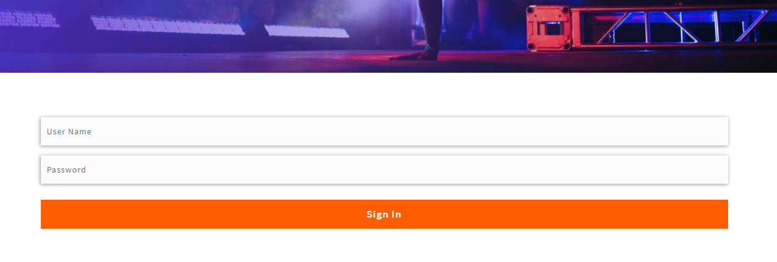

**About page:**

About page is telling about the history of Dance academy

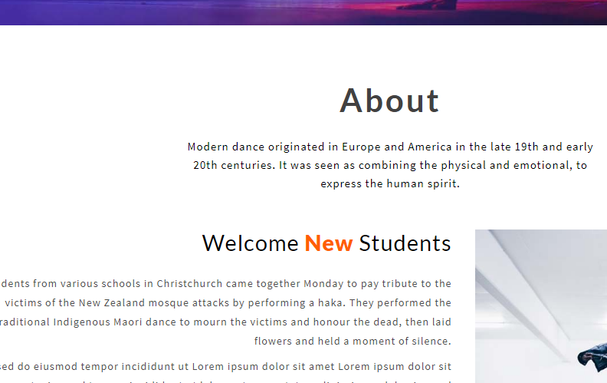

**Services:**

All the services that are offered Dance Studio are displayed on this services page

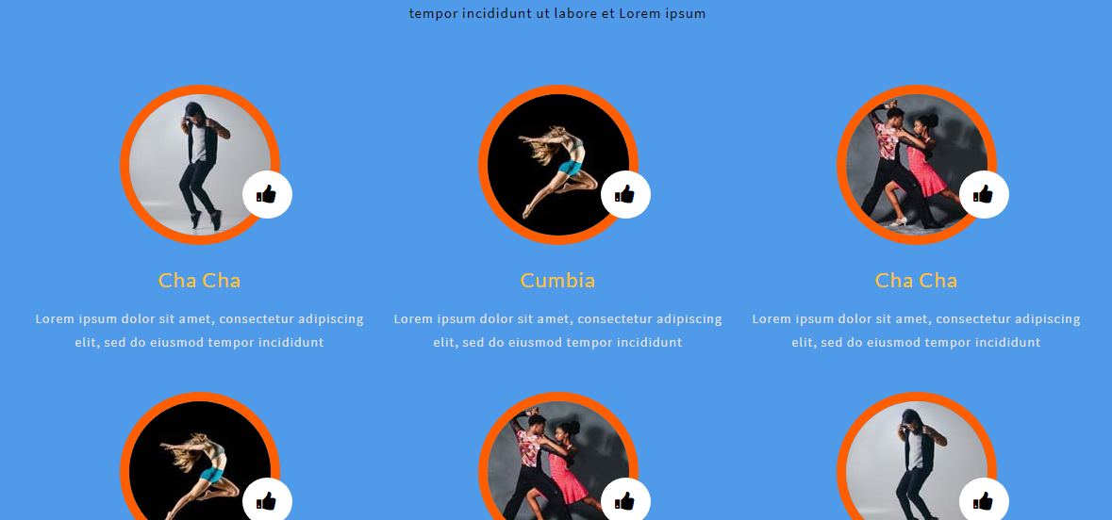

**Contact Page:**

