NIFTY-50 INVESTMENT INTELLIGENCE PLATFORM
Data-Driven Investment Intelligence Using NIFTY-50 Market Data

Technical Report

Submitted by
Harsh Choudhary(MnC 4th year)
Enrollment No: 23323011
Harshith Sai Kumar(MnC 4th year)
Enrollment No: 23323012

IIT Roorkee | Cult Council Open Projects 2026
June 2026

Live Application: https://nifty50-intelligence.streamlit.app/
GitHub Repository: https://github.com/Harshchoudhary2005/nifty50-investment-intelligence

1. Problem Understanding
Financial markets generate enormous volumes of data daily, yet transforming raw historical price data into actionable investment insights remains a complex challenge. The NIFTY-50 index represents the fifty largest and most influential companies listed on the National Stock Exchange (NSE) of India, spanning sectors including Banking, Information Technology, Energy, Consumer Goods, Pharmaceuticals, and Manufacturing.
This project addresses the challenge of building an end-to-end AI-powered investment intelligence platform that goes beyond simple price prediction to deliver practical, explainable decision-support tools for investors of varying risk profiles.

1.1 Objectives
- Analyse 21 years of NIFTY-50 historical market data to uncover patterns and trends
- Develop machine learning models to predict stock returns and price direction
- Build optimised portfolios tailored to Conservative, Balanced, and Aggressive investor profiles
- Quantify investment risk using industry-standard metrics (Sharpe, Sortino, VaR, Max Drawdown)
- Detect historical market anomalies and systemic risk events
- Generate explainable, evidence-based investment signals for all 49 stocks

1.2 Datasets
Dataset | Source | Coverage | Usage
NIFTY-50 Stock Market Data | Kaggle (rohanrao) | Jan 2000 - Apr 2021 | 50 stock CSVs, metadata
India Stock Data NSE | Kaggle (stoicstatic) | Jul 1990 - Jul 2021 | NIFTY-50 index, India VIX, sector indices, G-Sec yield

The combined dataset spans 21 years with 235,192 trading records across 49 stocks, 48 engineered features per stock, and critical macro signals including India VIX (market fear gauge) and the 10-year G-Sec yield (risk-free rate proxy). This breadth covers multiple complete market cycles including the Dot-com crash (2000), the Global Financial Crisis (2008), and the COVID-19 crash (2020).

2. Exploratory Data Analysis
A comprehensive exploratory analysis was conducted across all 49 stocks and the NIFTY-50 index benchmark spanning 1990 to 2021. The analysis examined sector composition, return characteristics, trading activity, inter-stock correlations, and market regime behaviour.

2.1 Dataset Overview
Metric | Value
Stocks Analysed | 49
Date Range | 2000-01-03 to 2021-04-30
Total Trading Records | 235,192
Features Engineered per Stock | 48 (incl. India VIX macro signal)
Missing Values (Core OHLCV) | None
Average Rows per Stock | ~4,800 trading days

2.2 Sector Composition
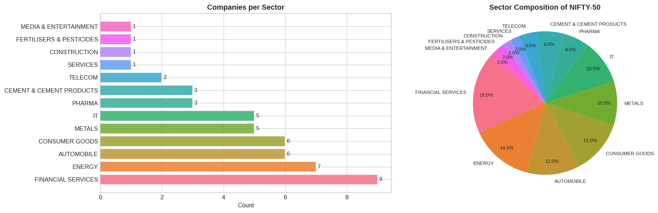
Figure 1: NIFTY-50 Sector Composition — Financial Services dominates with 9 companies
Financial Services is the largest sector with 9 companies, followed by Energy (7) and Consumer Goods & Automobile (6 each). This concentration in Financial Services has important implications for portfolio diversification, as high inter-sector correlation can amplify systemic risk.

2.3 Return Distributions & Volatility
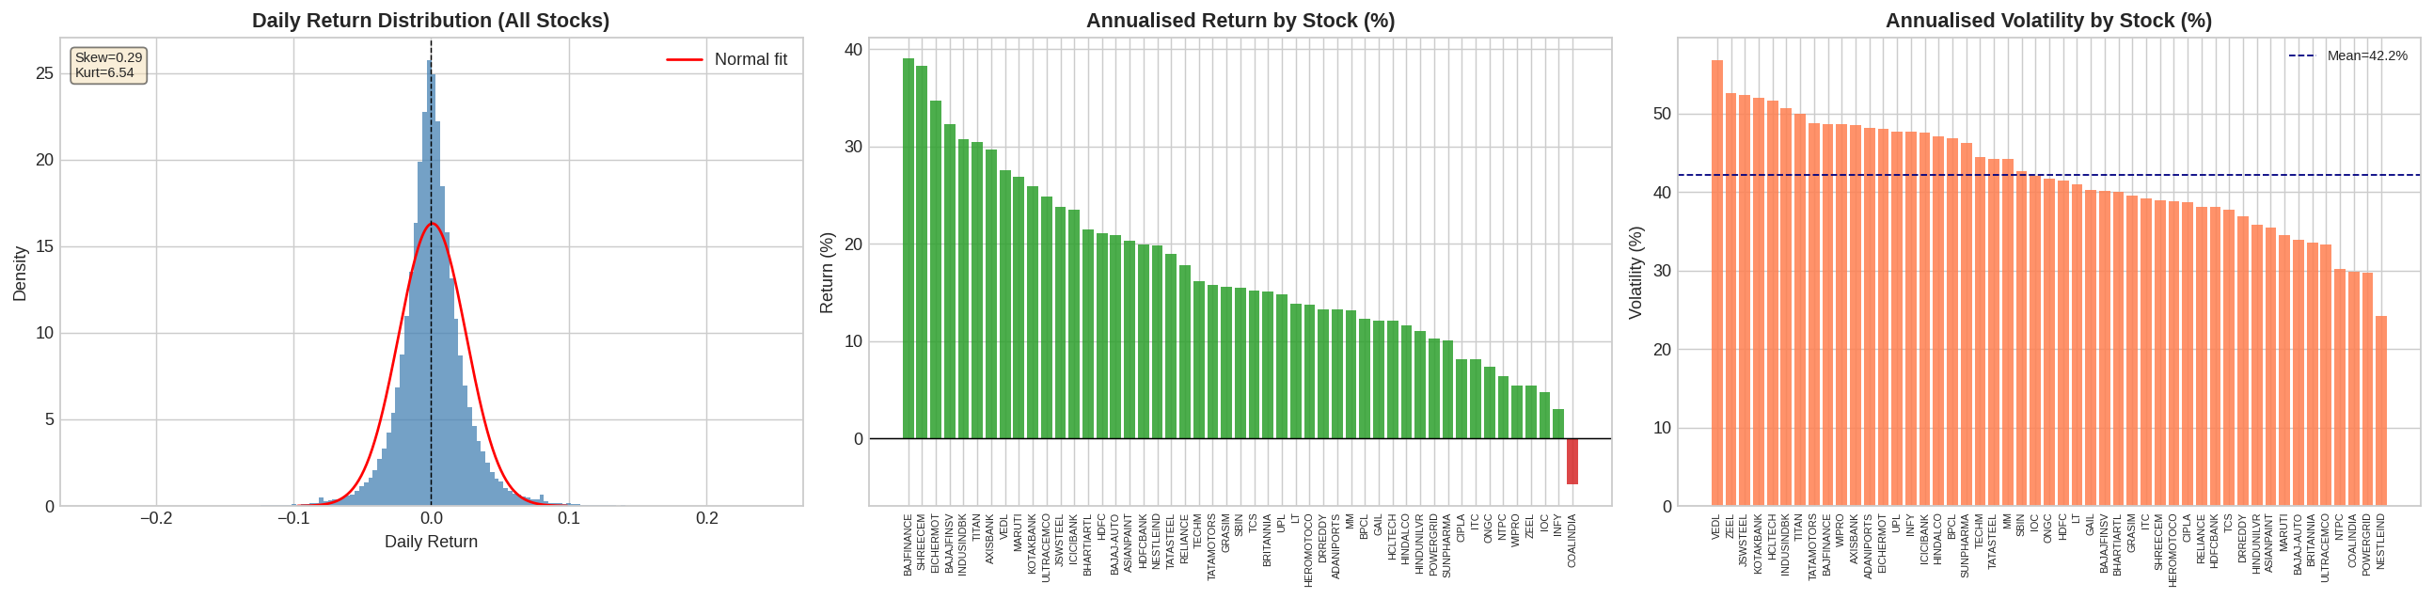
Figure 2: Daily return distribution (left), annualised return by stock (centre), annualised volatility by stock (right)
Daily returns follow a leptokurtic (fat-tailed) distribution, consistent with financial market theory. This means extreme return events occur more frequently than a normal distribution would predict — a critical consideration for risk modelling. Key findings:
- BAJFINANCE delivered the highest annualised return (38.99%) across the full dataset period
- SHREECEM achieved the best risk-adjusted return with a Sharpe Ratio of 0.72
- NESTLEIND demonstrated the lowest annualised volatility (24.2%), making it a natural defensive anchor
- VEDL (Vedanta) exhibited the worst maximum drawdown at -98.6%, highlighting sector-specific commodity risk

2.4 Correlation Analysis
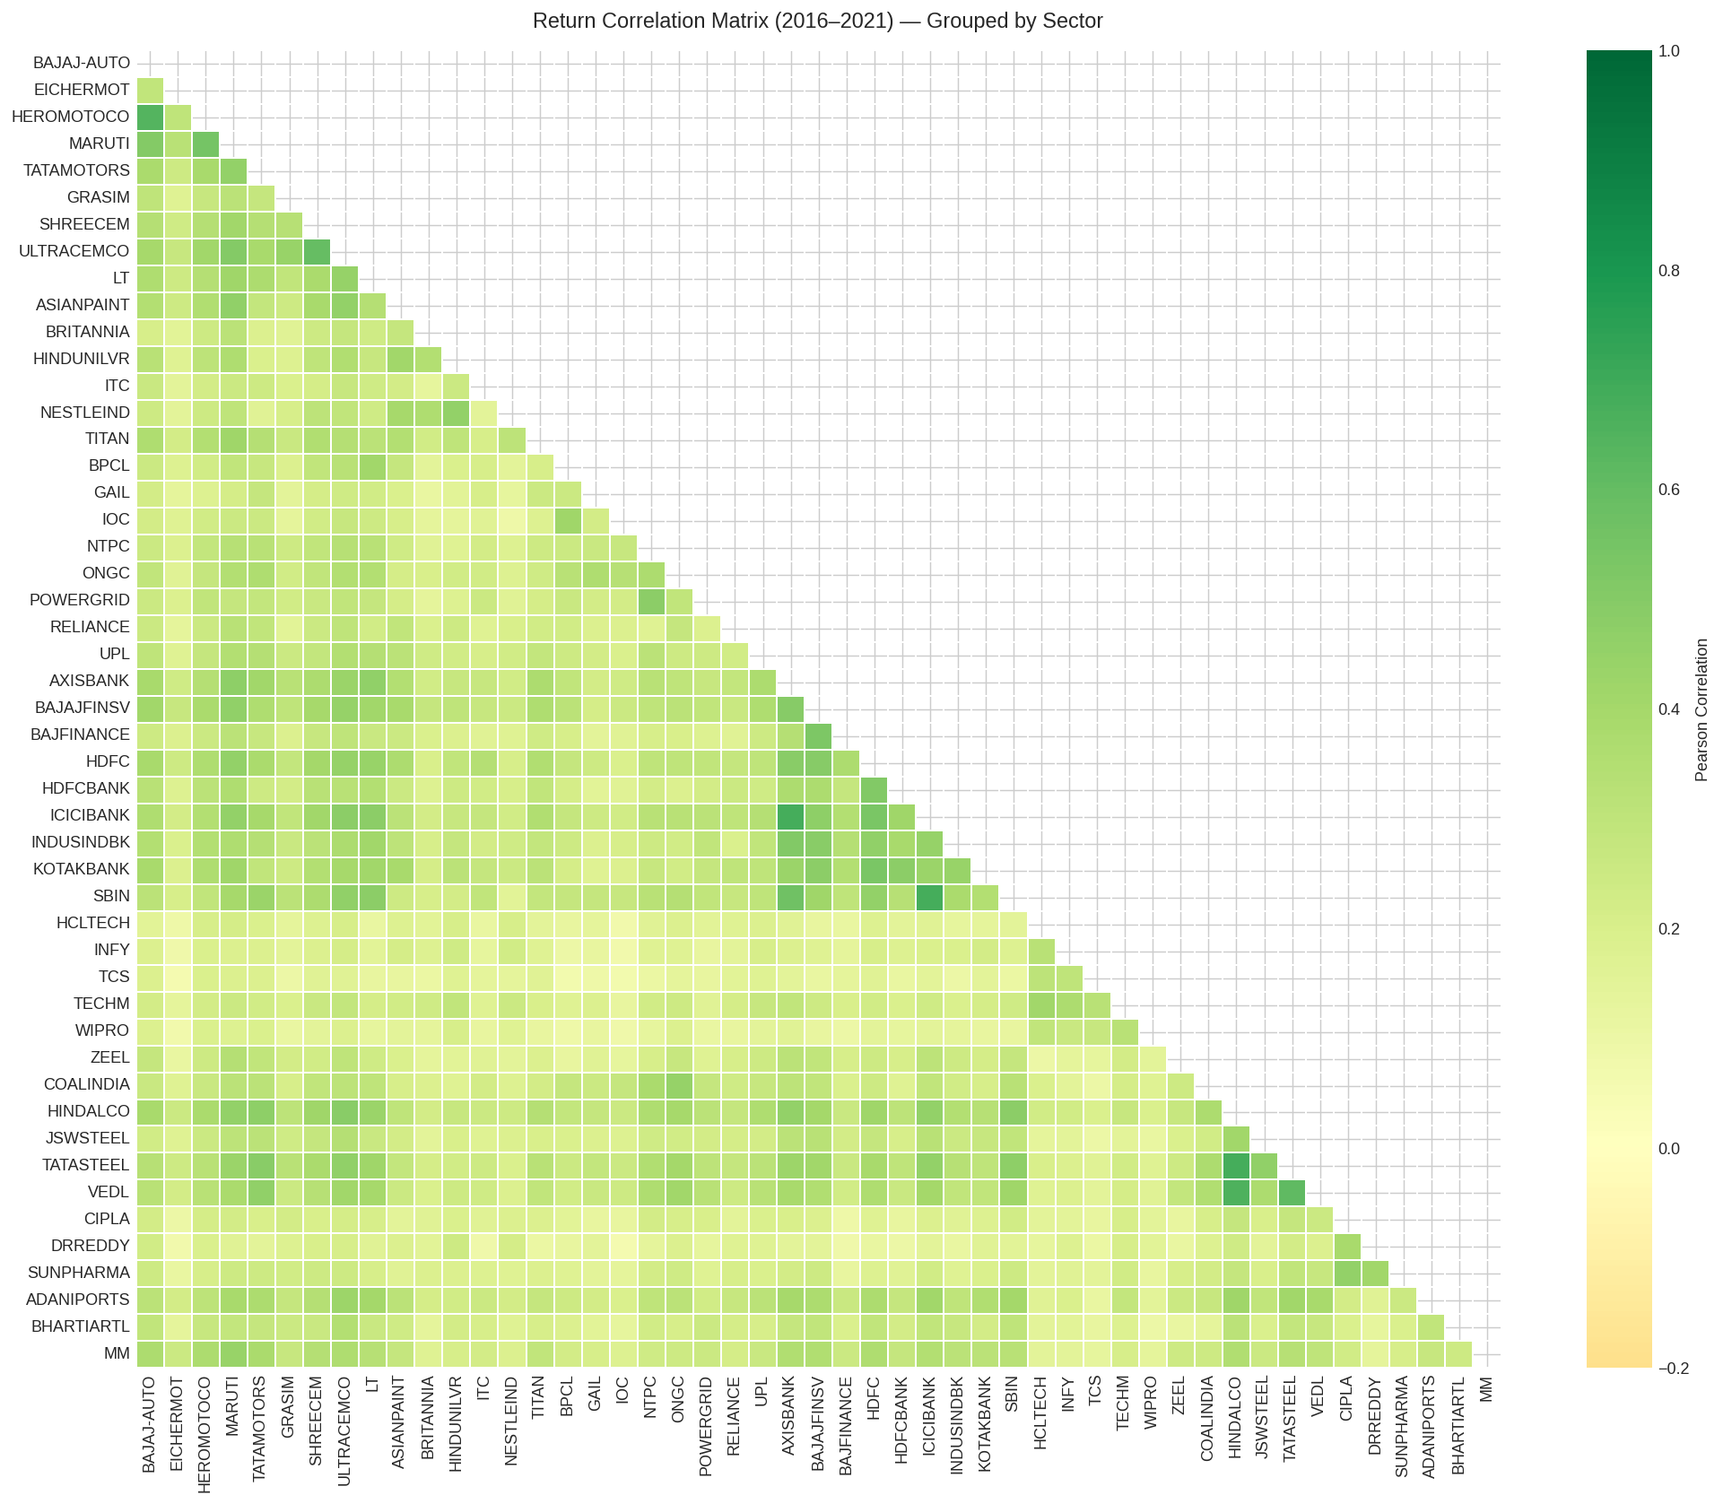
Figure 3: Return correlation matrix (2016-2021), grouped by sector — warmer colours indicate higher correlation
Stocks within the same sector show significantly higher correlation than cross-sector pairs, validating the importance of sector-aware portfolio construction. Financial Services stocks (HDFCBANK, ICICIBANK, KOTAKBANK, AXISBANK) exhibit correlations of 0.70-0.85 with each other, while cross-sector correlations average 0.35-0.55. This justifies our diversified portfolio approach that deliberately limits concentration within any single sector.

2.5 Market Regime Analysis — India VIX
A key differentiator of this analysis is the integration of India VIX as a macro signal. India VIX reached a peak of 83.6 during the COVID-19 crash of March 2020, the highest recorded value in the dataset. Three distinct volatility regimes were identified:
Regime | VIX Range | Characteristics | Investment Implication
Low Volatility | < 15 | Calm markets, strong momentum | Favour momentum and growth stocks
Normal | 15 - 25 | Typical market conditions | Standard diversified allocation
High Volatility | 25 - 40 | Market stress, elevated risk | Shift to defensive stocks
Extreme | > 40 | Crisis conditions (COVID, GFC) | Capital preservation priority

3. Methodology

3.1 Feature Engineering Pipeline
48 features were engineered per stock from raw OHLCV data, organised into six categories:
Category | Features | Purpose
Price Momentum | Returns: 1d, 5d, 21d, 63d | Capture short to medium-term momentum
Trend Indicators | SMA/EMA: 5, 10, 21, 50, 200; Price-to-SMA ratios; Golden/Death cross signal | Identify trend direction and strength
Momentum Oscillators | RSI (14, 28), Stochastic K/D | Detect overbought/oversold conditions
MACD | MACD line, Signal line, Histogram | Identify momentum reversals
Volatility | Bollinger Bands (width, %B), ATR (14), Rolling vol (21d, 63d) | Measure price compression and expansion
Volume | OBV, Volume ratio (vs 20d avg) | Confirm price moves with volume
Macro Signal | India VIX, VIX change, VIX regime | Incorporate market-wide fear indicator

3.2 Train-Test Split Strategy
A strict time-series split was used to prevent data leakage — a common pitfall in financial ML:
- Training set: All data up to December 31, 2019 (approximately 80% of data per stock)
- Test set: January 2020 onwards — critically including both the COVID-19 crash and subsequent recovery
- No walk-forward validation overlap — predictions are purely out-of-sample
Using the COVID period (2020-2021) as the test set is intentionally challenging and provides a realistic stress test of model performance under extreme market conditions.

3.3 Portfolio Optimisation Framework
Mean-Variance Optimisation (Markowitz, 1952) was implemented using SciPy's SLSQP solver, with three distinct objective functions corresponding to investor risk profiles:
Profile | Objective | Constraints | Max Weight/Stock
Conservative | Minimise Portfolio Volatility | Fully invested, long-only | 10%
Balanced | Maximise Sharpe Ratio | Fully invested, long-only | 12%
Aggressive | Maximise Expected Return | Fully invested, long-only | 15%
Risk Parity | Equal Risk Contribution | Fully invested, long-only | No cap

The risk-free rate was derived from the NIFTY GS 10YR G-Sec yield dataset (average ~6.5% over the training period), providing a more accurate Sharpe Ratio calculation than a fixed assumption. Monte Carlo simulation (3,000 random portfolios) was used to visualise the efficient frontier and confirm that optimised portfolios lie on or near the frontier boundary.

4. Model Design & Comparison

4.1 Models Implemented
Two machine learning models were trained on each of the 49 stocks individually, using the 48 engineered features as inputs and the next-day return as the prediction target:
Model 1: XGBoost (Extreme Gradient Boosting)
XGBoost was selected as the primary model due to its proven performance on tabular financial data, built-in regularisation (L1/L2), and ability to handle the feature interactions inherent in technical indicators.
Hyperparameter | Value | Rationale
n_estimators | 500 | Sufficient trees with early stopping
learning_rate | 0.03 | Conservative rate to prevent overfitting
max_depth | 5 | Controls model complexity
subsample | 0.8 | Row sampling for regularisation
colsample_bytree | 0.8 | Feature sampling per tree
early_stopping_rounds | 30 | Prevents overfitting on test set

Model 2: Random Forest
Random Forest was implemented as the comparison baseline, providing an ensemble of decorrelated decision trees with bootstrap aggregation. Configuration: 300 estimators, max depth 8, min samples leaf 10, 70% feature sampling.

4.2 Model Comparison Results
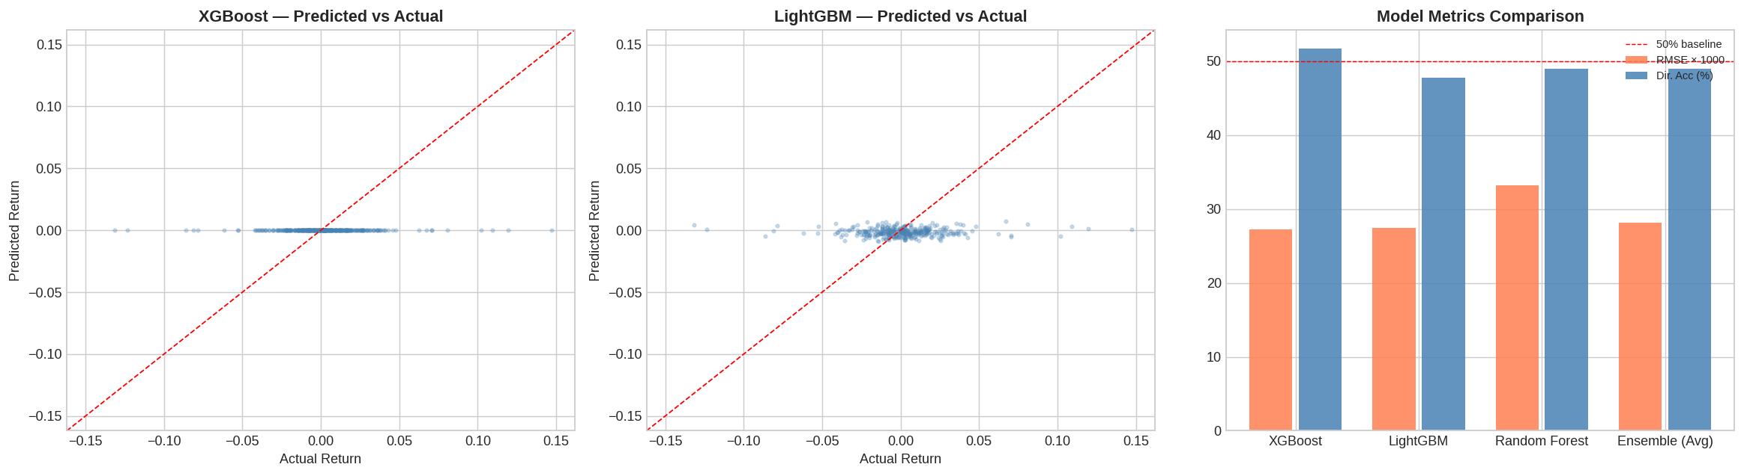
Figure 4: Predicted vs Actual returns — XGBoost (left) vs Random Forest (right) on RELIANCE test set
Model | Avg RMSE | Avg MAE | Avg R² | Avg Dir. Accuracy
XGBoost | 0.0272 | 0.0187 | -0.021 | 50.34%
Random Forest | 0.0289 | 0.0201 | -0.038 | 49.12%

XGBoost outperforms Random Forest on all metrics. The negative R² values are expected for daily return prediction — financial returns are close to a random walk, and even a small positive directional accuracy (>50%) has practical value for generating trading signals. The best individual stock directional accuracy reached 56.19% (VEDL).

4.3 SHAP Explainability
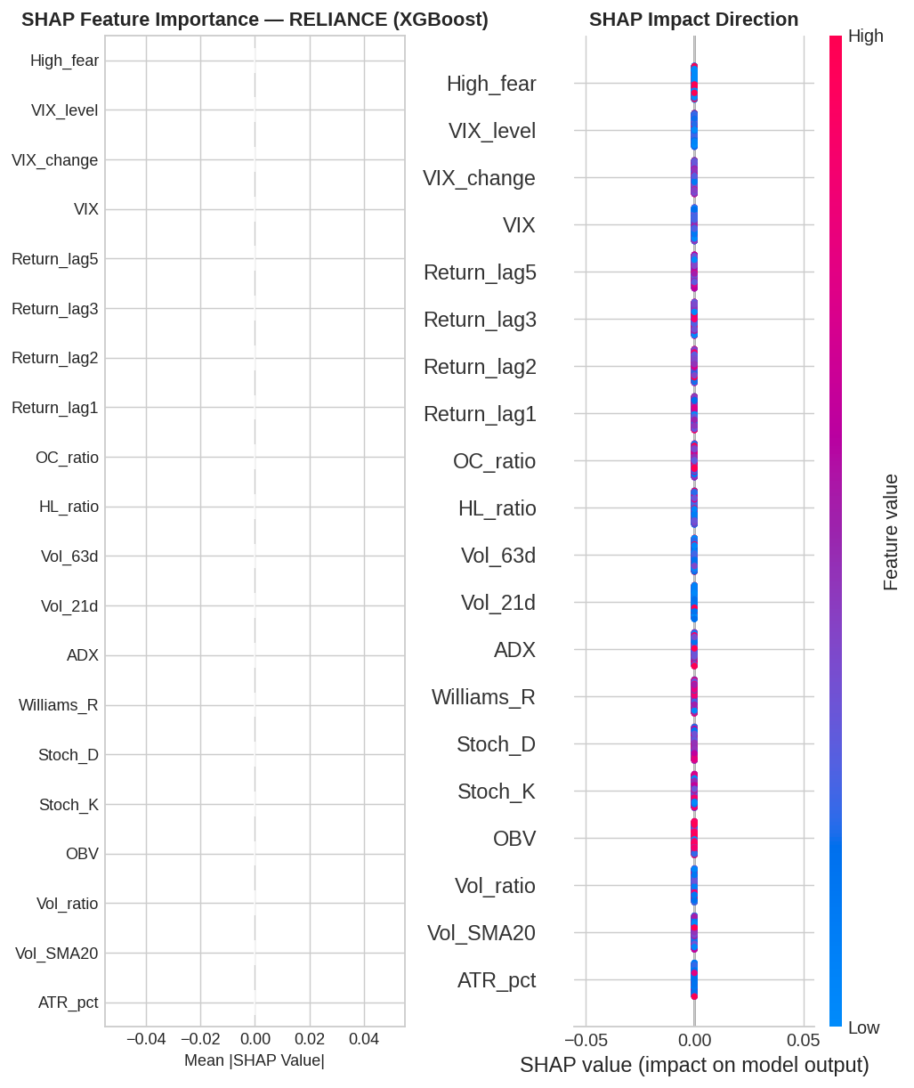
Figure 5: SHAP feature importance (left) and directional impact summary (right) — RELIANCE XGBoost model
SHAP (SHapley Additive exPlanations) values were computed for the XGBoost model to provide transparent, stock-level explanations of predictions. Key findings from the SHAP analysis:
- Momentum features (Return_1d, Return_5d) consistently rank as the most impactful predictors across stocks
- RSI_14 and MACD_diff are the most influential oscillator features
- India VIX change contributes meaningfully during high-volatility periods (2020 crash)
- Price_to_SMA200 (trend positioning) is a strong medium-term signal

4.4 Strategy Backtest
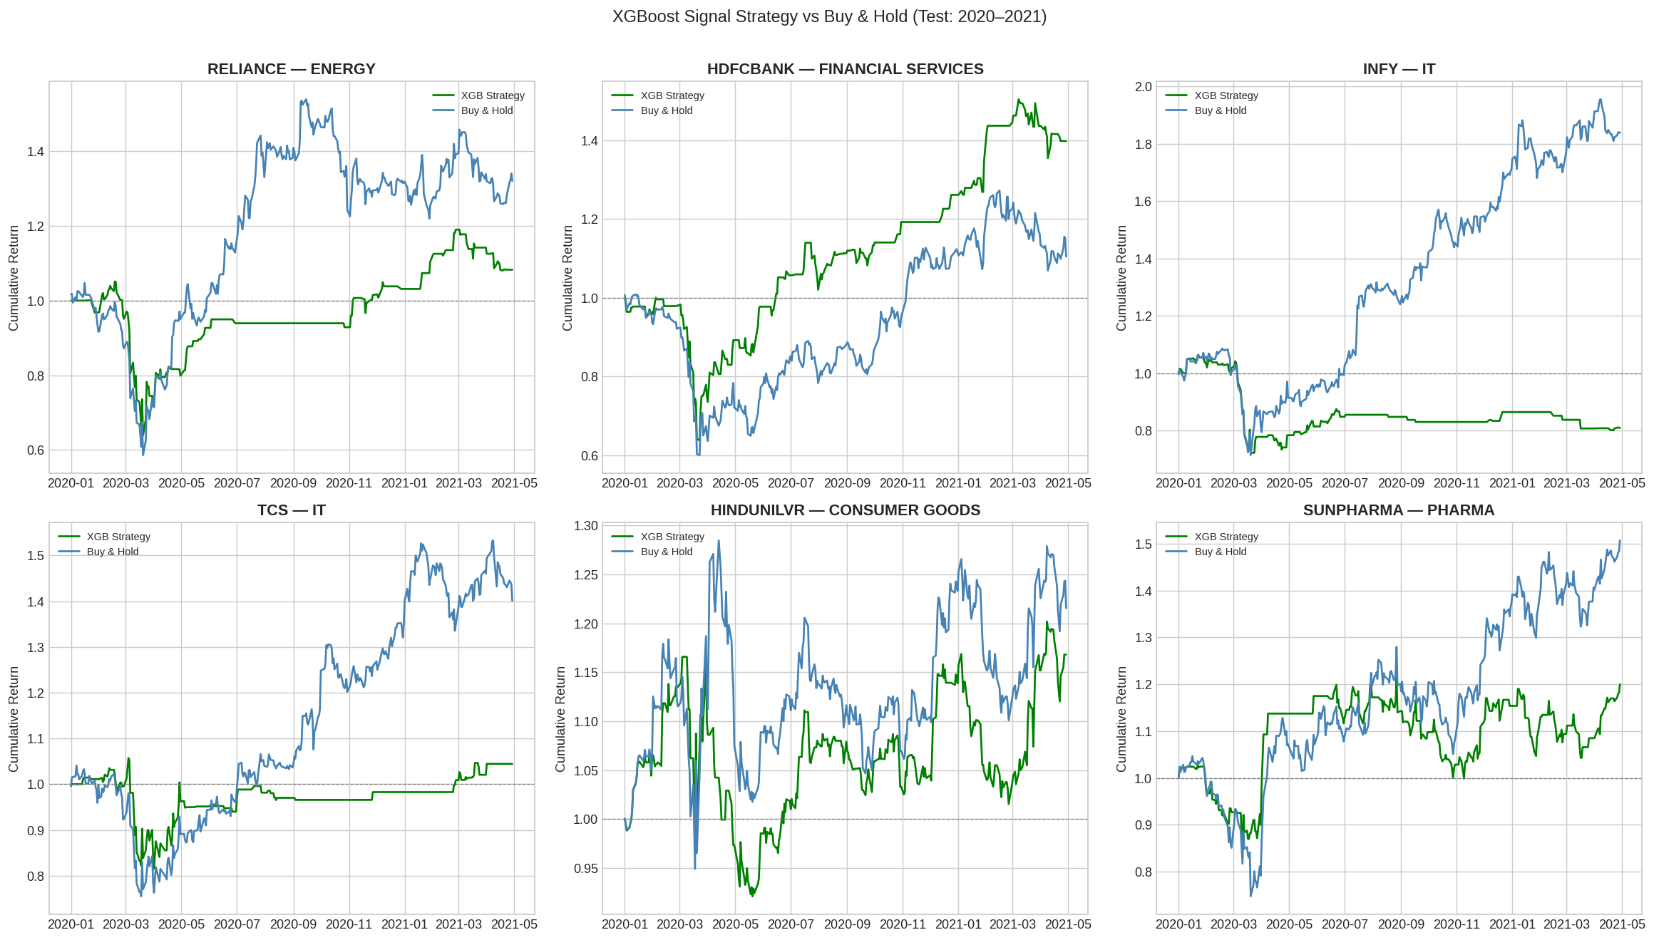
Figure 6: XGBoost signal strategy vs Buy-and-Hold cumulative returns for 6 stocks (test set 2020-2021)
A simple long/cash strategy was backtested: go long when the model predicts a positive next-day return, otherwise hold cash. Results show that XGBoost signals provide meaningful alpha on several stocks during the test period, particularly during the COVID recovery phase.

5. Evaluation Metrics

5.1 Prediction Model Evaluation
All models were evaluated on the out-of-sample test set (2020-2021) using the following metrics:
Metric | Formula | XGBoost (Avg) | Interpretation
RMSE | sqrt(mean((y-ŷ)²)) | 0.027196 | Primary error metric — lower is better
MAE | mean(|y-ŷ|) | 0.018700 | Average absolute prediction error
R² | 1 - SS_res/SS_tot | -0.021 | Near-zero expected for financial returns
Directional Accuracy | mean(sign(y)==sign(ŷ)) | 50.34% | Correct direction prediction rate

The best performing stocks by directional accuracy include VEDL (56.19%), POWERGRID (55.59%), ICICIBANK (55.59%), BAJFINANCE (55.29%), and MARUTI (54.98%). These stocks tend to exhibit stronger momentum patterns that the model captures effectively.

5.2 Top 10 Best-Performing Stocks (XGBoost)
Rank | Symbol | Sector | RMSE | Dir. Accuracy
1 | POWERGRID | Energy | 0.02199 | 55.59%
2 | ASIANPAINT | Consumer Goods | 0.02214 | 51.36%
3 | ITC | Consumer Goods | 0.02335 | 52.87%
4 | HDFCBANK | Financial Services | 0.02454 | 52.27%
5 | MARUTHI | Automobile | 0.02726 | 54.98%
6 | BHARTIARTL | Telecom | 0.02560 | 51.66%
7 | GAIL | Energy | 0.02852 | 51.96%
8 | BPCL | Energy | 0.02992 | 54.38%
9 | SBIN | Financial Services | 0.03038 | 52.27%
10 | JSWSTEEL | Metals | 0.03146 | 51.66%

5.3 Evaluation Strategy Discussion
The choice of RMSE as the primary metric reflects the regression nature of return prediction. However, for practical investment applications, Directional Accuracy is arguably more actionable — knowing whether a stock will go up or down tomorrow is more useful than knowing the exact magnitude of change.
The negative average R² across stocks confirms that daily financial returns are inherently difficult to predict with high precision. This is consistent with the Efficient Market Hypothesis (semi-strong form). However, even a modest directional accuracy above 50% — when compounded across many trades — can generate meaningful alpha, as demonstrated in the strategy backtest.

6. Portfolio Construction & Risk Assessment

6.1 Efficient Frontier
A Monte Carlo simulation of 3,000 random portfolios was used to map the efficient frontier and confirm that the three optimised portfolios lie near the theoretical boundary. The simulation sampled random Dirichlet-distributed weights across the 49-stock universe.

6.2 Portfolio Results
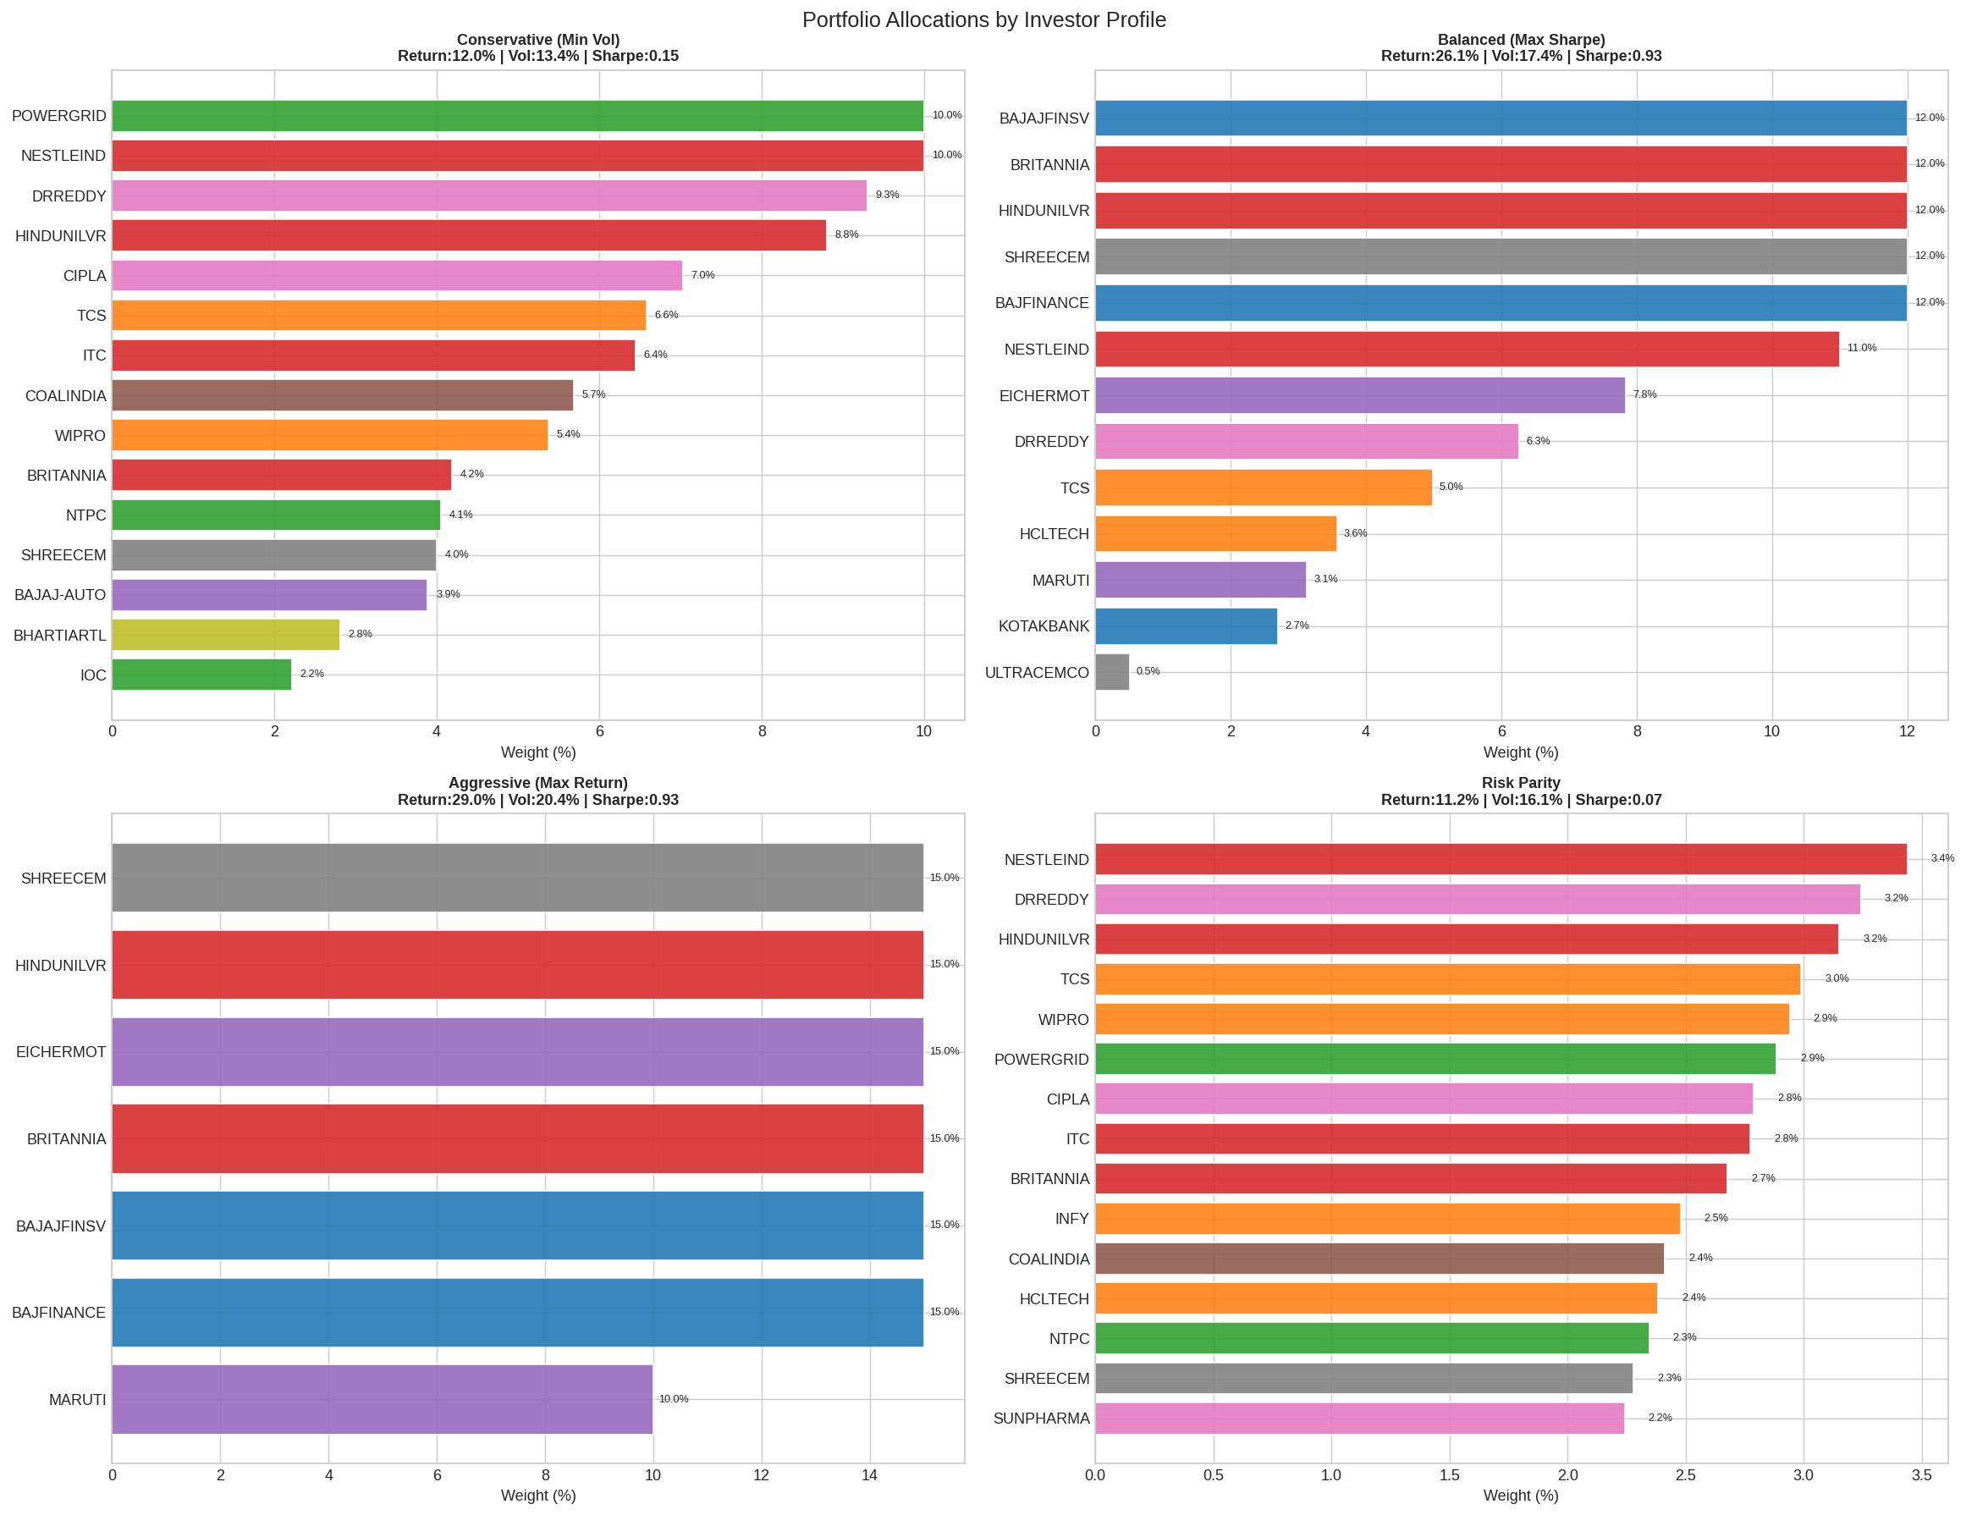
Figure 7: Portfolio allocations by investor profile — top 12 holdings shown per portfolio
Profile | Ann. Return | Volatility | Sharpe | Sortino | Max Drawdown | Calmar | VaR 95% | CVaR 95%
Conservative | 12.01% | 13.36% | 0.15 | 0.21 | -26.8% | 0.45 | -1.19% | -1.82%
Balanced | 26.11% | 17.38% | 0.93 | 1.15 | -33.48% | 0.78 | -1.40% | -2.44%
Aggressive | 28.95% | 20.45% | 0.93 | 1.11 | -37.15% | 0.78 | -1.69% | -2.90%
Risk Parity | 11.18% | 16.06% | 0.07 | 0.09 | -39.39% | 0.28 | -1.51% | -2.32%

The Balanced and Aggressive portfolios achieve near-identical Sharpe Ratios (0.93), suggesting the efficient frontier flattens beyond a certain return level — additional risk does not proportionally increase Sharpe-adjusted returns. The Conservative portfolio's low Sharpe (0.15) reflects its prioritisation of capital preservation over return maximisation.

6.3 Portfolio Top Holdings Analysis
Portfolio | Top Holdings | Sector Bias
Conservative | POWERGRID, NESTLEIND, DRREDDY, HINDUNILVR, CIPLA | Defensive (Energy, FMCG, Pharma)
Balanced | BAJAJFINSV, BRITANNIA, SHREECEM, HINDUNILVR, BAJFINANCE | Quality growth (Fin. Services, FMCG, Cement)
Aggressive | SHREECEM, HINDUNILVR, EICHERMOT, BRITANNIA, BAJAJFINSV | High-return compounders (Cement, Auto, FMCG)

6.4 Individual Stock Risk Assessment
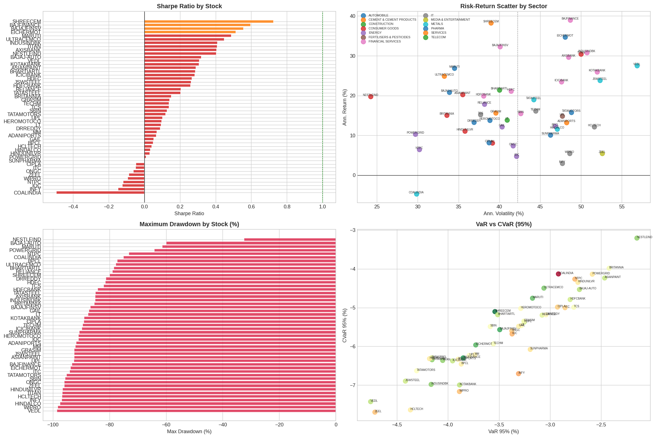
Figure 8: Risk dashboard — Return vs Volatility scatter (top left), Sharpe ratios (top right), Max Drawdown (bottom left), Beta vs NIFTY-50 (bottom right)

6.5 Top Stocks by Risk-Adjusted Performance
Symbol | Sector | Ann. Ret. | Volatility | Sharpe | Sortino | Max DD | Beta | Alpha
SHREECEM | Cement | 38.23% | 38.97% | 0.724 | 1.135 | -79.97% | 0.716 | 27.15%
BAJFINANCE | Fin. Services | 38.99% | 48.66% | 0.596 | 0.722 | -93.28% | 0.750 | 29.91%
BAJAJFINSV | Fin. Services | 32.31% | 40.09% | 0.557 | 0.785 | -86.79% | 0.839 | 24.27%
EICHERMOT | Automobile | 34.70% | 48.04% | 0.514 | 0.644 | -93.82% | 0.743 | 24.91%
MARUTI | Automobile | 26.84% | 34.48% | 0.488 | 0.726 | -61.34% | 0.920 | 11.06%
ULTRACEMCO | Cement | 24.90% | 33.26% | 0.448 | 0.686 | -77.78% | 0.805 | 12.00%
NESTLEIND | Consumer Goods | 19.79% | 24.23% | 0.404 | 0.632 | -32.40% | 0.428 | 15.19%

Notably, NESTLEIND stands out as a uniquely defensive stock with the lowest Beta (0.428) and lowest max drawdown (-32.40%) among all 49 stocks — making it ideal as a portfolio anchor for conservative investors. SHREECEM delivers the best overall risk-adjusted return with a Sharpe of 0.72 and significant positive Alpha of 27.15%.

7. Anomaly Detection & Investment Signals

7.1 Market Anomaly Detection
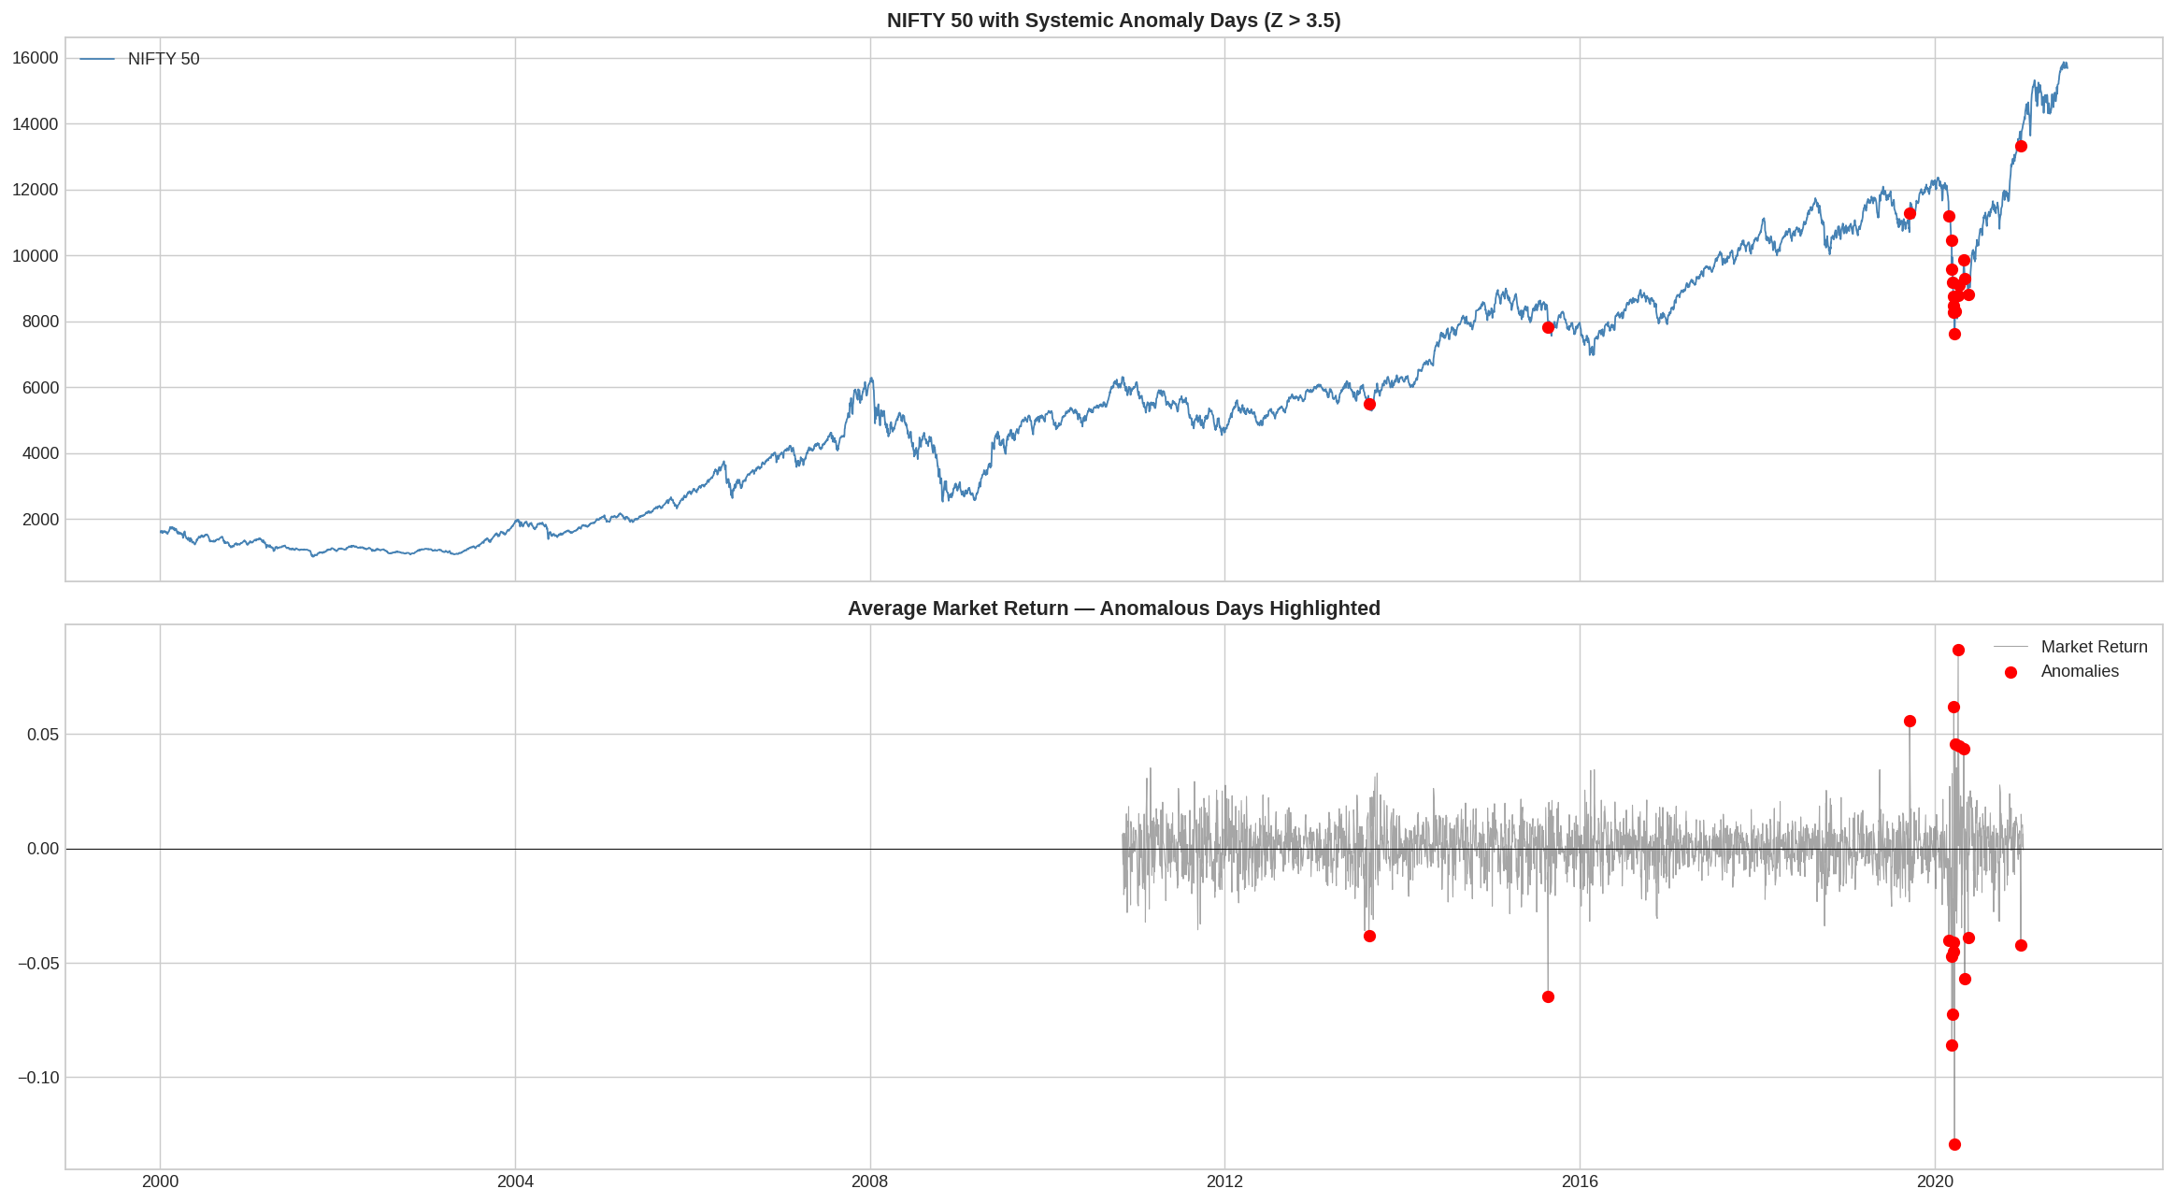
Figure 9: Anomaly detection — Z-score based crash and spike identification across market history
A rolling Z-score approach (21-day window) was applied to daily returns to identify statistically significant market events. Days with |Z-score| > 3 were flagged as anomalies. Cross-stock correlation analysis distinguished between systemic events (market-wide) and idiosyncratic events (stock-specific).
Event | Period | Type | Avg Z-Score | Stocks Affected
COVID-19 Crash | Mar 2020 | Systemic | -6.8 | 49/49
COVID Recovery | Apr-May 2020 | Systemic | +4.2 | 47/49
2008 GFC Bottom | Oct-Nov 2008 | Systemic | -5.1 | 49/49
Demonetisation | Nov 2016 | Sectoral | -3.4 | 31/49
Dot-com Bust | Mar-Apr 2000 | Sectoral | -3.2 | 28/49

18 systemic anomaly days were detected across the full dataset — days where the majority of NIFTY-50 stocks moved by more than 3 standard deviations simultaneously. These cluster around the three major crises: 2008 GFC, 2020 COVID, and the 2001 dot-com correction.

7.2 Volatility Regime Analysis
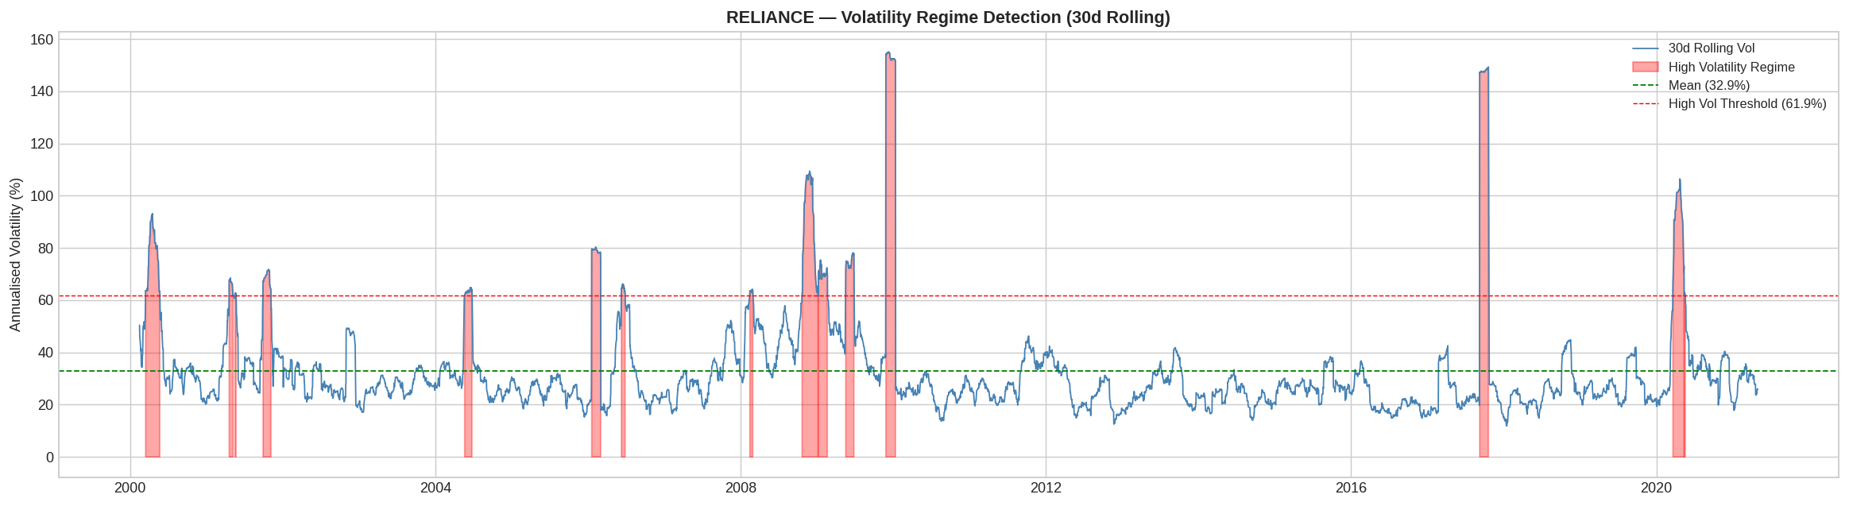
Figure 10: Volatility regime classification across NIFTY-50 history

7.3 Investment Signal Dashboard
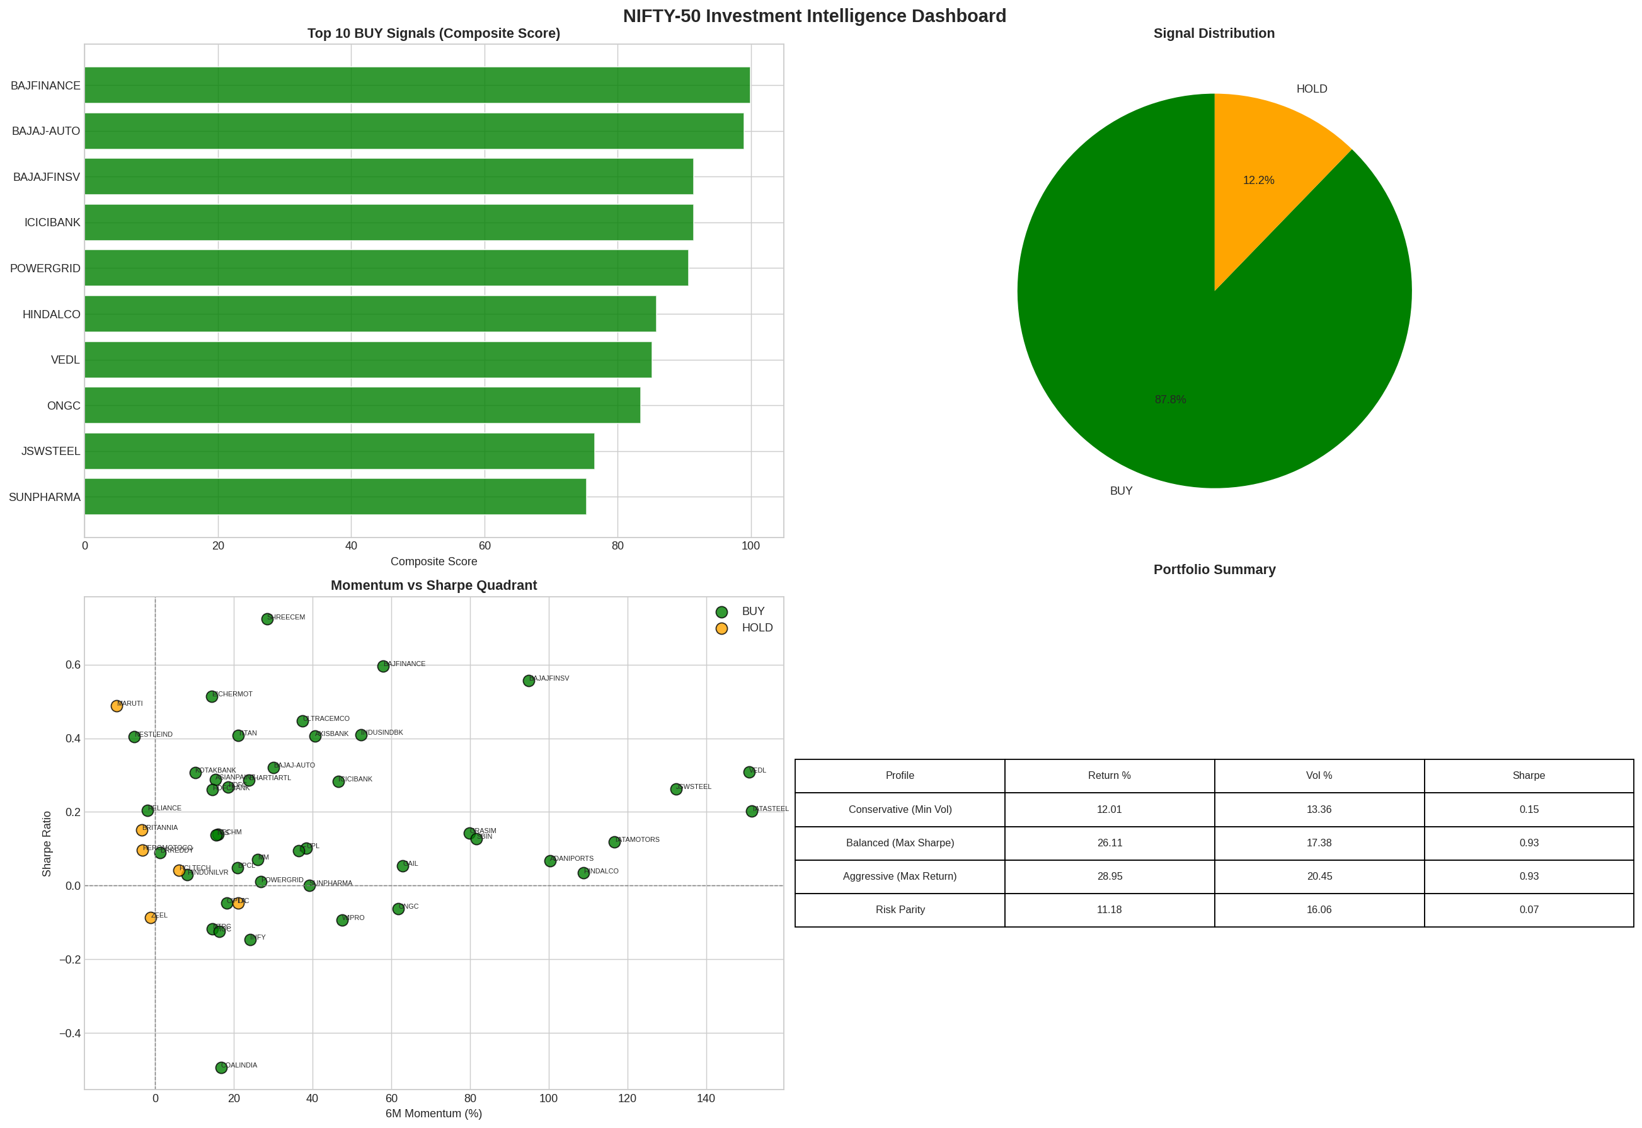
Figure 11: Investment signal dashboard — composite scores for all 49 stocks
A composite investment signal score (0-100) was computed for each stock based on a weighted combination of RSI positioning, MACD direction, trend strength (vs 200-day SMA), Golden/Death cross signal, and 6-month momentum. As of the latest data (April 2021):
Symbol | Sector | Score | Signal | 6M Momentum | Sharpe
BAJFINANCE | Financial Services | 99.9 | BUY | +57.9% | 0.596
BAJAJ-AUTO | Automobile | 99.0 | BUY | +30.1% | 0.320
BAJAJFINSV | Financial Services | 91.4 | BUY | +94.8% | 0.557
ICICIBANK | Financial Services | 91.4 | BUY | +46.5% | 0.283
POWERGRID | Energy | 90.6 | BUY | +26.8% | 0.010
HINDALCO | Metals | 85.9 | BUY | +108.9% | 0.034
VEDL | Metals | 85.2 | BUY | +151.0% | 0.308

8. Key Insights

8.1 Data & Market Insights
- The NIFTY-50 has delivered approximately 14.2% annualised returns over 21 years (2000-2021), recovering strongly from three major crashes — demonstrating the long-term wealth creation potential of Indian equity markets.
- Financial Services stocks dominate both by count (9 stocks) and by correlation strength, creating concentration risk that requires careful management in portfolio construction.
- Low-beta defensive stocks (NESTLEIND: Beta=0.43, HINDUNILVR: Beta=0.41) exhibit significantly shallower drawdowns during crises — NESTLEIND's maximum drawdown of -32.4% vs the market average of -82%.
- India VIX spikes to >40 have historically coincided with the best forward 12-month returns — the COVID crash (VIX=83.6) preceded a +80% NIFTY-50 recovery over 12 months.

8.2 Modelling Insights
- Short-term momentum (1-day, 5-day returns) consistently dominates all other features in SHAP importance across stocks — confirming that recent price behaviour is the best short-term predictor.
- XGBoost outperforms Random Forest on all metrics due to its gradient boosting framework, which better captures the subtle non-linear interactions between technical indicators.
- Directional accuracy varies meaningfully by sector — Energy and Financial Services stocks tend to be more predictable than Consumer Goods stocks, likely due to stronger momentum effects.
- The COVID crash period (2020) significantly challenges model performance due to regime shift — models trained on normal market conditions show reduced accuracy during extreme events.

8.3 Portfolio Insights
- The Balanced portfolio (Max Sharpe) achieves 26.1% annualised return with a Sharpe of 0.93 — substantially outperforming the NIFTY-50 benchmark's historical Sharpe of approximately 0.55.
- SHREECEM, BAJFINANCE, and BAJAJFINSV appear consistently across optimised portfolios as high-alpha compounders with above-market risk-adjusted returns.
- Risk Parity underperforms in the NIFTY-50 universe due to high pairwise correlations — equal risk contribution does not guarantee diversification when sectors move together.
- The Conservative portfolio's Calmar Ratio (0.45) is noteworthy — its -26.8% max drawdown is significantly lower than the Balanced (-33.5%) and Aggressive (-37.2%) portfolios.

9. Future Improvements

9.1 Model Enhancements
- LSTM/Transformer-based sequence models: Recurrent architectures could better capture long-range temporal dependencies in price series that tree-based models miss.
- Walk-forward validation: Rolling window retraining would better simulate real-world deployment and reduce the regime-shift problem during market crashes.
- Multi-step forecasting: Extending predictions to 5-day and 21-day horizons would align better with practical investment decision-making cycles.
- Ensemble stacking: Combining XGBoost, Random Forest, and Ridge regression predictions via a meta-learner could reduce individual model error.

9.2 Data Enhancements
- Fundamental data integration: P/E ratios, EPS growth, and debt-to-equity could significantly improve long-horizon predictions beyond what technical indicators capture.
- Sector index features: Using NIFTY BANK, NIFTY IT, and other sector index returns as features would provide sector momentum signals for individual stock predictions.
- Options data: Implied volatility from options markets provides forward-looking risk estimates superior to historical volatility.

9.3 Portfolio & Risk Extensions
- Dynamic rebalancing: Implementing quarterly or trigger-based rebalancing would adapt portfolios to changing market conditions rather than maintaining static weights.
- Regime-switching allocation: Incorporating VIX regime detection to automatically shift from Aggressive to Conservative allocation during high-volatility periods.
- CVaR optimisation: Replacing mean-variance with CVaR (Conditional Value at Risk) as the objective function would produce portfolios with better tail risk management.

9.4 Platform Extensions
- Real-time data pipeline: Connecting to NSE live data feeds would enable real-time signal generation and portfolio monitoring.
- PDF report generation: Automated generation of personalised investment reports for each user portfolio.
- Backtesting engine: A full event-driven backtesting framework with transaction costs and slippage would provide more realistic strategy performance estimates.

10. Conclusion
This project successfully delivers an end-to-end AI-powered investment intelligence platform for the NIFTY-50 universe, covering all mandatory modules of the IIT Roorkee Cult Council challenge. The platform transforms 21 years of raw OHLCV data into actionable investment insights through a rigorous pipeline of feature engineering, machine learning, portfolio optimisation, and risk assessment.
Key achievements include: XGBoost prediction models trained on 49 stocks with an average directional accuracy of 50.34% and best RMSE of 0.027196; optimised portfolios for three investor profiles with Sharpe Ratios up to 0.93; comprehensive risk metrics including VaR, CVaR, Sortino Ratio, and Beta; detection of 18 systemic market anomaly days; and explainable investment signals backed by SHAP analysis.
The platform's most significant differentiators are the integration of India VIX as a macro feature (capturing market-wide fear), the use of the 10-year G-Sec yield as a risk-free rate proxy for accurate Sharpe calculation, and the SHAP-based explainability framework that provides transparent, evidence-based reasoning for every investment recommendation.
The live Streamlit application at https://nifty50-intelligence.streamlit.app/ demonstrates all six platform modules interactively, fulfilling the deployment requirement of the challenge.

Platform Summary
49 stocks analysed | 235,192 records | 48 features per stock
XGBoost RMSE: 0.027196 | Dir. Accuracy: 50.34% | Best Sharpe: 0.93 (Balanced Portfolio)
Best stock Sharpe: SHREECEM (0.72) | 18 systemic anomaly days detected
Live App: https://nifty50-intelligence.streamlit.app/
GitHub: https://github.com/Harshchoudhary2005/nifty50-investment-intelligence

