SQL Queries Pizza_Sales

KPI Requirements

- select sum(total_price) as total_revenue from pizza_sales

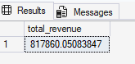

- select sum(total_price) / count(distinct order_id) as ratio from pizza_sales

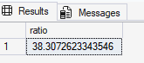

- select sum(quantity) as total_pizzaOrder from pizza_sales

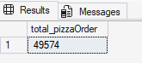

- select count(distinct order_id) as total_orders from pizza_sales



- select sum(quantity) / count(distinct order_id) as average_pizza_sold from pizza_sales

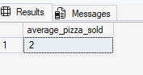

Chart Requirements

- select datename(dw,order_date) , count(distinct order_id) as order_rate from pizza_sales group by datename(dw,order_date)

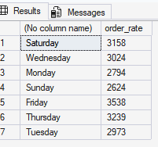

- select datename(month,order_date) , count(distinct order_id) as order_rate from pizza_sales group by datename(month,order_date)

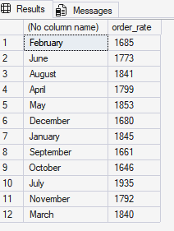

- select pizza_category , sum(total_price) * 100 / (select sum(total_price) from pizza_sales )
as percentage
from pizza_sales
group by pizza_category order by percentage desc

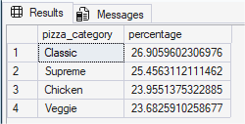

- select pizza_size , sum(total_price) * 100 / (select sum(total_price) from pizza_sales )
as percentage
from pizza_sales
group by pizza_size order by percentage desc

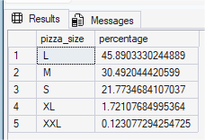

- select top 5 pizza_name, sum(total_price) as total_revenue from pizza_sales
group by pizza_name order by total_revenue desc

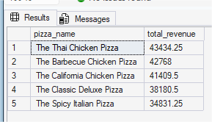

- select top 5 pizza_name, sum(total_price) as total_revenue from pizza_sales
group by pizza_name order by total_revenue asc

