EduManage
School & Institute Management Software
Project Documentation
Date: April 17, 2026

1. Introduction
EduManage is a school/institute management software designed to streamline day-to-day academic and administrative workflows. It provides a unified interface for managing students, teachers, classes, attendance, fees, exams, marks, report cards, timetables, announcements, and staff salaries.

2. System Overview
The application is built as a modern web dashboard. It supports role-based access for administrators and teachers, analytics on the dashboard, and a demo/offline-friendly mode using a local mock backend. Where configured, it can integrate with cloud services (Firebase) and/or a Google Apps Script (GAS) proxy.

3. User Roles & Access Control
EduManage supports the following roles:
- Administrator (Admin)
- Full access to student records, fee management, exams/marks, settings, data snapshot exports, and administrative actions.
- Teacher
- Access to class-relevant dashboards, student results for assigned classes, posting class announcements, and attendance-related workflows.
Demo logins are provided for testing in local/mock mode. In production, authentication should be configured via Firebase or a backend.

4. Core Modules & Features
EduManage is organized into clear modules so schools can manage each workflow independently while still keeping data consistent across the system (e.g., a student’s class/section is reused for attendance, fees, marks, report cards, and parent communication).

Dashboard & Analytics
- Overview cards (students, attendance, fees/collection where applicable).
- Charts for trends and class-wise distribution.
- Teacher: Today’s timetable panel based on schedule entries.

Student Management
- New student registration with photo upload (size-limited).
- Search, filter by class/section/academic year, pagination.
- Status management (Active/Inactive) and profile editing.

Teacher Management
- Add/update teacher profiles with photo and assignment (class/section).
- Delete teacher records (admin).

Classes & Schedule
- Create class-section records, assign class teacher, set room number.
- Create weekly schedule periods (day, period, subject, teacher, room, time slot).
- View schedule grouped by day and remove periods when needed.

Attendance (Students & Teachers)
- Mark or edit daily attendance by class/section/date.
- Student attendance codes: Present (P), Absent (A), Late (L).
- Attendance summaries per student/teacher.

Fees Management
- Add fee records (type, amount, due date, status).
- Quick views for All / Pending / Paid.
- Class fee structure setting (admin) for standardized fee rules by class.

Exams, Marks & Results
- Create exams (name, class, subject, date, max, pass).
- Enter marks and view marks list.
- Marks & Results matrix with filters and actions per student.
- Exports: CSV download, single PDF, class ZIP of PDFs (one per student).

Report Cards
- Generate single report card by student ID/name.
- Generate bulk report cards by class/section and print-friendly output.

Timetables
- Manage timetable entries for classes, tests, exams, and other events.
- Filter-friendly list with admin-only add/delete controls.

Announcements
- School-wide announcements with priority and optional attachment.
- Class announcements targeted to a specific class/section.

Salary Management
- Add salary records for teachers and staff.
- Filter by period (monthly/yearly/etc.) and status (paid/pending).
- Mark pending salaries as paid and maintain salary history.

Settings, Audit & Backups
- WhatsApp-style parent alerts (demo queue) with filters and logs.
- Audit log of recent actions for accountability.
- Admin data snapshot export as JSON for offline backup.

Offline-Friendly Operation
- When offline, write operations are queued in IndexedDB.
- When connectivity returns, queued operations sync automatically in order.

5. Typical Workflows (How Schools Use EduManage)

Student admission / onboarding
- Admin opens Students module and registers the student (name, parents, class/section, academic year, optional photo).
- Student becomes available immediately for attendance, fee records, and marks entry.
- For parent communication, admin/teacher can store Parent WhatsApp number (or fallback phone).

Daily attendance
- Teacher/admin selects date + class + section and fetches student list.
- Mark Present/Absent/Late and save; edits can be done later via the Edit tab.
- Parents can be notified (demo WhatsApp queue) when a student is marked absent.

Fees collection
- Admin records fee entries per student (monthly/annual/exam fee), sets due date and payment status.
- Use Pending/Paid views to track outstanding fees quickly.
- Optionally define a standard class fee structure so messages and reports can reference expected fees.

Exams, marks, and results
- Admin creates an exam entry (class, subject, max marks, pass marks, date).
- Teacher/admin enters marks for students.
- Results module shows a class-wise matrix and supports per-student result view and PDF export.
- Admins can export CSV or a ZIP of PDFs for a class/section for offline sharing and printing.

Announcements and class notices
- School-wide announcements: admin posts notices with priority and optional attachment.
- Class announcements: teacher/admin posts class-specific notice; parents of that class can be notified (demo WhatsApp queue).

Salary records (teachers and staff)
- Admin adds monthly salary records with role/designation and amount.
- Filter by month/year and paid/pending; mark records as paid once processed.

Backup & audit
- Admin downloads a JSON data snapshot for backup in demo mode.
- Audit log records key actions to help track changes and accountability.

6. Data Model (High-Level)
The system centers around a few core entities. The UI forms map closely to these entities, which helps keep operations predictable and reduces duplicate entry.
- Student: ID, name, parents, class/section, academic year, contact info, status, optional photo.
- Teacher: ID, name, subject, contact details, class/section assignment, optional photo.
- Class/Section: Class number, section, class teacher, room number.
- Schedule: Weekly periods: day, period number, subject, teacher name/ID, room, time slot.
- Attendance: Daily attendance entries for students and teachers; summaries and percentage calculations.
- Fee Record: Fee type, amount, due date, paid date (if any), status, receipt/remarks.
- Exam: Exam metadata and per-student marks entries with grade and result.
- Timetable Entry: Class/test/exam events with date/day, time slot, room, notes.
- Announcement: School-wide or class-specific notices, priority, timestamps, optional attachment.
- Salary Record: Staff/teacher salary entries by month/year with paid/pending status.
- Audit / Snapshot: Recent actions log + data export for backup and reporting.

7. Architecture & Technology Stack
- Frontend
- React + Vite, React Router for navigation.
- Chart.js for dashboards and analytics.
- i18next for translations/localization support.
- react-jss for styling.
- Data & Backend Options
- Demo/mock backend for local usage and testing without cloud dependencies.
- Firebase integration (Auth + Firestore/Realtime DB) when environment variables are configured.
- Google Apps Script (GAS) proxy support when running in a GAS container environment.

8. Setup & Running (Developer/Deployment Notes)
- Prerequisites:
- Node.js (for building/running the React app).
- Typical commands:
- Install dependencies: npm install
- Run locally: npm run dev
- Build: npm run build
If Firebase is not configured, the app can run in demo/mock mode with demo credentials. For production, configure authentication and data storage, and replace demo notification behavior with real integrations.

9. Screens (From Project Screenshots)

Screen 1
Source: school-admin-react\src\screenshots\Screenshot (398).png
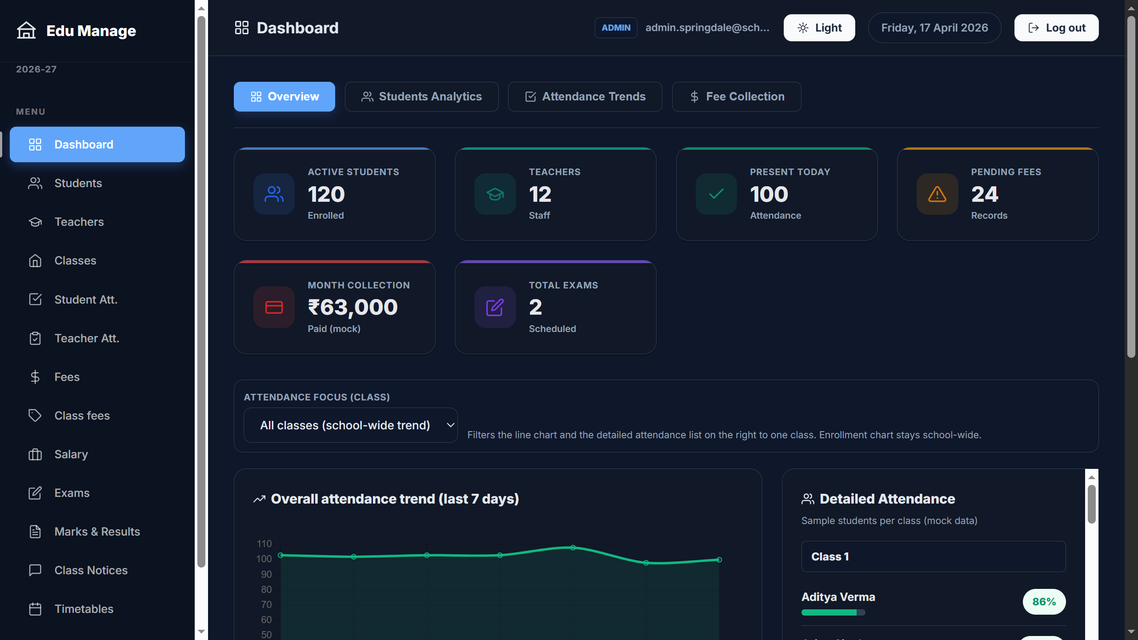

Screen 2
Source: school-admin-react\src\screenshots\Screenshot (399).png
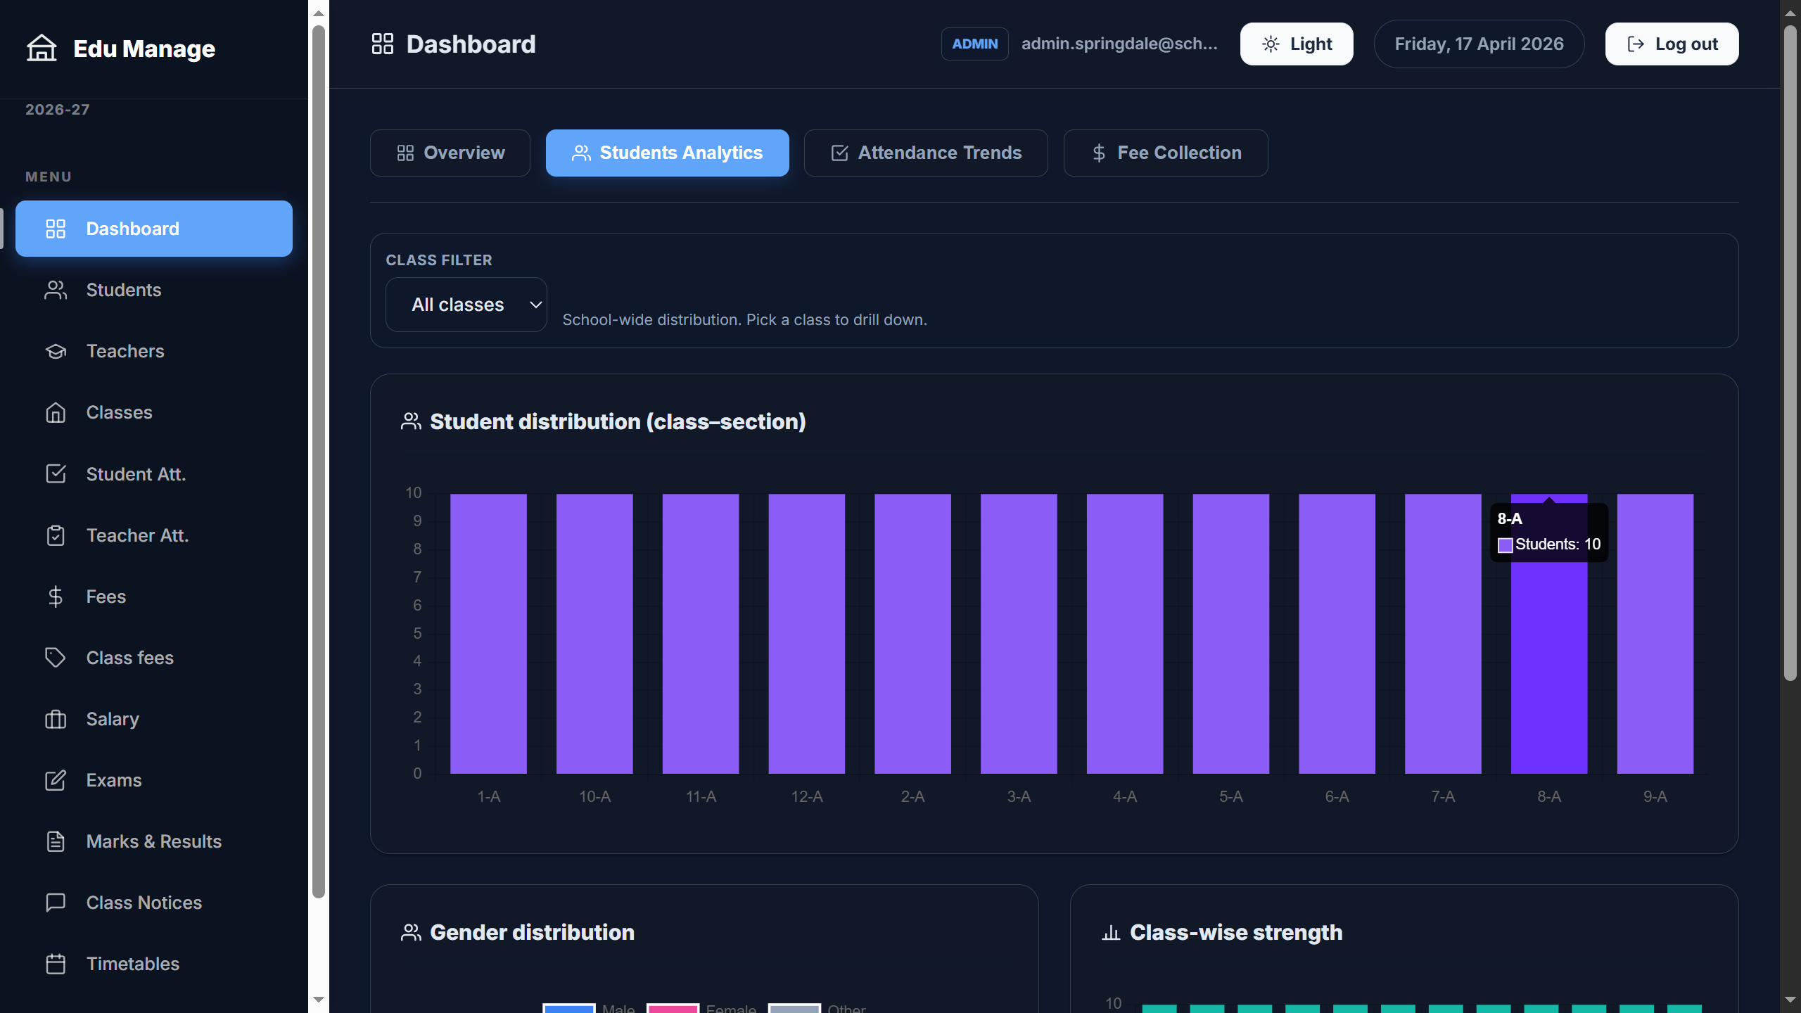

Screen 3
Source: school-admin-react\src\screenshots\Screenshot (400).png
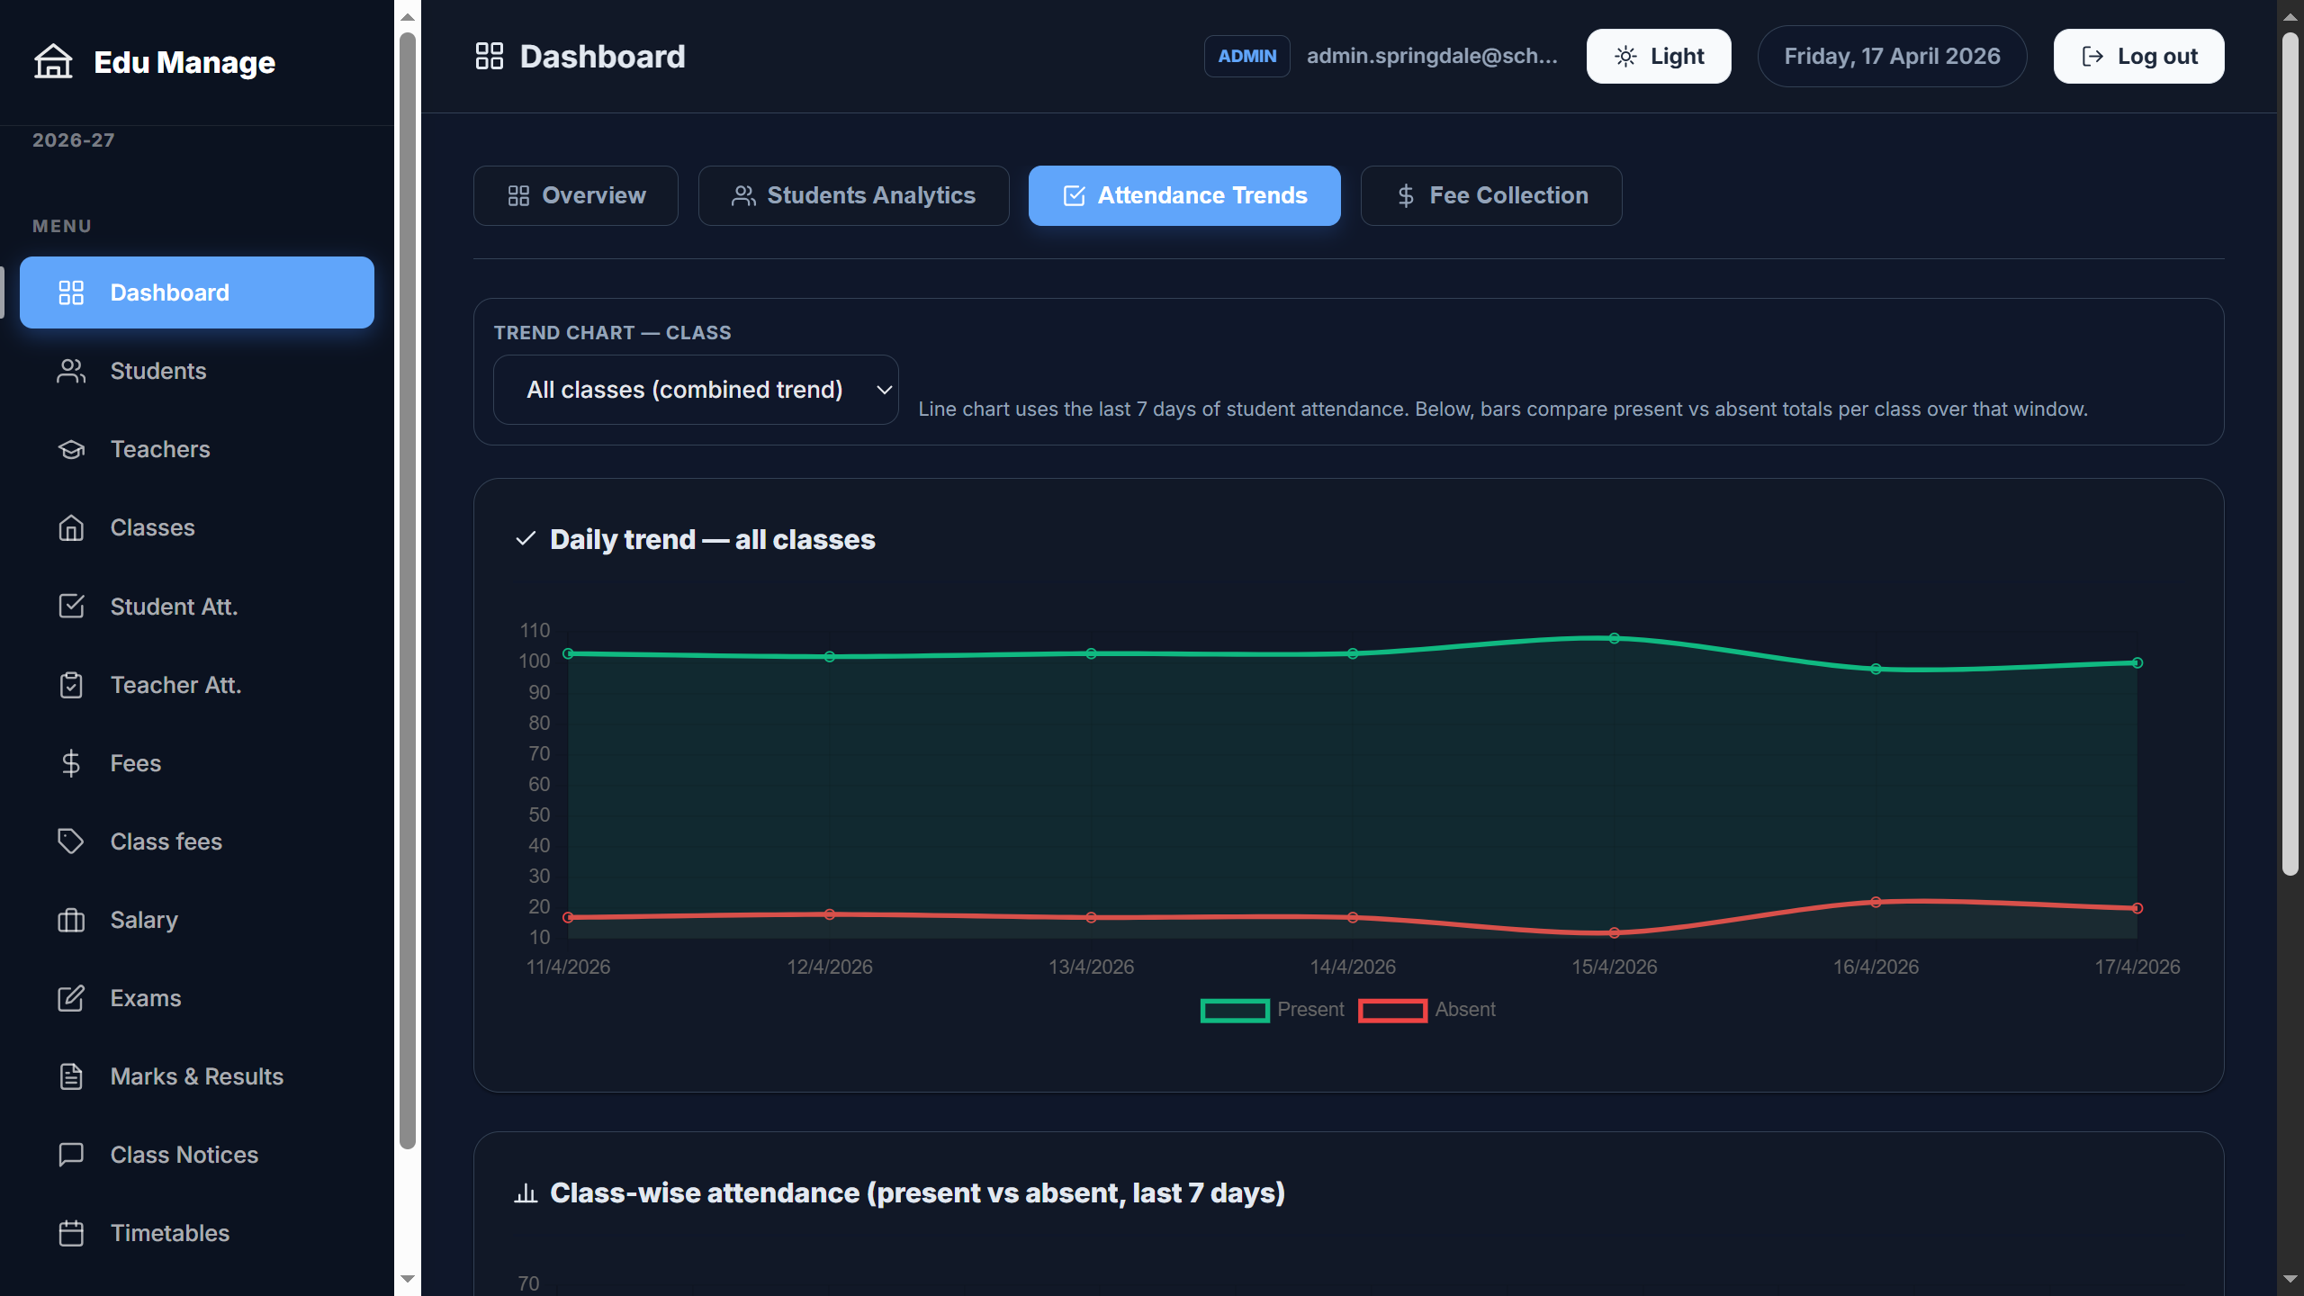

Screen 4
Source: school-admin-react\src\screenshots\Screenshot (401).png
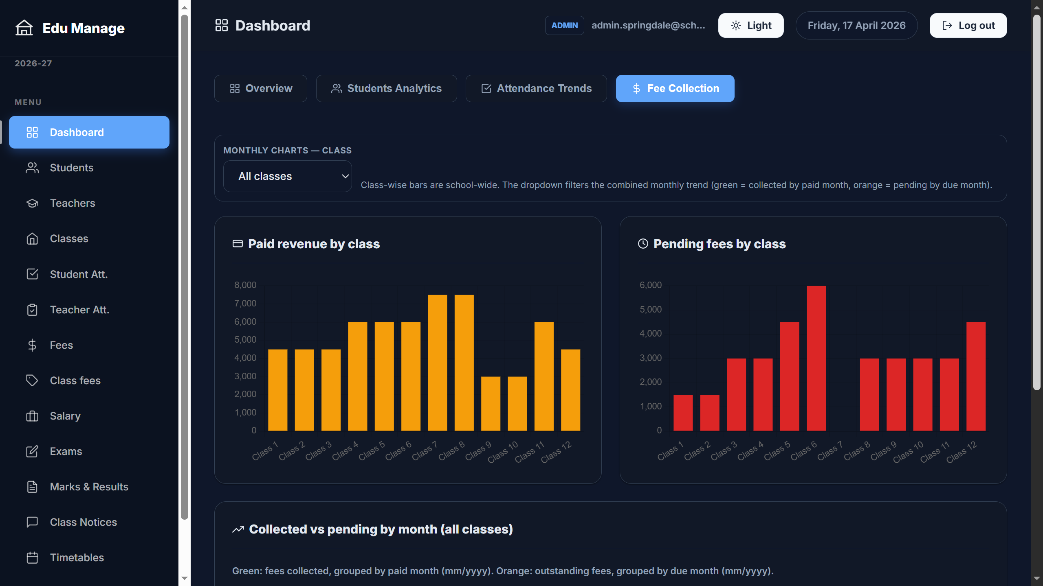

Screen 5
Source: school-admin-react\src\screenshots\Screenshot (402).png
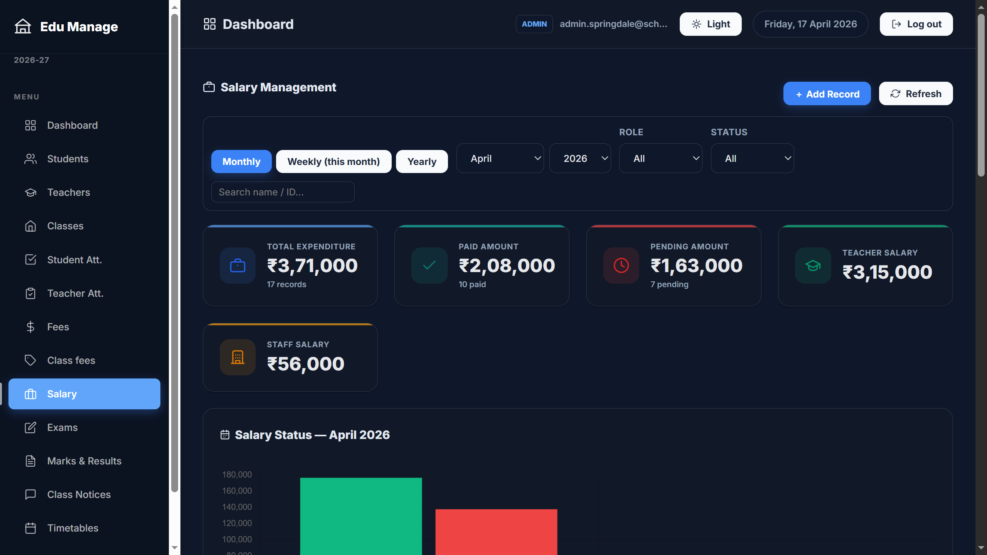

Screen 6
Source: school-admin-react\src\screenshots\Screenshot (403).png
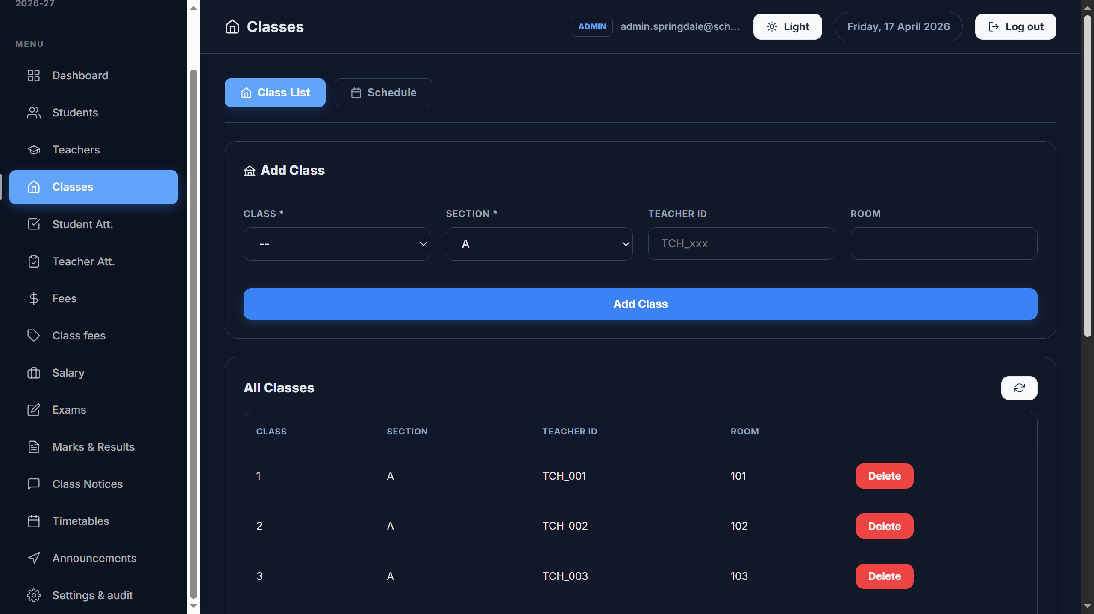

10. Security, Privacy & Production Notes
- Avoid using demo credentials in production; use a secure identity provider and strong password policies.
- Do not store sensitive personal data beyond what is necessary for school operations; follow local compliance requirements.
- Treat exports (PDFs, ZIPs, CSV, JSON snapshots) as confidential; secure access and storage.
- Replace mock notification flows with audited, consent-based messaging via approved providers.

11. Future Enhancements (Suggested)
- Integrate real WhatsApp/SMS/email provider for parent notifications.
- Add dedicated parent portal and student portal views.
- Stronger role management (multiple admin roles, permissions per module).
- Automated backups and scheduled reports.
- Improved reporting (custom templates, result analysis, dashboards per class/subject).

