HTML
1.DOM (Document Object Model)
- The DOM represents the structure of an HTML document as a tree of objects.
- It represents the structure of a webpage as a tree of objects, where each object corresponds to a part of the page (like an element, an attribute, or a piece of text).
- The Analogy: A Car Dashboard
Think of a physical car. The HTML is the engine, the wires, and the frame.
If you didn't have a dashboard, you would have to open the hood and manually inspect the engine to see how fast you were going or to change the radio station.
The DOM is the dashboard. It hooks into all the internal parts of the car and exposes steering wheels, buttons, and digital screens. JavaScript is the driver pressing those buttons. The DOM is required because it gives the driver a safe, standardized interface to control the machine.
2. What is BOM?
- BOM stands for Browser Object Model
- It represents the browser window and environment
- It allows JavaScript to interact with things outside the webpage .
- The main object in BOM is the window object
- It includes objects like location, history, navigator, screen.
- The BOM represents the browser itself as an object. It provides a way for JavaScript to interact and communicate with the web browser's environment
- The Core of the BOM: The “window” Object
- The window object is the king of the BOM. It represents the entire browser window.
- In JavaScript, the window object is the Global Object. This means everything running in your browser sits inside it—in fact, even the DOM is just a property of the BOM! You can access the DOM by calling window.document.

- What is DOCTYPE?
DOCTYPE (Document Type Declaration) tells the browser which version of HTML is being used so it can render the page correctly. It is always written at the very top of an HTML document.

- Character Encoding

What it is:
Character encoding tells the browser how text is stored and displayed, converting characters into bytes.

Common Encoding:
UTF-8 (most widely used)- UTF-8 (Unicode Transformation Format - 8-bit

Example:
HTML
<meta charset="UTF-8">
Show more lines

Why it’s important:
- Supports all languages and symbols.

Topic | Purpose
Character Encoding | Defines how text is displayed
<script> | Adds JavaScript
<link> | Connects external resources
HTML5 Document | Basic webpage structure
Comments | Notes for developers

- What are Formatting Tags?
Formatting tags are HTML tags used to style and format text.
They help make content bold, italic, highlighted, or structured.
HTML Formatting Tags Table
Tag | Name | What it does
<b> | Bold | Makes text bold (no importance)
<strong> | Strong | Indicates important text (bold + semantic meaning)
<i> | Italic | Displays text in italic style
<em> | Emphasis | Emphasizes text (italic + meaning)
<u> | Underline | Underlines the text
<mark> | Mark | Highlights text
<small> | Small | Makes text smaller
<del> | Deleted | Shows deleted text (strikethrough)
<ins> | Inserted | Shows inserted text (underlined)
<sub> | Subscript | Displays text below the line
<sup> | Superscript | Displays text above the line
<code> | Code | Displays text in code format
- Lists in HTML
Types:
- Ordered List (<ol>) → Numbered list
- Unordered List (<ul>) → Bullets list
- Description List (<dl>) → Terms + descriptions

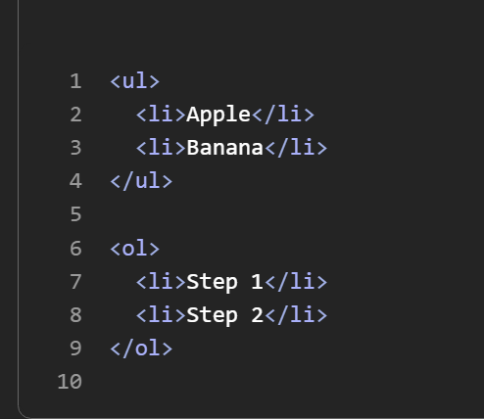

- Tables in HTML
Used to display data in rows and columns
Tags:
- <table> → Table
- <tr> → Row
- <th> → Header cell
- <td> → Data cell
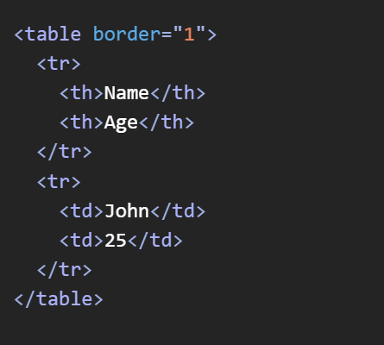
- Forms & Input Tags
Form:
- Used to collect user input
Common Input Types:
- text, password, email, radio, checkbox, submit
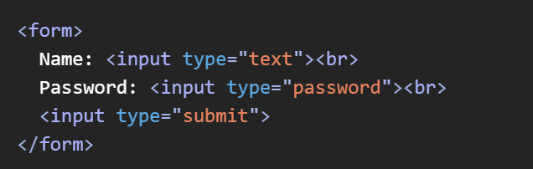
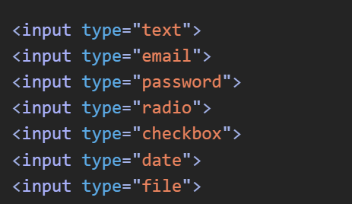
- Images in HTML
Tag: <img>
Attributes:
- src → Image path
- alt → Alternative text
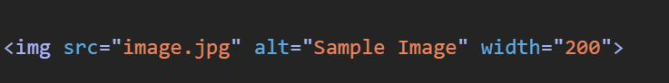
- Placeholder Attribute
Used in input fields to show hint text

- id vs class Attributes -> Selectors in CSS

Feature | id | class
Usage | Unique element | Multiple elements
Reuse | Cannot reuse | Can reuse
Selector | #id | .class
Priority | Higher | Lower
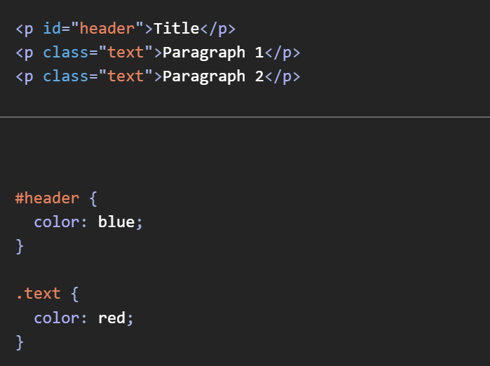
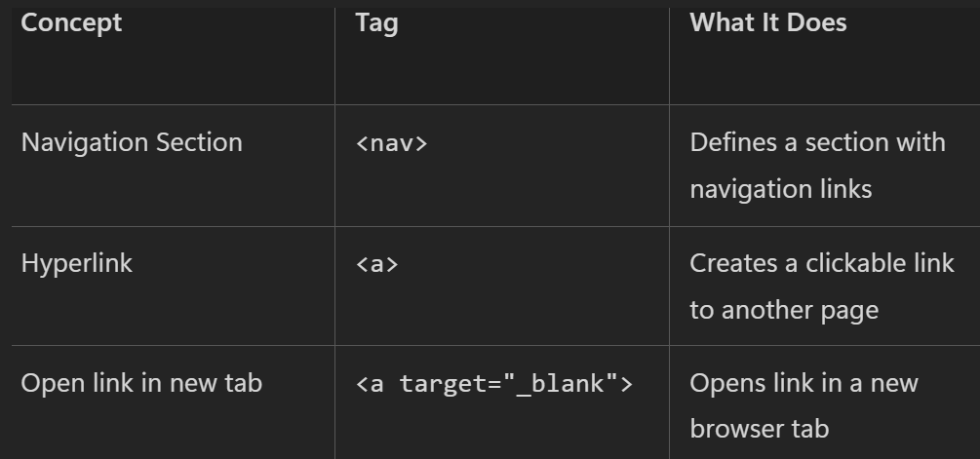
EVENTS IN HTML
1. onblur
🔹 What it is:
- Triggered when an element loses focus
- Mostly used with input fields
🔹 Example:
HTML
<input type="text" onblur="alert('Input lost focus')">
Show more lines

✅ 2. onchange
🔹 What it is:
- Triggered when the value of an input changes
- Fires after user leaves the field
🔹 Example:
HTML
<input type="text" onchange="console.log('Value changed')">

✅ 3. onclick
🔹 What it is:
- Triggered when an element is clicked
🔹 Example:
HTML
<button onclick="alert('Button clicked')">Click me</button>

✅ 4. Form Related Events
🔹 Common Events:
- onsubmit → when form is submitted
- onreset → when form is reset
- onfocus → when input gains focus
- onblur → when input loses focus
🔹 Example:
HTML
<form onsubmit="alert('Form submitted')">
<input type="text">
<input type="submit">
</form>
Show more lines

✅ 5. Load Events
🔹 onload
- Runs when the page or element is fully loaded
🔹 Example:
HTML
<body onload="alert('Page loaded')">

✅ 6. Key Events
🔹 Types:
- onkeydown → key is pressed
- onkeyup → key is released
- onkeypress → key is being pressed
🔹 Example:
HTML
<input type="text" onkeydown="console.log('Key pressed')">
Real-time Scenario: Character Counter
Imagine you are building a social media input box (like a tweet composer) that has a limit of 280 characters. You want to track the user's typing in real time.

✅ 7. Mouse Events
🔹 Common Mouse Events:
- onclick → click
- ondblclick → double click
- onmouseover → mouse over
- onmouseout → mouse leaves
- onmousedown → mouse button down
- onmouseup → mouse button up
🔹 Example:
HTML
<p onmouseover="this.style.color='red'">Hover me</p>
Show more lines

✅ 8. ondblclick
🔹 What it is:
- Triggered when user double-clicks
🔹 Example:
HTML
<p ondblclick="alert('Double clicked')">Double click me</p>
Show more lines

✅ 9. onbeforeunload (correct name)
🔹 What it is:
- Runs before leaving or refreshing the page
- Used to show confirmation messages
🔹 Example:
HTML
<body onbeforeunload="return 'Are you sure?'">
Show more lines

✅ 10. oncanplay
🔹 What it is:
- Triggered when media (audio/video) is ready to play
🔹 Example:
HTML
<video oncanplay="alert('Video ready')" controls>
<source src="video.mp4">
</video>

Topic | What It Is | Key Points
<input> Element | Used to take user input (self-closing tag) | • Uses type attribute (text, email, password, etc.)  • Used inside forms  • Supports HTML5 validation  • No closing tag required  • Works with labels & events
<output> Element | Displays result of calculations or user actions | • Shows dynamic results  • Works with forms & JavaScript  • Used in calculators  • Improves interactivity  • Read-only by default
placeholder Attribute | Shows hint text inside input field | • Disappears when user types  • Guides users  • Improves UX  • Works with text inputs  • Not a default value
autofocus Attribute | Automatically focuses input on page load | • Saves user effort  • Only one element should use it  • No JavaScript required  • Improves usability  • Common in forms
required Attribute | Makes input mandatory before submission | • Prevents empty submission  • Built-in validation  • No JavaScript needed  • Works with most input types  • Shows browser validation message

What is Web Storage?
- Web Storage is a feature in HTML5 that allows browsers to store data locally
- Data is stored as key–value pairs
- It is more secure and faster than cookies
- Two main types:
  - Local Storage
  - Session Storage
- Data is stored in the user’s browser

✅ Local Storage
🔹 What it is:
- Stores data without expiration time
- Data remains even after closing the browser
🔹 Key Features:
- Capacity: ~5–10 MB
- Data persists until manually deleted
- Accessible from same origin (domain)
- Stored as strings
- Shared across tabs of same site
🔹 Use Case:
- Remember login details
- Save user preferences (theme, language)
- Store cart items in e-commerce

✅ 3. Session Storage
🔹 What it is:
- Stores data only for one session
- Data is deleted when the tab/browser is closed
🔹 Key Features:
- Works per browser tab
- Data not shared across tabs
- Temporary storage
- Same API as localStorage
- Safer for short-term data
🔹 Use Case:
- Temporary login sessions
- Form data during navigation
- One-time session tracking

✅ 4. Difference Between Local Storage and Session Storage
Feature | Local Storage | Session Storage
Data duration | Permanent | Temporary
Lifetime | Until manually deleted | Until tab closed
Scope | All tabs | Single tab
Storage limit | ~5–10 MB | ~5 MB
Use case | Long-term data | Short-term data
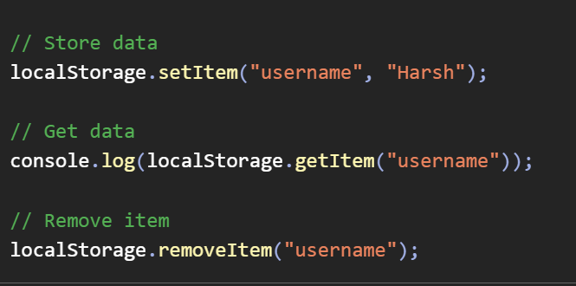
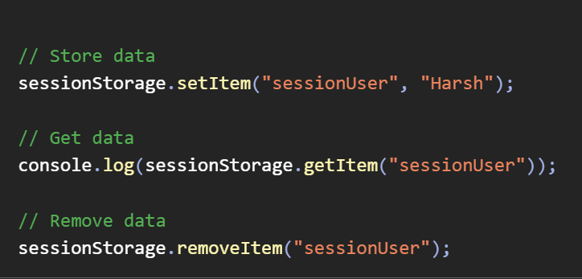

JavaScript Basics
🔹 What is JavaScript?
- JavaScript is a programming language for the web
- It makes webpages interactive and dynamic
- Runs directly in the browser
- Works with HTML and CSS
- Used for frontend and backend (Node.js)

1. Arrays

✅ What is Array?
An array is a collection of multiple values stored in a single variable.
JavaScript
let arr = [1, 2, 3, 4];

✅ Why use it?
To store and manage multiple values efficiently.

✅ When to use?
When you have a list of similar items (numbers, names, objects).

✅ Where used?
Used in loops, APIs, lists, UI data rendering.

🔹 Common Array Methods
JavaScript
arr.push(5); // add at end
arr.pop(); // remove last
arr.shift(); // remove first
arr.unshift(0); // add at start
arr.length; // size
arr.indexOf(3); // find index
arr.includes(2); // check existence
arr.slice(1,3); // copy part
arr.splice(1,2); // modify array
arr.map(x => x*2); // transform values
arr.filter(x => x>2); // filter values

🔤 2. Strings

✅ What?
A string is a sequence of characters.
JavaScript
let str = "Hello";

✅ Why?
To store and manipulate text.

✅ When?
User input, messages, names, etc.

🔹 String Methods
JavaScript
str.length;
str.toUpperCase();
str.toLowerCase();
str.trim();
str.slice(0,4);
str.includes("H");
str.replace("Hello", "Hi");
str.split(" ");

📅 3. Date

✅ What?
Used to work with date & time.
JavaScript
let now = new Date();

✅ Why?
To store, display, and manipulate dates.

✅ Where?
Apps, logs, timestamps, calendars.

🔹 Methods
JavaScript
now.getFullYear();
now.getMonth(); // 0–11
now.getDate();
now.getDay();
now.getHours();
now.getMinutes();
now.getSeconds();

➗ 4. Math

✅ What?
Built-in object for mathematical operations.

✅ Why?
Perform calculations easily.

🔹 Methods
JavaScript
Math.round(4.6); // 5
Math.floor(4.9); // 4
Math.ceil(4.1); // 5
Math.random(); // 0–1
Math.max(1,5,3);
Math.min(1,5,3);
Math.pow(2,3); // 8
Math.sqrt(16); // 4

🔢 5. Number

✅ What?
Represents numeric values.
JavaScript
let num = 10;
Show more lines

✅ Why?
To perform arithmetic operations.

🔹 Methods
JavaScript
num.toFixed(2); // decimal format
Number("10"); // convert
parseInt("10px");
parseFloat("10.5");
isNaN("abc"); // true

Show more lines

✅ 6. Boolean

✅ What?
Represents true or false.
JavaScript
let isLoggedIn = true;
Show more lines

✅ Why?
For decision-making (conditions).

🔹 Examples
JavaScript
Boolean(1); // true
Boolean(0); // false
Boolean(""); // false
Boolean("Hi"); // true
Show more lines

🔧 7. Functions

✅ What?
Reusable block of code.
JavaScript
function add(a, b) {
return a + b;
}
Show more lines

✅ Why?
Avoid repetition, make code modular.

✅ When?
Whenever logic repeats.

🔹 Types
JavaScript
// Normal
function greet() {}

// Expression
const greet = function() {};

// Arrow
const greet = () => {};
``
Show more lines

🧾 8. JSON (JavaScript Object Notation)

✅ What?
A format for storing & exchanging data.
JavaScript
let obj = {
name: "Harsh",
age: 25
};

✅ Why?
Used in APIs and data transfer.

✅ Where?
Frontend ↔ Backend communication.

🔹 Methods
JavaScript
JSON.stringify(obj); // object → JSON string
JSON.parse(jsonStr); // JSON → object

🔍 9. Regular Expressions (RegEx)

✅ What?
Used for pattern matching in strings.
JavaScript
let pattern = /abc/;

✅ Why?
Validate input (email, phone), search text.

🔹 Common Methods
JavaScript
pattern.test("abc"); // true/false
"abc".match(pattern);
"abc".search(pattern);
"abc123".replace(/\d/, "X");

🔹 Example Patterns
JavaScript
/^\d+$/ // only numbers
/^[a-zA-Z]+$/ // only letters
/^\w+@\w+\.\w+$/ // email
Show more lines

🔥 Quick Revision Table
Topic | Purpose | Example
Array | Store list | [1,2,3]
String | Text | "Hello"
Date | Time | new Date()
Math | Calculations | Math.random()
Number | Numeric ops | parseInt()
Boolean | True/False | true
Functions | Reusable code | function()
JSON | Data exchange | JSON.parse()
RegEx | Pattern match | /abc/

