Software Design Specifications

for

<TradeHawk and 1.0>

Prepared by: DevNest

DevNest

Document Information

Title: SDS(Software Design Specification)
 | Document Version No: 1.0
 | Document Version Date: 9-4-25
Prepared By:DevNest | Preparation Date:9-4-25

Version History

Ver No | Ver date | Revised by | Description | Filename
1.0 | 9-4-25 | DevNest | All the design specifications needed for tradehawk | Team11_Tradehawk_SDD

Table of Contents

1 INTRODUCTION ............................................................................................................................................................ |  | 4
1.1 | PURPOSE ...................................................................................................................................................................... | 4
1.2 | SCOPE .......................................................................................................................................................................... | 4
1.3 | DEFINITIONS, ACRONYMS, AND ABBREVIATIONS ........................................................................................................ | 4
1.4 | REFERENCES ................................................................................................................................................................ | 4

2 | USE CASE VIEW ............................................................................................................................................................ |  | 4
 | 2.1 | USE CASE ..................................................................................................................................................................... | 4
3 | DESIGN OVERVIEW ..................................................................................................................................................... |  | 4
 | 3.1 | DESIGN GOALS AND CONSTRAINTS ............................................................................................................................. | 5
 | 3.2 | DESIGN ASSUMPTIONS ................................................................................................................................................. | 5
 | 3.3 | SIGNIFICANT DESIGN PACKAGES ................................................................................................................................. | 5
 | 3.4 | DEPENDENT EXTERNAL INTERFACES ........................................................................................................................... | 5
 | 3.5 | IMPLEMENTED APPLICATION EXTERNAL INTERFACES ................................................................................................. | 5
4 | LOGICAL VIEW ............................................................................................................................................................. |  | 5
 | 4.1 | DESIGN MODEL ............................................................................................................................................................ | 6
 | 4.2 | USE CASE REALIZATION .............................................................................................................................................. | 6
5 | DATA VIEW .................................................................................................................................................................... |  | 6
 | 5.1 | DOMAIN MODEL .......................................................................................................................................................... | 6
 | 5.2 | D ATA MODEL (PERSISTENT DATA VIEW)...................................................................................................................... | 6
 | 5.2.1 Data Dictionary.................................................................................................................................................... |  | 6
6 | EXCEPTION HANDLING ............................................................................................................................................. |  | 6
7 | CONFIGURABLE PARAMETERS .............................................................................................................................. |  | 6
8 | QUALITY OF SERVICE ................................................................................................................................................ |  | 7
 | 8.1 | AVAILABILITY.............................................................................................................................................................. | 7
 | 8.2 | SECURITY AND AUTHORIZATION ................................................................................................................................. | 7
 | 8.3 | LOAD AND PERFORMANCE IMPLICATIONS ................................................................................................................... | 7
 | 8.4 | MONITORING AND CONTROL ....................................................................................................................................... | 7

1 Introduction

TradeHawk is a web-based online auction platform exclusively designed for Mahindra University students, aimed at facilitating the buying, selling, and repurchasing of items within a secure academic community. Built with a focus on sustainability, affordability, and user convenience, TradeHawk empowers students to engage in real-time bidding, manage their listings, and perform secure transactions through a streamlined interface.
This Software Design Specification (SDS) document provides a comprehensive overview of the TradeHawk system’s software architecture and detailed design. It translates the functional and non-functional requirements defined in the Software Requirements Specification (SRS) into a set of technical solutions, outlining how the various software modules interact with one another. The document covers the core components such as auction management, user authentication, payment processing, and notification services.
It serves as a blueprint for the development team, testers, and stakeholders, ensuring alignment in understanding the platform's structural and behavioral design. This SDS includes detailed UML diagrams—such as use case, class, sequence, activity, state chart, and composite diagrams—alongside definitions, acronyms, and design conventions used throughout the project.

1.1 Purpose

The purpose of this Software Design Specification (SDS) document is to present the architectural and detailed design of TradeHawk, an online auction platform tailored for Mahindra University students. This document acts as a critical link between the functional requirements outlined in the SRS and the actual implementation of the software. It defines the structural components, system behavior, data flow, and interactions between various modules such as user authentication, auction management, bidding, and payment processing.
This document is intended for use by software developers, testers, project stakeholders, and academic evaluators. Developers will use it to guide the implementation of system modules, testers will reference it to design relevant test cases, and stakeholders can consult it to ensure the design aligns with project goals and user needs.

1.2 Scope

TradeHawk is developed as an exclusive online auction platform for Mahindra University students, offering a secure and efficient space to buy, sell, and repurchase items within the campus community. The system allows users to register as buyers or sellers, list items for auction, place real-time bids, and process secure transactions. Key modules include user authentication, auction listing and management, bidding system, payment integration, and notification services.
This Software Design Specification applies to the design and interaction of these core modules, influencing all components related to auction flow, data handling, and user interaction. The document defines how the platform components are structured and communicate, ensuring a reliable and user-friendly marketplace tailored for a university environment.

1.3 Definitions, Acronyms, and Abbreviations
- API – Application Programming Interface
- UI/UX – User Interface / User Experience
- DBMS – Database Management System
- OTP – One-Time Password
- SDS – Software Design Specification
- SRS – Software Requirements Specification
- UML – Unified Modeling Language
- RBAC – Role-Based Access Control
- HTTP/HTTPS – Hypertext Transfer Protocol / Secure
- PWA – Progressive Web Application
- MFA – Multi-Factor Authentication
- React.js – JavaScript library for building user interfaces
- Node.js – JavaScript runtime environment for backend development
- MongoDB – NoSQL Database used for storing auction-related data
- MySQL – Relational Database Management System
- Socket.io – JavaScript library for real-time web applications

1.4 References

GIT HUB REPOSITORY - https://github.com/nikstar123/SE-project

UML Diagrams for the Group
USECASE,SEQUENCE,CLASS DIAGRAMS

MongoDB Security Practices
https://www.mongodb.com/docs/manual/security/

Information Technology Rules, 2011
https://www.meity.gov.in/

Aadhaar Data Security Guidelines
https://uidai.gov.in/

HTML, CSS, and JavaScript Documentation
https://developer.mozilla.org/

IEEE Standard 1016-2009: IEEE Standard for Information Technology—System Design—Software Design Descriptions
● Project Requirement Specification Document
● Technology Documentation

2 Use Case View

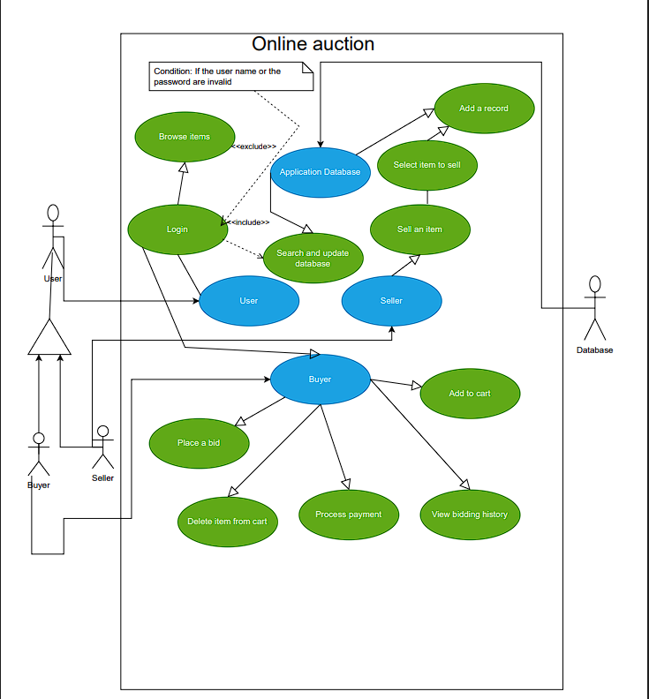
2.1 Use Case 1 : Payment Processing

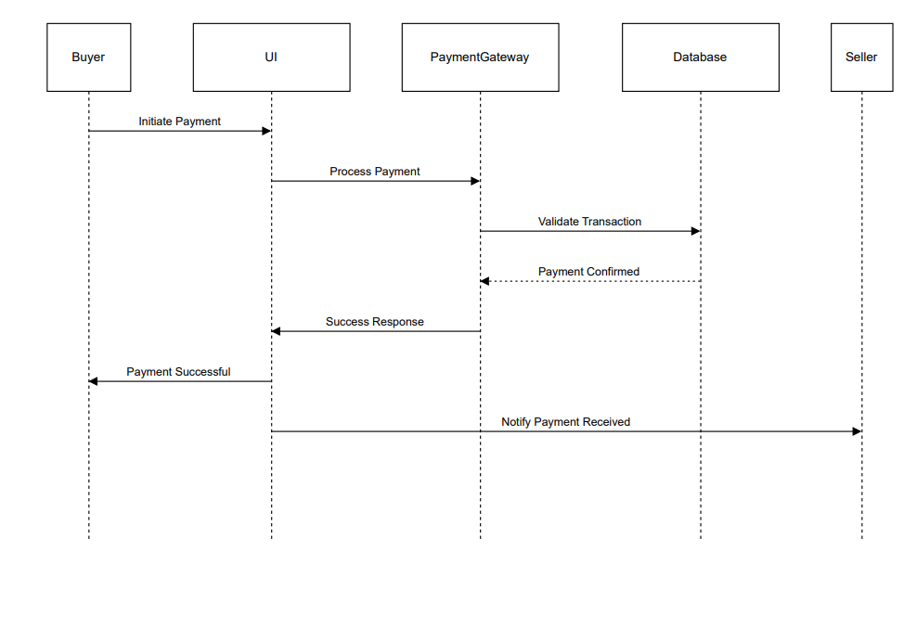

Author: Harshdeep(SE22UCSE108)
Purpose:
To securely handle payment transactions between a buyer and a seller through an integrated payment gateway, ensuring validation and confirmation of successful transactions.

Actors:
- Buyer
- Seller
- Payment Gateway
- Database

Preconditions:
- The buyer must have selected one or more items for purchase.
- A valid payment method must be available.
- The system must be online and fully functional.

Postconditions:
- If successful, the payment is processed, and both the buyer and seller are notified.
- If unsuccessful, an error message is displayed to the buyer.

Event Flow:
- Base Flow Sequence:
  - Buyer initiates a payment request from the UI.
  - The payment gateway processes the transaction.
  - The system validates transaction details against the database.
  - If valid, the payment is confirmed.
  - A success response is sent to the buyer.
  - The seller receives a notification of successful payment.
- Alternative Flow:
  - If the payment gateway response is delayed, the system retries the transaction after a short interval.

Exceptions:
- Invalid Payment Details: The transaction is declined and an error message is shown to the buyer.
- Database Unavailable: Payment validation fails; the buyer is prompted to retry.
- Insufficient Funds: The transaction fails and the buyer is notified.

Includes: None
Extends: None
Priority: High – Payment processing is critical to completing transactions on the platform.
Requirements Traceability:
- Supports secure payment operations
- Ensures transaction validation
- Notifies relevant parties upon success or failure

Use Case 2 : Auction Completion & Winner Notification

Author: Adarsh Ladi (SE22UCSE304)

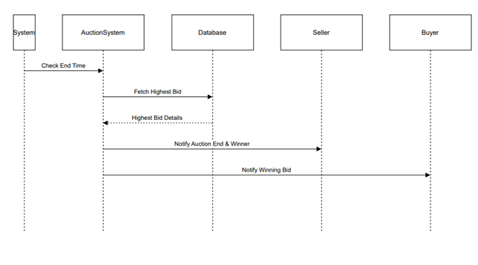

Purpose:
To finalize an auction by checking its scheduled end time, retrieving the highest bid, and notifying both the winning bidder and the seller with the result.

Actors:
- System
- Auction System
- Database
- Seller
- Buyer (Winning bidder)

Preconditions:
- An auction must be active and properly scheduled.
- At least one valid bid must have been placed.
- The system clock must be accurately synchronized.

Postconditions:
- The auction is marked as completed.
- The highest bid is stored in the database.
- The winning buyer and seller are notified of the result.

Event Flow:
- Base Flow Sequence:
  - System checks if the auction end time has been reached.
  - Auction System fetches the highest bid from the database.
  - The bid details are validated and stored.
  - Seller receives a notification with the auction result.
  - The winning buyer is notified of their successful bid.
- Alternative Flow:
  - If no valid bids are placed, the seller is notified that the auction ended without a winner.

Exceptions:
- Database Unavailable: Auction finalization fails, and a retry or manual resolution is required.
- System Time Sync Issue: The system clock error may cause premature or delayed auction end, requiring admin intervention.

Includes: None
Extends: None
Priority: High – Accurate and timely auction finalization is crucial for system trust and user experience.

Requirements Traceability:
- System must auto-check auction end times.
- Highest bid must be retrieved and stored.
- Notifications must be sent to seller and winner promptly.

Use case 3 :- Item Listing for Auction
Author: KTS Satwik Reddy (SE22UCSE122)

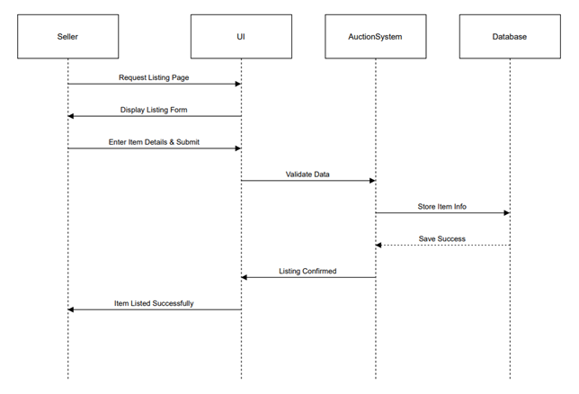

Purpose:
To enable a seller to list an item for auction by entering item details, validating the input, and storing the information in the database.

Actors:
- Seller UI
- Auction System
- Database

Preconditions:
- The seller must be logged in.
- The auction system must be running.
- The database must be accessible.

Postconditions:
- The item is successfully listed for auction.
- The seller receives a confirmation message.

Event Flow:
- Base Flow Sequence:
  - The seller navigates to the item listing page.
  - The system displays the item listing form.
  - The seller enters the item details and submits the form.
  - The auction system validates the entered data.
  - If valid, the item is saved in the database.
  - A success message is displayed to the seller.
- Alternative Flow:
  - If the data is invalid or incomplete, an error message is shown and the seller is prompted to correct the form.

Exceptions:
- Database Unavailable: Item cannot be stored; an error is shown to the seller.
- Invalid Data Entry: The form submission is rejected and the seller must correct the input.

Includes: None
Extends: None
Priority: High – Listing items is a core function of the auction system.

Requirements Traceability:
- Must allow sellers to access an item listing page.
- Input must be validated before saving.
- Listings must be stored securely and confirmed.

Use case 4:- User Login Authentication
Author: G Nikhilesh (SE22UCSE098)

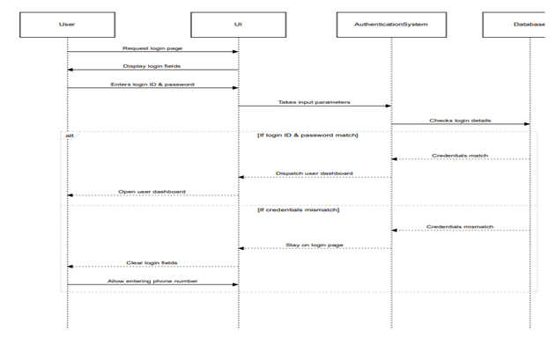

Purpose:
To authenticate users securely by verifying login credentials and managing success or failure scenarios, granting access to their respective dashboards.

Actors:
- User UI
- Authentication System
- Database

Preconditions:
- The user must have a registered account.
- The authentication system must be online.
- The credentials database must be accessible.

Postconditions:
- If successful, the user is logged in and redirected to their dashboard.
- If authentication fails, the user is prompted to retry or use an alternative method.

Event Flow:
- Base Flow Sequence:
  - User navigates to the login page.
  - Login fields are displayed.
  - User enters email/username and password.
  - The authentication system verifies the credentials.
  - If valid, the user is logged in and redirected to their dashboard.
- Alternative Flow:
  - If credentials are incorrect, the fields are reset.
  - The user is prompted to re-enter credentials or use an alternative method (e.g., OTP or forgot password).

Exceptions:
- Database Unavailable: Authentication fails and an error message is shown.
- Incorrect Credentials: The system prompts the user to try again.
- Multiple Failed Attempts: The system may lock the account or require additional verification (e.g., CAPTCHA or OTP).

Includes: None
Extends: None
Priority: High – Secure login is critical to protect user data and system integrity.

Requirements Traceability:
- Must validate login credentials securely.
- Must redirect users upon success.
- Must handle incorrect or failed login attempts appropriately.

Use case 5:- Order Shipment & Delivery Tracking

Author: Amith Reddy (SE22UCSE266)

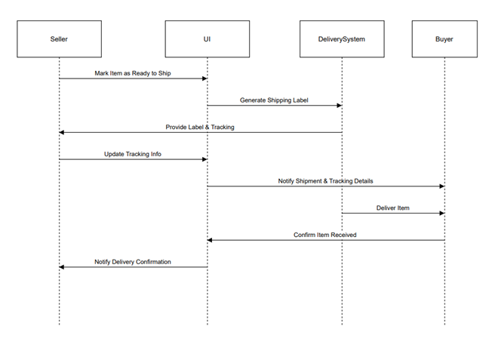

Purpose:
To handle the shipment process after an order is placed, including generating tracking information, notifying the buyer, and confirming successful delivery.

Actors:
- Seller UI
- Delivery System
- Buyer

Preconditions:
- The buyer has placed and paid for an order.
- The seller has packed and prepared the item for shipment.
- The delivery system is online and functional.

Postconditions:
- The item is marked as shipped and tracking details are shared with the buyer.
- The buyer receives delivery confirmation.
- The seller is notified of successful delivery.

Event Flow:
- Base Flow Sequence:
  - The seller marks the item as ready for shipment.
  - The delivery system generates a shipping label and tracking number.
  - The system updates tracking details and provides them to the seller.
  - The buyer is notified with tracking info.
  - The item is delivered to the buyer.
  - The buyer confirms delivery.
  - The system notifies the seller of successful delivery.
- Alternative Flow:
  - If tracking info fails to update, the system retries after a set interval.

Exceptions:
- Delivery System Failure: Shipping label generation is delayed and may require manual handling.
- Incorrect Tracking Details: The seller is prompted to correct the data.
- Buyer Unavailable for Delivery: Delivery system schedules a reattempt or requests alternate delivery instructions.

Includes: None
Extends: None
Priority: High – Timely and accurate delivery tracking is key to maintaining user trust.

Requirements Traceability:
- System must allow shipment marking and tracking generation.
- Buyers must be notified in real time.
- Delivery status must be accurately updated and confirmed.

Use case 6:- Auction Winner Notification
Author: K Karthik Reddy (SE22UCSE128)

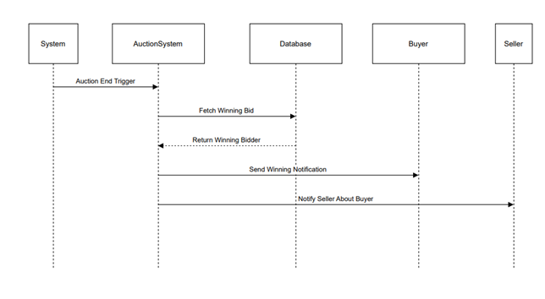

Purpose:
To identify the highest bidder once an auction ends and notify both the winning buyer and the seller of the auction result.

Actors:
- System
- Auction System
- Database
- Buyer
- Seller

Preconditions:
- The auction has ended.
- Valid bids have been recorded.
- The bidding data is accessible from the database.

Postconditions:
- The winning bidder is successfully identified.
- Notifications are sent to both the buyer and the seller.

Event Flow:
- Base Flow Sequence:
  - The system detects that the auction end time has been reached.
  - The Auction System retrieves the highest bid from the database.
  - The winning bidder is confirmed.
  - A notification is sent to the winning buyer.
  - The seller is notified with the winner’s details.
- Alternative Flow:
  - If no bids were placed, the system informs the seller that the auction ended without a winner.

Exceptions:
- Database Unavailable: The highest bid can't be fetched; notification is delayed.
- System Failure: Auction result generation is delayed, requiring manual follow-up.

Includes: None
Extends: None
Priority: High – Notifying auction results promptly is essential for order processing.

Requirements Traceability:
- Detect auction end times automatically.
- Fetch and validate the highest bid.
- Notify both buyer and seller without delays.

Use Case 7:- User Login Authentication
Author: EVM Teja (SE22UCSE091)

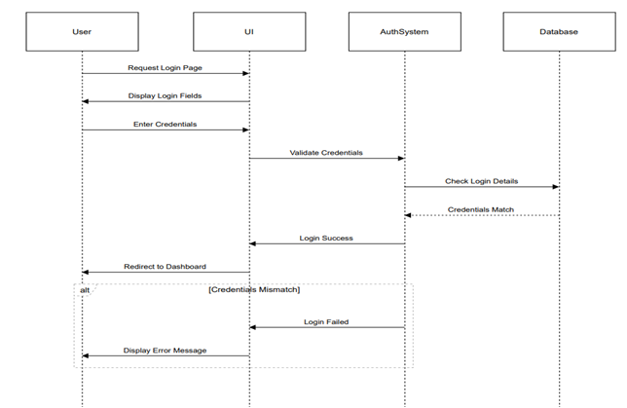

Purpose:
To securely authenticate users by validating their login credentials and managing both successful and failed login scenarios.

Actors:
- User UI
- Auth System
- Database

Preconditions:
- The user has an existing registered account.
- The authentication system is operational.
- The user credentials database is accessible.

Postconditions:
- On success, the user is redirected to their dashboard.
- On failure, the user is prompted to re-enter credentials or shown an error message.

Event Flow:
- Base Flow Sequence:
  - The user navigates to the login page.
  - The system displays input fields for username and password.
  - The user enters credentials and submits the form.
  - The authentication system verifies the credentials by querying the database.
  - If valid, the system grants access and redirects the user to their dashboard.
- Alternative Flow:
  - If the credentials are incorrect, the system shows an error and prompts the user to try again.

Exceptions:
- Database Unavailable: Login cannot proceed and an error is displayed.
- Incorrect Credentials: The user is asked to re-enter valid information.
- Multiple Failed Attempts: Account may be locked or additional verification (like OTP) may be triggered.

Includes: None
Extends: None
Priority: High – Secure and reliable login is fundamental to platform security.

Requirements Traceability:
- Validate login credentials accurately and securely.
- Redirect authenticated users to their dashboard.
- Handle failed logins with error prompts and fallback options.

Use Case 8:- Placing a Bid on an Auction Item
Author: Karthik Kumar Reddy (SE22UCSE276)

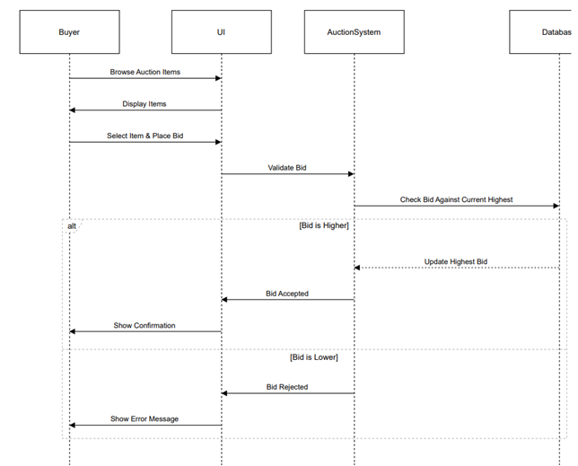

Purpose:
To allow buyers to browse auction items, place bids, and receive appropriate feedback based on the bid’s validity.

Actors:
- Buyer UI
- Auction System
- Database

Preconditions:
- The buyer is logged into the system.
- Active auction listings are available.
- The bid database is accessible and functional.

Postconditions:
- If the bid is valid and higher than the current bid, it is recorded as the highest bid.
- If the bid is invalid or lower, it is rejected and an error message is shown to the buyer.

Event Flow:
- Base Flow Sequence:
  - The buyer browses available auction listings.
  - The buyer selects an item and enters a bid amount.
  - The auction system validates the bid.
  - If the bid is higher than the current highest:
    - The bid is stored in the database.
    - The buyer receives a confirmation message.
- Alternative Flow:
  - If the bid is lower than the current highest:
    - The system rejects the bid.
    - An error message is displayed to the buyer.

Exceptions:
- Database Unavailable: Bid cannot be processed; an error is shown.
- Bid Entry Error: If the bid amount is invalid or missing, the user is prompted to correct it.

Includes: None
Extends: None
Priority: High – Correct and fair bid handling is crucial for auction integrity.

Requirements Traceability:
- Buyers must be able to place bids on active auctions.
- Bids must be validated against the current highest.
- System must update the highest bid and notify the user accordingly.

- Design Overview

3.1 Design Goals and Constraints

The TradeHawk platform will run on modern web browsers and support devices with at least 2GB RAM. It is developed using React.js, Node.js, and MongoDB, with real-time features powered by Socket.io.

3.2 Design Assumptions
- The platform will be accessed primarily through modern web browsers on devices with at least 2GB RAM.
- Mahindra University students will use their university credentials to log in and access the system.
- MongoDB Atlas and MySQL will be available 24/7 with minimal downtime and quick response times (<300ms).
- The frontend will use Axios to communicate with Express.js backend APIs.
- A stable internet connection is available for users to participate in real-time bidding without interruptions.

3.3 Significant Design Packages

Frontend
- App Layer: Manages application routes using react-router-dom and handles global state (e.g., user auth, theme).
- Component Layer: Contains modular and reusable UI components styled with Tailwind CSS for consistency and responsiveness.
- Service Layer: Uses Axios to interact with backend APIs for user authentication, bidding, item listing, etc.
- Routing: Handles dynamic navigation between pages like login, dashboard, item listing, and bidding using react-router-dom.
Backend
- Routing Layer: Built with Express.js to define API endpoints for user, auction, bid, and payment operations.
- Controller Layer: Implements business logic for features like starting auctions, placing bids, and processing payments.
- Model Layer: Includes Mongoose schemas for users, items, bids, and transactions stored in MongoDB Atlas.
- Middleware Layer: Manages authentication (e.g., JWT), input validation, error handling, and environment configs using dotenv.
Shared / External
- Real-time Layer: Socket.io enables real-time bid updates and live auction events.
- Database Integration:
  - MongoDB Atlas is used for storing auction data and user info via Mongoose ODM.
  - MySQL handles structured transaction logs and admin reporting.
- Payment Integration: Secure third-party payment gateway APIs are used for transaction processing.
- Build Tool: Uses Vite for fast development builds and optimized frontend bundling.

3.4 Dependent External Interfaces

The table below lists the public interfaces this design requires from other modules or applications.

External Application Interface Name | Module Using the Interface | Functionality / Description
MongoDB Atlas (Mongoose ODM) | Backend - Data Persistence Module | Used to define schemas and perform secure CRUD operations for users, items, bids, and auction transactions
MySQL (mysql2 / Sequelize) | Backend - Transaction Logging Module | Stores structured data such as transaction logs, reports, and admin analytics
Dotenv | Backend - Configuration Module | Loads environment variables including database credentials, API keys, and JWT secrets at runtime.
react-router-dom | Frontend - Routing Module | Manages navigation between UI views like login, dashboard, auctions, and admin pages.
Tailwindcss | Frontend - UI Styling Module | Provides a utility-first CSS framework for styling reusable components and ensuring responsive design.
Vite | Frontend - Build Tool Module | Used for fast local development and building optimized frontend bundles for deployment.
socket.io | Backend & Frontend - Real-Time Module | Enables live bid updates and auction events across connected clients and the server.
Axios | Frontend - API Communication Module | Sends asynchronous HTTP requests to the backend for authentication, item listings, bids, and payments.
Payment Gateway API (e.g., Razorpay) | Backend - Payment Module | Handles secure processing of online payments for successful auction transactions.

3.5 Implemented Application External Interfaces (and SOA web services)

The table below lists the implementation of public interfaces this design makes available for other applications.

Interface Name | Module Implementing the Interface | Functionality / Description
/api/auth/login | Auth Module (Backend) | Authenticates users (buyers, sellers, admins) and returns a JWT token for session management.
/api/items/list | Item Management Controller (Backend) | Allows sellers to create and post new auction listings with item details.
/api/items/:id | Item Management Controller (Backend) | Retrieves item details by ID for display on the bidding page.
/api/bids/place | Bidding Controller (Backend) | Accepts bid submissions, validates them, updates the current highest bid in real time using Socket.io.
/api/payment/checkout | Payment Module (Backend) | Initiates the payment process for auction winners using a secure payment gateway.
/api/transactions/history | User Dashboard Controller (Backend) | Provides users access to their past bids, purchases, and sales data.
/api/notify/bid-update | Notification Module (Backend) | Sends bid outbid alerts or auction ending reminders to users via Socket.io or email.
/api/auth/register | Auth Module (Backend) | Registers new users and stores encrypted credentials in the database.

4 Logical View

The TradeHawk platform follows a layered architecture to ensure modularity and maintainability. The main layers are:
- Presentation Layer: Built with React.js, handles user interaction and routing using react-router-dom.
- Application Layer: Express.js controllers manage API endpoints and route requests.
- Business Logic Layer: Contains core logic for auctions, bidding, payments, and user management.
- Data Access Layer: Uses Mongoose for MongoDB and Sequelize/MySQL for structured data operations.
- Database Layer: Stores data in MongoDB Atlas (for bids, users, items) and MySQL (for transactions and logs).
Each layer communicates with adjacent layers through well-defined interfaces
4.1 Design Model

Module | Description
User Management Module | Handles registration, login, profile updates, and role-based access for buyers and sellers.
Auction Management Module | Manages creation, editing, scheduling, and deletion of auction listings by sellers.
Bidding Module | Allows buyers to place bids, view live bidding status, and receive bid feedback.
Winner Notification Module | Automatically determines auction winners after deadlines and notifies both buyers and sellers.
Transaction Module | Handles payment details, stores transaction records, and confirms item delivery status.
Feedback Module | Enables users to leave feedback and rate sellers/buyers based on transaction experience.

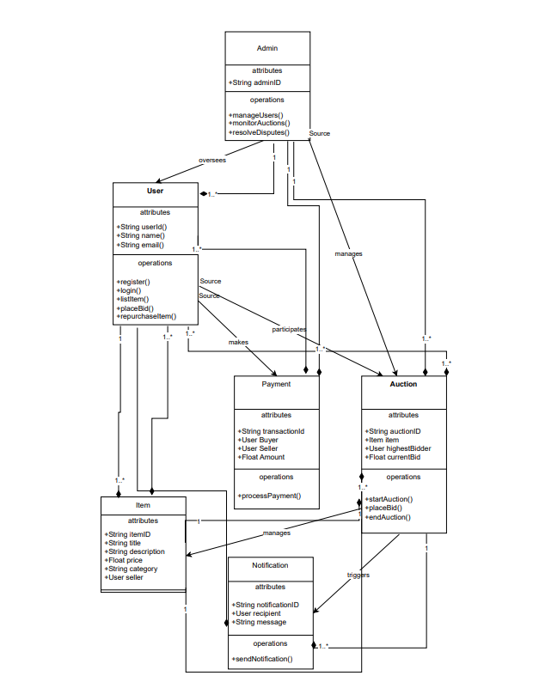

4.2 Use Case Realization

Use Case 1 : Payment Processing

Author: Harshdeep(SE22UCSE108)

Use Case 2 : Auction Completion & Winner Notification

Author: Adarsh Ladi (SE22UCSE304)

Use case 3 :- Item Listing for Auction
Author: KTS Satwik Reddy (SE22UCSE122)

Use case 4:- User Login Authentication
Author: G Nikhilesh (SE22UCSE098)

Use case 5:- Order Shipment & Delivery Tracking

Author: Amith Reddy (SE22UCSE266)

Use case 6:- Auction Winner Notification
Author: K Karthik Reddy (SE22UCSE128)

Use Case 7:- User Login Authentication
Author: EVM Teja (SE22UCSE091)

Use Case 8:- Placing a Bid on an Auction Item
Author: Karthik Kumar Reddy (SE22UCSE276)

5 Data View

In the TradeHawk Online Auction Platform, MongoDB Atlas is used as the primary NoSQL database, and MySQL is used for managing structured transaction and analytics data. MongoDB stores flexible, JSON-like documents representing entities such as users, auctions, and bids. MySQL is used for structured logs, reports, and admin-related queries.

5.1 Domain Model

1.User collection
{
"_id": ObjectId,
"name": "satwik_reddy",
"email": "satwik@mahindra.edu.in",
"password": "hashed_password",
"role": "Buyer / Seller / Admin",
"phone": "9876543210",
"verified": true
}

2. Items Collection
{
"_id": ObjectId,
"seller_id": ObjectId, // Reference to Users
"title": "Scientific Calculator",
"description": "Used Casio FX-991EX",
"start_bid": 500,
"category": "Electronics",
"condition": "Good",
"end_time": ISODate("2025-04-15T18:30:00Z"),
"status": "Active / Sold / Expired"
}

3.bids collection
{
"_id": ObjectId,
"item_id": ObjectId, // Reference to Items
"bidder_id": ObjectId, // Reference to Users
"bid_amount": 650,
"bid_time": ISODate("2025-04-09T14:00:00Z")
}
4.transactions
CREATE TABLE transactions (
transaction_id INT PRIMARY KEY AUTO_INCREMENT,
buyer_id VARCHAR(255),
seller_id VARCHAR(255),
item_id VARCHAR(255),
payment_status VARCHAR(20), -- Paid / Failed / Pending
payment_date DATETIME,
amount DECIMAL(10,2)
);

5.2 Data Model (Persistent Data View)
Collection / Table | Relationships | Purpose
users | Referenced by items, bids, transactions | Stores all user profiles and authentication data
items | References users (seller_id), linked with bids | Stores auction item details
bids | References items and users (bidder_id) | Stores each bid placed by a user on an item
transactions | References users and items (buyer_id, seller_id, item_id) | Stores structured payment and transaction logs

5.2.1 Data Dictionary

i) Users Collection

Field Name | Data Type | Description | Constraints
_id | ObjectId | Unique user ID | Primary Key
name | String | Full name of user | Required
email | String | Email address | Required, Unique
password | String | Hashed password | Required
role | String | Role of the user (Buyer/Seller/Admin) | Required
phone | String | Contact number | Unique
verified | Boolean | Account verification status | Default: false

ii) Items Collection

Field Name | Data Type | Description | Constraints
_id | ObjectId | Unique item ID | Primary Key
seller_id | ObjectId | Reference to the seller (User) | Foreign Key
title | String | Item name/title | Required
description | String | Description of item | Optional
start_bid | Number | Minimum starting bid | Required
category | String | Item category | Required
condition | String | Item condition (New/Good/Fair) | Required
end_time | DateTime | Auction end timestamp | Required
status | String | Auction status | Default: Active

iii) Bids Collection

Field Name | Data Type | Description | Constraints
_id | ObjectId | Unique bid ID | Primary Key
item_id | ObjectId | Reference to auction item | Foreign Key
bidder_id | ObjectId | Reference to bidding user | Foreign Key
bid_amount | Number | Amount placed in bid | Required
bid_time | DateTime | Timestamp of bid | Required

iv) Transactions Table (MySQL)

Field Name | Data Type | Description | Constraints
transaction_id | INT | Unique ID | Primary Key
buyer_id | VARCHAR | Buyer user ID | Foreign Key
seller_id | VARCHAR | Seller user ID | Foreign Key
item_id | VARCHAR | Item ID from auction | Foreign Key
payment_status | VARCHAR | Status of payment | Default: Pending
payment_date | DATETIME | Time of transaction | Optional
amount | DECIMAL(10,2) | Total amount paid | Required

6 Exception Handling

In TradeHawk, exception handling is implemented systematically to maintain platform stability, ensure secure transactions, and provide users with meaningful feedback. The following outlines the key exceptions defined within the system, their triggering conditions, logging mechanisms, and recommended follow-up actions:

1. AuthenticationFailedException

- Triggered When: A user (buyer, seller, or admin) enters an incorrect university email or password during login.
- Handling: A generic message "Invalid login credentials" is shown to avoid disclosing account existence.
- Logging: Entered email, IP address, browser details, and timestamp are stored in the authentication logs.
- Follow-up Action: After 5 failed attempts, the account is temporarily locked for 15 minutes. Users can reset their password via email-based verification.

2. InvalidAuctionIDException

- Triggered When: A user tries to access or interact with an auction item using an invalid or non-existent Auction ID.
- Handling: Displays error message "Auction not found or has been removed."
- Logging: User ID, entered Auction ID, and timestamp are logged.
- Follow-up Action: Users are prompted to verify the auction ID or return to the homepage. Repeated issues may be flagged for admin review.

3. UnauthorizedAccessException

- Triggered When: A user attempts to perform an action not permitted for their role (e.g., buyer accessing admin panel).
- Handling: Redirected to a "403 - Access Denied" page with no additional details revealed.
- Logging: User ID, unauthorized route/action attempted, and timestamp are recorded.
- Follow-up Action: Admins receive alerts on repeated attempts and may suspend the account if suspicious activity is detected.

4. PaymentProcessingException

- Triggered When: A transaction fails due to issues with the payment gateway or invalid payment details.
- Handling: User is shown a message like "Transaction failed. Please try again or use a different payment method."
- Logging: Buyer ID, transaction attempt details, payment method used, and error message are logged.
- Follow-up Action: The system attempts auto-retry once. If failure persists, support team is notified for manual investigation.

5. BidRejectedException

- Triggered When: A buyer places a bid lower than the current highest bid or outside auction rules.
- Handling: Displays message "Your bid is too low or invalid. Please increase your bid."
- Logging: Buyer ID, item ID, bid value, current highest bid, and timestamp are logged.
- Follow-up Action: Repeated invalid bids may trigger a prompt explaining bidding rules or be flagged as potential abuse.

6. DatabaseConnectionException

- Triggered When: The platform cannot connect to MongoDB or MySQL databases due to server downtime or connectivity issues.
- Handling: All users see a "System temporarily unavailable" banner across the platform.
- Logging: Error stack trace, server response codes, and timestamp are stored in the backend logs.
- Follow-up Action: The DevOps team receives an immediate alert. A health check script auto-runs every 5 minutes until connection is restored.

7. RecordNotFoundException

- Triggered When: System fails to retrieve user profiles, auction data, or transaction history that should exist.
- Handling: A "Requested data not found" message is shown.
- Logging: Affected User ID, resource type (e.g., Auction, Transaction), and attempted query parameters are recorded.
- Follow-up Action: If frequent, admins are notified to check for data inconsistencies or deletion errors.

7 Configurable Parameters

Configuration Parameter Name | Definition and Usage | Dynamic?
MAX_LOGIN_ATTEMPTS | Maximum number of failed login attempts before temporarily locking the user account. Prevents brute force login. | Yes
TOKEN_EXPIRY_DURATION | Duration (in minutes) an access token remains valid after login. Manages session security and timeout. | Yes
MAX_ITEM_UPLOAD_SIZE_MB | Maximum allowed file size (in MB) for images or item listing uploads. Helps control resource usage. | Yes
ALLOWED_IMAGE_FILE_TYPES | Specifies accepted formats (e.g., JPG, PNG, WEBP) for item image uploads during listing. | Yes
BID_INCREMENT_STEP | Minimum increment value allowed between two consecutive bids. Ensures fair bidding process. | Yes
ENCRYPTION_ALGORITHM | Encryption algorithm (e.g., AES-256) used for storing sensitive data Yes like passwords and transaction logs. | No
DATABASE_CONNECTION_TIMEOUT | Timeout threshold (in seconds) before a database connection attempt is marked as failed | No
SELLER_ROLE_ID | Unique role ID assigned to sellers for permissions like listing and managing items. | No
BUYER_ROLE_ID | Unique role ID for buyers, used to restrict access to bidding and purchase operations. | Yes
ADMIN_ROLE_ID | Unique ID to authorize admin-level actions such as auction monitoring and user control. | Yes
PAYMENT_TIMEOUT_SECONDS | Maximum time allowed to complete a payment before marking it as failed. | Yes
REALTIME_BID_UPDATE_INTERVAL_MS | Interval in milliseconds for broadcasting new highest bids in real-time to users. | Yes
AUCTION_DURATION_LIMIT_HOURS | Maximum number of hours an auction can remain open. Helps standardize auction timings. | Yes
EMAIL_NOTIFICATION_ENABLED | Enables or disables email notifications for auction results, bid alerts, or system events. | Yes
SMS_NOTIFICATION_ENABLED | Toggles SMS notifications for bid alerts and transaction updates. | Yes
SYSTEM_LOGGING_LEVEL | Defines the logging verbosity (e.g., DEBUG, INFO, WARN, ERROR) used for diagnostics and system monitoring. | Yes
MAX_CONCURRENT_BIDS_PER_USER | Caps the number of live bids a user can place at a time. Prevents spamming and misuse. | Yes
PAYMENT_GATEWAY_RETRY_LIMIT | Number of retry attempts allowed for failed payment processing before alerting the user. | Yes
WATCHLIST_LIMIT_PER_USER | Maximum number of items a user can add to their watchlist. | Yes
BID_VALIDITY_BUFFER_SECONDS | Time buffer added before auction ends to allow last-second bid validation. | Yes

8 Quality of Service

The TradeHawk online auction system is designed with an emphasis on high availability, robust security, scalable performance, and real-time monitoring to ensure a seamless user experience for Mahindra University students. This section outlines critical design aspects related to system resilience, access control, load handling, and observability.

8.1 Availability

TradeHawk must maintain 99.5% uptime to support uninterrupted access to the student auction platform. Given that auctions involve real-time bidding and time-sensitive interactions, high availability is essential to ensure fairness and reliability.

Design Features Supporting Availability:

- Cloud Deployment: TradeHawk is hosted on scalable cloud services (e.g., AWS EC2, MongoDB Atlas), leveraging availability zones for redundancy.
- Load Balancing: Incoming requests are routed through a load balancer to distribute traffic across multiple backend instances.
- Database Replication: MongoDB and MySQL are configured with primary-secondary replication for automatic failover and data continuity.
- Real-time Bid Broadcasting: WebSocket-based architecture ensures bid updates are pushed without overloading the server.
- Service Isolation: Microservices architecture separates auction management, user services, and payment processing, reducing cross-service impact during outages.
- Graceful Fallback: In case of component failures (e.g., payment), TradeHawk supports fallback actions like retry mechanisms or temporary item lockout.

Downtime Considerations:

- Data Migration & Batch Jobs: Large data uploads (e.g., bulk item listings during semester start) are scheduled during off-peak hours.
- Maintenance Windows: Routine server patches and upgrades occur between 1 AM – 3 AM IST with advance user notification. During this time, TradeHawk enters read-only mode.
- Log Cleanup & Token Purging: Conducted during off-peak periods asynchronously to avoid performance degradation.

Recovery & Failover:

- Automated scripts detect application crashes and switch over to standby services or read replicas.
- Backup snapshots are generated nightly and can be restored within 10 minutes in case of critical failure.
- Uptime monitoring tools (e.g., UptimeRobot, Pingdom) alert the engineering team on any availability issues.

8.2 Security and Authorization

TradeHawk must ensure that only authenticated and authorized Mahindra University students and administrators can access auction functionalities. Data protection and fair bidding are mandatory requirements.

Authorization & Role Management:

- Role-Based Access Control (RBAC): Three roles are defined:
  - Buyer: Can view auctions, place bids, and track purchases.
  - Seller: Can list items, monitor bids, and manage product listings.
  - Admin: Has elevated permissions to monitor activity, handle disputes, and configure auction rules.
- Enforcement Layer: Role permissions are validated at the API gateway level and in backend middleware to prevent privilege escalation.

Authentication Mechanisms:

- University Email Verification: Registration requires a valid Mahindra University email.
- Password Login with Encryption: User passwords are securely hashed using bcrypt or similar algorithms.
- JWT-based Sessions: Access tokens are used to maintain session state, with configurable expiry times and support for refresh tokens.
- Optional MFA: Admin accounts can enforce 2FA (via OTP) for added security.

Custom Authorization Rules:

- Bid Access Restriction: Users cannot bid on their own items or modify bids post-submission.
- Payment Gateway Validation: Only verified winners can initiate payments on completed auctions.
- Audit Logging: Critical actions (e.g., bid updates, payment processing, admin changes) are logged with timestamps and user identifiers.

User Administration:

- Admin dashboard provides:
  - Account activation/deactivation
  - Role updates and permission audits
  - View access logs and login attempts
  - Password reset and session termination
All access control changes are logged and reviewed periodically to ensure compliance with institutional policies.

8.3 Load and Performance Implications

TradeHawk must support real-time auction updates, multiple concurrent bids, and seamless item browsing under variable load conditions, especially during peak hours like semester start or festival seasons.

Expected Load:

- Concurrent Users: 300–700 active users during peak bidding events
- Bid Frequency: Up to 50 bids per minute platform-wide
- Item Listings: Up to 100 active auctions
- Payments: Approx. 100 payment completions per day
- Notifications: Up to 1000 bid status notifications per hour

Performance Targets:

- API Response Time: Critical endpoints (login, bid, place item) must respond in <400ms
- Bid Update Latency: Less than 150ms end-to-end using WebSockets
- Page Load Time: Under 2 seconds for the item detail and dashboard pages
- Database Query Time: Under 800ms for auction lookups and filtered searches

Database & Storage Design:

- Indexing: Primary keys and auction timestamps indexed for fast retrieval
- Expected Growth:
  - Bids Table: ~200 new entries/month
  - Transactions Table: ~300/month
  - Item Listings: ~50/month
- Archiving Policy: Sold auctions older than 3 months are moved to cold storage

Design Strategies to Support Performance:

- Asynchronous Processing: Payments, notifications, and delivery tracking handled via background jobs (e.g., RabbitMQ or Node worker pools)
- Caching Layer: Frequently accessed data cached using Redis (e.g., popular items, auction leaderboard)
- Horizontal Scaling: Servers and services auto-scale based on CPU/network usage thresholds
- Database Connection Pooling: Reduces overhead during high concurrency periods

Load Testing Plan Support:

- Simulate 1,00 concurrent users placing bids across 30 items
- Stress test the payment system with 20 back-to-back payment attempts
- Run auction closing simulations under high-bid volume to test database write performance
- Monitor real-time bidding performance during simulated spikes

8.4 Monitoring and Control

Controllable Processes:

- WebSocket Handler: Manages bid event broadcasts, maintains live bid channels, and handles session disconnects gracefully.
- Cron Jobs:
  - Auction Expiry Monitor: Closes auctions when end time is reached and triggers winner notifications.
  - Payment Expiry Checker: Cancels unpaid winning bids after expiry window lapses.
  - Token Cleanup Job: Removes expired sessions and stale JWT tokens.
  - Log Archiver: Backs up logs and rotates files daily to optimize performance.
- Delivery Tracker: Periodically checks order delivery statuses and notifies users.

Monitoring Metrics:

- User Activity:
  - Logged-in users per hour
  - Auction participation rate
  - Failed login attempts
- Performance:
  - API latency per route
  - Real-time bid propagation delay
  - Auction processing throughput
- System Health:
  - Server uptime/downtime
  - Error rate by service (4xx/5xx breakdown)
  - Memory and CPU usage per container
- Database Monitoring:
  - Query response time
  - Slow query logs
  - Storage growth rate
- Custom Logs:
  - Payment gateway callbacks (success/failure)
  - Notification delivery status
  - Auction event lifecycle logs

Control Interfaces:

- Admin dashboard includes:
  - Live metrics view
  - Alerts and status checks
  - Toggle maintenance mode
  - Start/stop background jobs
- CLI & Scripts:
  - Restart auction engine
  - Force-close stuck auctions
  - Flush Redis cache
- Alerting System:
  - Integrated with tools like Grafana/Prometheus or third-party services for real-time alerts (email/SMS) on anomalies

