* **What is software? What is software engineering?**

**DEFENATION & EXPLIANATION**

* Software is a set of data, instructions or programs used to operate computers and specific tasks.
* Software is a general term used to refer to scripts, applications and program that run on a device.
* Variable part is software and invariable part is hardware.

**Software Engineering**

* Software Engineering provides a standard procedure to design and develop the software.
* **Software**is a collection of integrated programs.
* **Engineering** is the application of **scientific**and**practical** knowledge to **invent, design, build, maintain**, and **improve frameworks, processes etc.**
* The result of software engineering is an effective and reliable software product.
* **Explain types of software.**

**TYPES OF SOFTWARE**

Various categories of software:-

* Application software -

1. Application software is a computer software package that performs a particular task and function for a user.
2. It can be bunch of program that run the application for the user.
3. Example- Office suites, graphics software, databases, images or videos editors, communication platforms, web browsers etc.

* **System software -**

1. It designed to run a computer’s application programs and hardware.
2. It is software designed to provide a platform for other software.
3. Examples Operating Systems (OS) Like Mac OS, Linux, Android and Microsoft Windows, Science Software, Game Engines, Search Engines, Industrial Automation.

* Driver Software -

1. It provide a programming interface to control or manage special low level interface that was linked to a special type of hardware, or other low service.
2. A computer needs at least one device driver to function.
3. For Example - The MySQL native driver for PHP, Game controller driver, Standard Hardware- USB devices, keyboards, headphones and printers.

* **Middleware -**

1. Middleware acts like the connective tissue b/w applications, data, and users.
2. Middleware is software that different applications use to communicate with each other.
3. Example- Database Middleware, Application Middleware, Message-Oriented Middleware, Web Middleware.

* Programming Software –

1. It is a set of programs which helps the software developers by assisting them in creating, debugging and maintaining other programs.
2. Programming software is for computer programmers and developers who are writing code. It is also known as software development tool.
3. Example – IDEs (Integrated development environments)

* **What is SDLC? Explain each phase of SDLC.**
* **SDLC -**

1. It is SOFTWARE DEVELOPMENT LIFE CYCLE.
2. It is describing how to develop, maintain, replace and alter or enhance specific software.
3. It main aim to produce a high quality software that meets customer, reaches within times and cost estimates.
4. There are six phases-
5. Requirement
6. Analysis or Planning
7. Designing
8. Implementation
9. Testing
10. Maintenance

* **SIX phases of SDLC –**

1. REQUIREMENT -
2. Inputs from the customer, the sales department, market surveys..
3. Used to plan the basic project approach and to conduct product.
4. ANALYSIS –
5. This consists of all the product requirements to be designed and developed during the project life cycle.
6. Clearly define and document the product requirements and get them approved from the customer.
7. DESIGNING –
8. Design approach clearly defines all the architectural modules of the product along with its communication and data flow representation with the external.
9. Ideas are documented in a design document specification (DDS).
10. IMPLEMENTATION –
11. Developers use various tools and programming languages to build the code.
12. Some of the programming tools may involve:
13. Compilers
14. Interpreters
15. Debuggers
16. The programming languages may entail:
17. C
18. C++
19. Java
20. PHP
21. Python
22. TESTING –

The development team tests the software for errors and deficiencies.

1. Maintenance
2. These customer issues are solved in this maintenance stage.
3. Product’s usage varies from customer to customer (each person has different needs), there may be unique issues.

* **What is DFD? Create a DFD diagram on Flipkart.**
* **DFD –**

1. It full form is DATA FLOW DIAGRAM.
2. It is also called as a “Bubble Chat”.
3. It is visual representation using a set of symbols and notation to explain operations through data movement.
4. COMPONENTS –
5. **External entity**

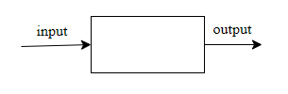

1. **Data flow**



1. **Process or Bubble**

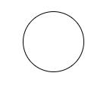

1. **Data store**



* **DFD diagram on Flipkart –**

1. 0th Level Diagram →

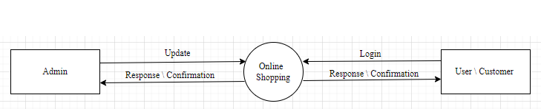

1. 1st Level Diagram →

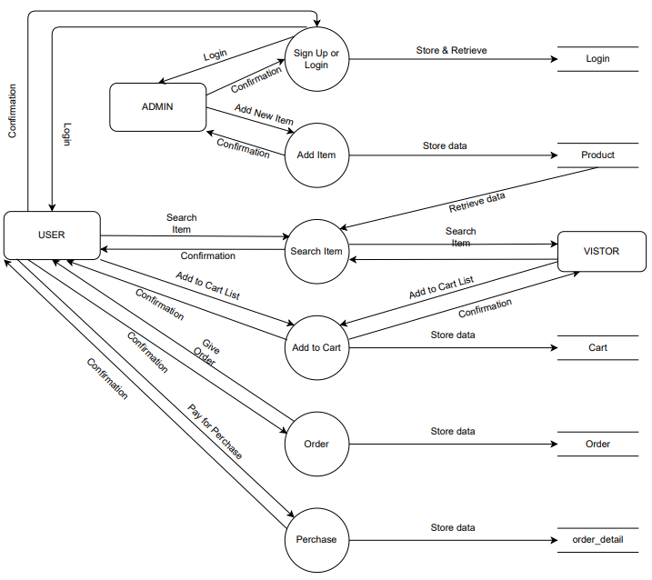

* **What is Flow chart? Create a flowchart to make addition of two numbers.**
* **Flow Chart –**

1. A flowchart is a picture of the separate steps of a process in sequential order.
2. Component of FLOW Chart –
3. START / END –

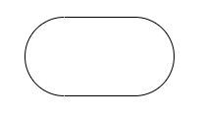

1. ARROW –



1. IN/OUT –

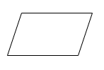

1. PROCESS –

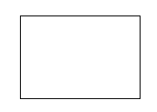

1. DECISION –



* **A flowchart to make addition of two numbers –**

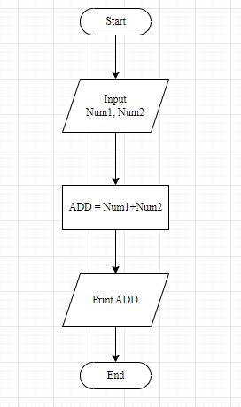

* **What is Use case Diagram? Create a use-case on bill payment on Paytm**.
* **Use case Diagram –**

1. Describe the high-level functions and scope of a system.
2. Interactions b/w the system and its actors.
3. Components of Use Case Diagram –
4. ACTOR –

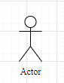

1. USE CASE –

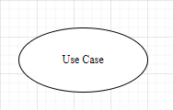

1. CONNECTOR –



1. STERO LINE –



1. GENERLIZAITION –



* **A use-case on bill payment on Paytm –**

