# **Parallelism 7**

## **Concurrency**

- The producer-consumer problem is a common problem in computer science.  
- The challenge is ensuring that the producer and consumer work together without wait or waste.

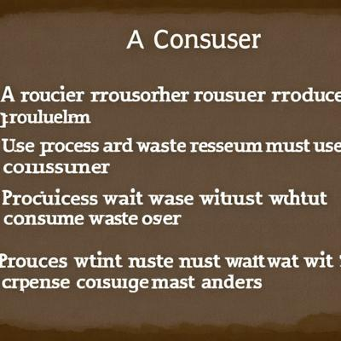

## **Multithreading**

1. Concurrency allows the producer and consumer to run independently, enabling them to work simultaneously, sometimes concurrently, or even in parallel.  
2. Producers produce items and place them in a buffer, while consumers consume items from the buffer.

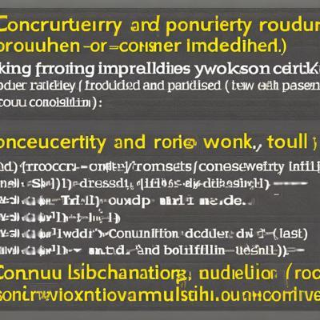

## **This text is about the process of creating a thread in a programming language.**

- Threads are like tiny, parallel workers within a computer program.  
- Threads allow programs to multitask and accomplish various operations concurrently.

