Synthetic Longitudinal Brain MRI Generation via a
Two-Generator Progressive GAN for Temporal Tumour Progression Modelling

1. Problem Statement
Tracking brain tumour progression over time requires paired MRI scans taken at a baseline visit and a later follow-up visit. These longitudinal datasets are critical for applying the RANO (Response Assessment in Neuro-Oncology) criteria, which classify treatment response as Complete Response, Partial Response, Stable Disease, or Progressive Disease. However, acquiring such paired datasets at scale is extremely difficult: scans are costly, patients drop out of studies, and strict privacy regulations limit data sharing. The resulting scarcity of paired data severely constrains the training of robust 3D tumour segmentation models and reliable RANO classifiers. This project addresses that gap by developing a system that synthetically generates anatomically consistent, temporally coherent baseline and follow-up MRI pairs, which can then augment real clinical datasets to improve downstream AI performance.

2. Literature Review
[1] Han et al. -- Combining Noise-to-Image and Image-to-Image GANs for Brain MR Image Augmentation for Tumor Detection (IEEE Access, 2019) [Paper Link]
This paper showed that sequentially combining a noise-to-image GAN (which generates new brain MRI volumes from random noise) with an image-to-image GAN (which refines or translates those volumes) produces richer and more realistic augmented datasets than either approach used alone. The combined pipeline raised tumour-detection sensitivity from 93.67% to 97.48%, establishing the conceptual foundation for the dual-generator design adopted in this project.
[2] Karras et al. -- Progressive Growing of GANs for Improved Quality, Stability, and Variation (ICLR 2018) [Paper Link]
PGGAN introduced a training curriculum in which both the generator and discriminator start at a very low spatial resolution (4x4) and gain new layers incrementally until reaching the target resolution. Each new layer is faded in smoothly via an alpha blending parameter, preventing the training instability that arises when attempting to generate high-resolution images from scratch. This progressive growing strategy forms the architectural backbone of the present work, enabling stable 3D volume synthesis up to 256 cubed voxels.
[3] Gulrajani et al. -- Improved Training of Wasserstein GANs (NeurIPS 2017) [Paper Link]
WGAN-GP replaced the weight-clipping mechanism of the original Wasserstein GAN with a gradient penalty term, softly enforcing the Lipschitz constraint on the discriminator. This yields significantly more stable training across a wide range of architectures and tasks. The present project adopts WGAN-GP with a gradient penalty coefficient of 10, as recommended in this paper, for both the baseline and follow-up discriminators.
[4] Cicek et al. / Ronneberger et al. -- 3D U-Net: Learning Dense Volumetric Segmentation from Sparse Annotation (MICCAI 2016) [Paper Link]
The 3D U-Net extended the original encoder-decoder architecture with skip connections into full volumetric convolutions, demonstrating that processing the entire 3D MRI volume at once substantially outperforms slice-by-slice approaches for brain tumour delineation. The downstream segmentation models used in this project (CoTrSeg, nnU-Net, DynUNet) are all direct descendants of this architecture.

3. Novelty
Existing GAN-based MRI augmentation methods generate a single scan at a time, either from noise or by translating between imaging modalities. None of them model the temporal relationship between a patient's baseline and follow-up scan as a jointly generated pair. This project introduces a dual-generator, dual-discriminator PGGAN architecture where both time points are synthesised together in a single forward pass:
- G_Baseline: Generates a 3D baseline T1ce volume from a sampled latent vector z, using standard progressive growing blocks.
- G_Followup: Generates the corresponding follow-up volume by conditioning on z together with multi-scale feature maps extracted from G_Baseline at every resolution stage. This hierarchical conditioning ensures the follow-up inherits both the global anatomy and fine-grained texture of the baseline.
- Combined loss: The follow-up generator is trained with a loss of the form: L = L_adv + L1 x L1 + L2 x SSIM. L1 penalises absolute pixel differences, while SSIM penalises perceptual and structural divergence, jointly enforcing that the generated pair looks like it belongs to the same patient.
This joint, temporally-conditioned generation inside a 3D progressive growing framework has not previously been demonstrated for longitudinal brain MRI. The figure below illustrates the full architecture. The synthetic pairs subsequently feed a 3D segmentation model and an XGBoost RANO classifier enriched with SMOTE-balanced radiomics features, forming a complete end-to-end pipeline.
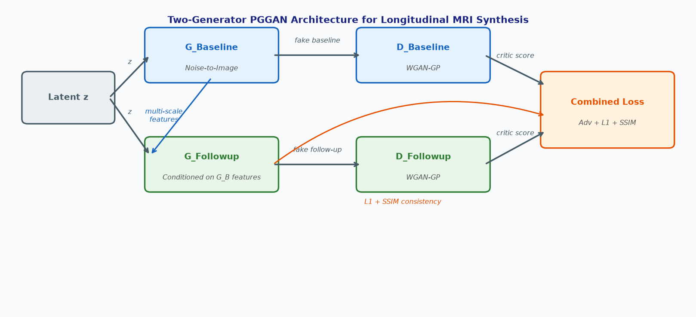
Figure 1: Two-Generator PGGAN architecture. G_Baseline and G_Followup share the same latent vector z; multi-scale features from G_Baseline condition G_Followup at every resolution stage. Both discriminators use WGAN-GP, and the combined loss enforces adversarial realism plus L1 and SSIM temporal consistency.

4. Work Done So Far
- Architecture: Dual generators and dual discriminators with 3D progressive growing blocks have been fully implemented and tested for volumes up to 256 cubed voxels.
- Training pipeline: The training loop implements WGAN-GP, the dual generator-discriminator update schedule, SSIM and L1 consistency losses, mixed-precision (AMP) training, multi-worker data loading with prefetching, and checkpoint saving with three-plane sample grids at configurable intervals.
- Dataset loader: A custom loader reads paired ten-channel MRI volumes, extracts the baseline and follow-up T1ce channels, normalises values to the range [-1, 1], and dynamically resizes each volume to match the current progressive-growing resolution stage.
- Configuration system: All hyperparameters are centralised in a single configuration object: resolution schedule (4 to 256), per-stage batch sizes, gradient penalty coefficient (10), Adam optimiser betas (0 and 0.99), learning rate (0.0015), and a total training budget of 1,500 k-images.
- Downstream pipeline: The post-GAN stages covering synthetic pair generation, 3D tumour segmentation training, and XGBoost-based RANO classification with SMOTE-balanced radiomics features have been fully designed and are currently being implemented.

