AMSecBench
AI-Native Security for Additive Manufacturing: Can Large Language and Vision-Language Models Detect Toolpath Sabotage — and Can They Defeat Design Obfuscation?
Research Proposal
Harsh Vardhan Gupta (proposer) · Prof. Nikhil Gupta, FASM · Prof. Ramesh Karri
NYU Tandon School of Engineering / NYU Center for Cybersecurity
August 2026 · Code: github.com/Harshelite2503/amsecbench

Abstract
Additive manufacturing (AM) is a cyber-physical process: a design file becomes a toolpath (G-code) becomes a part, and every hop is a place where an attacker can degrade the part without changing how it looks. The AM-security literature — including the Proc. IEEE survey by Gupta, Karri and colleagues — established the attack taxonomy (internal voids, infill reduction, parameter manipulation, dimensional sabotage) and two defensive families: verification of the toolpath against the design, and design obfuscation so a stolen file prints the wrong part. Large language and vision-language models (LLMs/VLMs) have not been evaluated on either side of this problem. We propose AMSecBench, a fully synthetic, labelled benchmark with two tracks. Track A (defense) asks whether LLMs/VLMs can detect G-code sabotage, with and without a trusted reference, better than rule-based and classical-ML detectors. Track B (red team) asks whether LLMs/VLMs can defeat the design-based obfuscation schemes developed in the collaborating group by recovering the intended design from an obfuscated file. A working benchmark exists: 141 G-code files (45 clean incl. benign parameter variants, 96 attacked across 7 attack classes on 5 parts). Baselines already show the central difficulty: a reference-comparison detector catches 75–100% of attacks but falsely flags 33% of legitimate parameter variants, and reference-free ML reaches AUC 0.86 with a 38% false-positive rate. Outcomes are a benchmark paper at a security venue, a defense/attack findings paper, and a proposal-ready basis for NSF SaTC / DoD funding.

1. Problem Statement

1.1 The AM pipeline is attackable at every hop and the damage is invisible
A 3D-printed part is produced from a CAD/STL file through slicer software into G-code executed by the printer. Prior work (dr0wned, 2017; Gupta et al., 2020; Rossel et al., USENIX Security 2025) has shown that small edits to the G-code — removing a few millimetres of extrusion to create a void, reducing infill in a band of layers, lowering nozzle temperature for a few layers — yield parts that pass visual inspection and fail in service. Distributed and outsourced printing widens the attack surface: the file leaves the designer’s control.

1.2 Existing detectors are brittle
Verification approaches compare the toolpath to the design or to a trusted reference. They work when the reference and the suspect were produced with identical settings, but legitimate operators change infill, layer height, temperature and speed routinely; a naive comparison flags those changes as attacks. Reference-free anomaly detectors must instead generalise across geometries they have never seen. Neither approach reasons about intent — whether a change is a plausible operator choice or a degradation.

1.3 Obfuscation defenses have never faced an AI adversary
Design-based security (Chen & Gupta; NYU) embeds decoy features and parameter-gated ‘key’ features so a stolen STL prints a wrong or failed part unless the process recipe is known. These schemes were evaluated against human reverse engineers and conventional tooling. Multimodal LLMs can now read STL geometry, renders and G-code, and reason about mechanical function; whether they can identify and strip decoys is unknown — and directly determines whether these defenses remain valid.

1.4 LLMs are entering manufacturing workflows without a security evaluation
LLM assistants are being integrated into slicers, print-farm management and CAD tools. There is no benchmark that measures their value as a detector or their threat as an attacker in AM. Both the defensive community and the roadmap literature (Advanced Intelligent Systems 2026) identify this as an open problem.

2. Objectives
- O1 — Benchmark: an open, synthetic, reproducible dataset of clean, benign-variant and sabotaged G-code with ground-truth labels and attack metadata, plus rendered toolpath images.
- O2 — Defense evaluation: measure LLM (text) and VLM (image) detection accuracy, false-positive rate on benign variants, attack-class attribution and calibration, with and without a trusted reference, against rule and ML baselines.
- O3 — Red-team evaluation: implement the group’s obfuscation schemes on benchmark parts and measure whether LLMs/VLMs recover the intended design (IoU) and identify parameter-gated features.
- O4 — Hardening: use red-team results to propose obfuscation variants that resist multimodal AI, and LLM-in-the-loop detection that reasons about operator intent.
- O5 — Real-slicer validation: reproduce the key results on PrusaSlicer/Cura output and, where available, on printed specimens from the collaborating lab.

3. Background and Related Work
AM security surveys: Gupta, Karri et al. (Proc. IEEE 2020) taxonomise threats and countermeasures including obfuscation and embedded security features. Attack studies: dr0wned (Belikovetsky et al. 2017) demonstrated void-sabotage of a drone propeller; Rossel et al. (USENIX Security 2025) analysed malicious G-code at scale across slicers. Detection: probabilistic anomaly models on printer telemetry (Yoginath et al. 2022), power side-channels (PowerGuard 2024), design-vs-toolpath verification (Mahmood et al. 2025), hardware firewalls (Firewall3D 2026). Design-based security: Chen (PhD, NYU 2019, advised by N. Gupta) — embedded tracking codes and parameter-gated features. AI in AM: roadmap papers call for LLM/VLM quality assurance but no security benchmark exists.

4. Approach

4.1 Track A — sabotage detection benchmark
Component | Design | Status
Parts | 5 parametric parts: block, bracket with holes, thin-wall tube, ASTM-style dog-bone, grid plate (generated, no downloads) | Done
Slicer | Minimal inspectable FDM slicer (perimeters + rectilinear infill, absolute E) so every attack has a known effect | Done
Attacks | infill reduction, void insertion (segment-split), layer-height change, mid-print temperature drop, 3% XY scaling, under-extrusion band, infill toolpath jitter | Done
Benign variants | 8 legitimate parameter changes per part (infill 0.2/0.4, layer 0.15/0.25, temp 200/220, speed 30/60) — detectors must not flag these | Done
Features / renders | 17 per-file features (layer statistics, extrusion-rate, infill ratio, temperature, bbox, jitter, travel-in-fill); PNG toolpath renders | Done
Baselines | Rule detector (reference comparison); logistic / random-forest / gradient-boosting, leave-one-part-out | Done
LLM / VLM detectors | Claude on per-layer summaries with reference; on raw G-code without reference; on rendered images | Code ready; runs pending

4.2 Track B — obfuscation red team
- Decoy features: extra bosses added to the intended design; the attacker must decide which features to remove.
- Parameter-gated keys: 0.25 mm ribs that only print with a specific nozzle profile and carry a load path.
- Adversary: LLM/VLM given STL statistics, multi-view renders and (optionally) the G-code, asked to output the intended design as a feature list / edit script; scored by volumetric IoU against ground truth and by whether keys are identified.
- Threat model: attacker has the file but not the process recipe; no physical access; this mirrors the design-theft scenario the defenses target.

4.3 Ethics and scope
All artefacts are synthetic and generated locally. No firmware, network or physical printer is targeted, and no exploit tooling against real systems is produced. Track B evaluates academic defenses published by the collaborating group, with their authors, which is standard practice for security research.

5. Preliminary Results
The Track A benchmark is built and two baseline families have been evaluated on 141 G-code files (45 clean/benign, 96 attacked; attacks that had no geometric effect, e.g. a void placed in a part with no infill, are excluded rather than mislabelled).
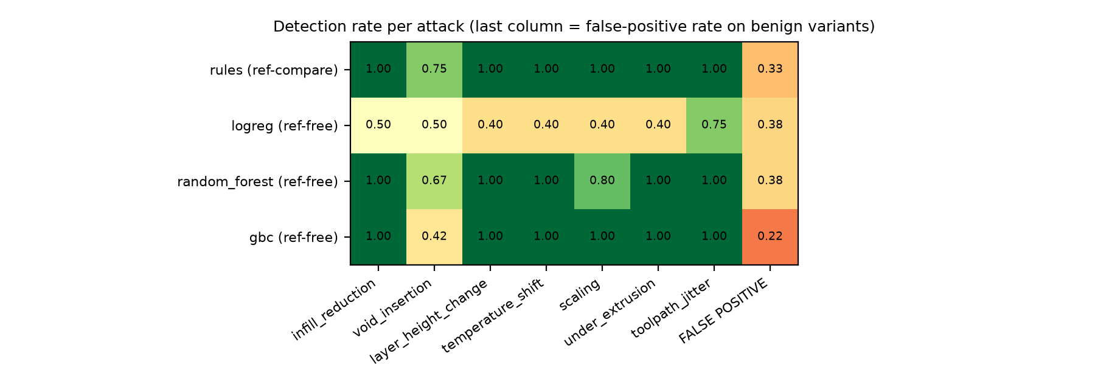
Figure 1. Detection rate per attack class for the baseline detectors; the last column is the false-positive rate on benign parameter variants.

5.1 Reference comparison is sensitive but not specific
The rule detector, which compares a suspect file with the trusted reference, detects infill reduction 100%, void insertion 75%, layer height change 100%, temperature shift 100%, scaling 100%, under extrusion 100%, toolpath jitter 100%. However it flags 33% of legitimate parameter variants as attacks — every layer-height and temperature change an operator might legitimately make is indistinguishable from sabotage without reasoning about intent. This is the specificity problem that motivates an LLM-in-the-loop detector.

5.2 Reference-free ML generalises only partially to unseen parts
Model | AUC | F1 | False-positive rate
logreg | 0.667 | 0.57 | 0.38
random_forest | 0.857 | 0.881 | 0.38
gbc | 0.825 | 0.913 | 0.22

Under leave-one-part-out evaluation (the model never sees the test geometry), the best model reaches AUC 0.86 but still mislabels 38% of benign files. Void insertion and infill reduction are the hardest classes because their signature is local (a few layers) while the features are global. These are exactly the cases where a model that can read the per-layer table and reason about where the change occurred should help.

5.3 Engineering findings
- A void attack must split toolpath segments at the void boundary; naïve endpoint deletion is a no-op on edge-to-edge infill lines — a subtlety that likely affects earlier synthetic studies.
- Per-layer features are required to see small voids; whole-file ratios dilute them below the benign-variation noise floor (benign variants move the travel-in-fill feature by ≤0.024, real voids by 0.05–0.32).
- Thin-wall parts carry no infill, so void/infill attacks are inapplicable — the benchmark records this rather than mislabelling.
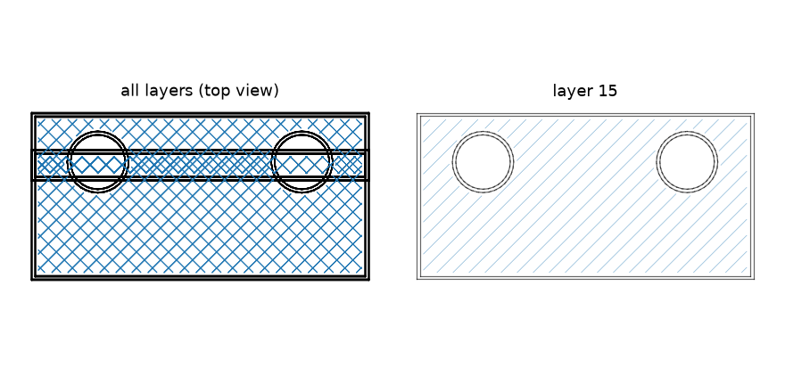
Figure 2. Rendered toolpath of the bracket with an inserted void (right: the affected layer).

6. Work Plan
Phase | Weeks | Activities | Deliverable
1. LLM/VLM detection | 1–3 | Run Claude detectors (summary+reference, raw no-reference, image); calibration; attribution accuracy; cost | Track A results
2. Real-slicer port | 3–5 | Regenerate attacks on PrusaSlicer/Cura G-code; confirm findings transfer | Benchmark v1.0
3. Obfuscation red team | 4–8 | Implement Chen–Gupta schemes on benchmark parts; LLM/VLM de-obfuscation; IoU scoring; hardening variants | Track B results
4. Physical validation | 6–10 | Print a subset (clean vs sabotaged) in the Gupta lab; µCT/mechanical test to confirm attack effect | Validation data
5. Writing / proposal | 8–12 | Benchmark + findings papers; NSF SaTC / DoD white paper | Submissions

7. Expected Outputs
Output | Venue options | Contribution
Benchmark + detection paper | USENIX Security / IEEE S&P (dataset & benchmark track); ACSAC; Additive Manufacturing | First LLM/VLM evaluation for AM sabotage detection with benign-variant false-positive analysis
Red-team paper | IEEE S&P / CCS workshops (CPS-SPC); Journal of Manufacturing Systems | Whether design obfuscation survives multimodal AI; hardened variants
Open benchmark + code | GitHub + Zenodo | Reusable, extendable to other AM processes
Funding proposal | NSF SaTC, DoD/ARL manufacturing security, NYU CCS seed | Both PIs have track record; benchmark provides preliminary data

8. Resources and Budget
Item | Estimate
LLM/VLM detection runs (Track A, ~150 files × 3 modes) | ≈ US$50–100
Red-team runs (Track B, 10 parts × 2 schemes × repeats) | ≈ US$30–60
Printing + testing of validation specimens | Gupta lab consumables; µCT time
Compute | Laptop-scale

9. Roles
- Harsh Vardhan Gupta: benchmark engineering, attack/detector implementation, LLM/VLM experiments, analysis, drafting.
- Prof. Nikhil Gupta: AM process and materials expertise, obfuscation schemes, physical validation, co-authorship.
- Prof. Ramesh Karri: threat modelling, security-venue framing, red-team methodology, co-authorship and funding strategy.

10. Risks and Mitigations
Risk | Mitigation
Synthetic slicer differs from real slicers | Phase 2 port to PrusaSlicer/Cura; attacks operate on G-code so they transfer
LLM cost / context limits on raw G-code | Per-layer summary mode; chunked windows; Message Batches
Dual-use concern in Track B | Synthetic parts only; academic defenses evaluated with their authors; no real-system exploitation; responsible disclosure norms
Small part library | Parametric generator scales to hundreds of parts; add open-source functional parts

References
- Gupta N., Karri R. et al. A survey of cybersecurity of digital manufacturing. Proceedings of the IEEE, 2020.
- Chen F. Design-based security strategies for the additive manufacturing cyber-physical systems. PhD thesis, NYU, 2019.
- Belikovetsky S. et al. dr0wned — cyber-physical attack with additive manufacturing. USENIX WOOT, 2017.
- Rossel J. et al. Security implications of malicious G-codes in 3D printing. USENIX Security, 2025.
- Yoginath S. et al. Stealthy cyber anomaly detection on large noisy multi-material 3D printer datasets. ACM AMSec, 2022.
- Mahmood M.A. et al. A novel framework for identification of cyber-physical attacks in additive manufacturing. Progress in Additive Manufacturing, 2025.
- Asgar S.A.G., Reddy N. Firewall3D: a hardware firewall for defending 3D printers against firmware attacks. arXiv, 2026.
- Zolfagharian A. et al. Roadmap on artificial intelligence-augmented additive manufacturing. Advanced Intelligent Systems, 2026.
- Gupta N., Beckwith C. Architected Metamaterials: Design Principles and Properties. Springer, 2025.

