System Requirements Statement (SRS) –

E-Raktkanika

* **1.** **Introduction 3**
* **2.** **Functional Requirements 4**
* 2.1 Receiver Module 5
* 2.2 Blood Bank Module 9
* 2.3 Organization Module 12
* 2.4 Admin Module 15
* 2.5 Use Case Diagram 17
* **Introduction**

This document explains the system requirements and scope for developing E-Raktkanika System.

E-Raktkanika System could be divided into the four main parts, Receiver part, Blood Bank part, Organisation part and the Administrator part.

* **Functional Requirements**

The E-Raktkanika System has four modules which are divided in processes described as below.

|  |  |  |
| --- | --- | --- |
| **No** | **BRS requirement ID** | **Description** |
| **2.1** | **Receiver Module** | |
| **2.1.1** | **F1** | **Determining type of Receiver** |
| **2.1.2** | **F2** | **Registration Process for Hospitals** |
| **2.1.3** | **F3** | **Login** |
| **2.1.4** | **F4** | **Blood Bank searching Process** |
| **2.1.5** | **F5** | **Contacting Blood Bank process** |
| **2.1.6** | **F6** | **Updating or removing the profile** |
| **2.2** | **Blood Bank Module** | |
| **2.2.1** | **F7** | **Registration Process** |
| **2.2.2** | **F8** | **Login Process** |
| **2.2.3** | **F9** | **Updating or removing the profile** |
| **2.2.4** | **F10** | **Maintaining the Blood Reserves Info** |
| **2.2.5** | **F11** | **Approval of blood receiver’s request** |
| **2.3 Organisation Module** | | |
| **2.3.1** | **F12** | **Registration process** |
| **2.3.2** | **F13** | **Login process** |
| **2.3.3** | **F14** | **Form filling and sending request for organizing camp** |
| **2.3.4** | **F15** | **Advertisement uploading process** |
| **2.3.5** | **F16** | **Remove profile** |
| **2.4 Administrator Module** | | |
| **2.4.1** | **F17** | **Login process** |
| **2.4.2** | **F18** | **Approve Hospitals** |
| **2.4.3** | **F19** | **Approve Blood Banks** |
| **2.4.4** | **F20** | **Approve Blood Donation Camp** |
| **2.4.5** | **F21** | **Remove Hospitals** |
| **2.4.6** | **F22** | **Remove Blood Bank** |
| **2.4.7** | **F23** | **Remove Organization** |
| **2.4.8** | **F24** | **Post Advertisement on website** |

* 1. **Receiver Module**
* Receiver is the user of system who is in need of particular type and quantity of blood.
  + 1. **Determining type of Receiver**
* E-Raktkanika system should compel the receivers (Either individual person or Registered Hospitals) to define their type before allowing them to continue further with the required blood group searching process.
* Any one type should be selected from below two

1. Individual user
2. Registered Hospital
   * 1. **Registration process for Hospitals**

* E-Raktkanika system compels unregistered Hospitals to register before they could successfully able to use the provided portal functionalities. At the time of registration, it is compulsory for respective oHospitalsHospitals to provide data for below entries.

1. Hospital Name
2. Login ID
3. Password
4. Address
5. Contact Number
6. License no./Registration no.
7. Email ID

* All fields are compulsory demanded
* Hospital Name

This field will take hospital name as input.

* Login ID

Hospitals should be provided with system generated Login ID after registering on the E-Raktkanika system successfully.

* Password

The Password has constraints which makes the Password consists of more than or equal 8 and less than or equal 16 characteristics including characters described as below.

* + - Numeric figure (at least one)
    - Capital alphabet (A-Z) (at least one)
    - Small alphabet (a-z) (at least one)
    - Special character (#, $, %, &, etc.) (at least one)
    - The Password is masked by dummy characters.
* Address

This field should take Hospital address which will include data like area, city, Pin code.

* Contact Number

This field should take Contact number of hospital

* Registration no.

This field should take Registration number of hospital which will be used to authenticate identity of hospital.

* Email ID

This field should take Email address of Hospital.

**2.1.3 Login**

* If the Receiver is registered hospital, then they should use email and password to Login to the portal.
* E-Raktkanika system should authenticate the entered credentials data before allowing the registered hospital to continue using the further functionalities provided by the system.
  + 1. **Blood Bank Searching process**
* E-Raktkanika system should display the Blood Bank directory to the receiver which should have data about the following fields.

1. Blood bank name
2. Area
3. Blood group
4. Reserves availability

* Blood bank name

This field should display the name of blood bank.

* Area

This field should display the area where blood bank is located.

* Blood Group

This field should display type of blood groups available in the blood bank.

* Reserves availability

This field should display the units of respective blood group

* E-Raktkainka system should provide the functionality so that viewer of this data could apply searching criteria / Filter based on location/Blood group. E-Raktkanika system should be able to redisplay the data with criteria applied by the viewer
* Individual user type of receiver should be compelled to fill the form having the below mentioned fields before they could actually see the blood bank related data.

1. User Name
2. Email ID
3. Age
4. Preferred area
5. Blood Group
6. Contact Number
7. Aadhar No.

* All fields are compulsory demanded.
* User Name

This field should take User name as input.

* Email ID

This field should take Email address of Individual user.

* Age

This field should take age of user.

* Preferred Area

This field should take name of area for displaying blood banks within that area.

* Blood Group

This field should specify type of blood group receiver is looking for.

* Contact Number

This field should take Contact number of user

* Aadhar no.

This field should take Aadhar Card number of user that should be used to authenticate identity of user by the admin.

* E-Raktkanika system should now display the Blood Bank directory data to the individual user based on the entries filled in the above mentioned fields.
  + 1. **Contacting Blood Bank**
* E-Raktkanika system should display the contact details of respective Blood Banks once the request posted by the Receiver (of any one type) is approved by the corresponding Blood Banks.
  + 1. **Updating / Removing the profile**
* E-Raktkanika system should allow the respective logged in user to update their information about the below mentioned field.

1. Contact details (For both Individual user and Hospital)

* E-Raktkanika system should allow the particular logged in Hospital to remove/delete their profile from the system.

* 1. **Blood Bank Module**

Blood Bank is the user of system who should take a call on approval of receiver’s request and fulfil need of particular type and quantity of blood posted by receiver.

* + 1. **Registration process**
* E-Raktkanika should compulsorily register the Blood Bank who wish to use to the system. To perform this task, system should collect the information about following fields.

1. Blood bank ID
2. Blood Bank name
3. Address
4. Contact Number
5. Email ID
6. Password
7. Registration number
8. Blood group type
9. Available quantity (units)

* All fields are compulsory demanded.
* Blood Bank ID

This ID should be unique and it would be useful for identifying blood banks uniquely.

* Blood Bank Name

This field should take blood bank name as input

* Address

This field should take Blood Bank address which includes data of fields such as area, city, pin code.

* Contact Number

This field should take Contact number of Blood bank.

* Email ID

This field should take Email address of Blood Bank

* Password

The Password has constraints which makes the Password consists of more than or equal 8 and less than or equal 16 characteristics including characters described as below.

* Numeric figure (at least one)
* Capital alphabet (A-Z) (at least one)
* Small alphabet (a-z) (at least one)
* Special character (#, $, %, &, etc.) (at least one)
* The Password is masked by dummy characters.
* Registration no.

This field should take Registration number of Blood Bank which should be used to authenticate identity of hospital.

* Blood group type

This field should provide multiple input lines for inserting all available blood group types in the blood bank.

* Available quantity

This field should take input as the quantity of stocks/units for respective blood group available in the blood bank.

* + 1. **Login Process**
* If the Blood Bank is registered, then they should use email and password to Login to the portal.
* E-Raktkanika system should authenticate the entered credentials data before allowing the registered Blood Bank to continue using the further functionalities provided by the system.
  + 1. **Updating / Removing the profile**
* E-Raktkanika system should allow the respective logged in Blood Bank to update their information about the below mentioned fields.

1. Contact details
2. Blood Reserves stock/Available quantity of blood group

* E-Raktkanika system should allow the particular logged in Blood Bank to remove/delete their profile from the system.
  + 1. **Maintaining the blood reserves info**
* After successfully logging into the portal, Blood Banks should be allowed to maintain their blood reserves data by updating the available quantity of blood groups.
* Blood Banks should able to see the data about below fields.

1. Blood Bank ID
2. Blood Bank name
3. Blood group type
4. Available quantity

* Out of above fields, Blood Banks should be allowed to update the information about available quantity of each blood group.
* E-Raktkanika system should be able to reflect the updated changes of Blood Banks at the time of displaying blood bank’s data.
  + 1. **Approval of Blood Receiver’s requests**
* After logging into the portal successfully, E-Raktkainka system should have provision for Blood Banks to be able to see all the approval requests posted by the

receiver (Either individual user or Registered Hospitals).

* Blood Banks then should be given authority by the system to take a call on which requests should be approved or declined.
* According to the decision taken by Blood Banks, E-Raktkanika system should then take further steps to inform the respective receiver.
  1. **Organisation Module**

Organisation is the user of system who would make collaboration request to blood banks for blood donation camp.

* + 1. **Registration process**
* E-Raktkanika should compulsorily register the Organizations who wish to use to the system. To perform this task, system should collect the information about following fields.

1. Name of the organization
2. Type: Certified/Private
3. Email ID
4. Contact No.
5. Address
6. Password

* Name of Organization

This field should take organizing party’s name who want to arrange the camp.

* Type: Certified/Private/NGO

This field should take the type of organization as input.

* Email

This field should take Email address of Organisation.

* Contact Number

This field should take Contact number of organization.

* Address

This field should take Organization’s address which includes data of fields such as area, city, pin code.

* Password

The Password has constraints which makes the Password consists of more than or equal 8 and less than or equal 16 characteristics including characters described as below.

* Numeric figure (at least one)
* Capital alphabet (A-Z) (at least one)
* Small alphabet (a-z) (at least one)
* Special character (#, $, %, &, etc.) (at least one)
* The Password is masked by dummy characters.
  + 1. **Login Process**
* If the Organization is registered, then they should use email and password to Login to the portal.
* E-Raktkanika system should authenticate the entered credentials data before allowing the registered Organizations to continue using the further functionalities provided by the system.
  + 1. **Form Filling and sending request for organizing camp.**
* After logging in successfully, E-Raktkanika system should provide organization feature to create a request for arranging blood donation camp.
* Organizations should be made to fill below details in the form in order to successfully generate the request for blood donation camp.

1. Blood donation camp’s name
2. Location of Camp
3. Date
4. Time Slot
5. Estimated Participants
6. Selection of blood banks

* Blood donation Camp’s name

This field should take name of blood donation camp.

* Location of camp

This field should take location for camp.

* Date

This field should take Date for camp.

* Time Slot

This field should take time slots in hours for camp.

* Estimated Participants

This field should specify approximate number of participants for camp.

* Blood banks

This field should display the list of all blood banks, and from this list organization should be allowed to select maximum three numbers of blood banks for requesting collaboration.

* + 1. **Advertisement upload process**
* E-Raktkanika system should allow the respective organization to submit their camp details for advertisement purpose only after the requests created by organizations are approved.
  + 1. **Remove Profile**
* E-Raktkanika system should allow the particular logged in organization to remove/delete their profile from the system.
  1. **Administrator Module**

Admin is the user of system whose main function is to ensure the smooth working of system, authenticate Blood Banks and Hospitals, approve Blood donation camps, Remove Blood Bank/Hospitals entry.

* + 1. **Login Process**
* E-Raktkanika system should authenticate the entered credentials data before allowing the admin to continue using the further functionalities provided by the system.
  + 1. **Approve Hospitals**
* E-Raktkanika system should allow the admin to be able to see all the registered hospitals along with their details.
* Admin then should have the authority to either approve or decline the registered hospitals based on their data.
  + 1. **Approve Blood Banks**
* E-Raktkanika system should allow the admin to be able to see all the registered Blood Banks along with their details.
* Admin then should have the authority to either approve or decline the registered Blood Banks based on their data.
  + 1. **Approve Blood Donation Camps**
* E-Raktkanika system should allow the admin to be able to see all the registered organization along with their details.
* Admin then should have the authority to either approve or decline the blood donation camp requests.
* To be able to take call on approval of camps, admin should be provided with authority to connect with blood banks by E-Raktkanika system.
  + 1. **Remove Hospitals**
* E-Raktkanika system should allow the particular registered Hospital to remove/delete their profile from the system.
  + 1. **Remove Blood Banks**
* E-Raktkanika system should allow the particular registered Blood Banks to remove/delete their profile from the system.
  + 1. **Post Advertisement on website**
* E-Raktkanika system should provide the admin authority to be able to post the Blood donation camp advertisement on the portal.

**2.5 Use Case Diagrams**

Receiver: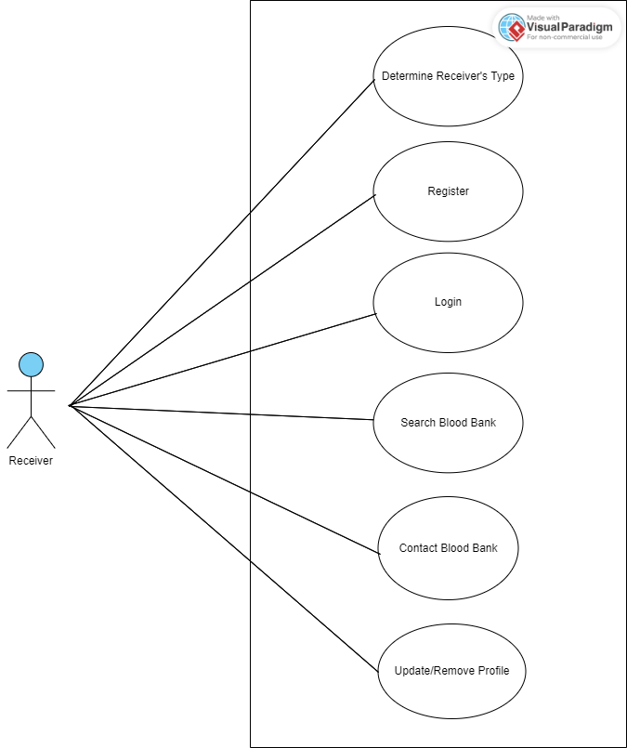

Blood Bank:

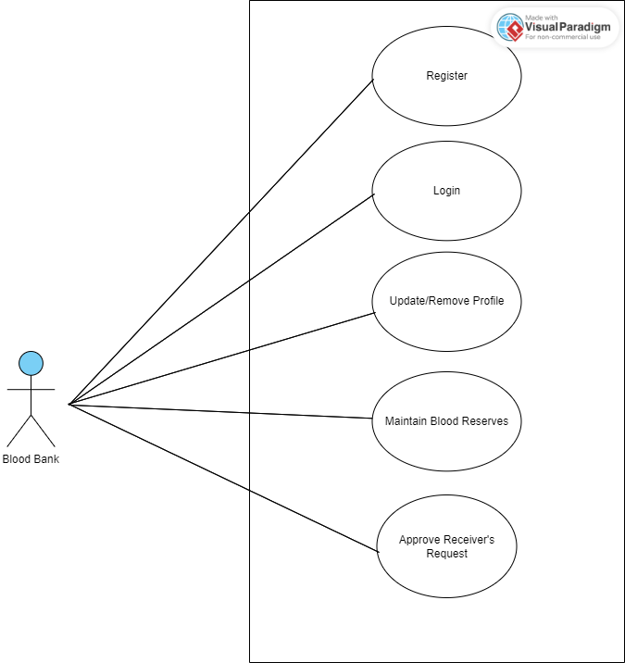

Organization:

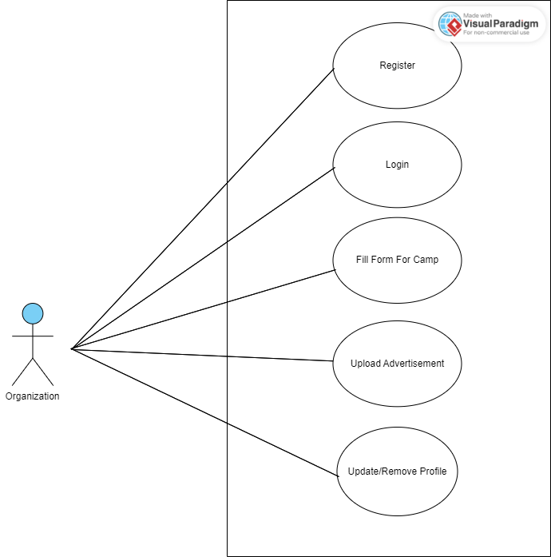

Administrator:

