OBJECT DETECTION AND MATCHING

Team Members

Likhitha Reddy (21R25A6702)

G. Harsh Vardhan (21R25A6703) Ashwanth Reddy(21R25A6701) Sharath Chandra(20R21A6712)

Submitted by

Under guidance of mr. Sreenivas

# CONTENTS

* Abstract
* Objective/Aim of the Project
* Requirement Analysis
* Packages
* Working Principle
* Working Block diagram
* Applications
* Conclusion

# ABSTRACT

This presentation considers the objective of efficient object detection and matching images. These objectives lead to the proposed classification scheme that classifies the extracted features in new images into object features and non-object features. It is shown out that this binary classification scheme has turned out to be an efficient tool that can be used for object detection and matching. This method considers the objective of accurate matching and robustness. Due to this classification, the matching process becomes more robust and faster. In this case robust object registration also becomes fast. It shows the advantages of using classification stage for object matching and registration using the quantitative evaluation. This approach can be used for real-time object tracking and detection.

# OBJECTIVE /AIM OF THE PROJECT

* Whenever we hear about ‘*Object Detection*’, machine learning along with different frameworks comes to our mind. But we can actually do object detection without using machine learning or any other frameworks by only using only PyCharm.
* Here we define a Reference image(object), and the system is going to find objects in the source image that matches the reference image we picked.

# REQUIREMENT ANALYSIS

HARDWARE REQUIREMENTS

* Laptop/PC
* Webcam/Camera module

SOFTWARE REQUIREMENTS

* PyCharm

PACKAGES USED

* OpenCV
* Numpy

# PACKAGES

OPEN CV

* OpenCV( Open-Source Computer Vision ) is a cross-platform library using which we can develop real-time computer vision applications.
* It mainly focuses on image processing.
* Analysis including features like face detection and object

detection.

* OpenCV features GPU acceleration for real-time operations.
* The library has more than 2500 optimized Machine Learning

algorithms.

* These Algorithms are used to recognize faces, identify objects recognize faces, identify object’s, find similar images from an image database.

NUMPY

* NumPy is a Python library used for working with arrays.
* It is the fundamental package for scientific computing in Python.
* It is also a library that provides a multidimensional array object

and various derived objects.

* It can perform mathematical, logical, shape manipulation, sorting, selecting, I/O, discrete Fourier transforms, basic linear algebra, basic statistical operations, random simulation and much more..
* At the core of the NumPy package, is the nd array object. This encapsulates n-dimensional arrays of homogeneous data types, with many operations being performed in compiled code for performance.

# WORKING PRINCIPLE

The Algorithms in OpenCv package will take the reference image and creates a key points in particular areas of image and will save those key points and descriptor(binary data) as shown below

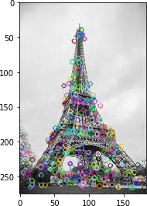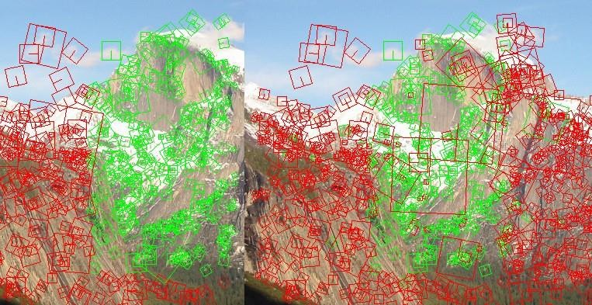

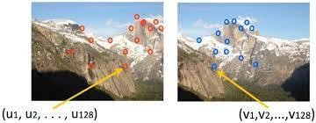

Later when we give input from webcam/camera module in the form of visual data. The algorithms will again create the key points for that image and try to match with the reference image key point’s.

If the key points match then it gives output feedback in the form of

classification of that image as we specified as shown below..

# WORKING BLOCK DIAGRAM

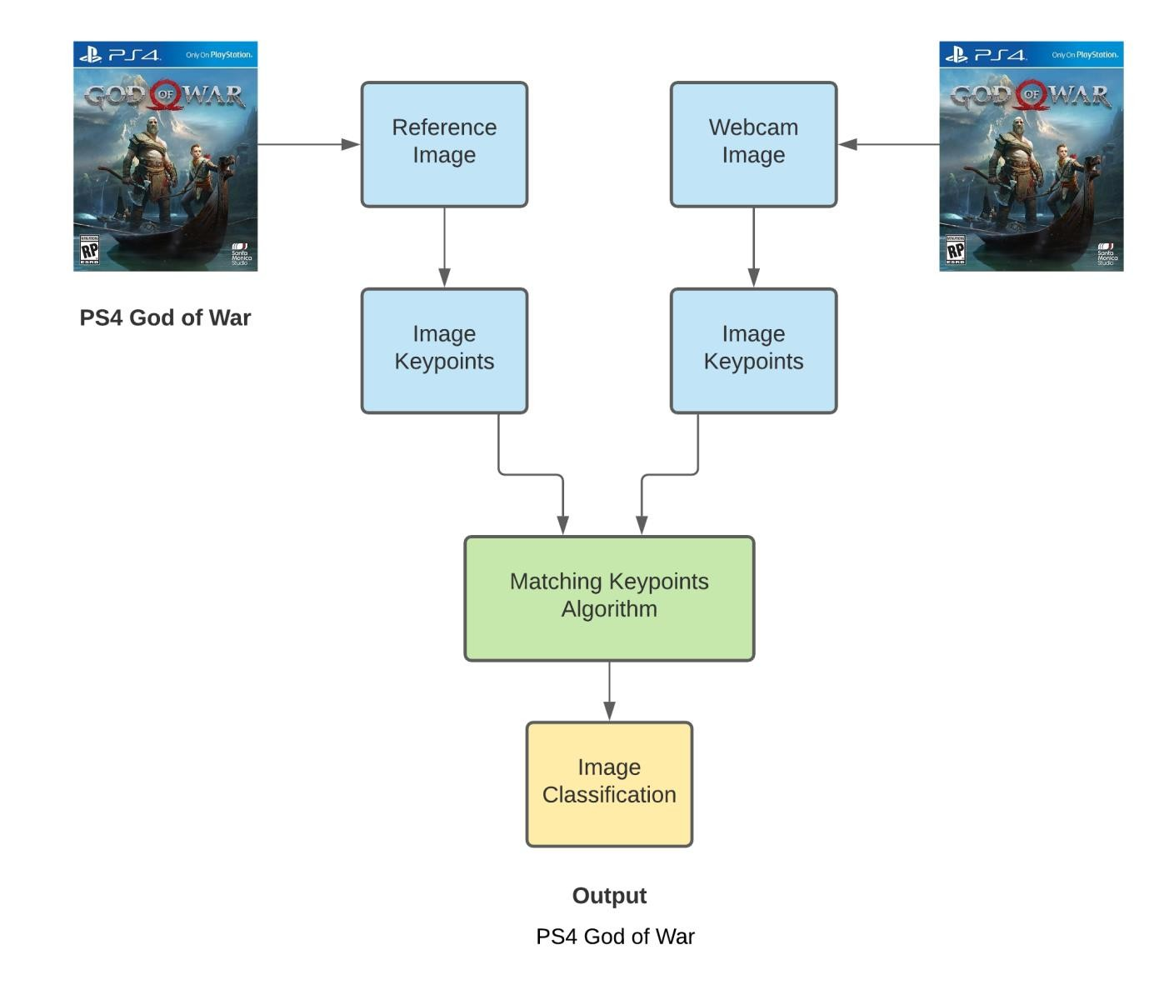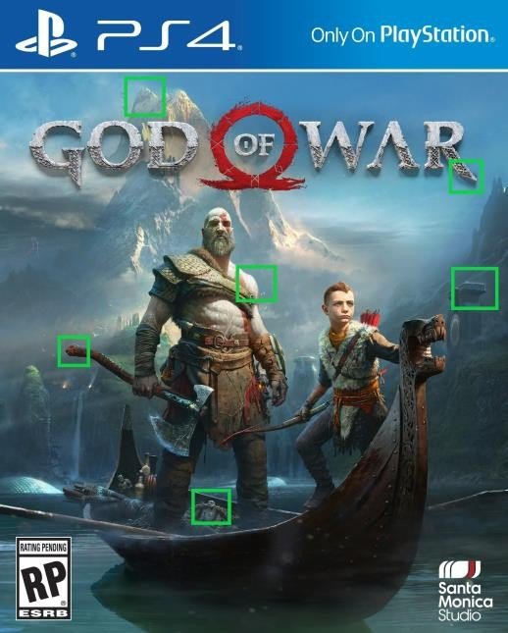

APPLICATIONS

* Object Detection.
* Reverse Image search on Internet.
* Counting the crowd.
* Self Driving Cars
* Tracking Objects.
* CCTV surveillance.
* Identity verification through Iris.
* Person Detection.
* Digital watermarking
* Ball tracking in Sports.
* Object Counting

# CONCLUSION

This approach for detecting and matching an object with an image will show the use of feature classification makes the whole process of matching and registration faster and more efficient.

THANK YOU