



Results :

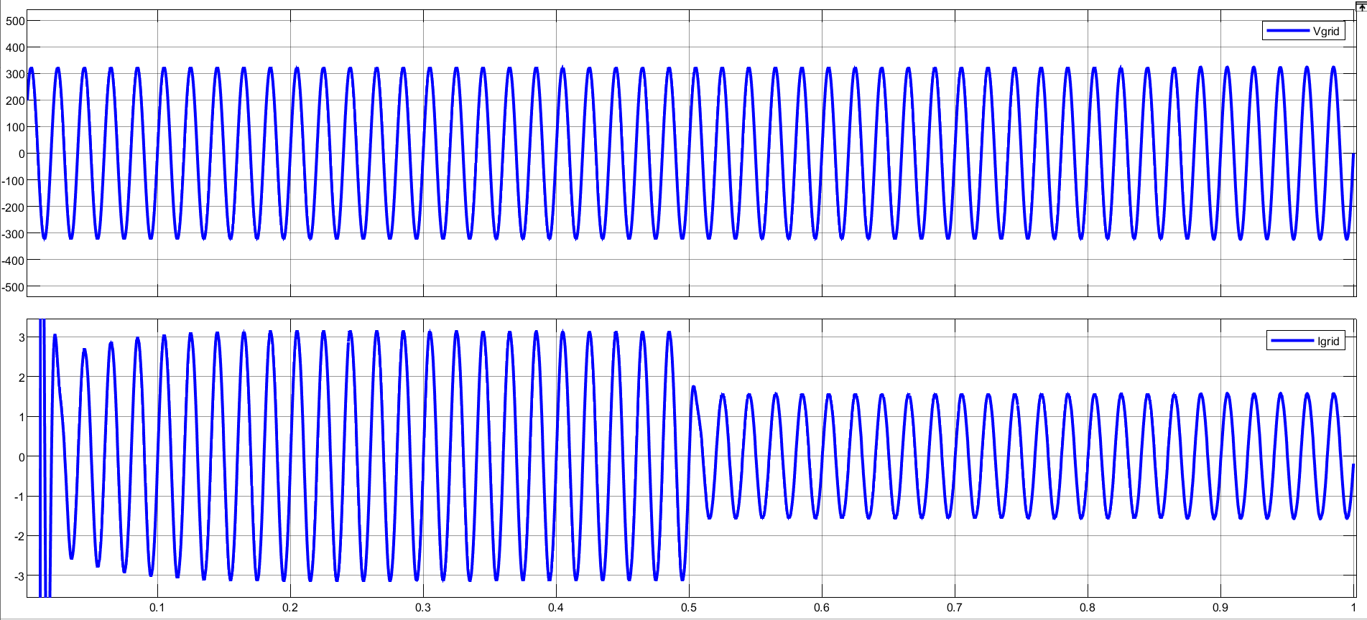

Figure 1 Vgrid and Igrid

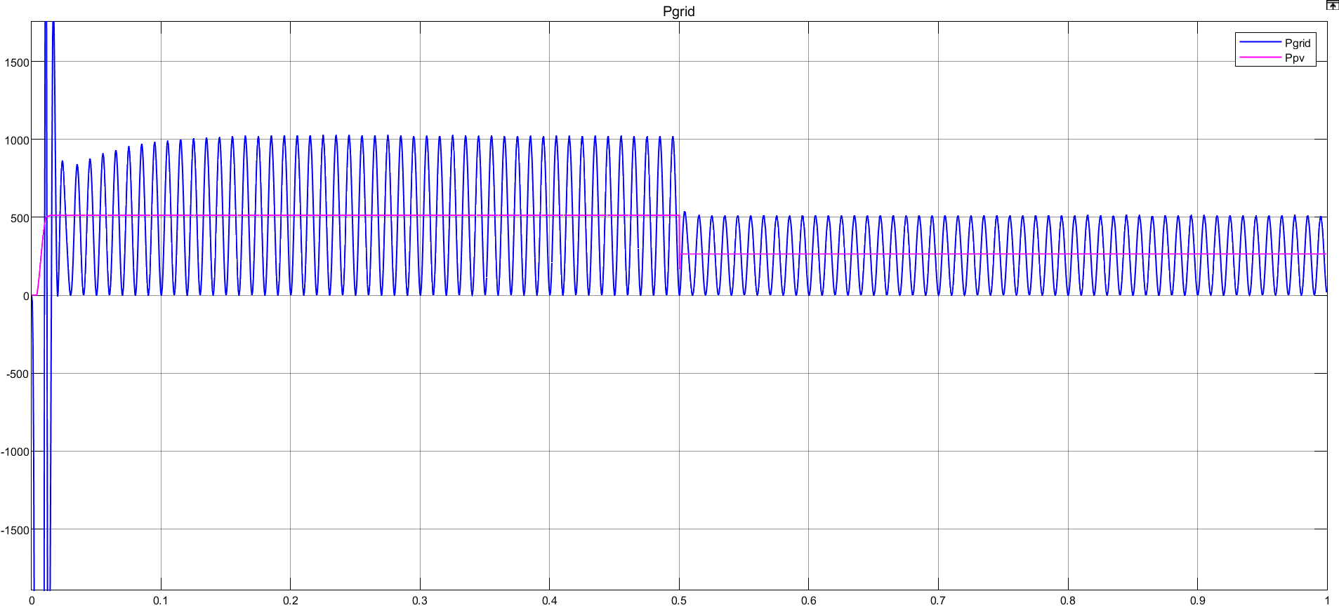

Figure 2 Ppv and Pgrid

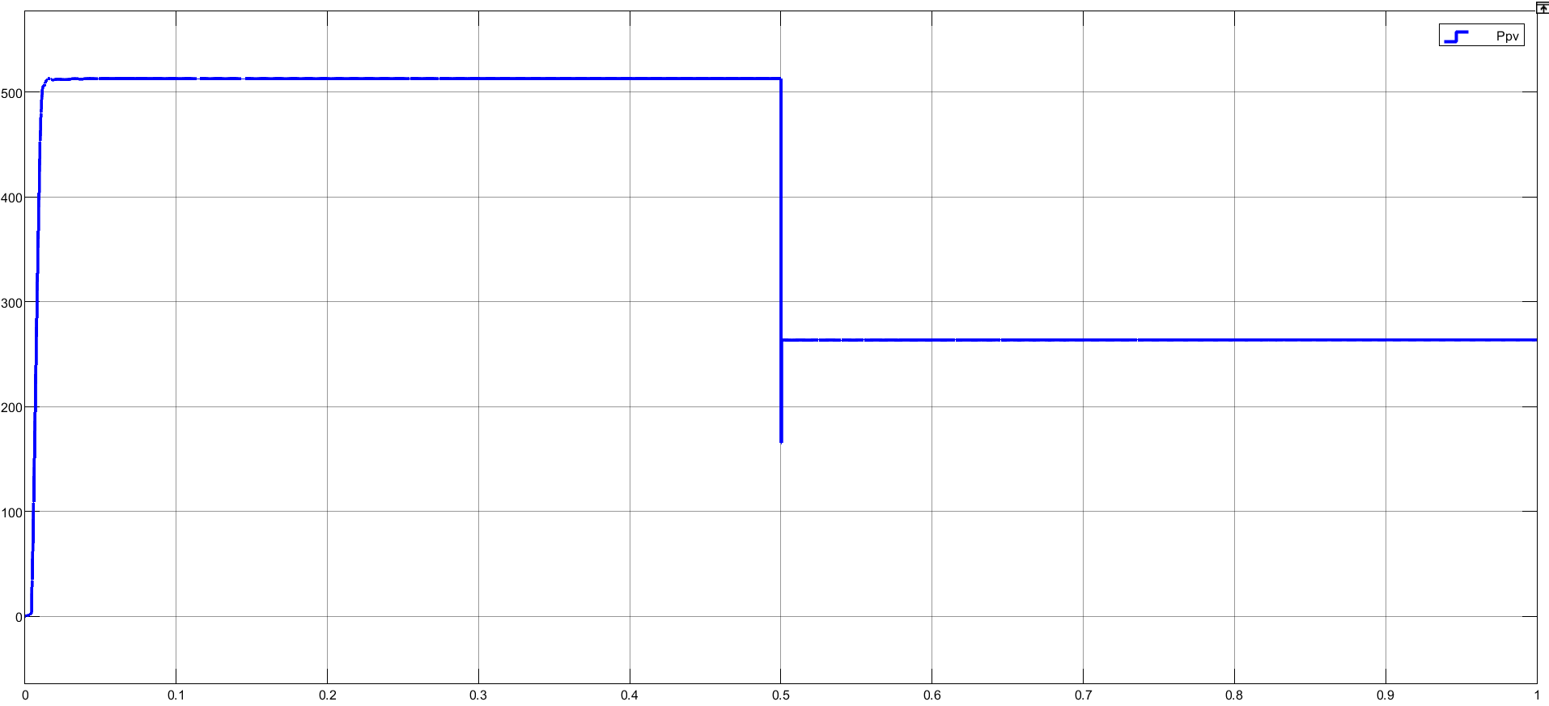

Figure 3 Ppv

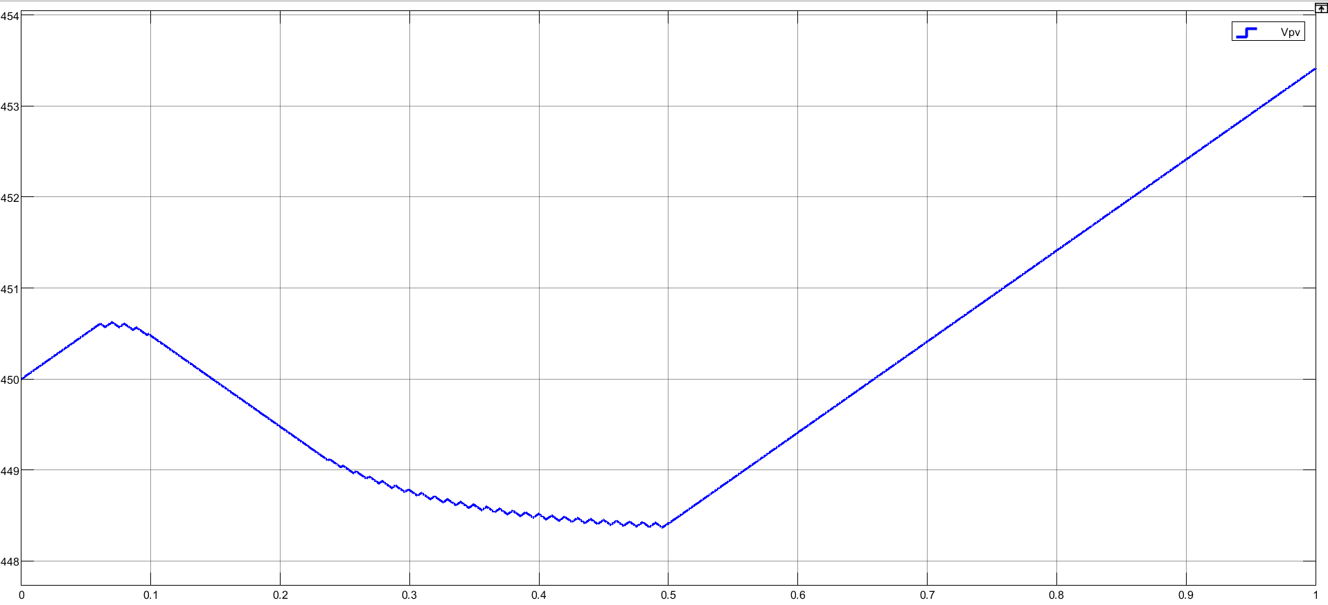

Figure 4 Vmpp



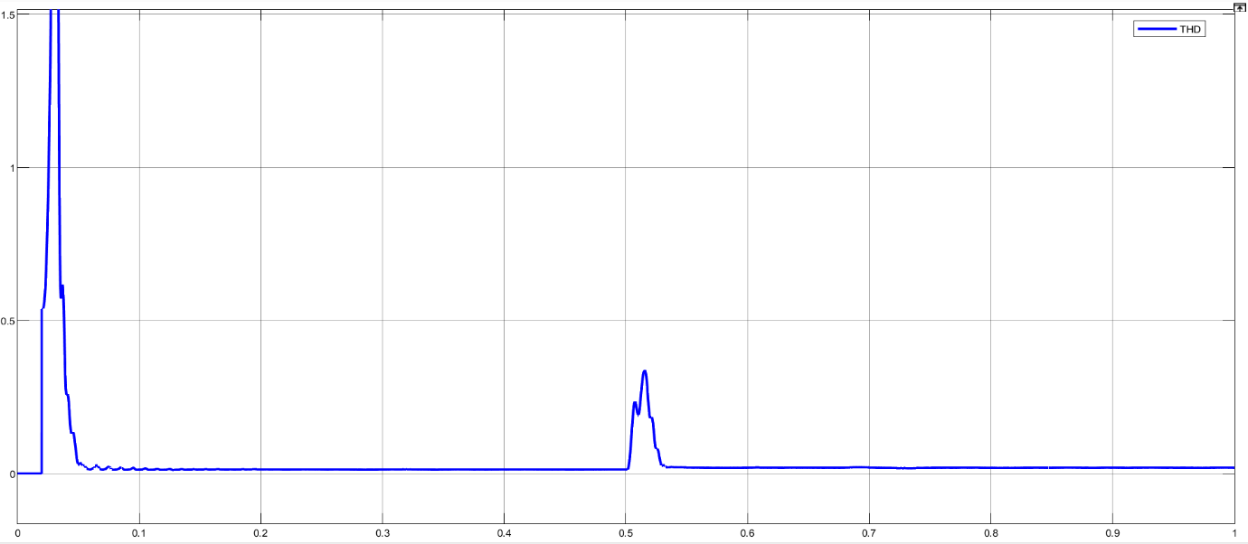 Figure 5 Irradiation

Figure 6 THD of Igrid