**Name: Harshitha T**

**OUTPUT - Screenshots**

**--------------------------------------------Part - A-------------------------------------------------**

OUTPUT:

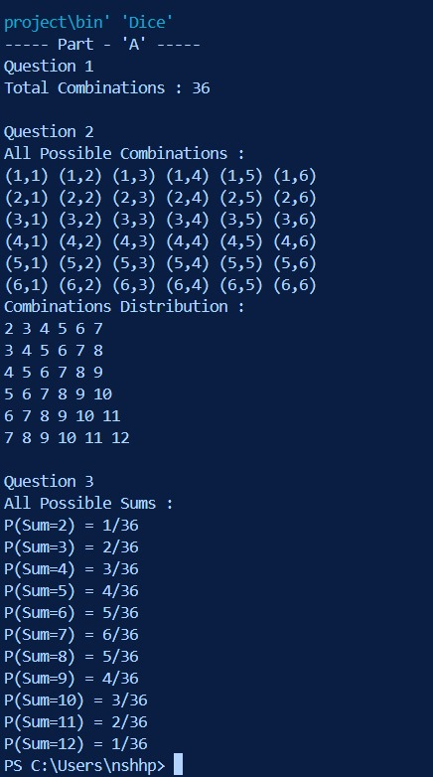

-----------------------------------------------**Part – B**----------------------------------------------------

OUTPUT:

