# Harshitha M

Superset id : 6390499

WEEK : 05

# Microservices for Account and Loan - Spring Boot

This document explains the steps to create two Spring Boot RESTful microservices: one for managing accounts and the other for handling loans. Each microservice is a separate Maven project with its own configuration and runs independently.

## 1. Folder Structure Setup

1. Create a folder with your employee ID in the D: drive.  
2. Inside that folder, create another folder named 'microservices'.  
3. This folder will contain all the microservice projects.

## 2. Account Microservice Setup

1. Open https://start.spring.io/ in a browser.  
2. Use the following inputs:  
 - Group: com.cognizant  
 - Artifact: account  
3. Add dependencies:  
 - Developer Tools > Spring Boot DevTools  
 - Web > Spring Web  
4. Generate and extract the ZIP file.  
5. Move the 'account' folder to 'microservices' directory.  
6. Open command prompt in the 'account' folder and run:  
 mvn clean package  
7. Import the project into Eclipse.  
8. Implement the following controller:

package com.cognizant.account.controller;  
  
import org.springframework.web.bind.annotation.GetMapping;  
import org.springframework.web.bind.annotation.PathVariable;  
import org.springframework.web.bind.annotation.RestController;  
import java.util.Map;  
  
@RestController  
public class AccountController {  
  
 @GetMapping("/accounts/{number}")  
 public Map<String, Object> getAccount(@PathVariable String number) {  
 return Map.of(  
 "number", number,  
 "type", "savings",  
 "balance", 234343  
 );  
 }}OUTPUT

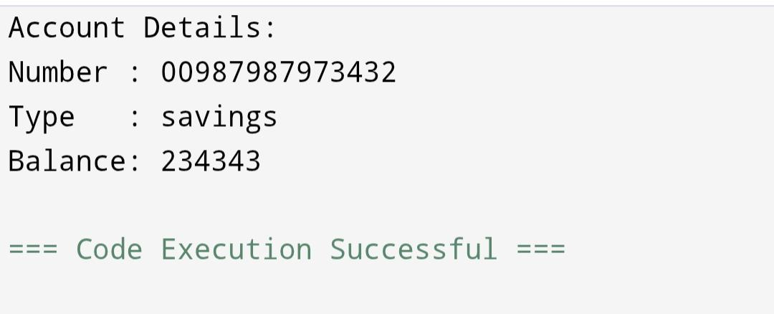

## 3. Loan Microservice Setup

Repeat the steps used for the account microservice with the following changes:  
1. Artifact: loan  
2. Move the 'loan' folder to 'microservices'.  
3. Open command prompt in the 'loan' folder and run:  
 mvn clean package  
4. Import into Eclipse and add the following controller:

package com.cognizant.loan.controller;  
  
import org.springframework.web.bind.annotation.GetMapping;  
import org.springframework.web.bind.annotation.PathVariable;  
import org.springframework.web.bind.annotation.RestController;  
import java.util.Map;  
  
@RestController  
public class LoanController {  
  
 @GetMapping("/loans/{number}")  
 public Map<String, Object> getLoan(@PathVariable String number) {  
 return Map.of(  
 "number", number,  
 "type", "car",  
 "loan", 400000,  
 "emi", 3258,  
 "tenure", 18  
 );  
 }  
}

OUTPUT

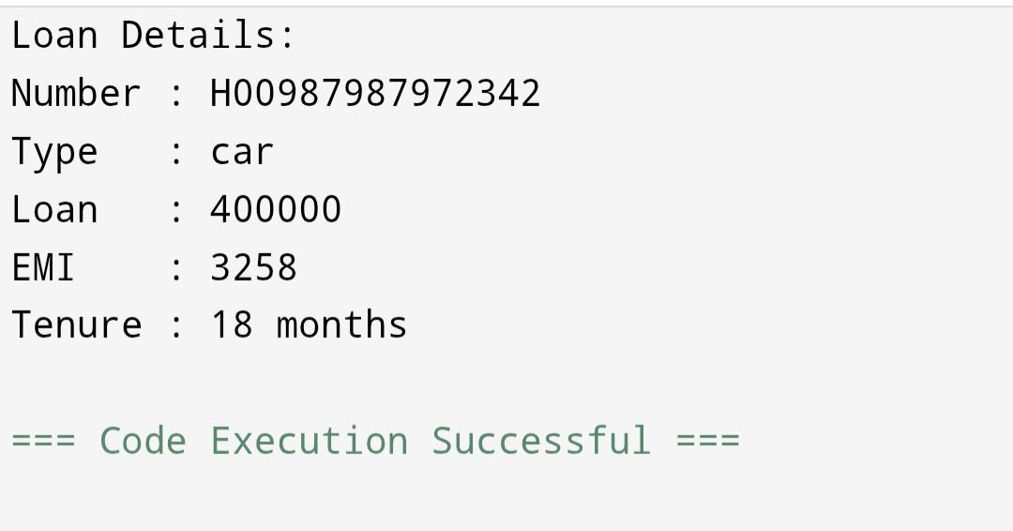

4. Port Configuration for Loan Microservice

To avoid port conflict (default is 8080), set a different port for the loan service:  
1. Open 'src/main/resources/application.properties'  
2. Add the following line:  
 server.port=8081  
3. Run the application and test the endpoints.