**Harshitha M**

**Superset id : 6390499**

**WEEK 3**

**Spring Core_Maven**

**Exercise 1: Configuring a Basic Spring Application**

Project Name: LibraryManagement

**STEP 1: pom.xml**

Place this file in the root of the project.

<?xml version="1.0" encoding="UTF-8"?>

<project xmlns="http://maven.apache.org/POM/4.0.0"

xmlns:xsi="http://www.w3.org/2001/XMLSchema-instance"

xsi:schemaLocation="http://maven.apache.org/POM/4.0.0

https://maven.apache.org/xsd/maven-4.0.0.xsd">

<modelVersion>4.0.0</modelVersion>

<groupId>com.library</groupId>

<artifactId>library-management</artifactId>

<version>1.0-SNAPSHOT</version>

<properties>

<maven.compiler.source>1.8</maven.compiler.source>

<maven.compiler.target>1.8</maven.compiler.target>

</properties>

<dependencies>

<dependency>

<groupId>org.springframework</groupId>

<artifactId>spring-context</artifactId>

<version>5.3.31</version>

</dependency>

<dependency>

<groupId>commons-logging</groupId>

<artifactId>commons-logging</artifactId>

<version>1.2</version>

</dependency>

</dependencies>

</project>

**STEP 2: applicationContext.xml**

Path: src/main/resources/applicationContext.xml

<?xml version="1.0" encoding="UTF-8"?>

<beans xmlns="http://www.springframework.org/schema/beans"

xmlns:xsi="http://www.w3.org/2001/XMLSchema-instance"

xsi:schemaLocation="

http://www.springframework.org/schema/beans

https://www.springframework.org/schema/beans/spring-beans.xsd">

<bean id="bookRepository" class="com.library.repository.BookRepository"/>

<bean id="bookService" class="com.library.service.BookService">

<property name="bookRepository" ref="bookRepository"/>

</bean>

</beans>

**STEP 3: BookRepository.java**

Path: src/main/java/com/library/repository/BookRepository.java

package com.library.repository;

public class BookRepository {

public void saveBook(String bookName) {

System.out.println("📚 Book saved to repository: " + bookName);

}

}

**STEP 4: BookService.java**

Path: src/main/java/com/library/service/BookService.java

package com.library.service;

import com.library.repository.BookRepository;

public class BookService {

private BookRepository bookRepository;

public void setBookRepository(BookRepository bookRepository) {

this.bookRepository = bookRepository;

}

public void addBook(String bookName) {

System.out.println("🛠️ Adding book: " + bookName);

bookRepository.saveBook(bookName);

}

}

**STEP 5: App.java**

Path: src/main/java/com/library/App.java

package com.library;

import com.library.service.BookService;

import org.springframework.context.ApplicationContext;

import org.springframework.context.support.ClassPathXmlApplicationContext;

public class App {

public static void main(String[] args) {

ApplicationContext context = new ClassPathXmlApplicationContext("applicationContext.xml");

BookService bookService = (BookService) context.getBean("bookService");

bookService.addBook("The Great Gatsby");

}

}

**Output (when App.java is run):**

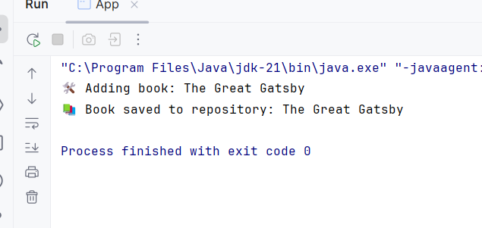

**Exercise 2: Implementing Dependency Injection**

**STEP 1: applicationContext.xml  
Path: src/main/resources/applicationContext.xml**

<?xml version="1.0" encoding="UTF-8"?>

<beans xmlns="http://www.springframework.org/schema/beans"

xmlns:xsi="http://www.w3.org/2001/XMLSchema-instance"

xsi:schemaLocation="

http://www.springframework.org/schema/beans

https://www.springframework.org/schema/beans/spring-beans.xsd">

<!-- Repository Bean -->

<bean id="bookRepository" class="com.library.BookRepository" />

<!-- Service Bean with Dependency Injection -->

<bean id="bookService" class="com.library.BookService">

<property name="bookRepository" ref="bookRepository" />

</bean>

</beans>

**STEP 2: BookRepository.java  
 Path: src/main/java/com/library/BookRepository.java**

package com.library;

public class BookRepository {

public void saveBook(String bookName) {

System.out.println("📚 Book saved to repository: " + bookName);

}

}

**STEP 3: BookService.java**

**Path: src/main/java/com/library/BookService.java**

package com.library;

public class BookService {

private BookRepository bookRepository;

// Setter for Dependency Injection

public void setBookRepository(BookRepository bookRepository) {

this.bookRepository = bookRepository;

}

public void addBook(String bookName) {

System.out.println("🛠️ Adding book: " + bookName);

bookRepository.saveBook(bookName);

}

}

**STEP 4: App.java (Main Class)**

**Path: src/main/java/com/library/App.java**

package com.library;

import org.springframework.context.ApplicationContext;

import org.springframework.context.support.ClassPathXmlApplicationContext;

public class App {

public static void main(String[] args) {

// Load Spring Container

ApplicationContext context = new ClassPathXmlApplicationContext("applicationContext.xml");

// Get the BookService bean

BookService bookService = (BookService) context.getBean("bookService");

// Test DI

bookService.addBook("The Great Gatsby");

}

}

OUT PUT (when App.java is ru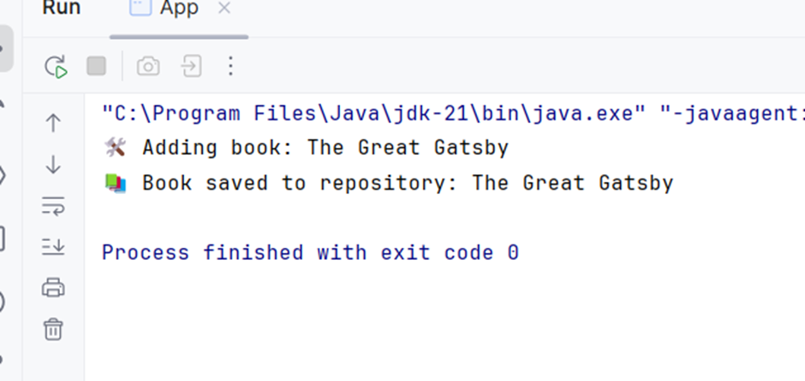

**Exercise 4: Creating and Configuring a Maven Project**STEP 1: Create a Maven Project  
Use your IDE (e.g., IntelliJ or Eclipse) to create a Maven project named LibraryManagement.

**STEP 2: Configure pom.xml**

File: pom.xml (in project root)

<?xml version="1.0" encoding="UTF-8"?>

<project xmlns="http://maven.apache.org/POM/4.0.0"

xmlns:xsi="http://www.w3.org/2001/XMLSchema-instance"

xsi:schemaLocation="http://maven.apache.org/POM/4.0.0

https://maven.apache.org/xsd/maven-4.0.0.xsd">

<modelVersion>4.0.0</modelVersion>

<groupId>com.library</groupId>

<artifactId>LibraryManagement</artifactId>

<version>1.0-SNAPSHOT</version>

<properties>

<maven.compiler.source>1.8</maven.compiler.source>

<maven.compiler.target>1.8</maven.compiler.target>

</properties>

<dependencies>

<!-- Spring Context -->

<dependency>

<groupId>org.springframework</groupId>

<artifactId>spring-context</artifactId>

<version>5.3.31</version>

</dependency>

<!-- Spring AOP -->

<dependency>

<groupId>org.springframework</groupId>

<artifactId>spring-aop</artifactId>

<version>5.3.31</version>

</dependency>

<!-- Spring Web MVC -->

<dependency>

<groupId>org.springframework</groupId>

<artifactId>spring-webmvc</artifactId>

<version>5.3.31</version>

</dependency>

<!-- Commons Logging -->

<dependency>

<groupId>commons-logging</groupId>

<artifactId>commons-logging</artifactId>

<version>1.2</version>

</dependency>

</dependencies>

<build>

<plugins>

<!-- Maven Compiler Plugin for Java 1.8 -->

<plugin>

<groupId>org.apache.maven.plugins</groupId>

<artifactId>maven-compiler-plugin</artifactId>

<version>3.8.1</version>

<configuration>

<source>1.8</source>

<target>1.8</target>

</configuration>

</plugin>

</plugins>

</build>

</project>

**STEP 3: Create applicationContext.xml**

<?xml version="1.0" encoding="UTF-8"?>

<beans xmlns="http://www.springframework.org/schema/beans"

xmlns:xsi="http://www.w3.org/2001/XMLSchema-instance"

xsi:schemaLocation="

http://www.springframework.org/schema/beans

https://www.springframework.org/schema/beans/spring-beans.xsd">

</beans>

**STEP 4: Add Test Class**

File: src/main/java/com/library/App.java

Paste this test program to verify Spring setup:

package com.library;

import org.springframework.context.support.ClassPathXmlApplicationContext;

public class App {

public static void main(String[] args) {

ClassPathXmlApplicationContext context =

new ClassPathXmlApplicationContext("applicationContext.xml");

System.out.println("✅ Spring Context Loaded Successfully");

context.close();

}

}

**OUTPUT**

