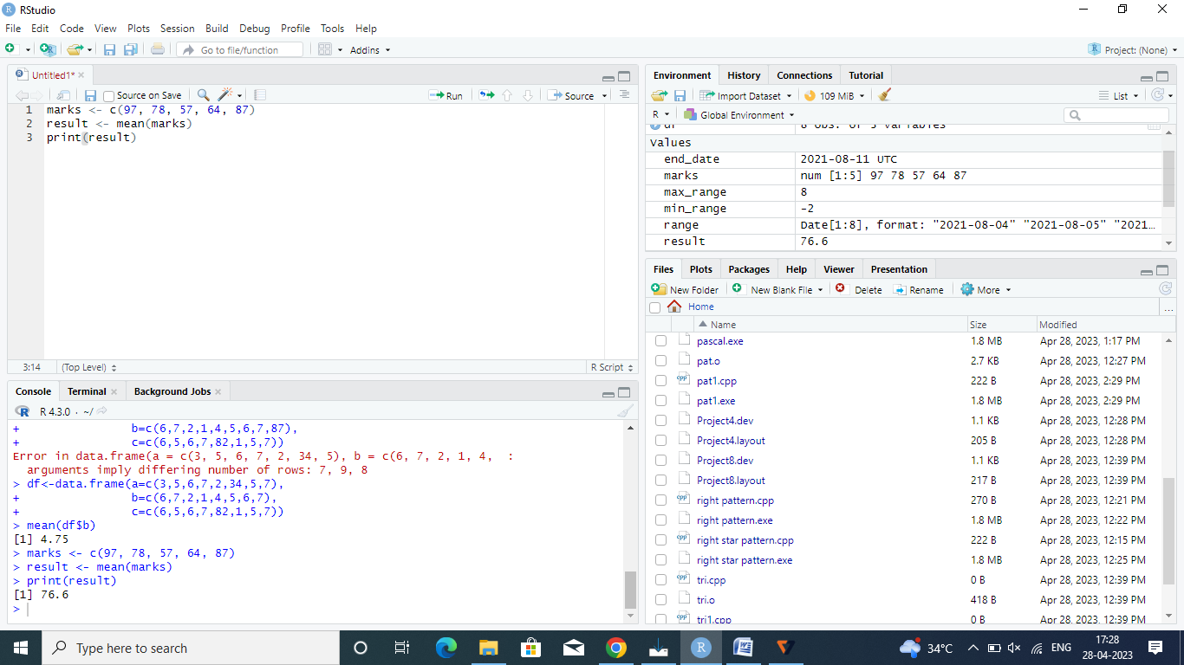

marks <- c(97, 78, 57, 64, 87)

result <- mean(marks)

print(result)

2

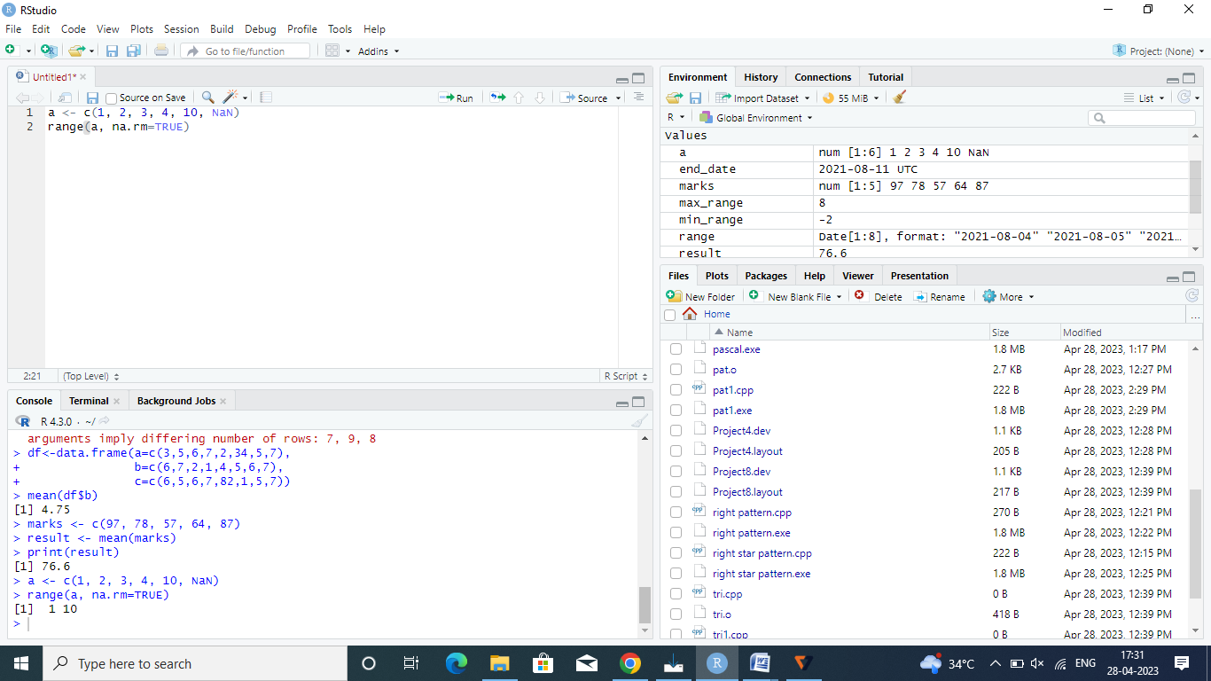

a <- c(1, 2, 3, 4, 10, NaN)

range(a, na.rm=TRUE)

3

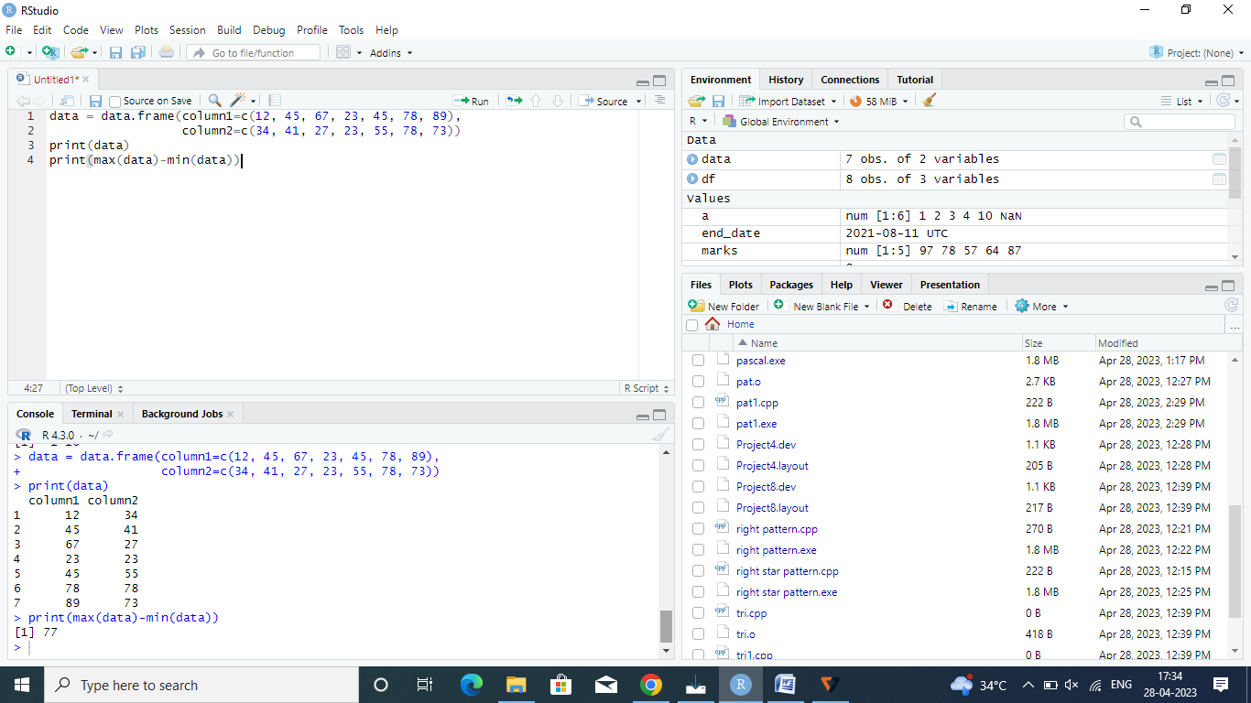

data = data.frame(column1=c(12, 45, 67, 23, 45, 78, 89),

column2=c(34, 41, 27, 23, 55, 78, 73))

print(data)

print(max(data)-min(data))

4

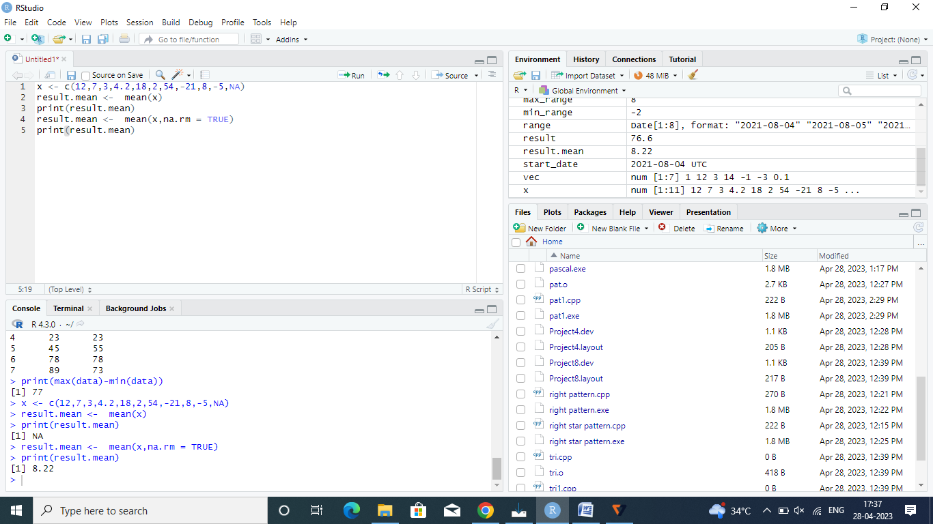

x <- c(12,7,3,4.2,18,2,54,-21,8,-5,NA)

result.mean <- mean(x)

print(result.mean)

result.mean <- mean(x,na.rm = TRUE)

print(result.mean)

5

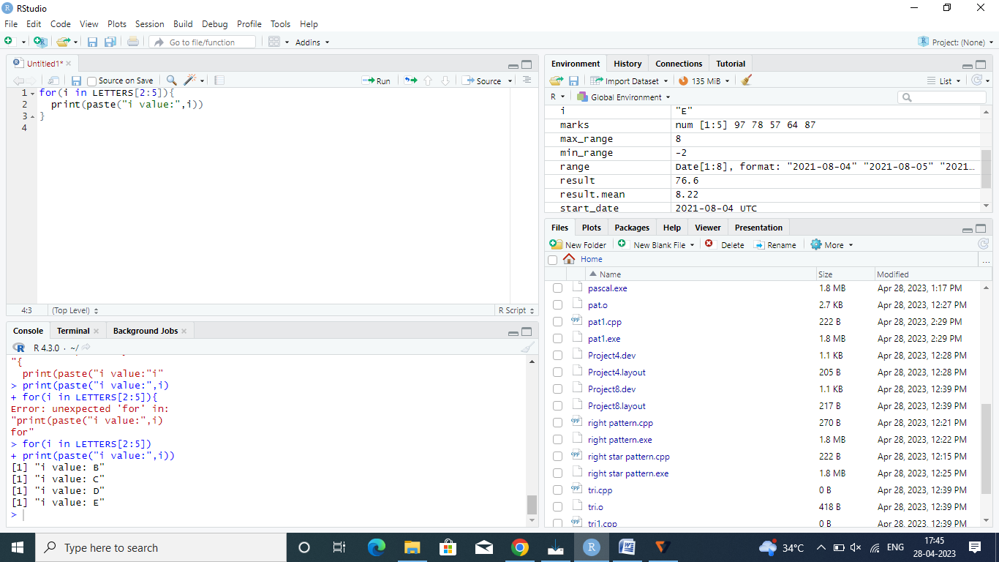

for(i in LETTERS[2:5]){

print(paste("i value:",i))

}