STACKUP

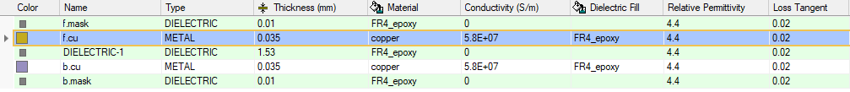

FREQUENCY DOMAIN ANALYSIS

FLASH MEMORY
DRIVER – STM32
RECIEVER – FLASH MEMORY
Signal | Parameter | Model
SPI_MISO, MOSI, SCK | Driver Model | STM32
SPI_MISO, MOSI, SCK | Receiver Model | FLASH MEMORY
FREQUENCY – 20MHz

PORTS(STM32) | Name of the Signal | PORTS(FLASH)
P1 | SPI1_flash_MISO | P2
P3 | SPI1_flash_MOSI | P4
P5 | SPI1_flash_SCK | P6

RL, p1, p1 ; p2,p2
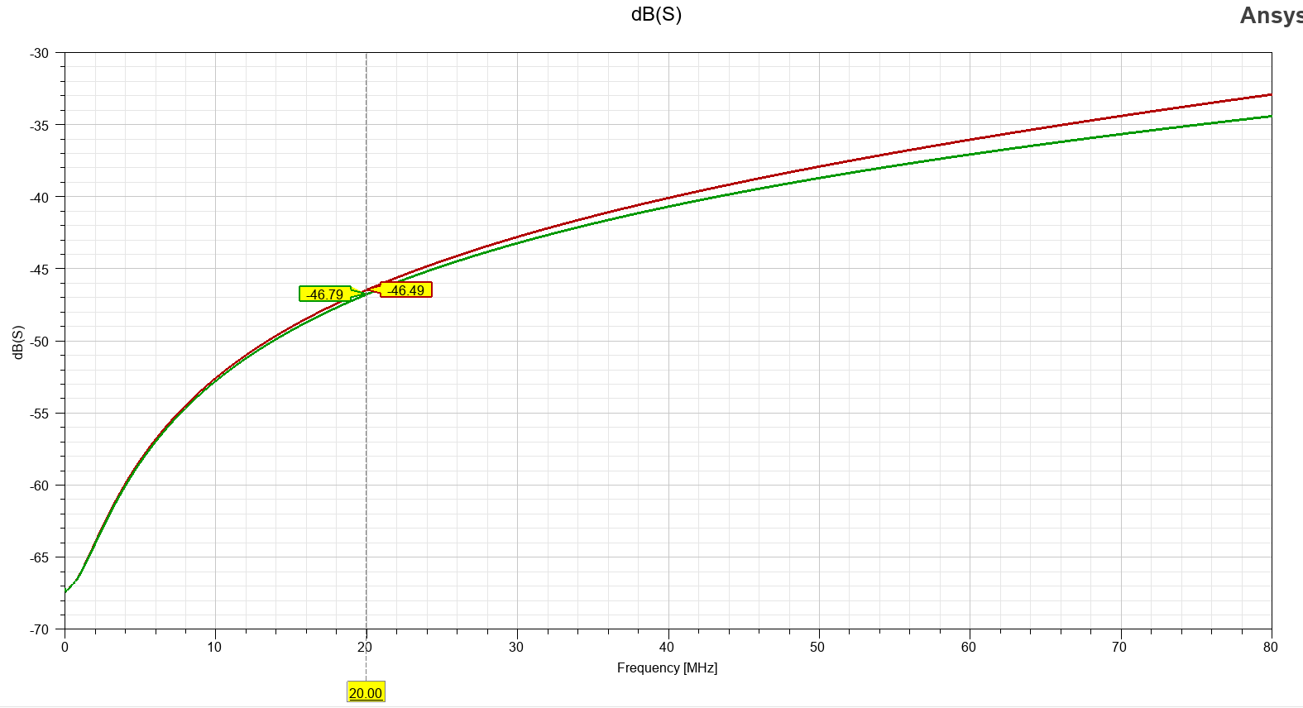

RL p3, p3 ; p4, p4
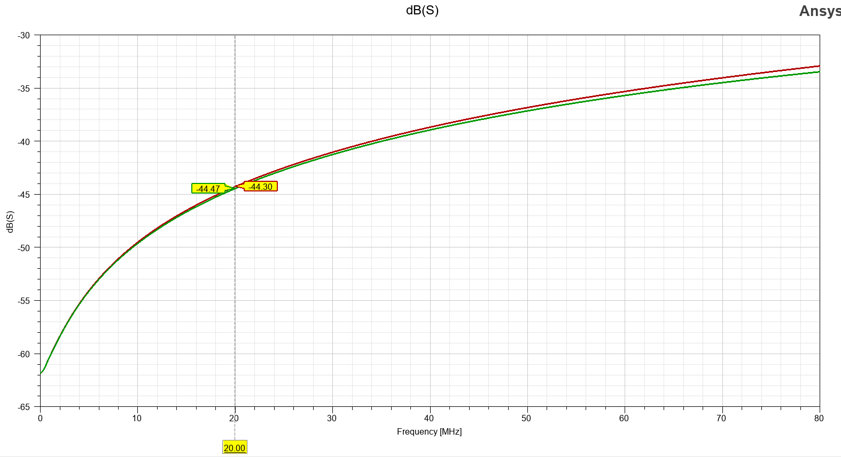

RL p5, p5; p6,p6
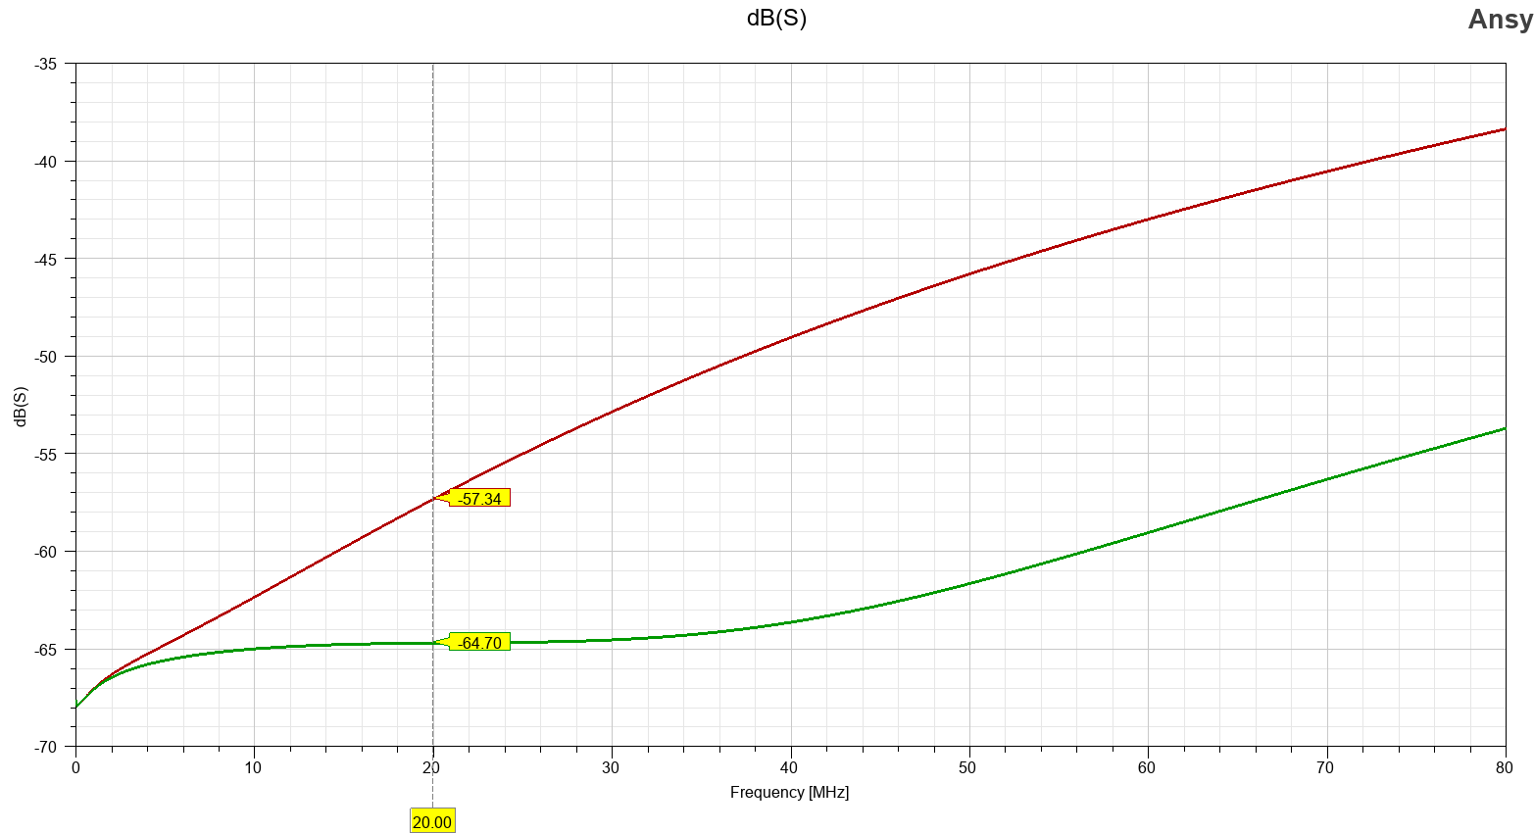

IL for p1,p2 ; p3, p4 ; p5, p6
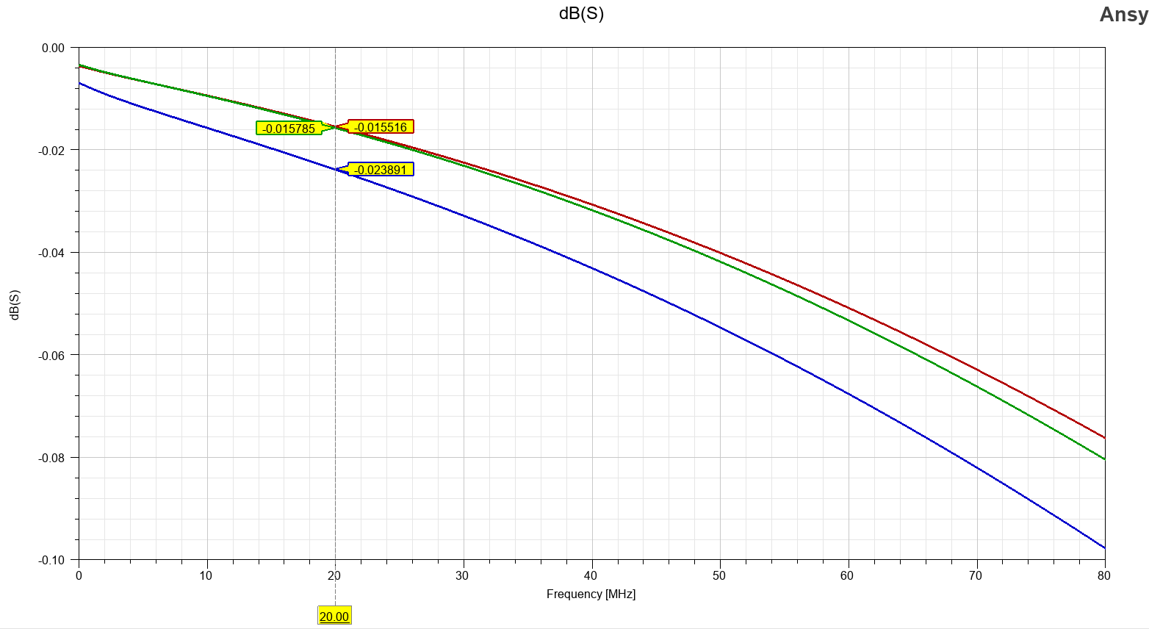

SD CARD
DRIVER – STM32
RECIEVER – SD CARD
Signal | Parameter | Model
SPI_MISO, MOSI, SCK | Driver Model | STM32
SPI_MISO, MOSI, SCK | Receiver Model | SD CARD
FREQUENCY – 20MHz

Frequency domain analysis
PORTS(STM32) | Name of the Signal | PORTS(SD CARD)
P1 | SPI1_SDCARD_MISO | P2
P3 | SPI1_SDCARD_MOSI | P4
P5 | SPI1_SDCARD_SCK | P6

RL, p1, p1 ; p2, p2
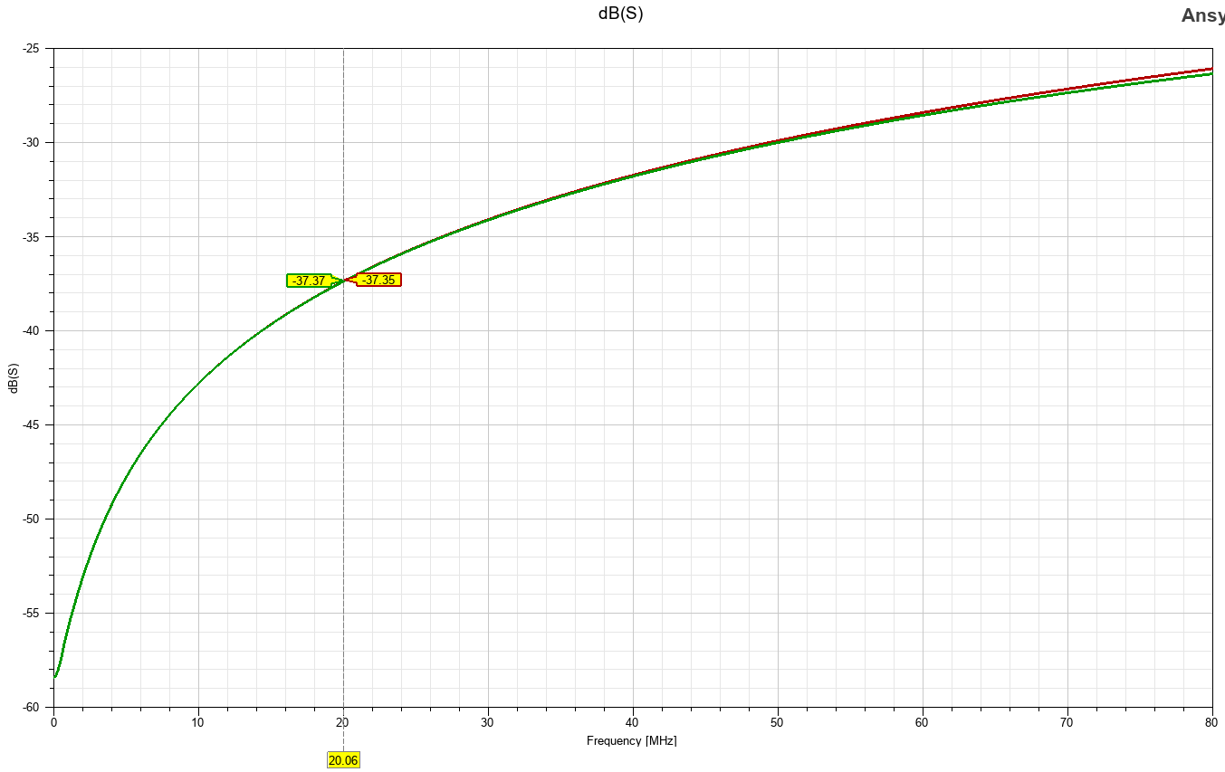

RL p3, p3 ; p4, p4

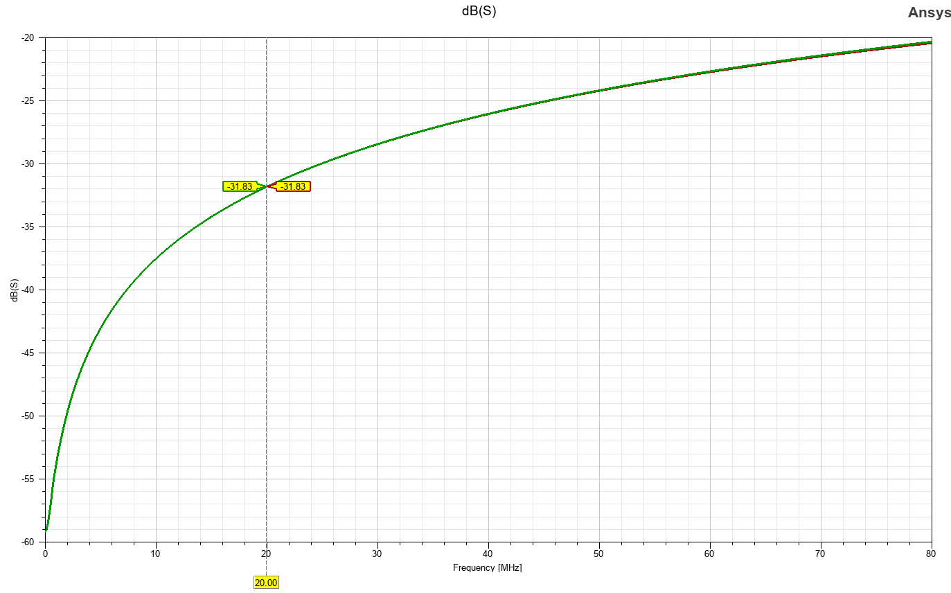

RL p5, p5; p6,p6
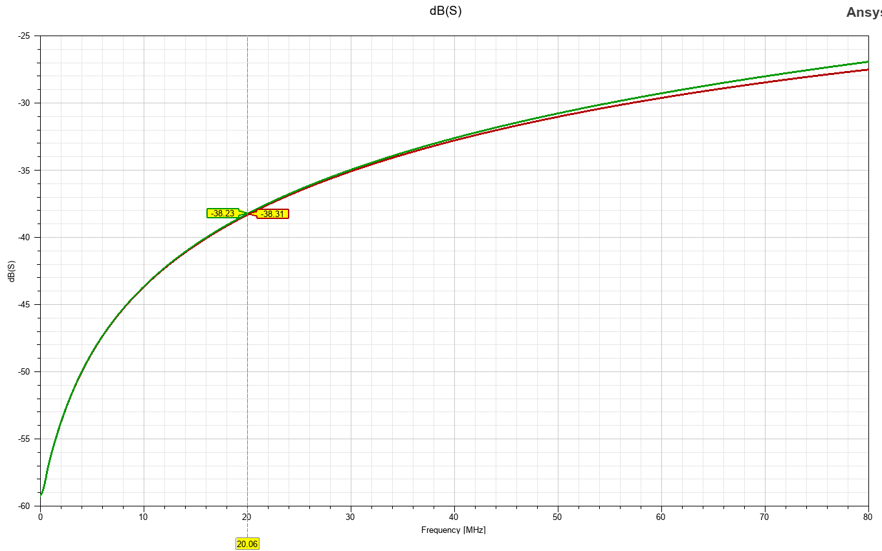
IL for p1,p2 ; p3, p4 ; p5, p6
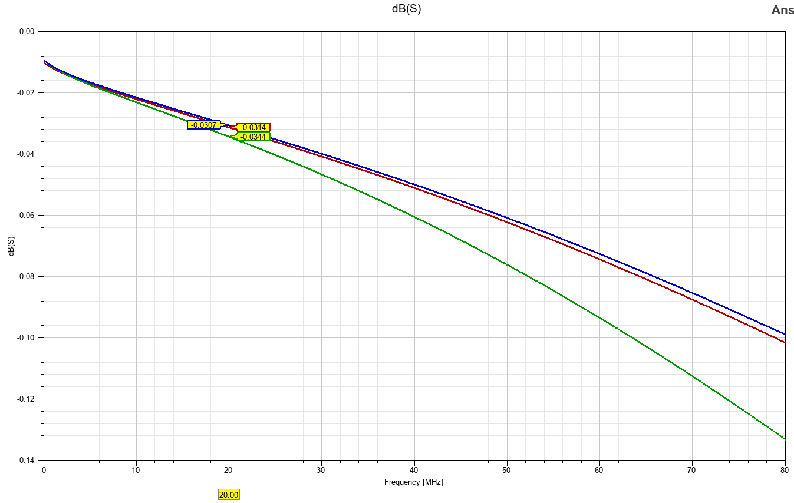

IMU SENSOR
DRIVER – STM32
RECIEVER – IMU
Signal | Parameter | Model
SPI_MISO, MOSI, SCK | Driver Model | STM32
SPI_MISO, MOSI, SCK | Receiver Model | IMU SENSOR
FREQUENCY – 10MHz

Frequency domain analysis
PORTS(STM32) | Name of the Signal | PORTS(IMU)
P1 | SPI1_IMU_MISO | P2
P3 | SPI1_IMU_MOSI | P4
P5 | SPI1_IMU_SCK | P6

RL, p1, p1 ; p2, p2
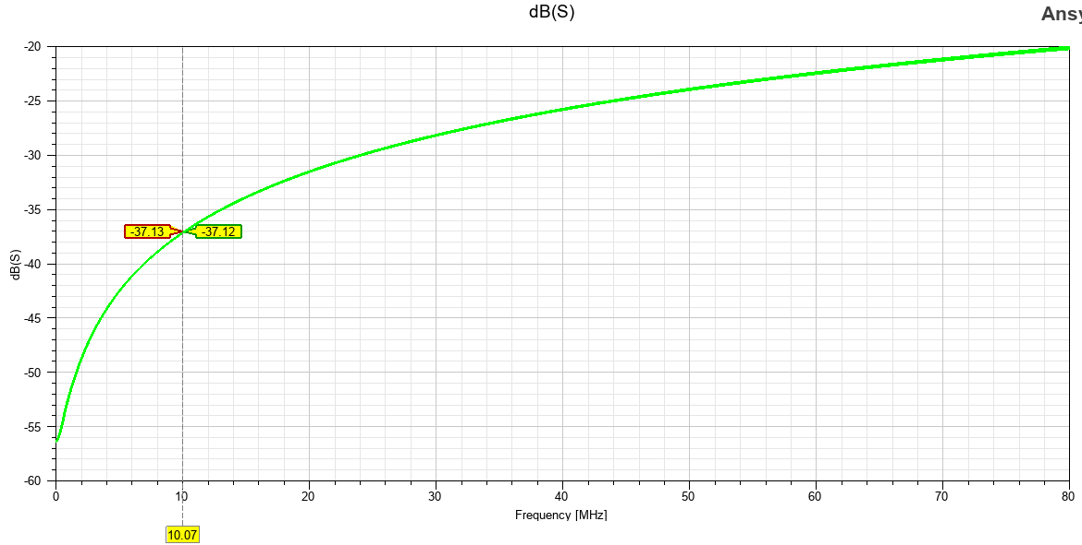

RL p3, p3; p4, p4
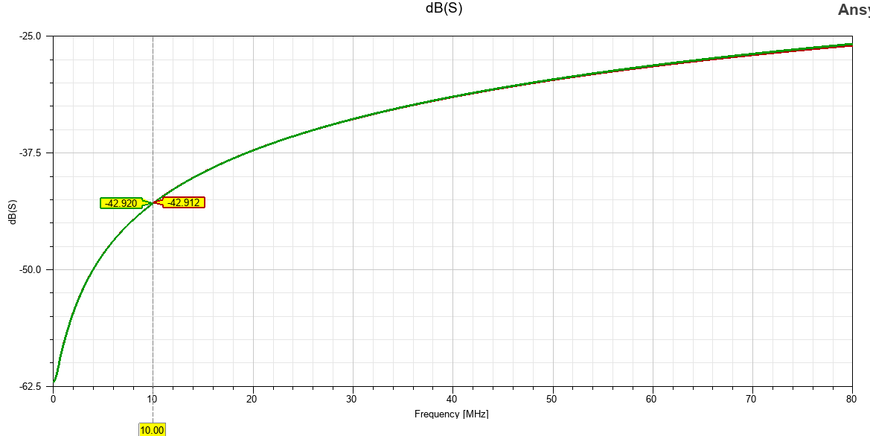

RL p5, p5; p6, p6
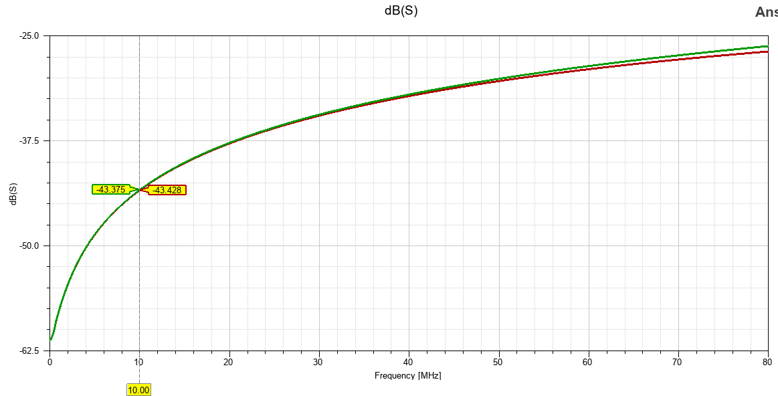

IL for p1, p2 ; p3, p4; p5, p6
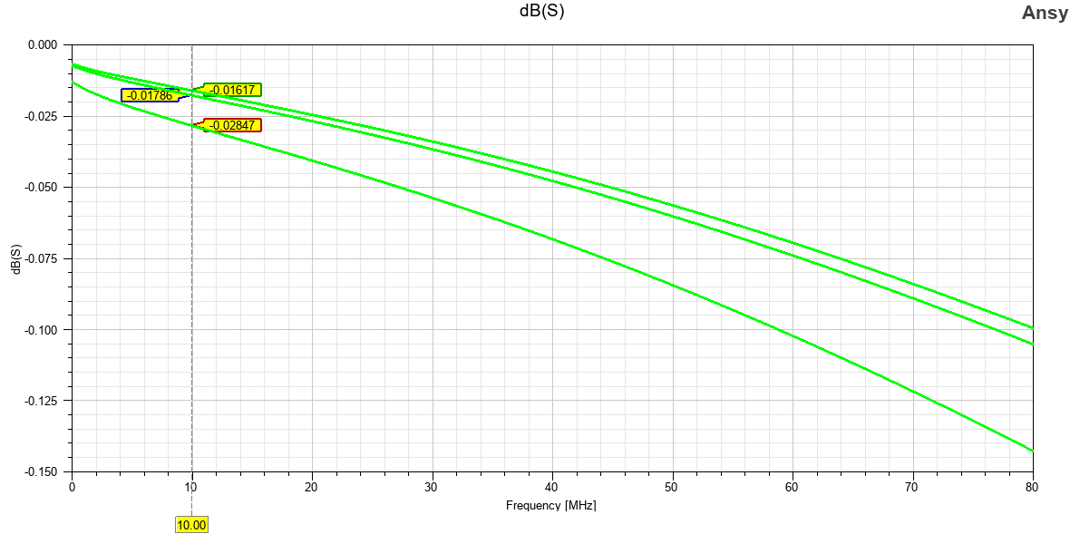

I2C
DRIVER – STM32
RECIEVER – I2C
Signal | Parameter | Model
SPI_MISO, MOSI, SCK | Driver Model | STM32
SPI_MISO, MOSI, SCK | Receiver Model | CURRENT SENSOR
FREQUENCY – 10MHz

Frequency domain analysis
PORTS(STM32) | Name of the Signal | PORTS(CURRENT SENSOR)
P1 | SPI1_I2C_SCL_MISO | P2
P3 | SPI1_I2C_SDA_MOSI | P4

RL, p1, p1; p2, p2
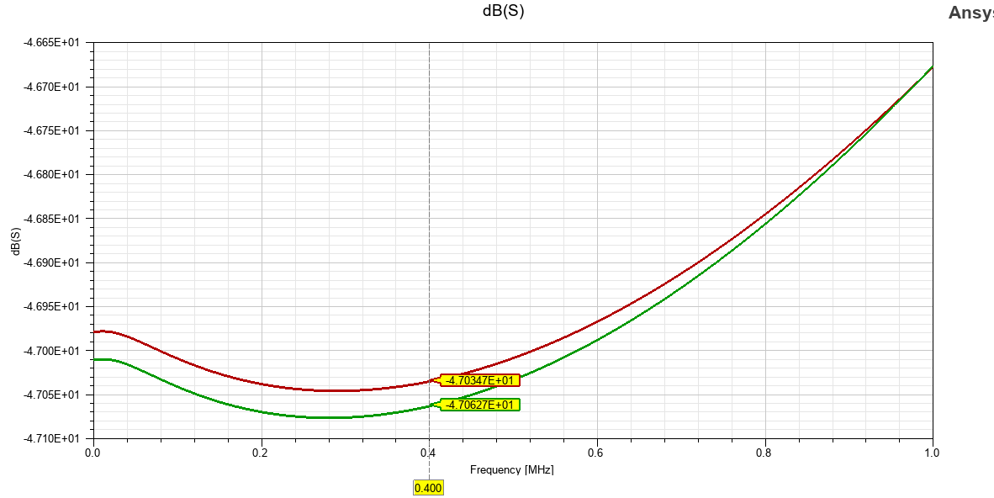

RL p3, p3; p4, p4
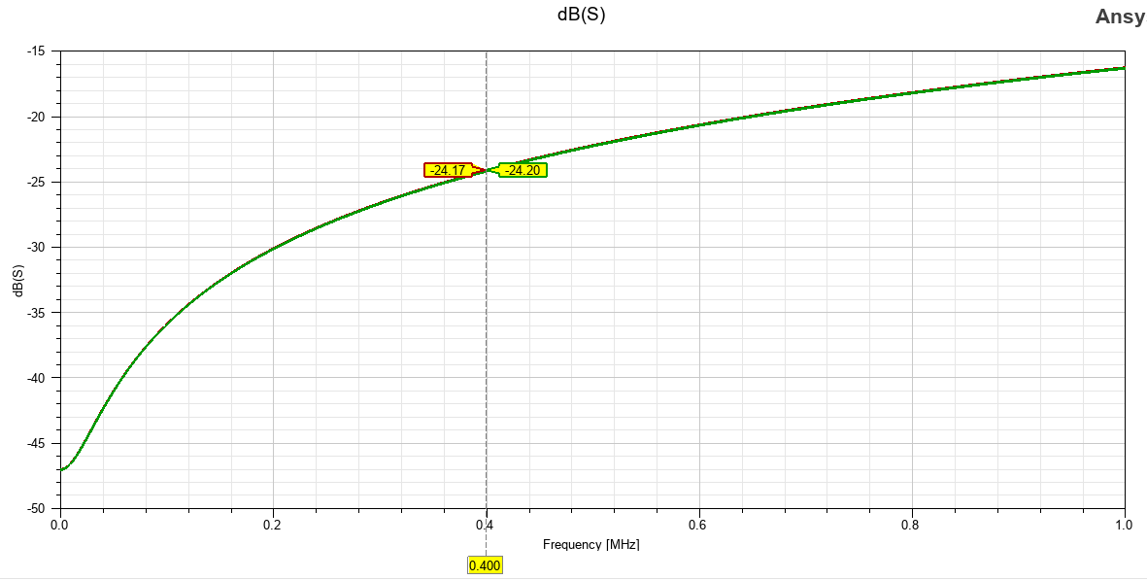

IL for p1, p2; p3, p4; p5, p6

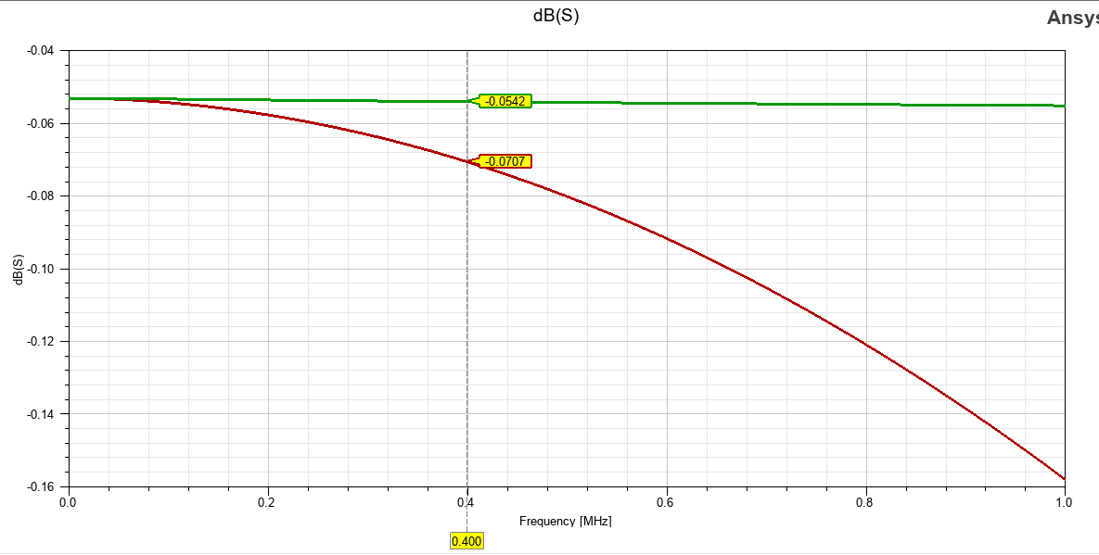

TIMING DOMAIN ANALYSIS

SDCARD
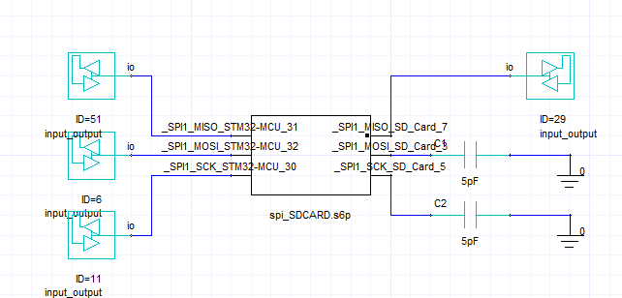

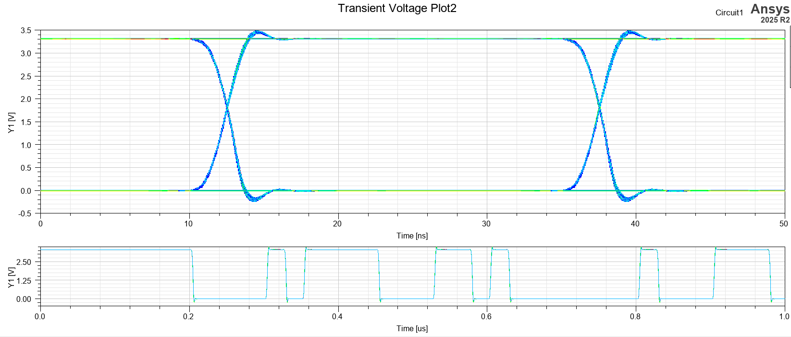
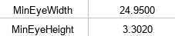

FLASH MEMORY
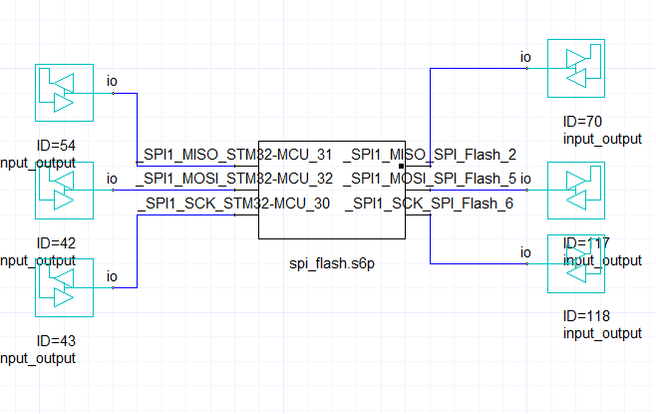
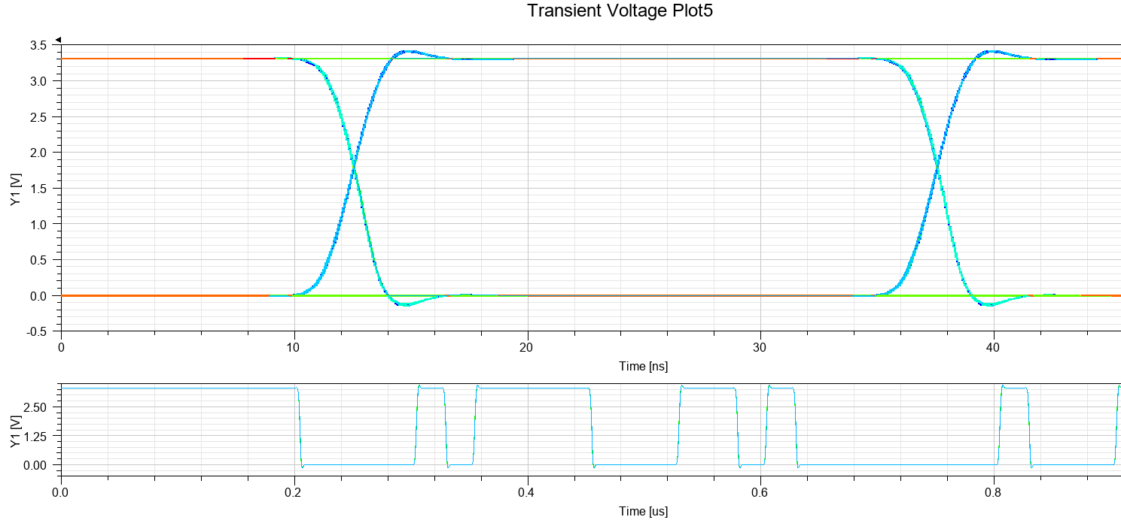
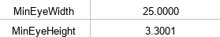

IMU
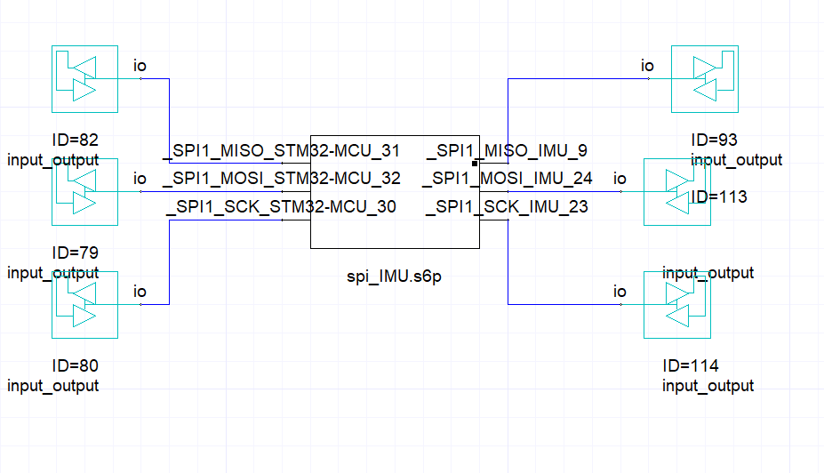

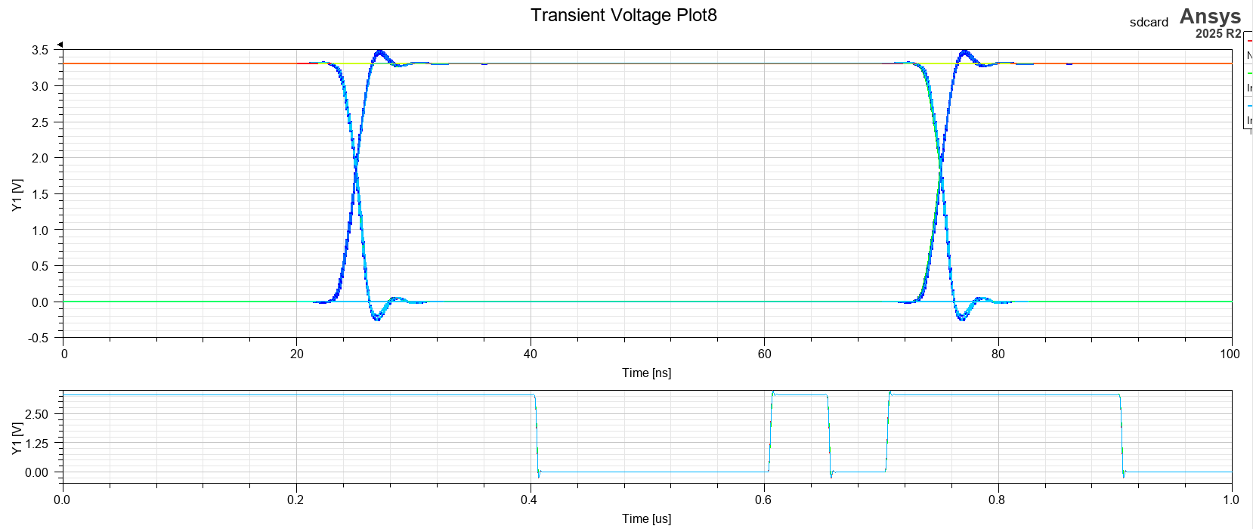
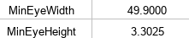

I2C
