**1.Created a file more than 500 MB**

**Command: dd if=/dev/zero of=dummyfile bs=1024 count=563200**

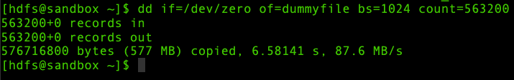

**2.Uploaded in a directory called test_data in hdfs.**

**Command: hdfs dfs -put dummyfile /test_data**

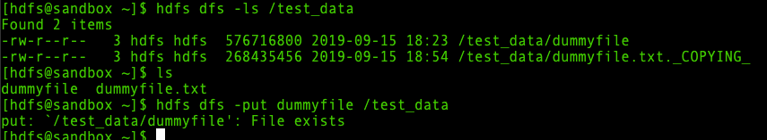

Dummyfile was previously put under the directory test_data. So, when it is put again it shows “File Exists”.

dummyfile exists under test_data. It has got replication factor 3 with owner and group as hdfs.

**3.FSCK commands**

**FSCK commands are used to check the healthiness of the files.**

**Command: hdfs fsck /test_data**

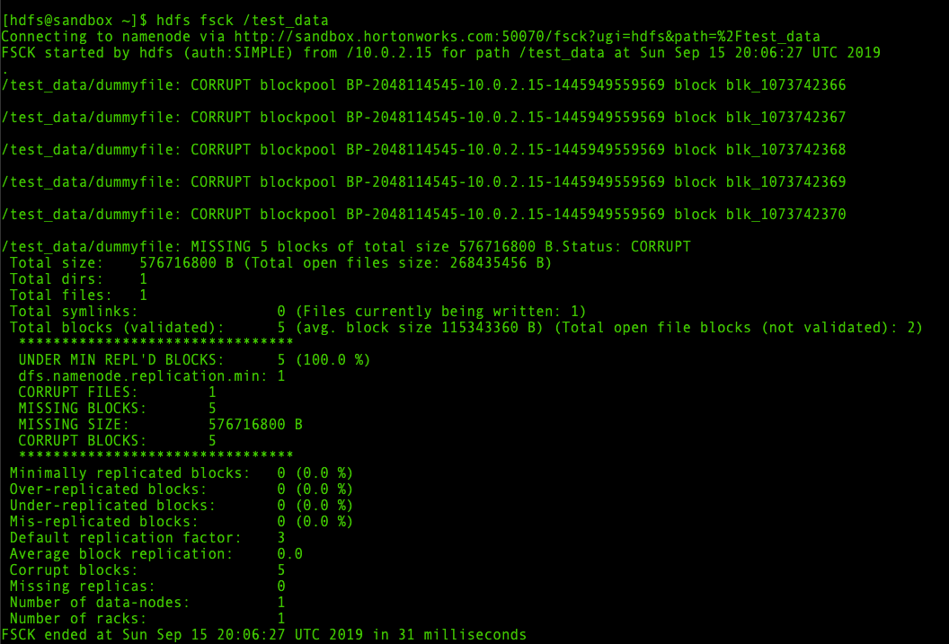

**4. command: hdfs fsck /test_data -files**

**Checks all the files under test_data (dummyfile)**

**The file is CORRUPT**

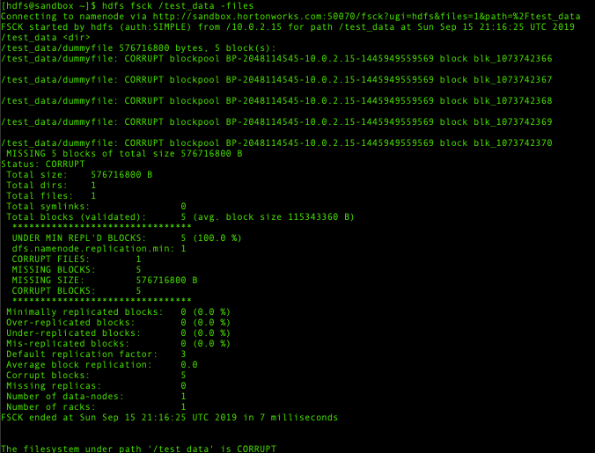

**5. command: hdfs fsck /test_data -files -blocks**

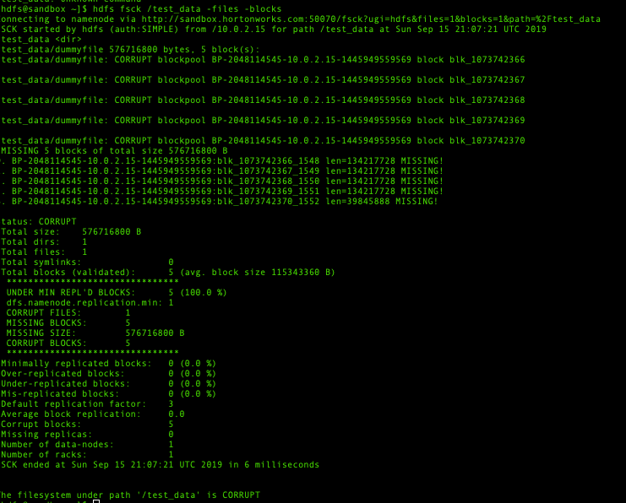**Checks all the blocks of files under the given path**

**6.command: hdfs fsck /test_data -files -blocks -locations**

**Checks all the files’ block locations under the given path**

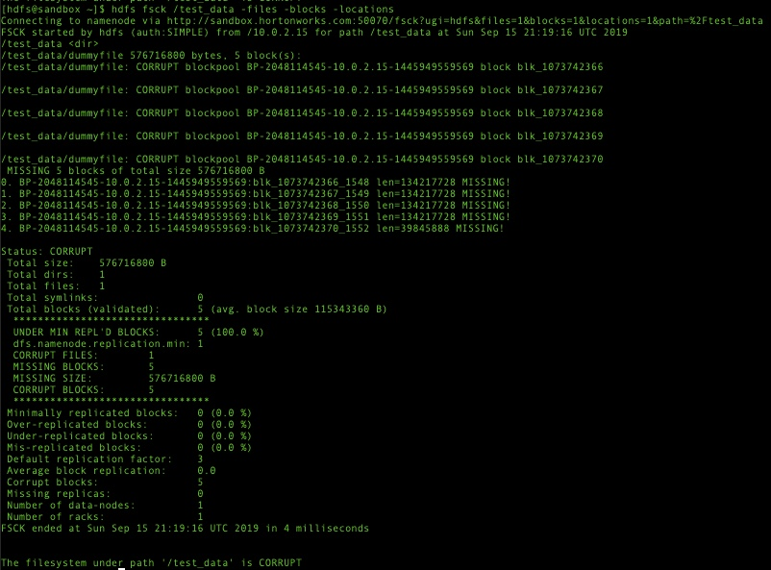**There are totally 5 missing blocks**

**7.command: hdfs fsck /test_data -racks**

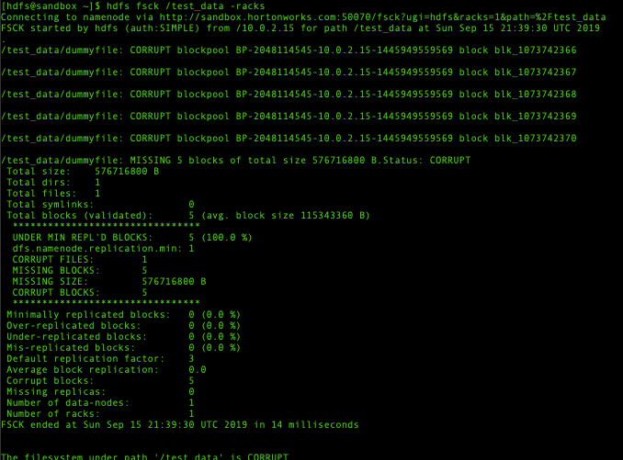There is only 1 rack and there is only one data node

**8.command: hdfs dfsadmin -report**

**Gives a detailed information about the filesystem and its statistics. There is only one data node.**

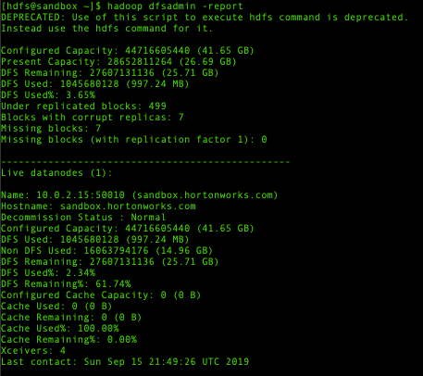

9.**command: hdfs fsck / -openforwrite**

**Displays all the files under / path that are open for write.**

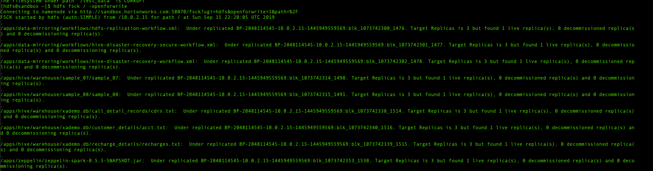

**DFS commands**

**1.command: hdfs dfs -touchz /test_data/dummyfile.txt**

**Creates a file of 0 bytes under the given directory test_data**

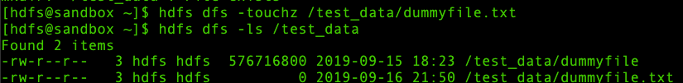**2.command: hdfs dfs -mkdir dir1**

**Makes a directory in the current location**

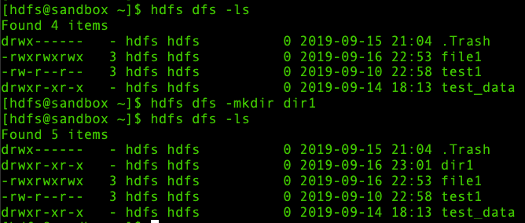

**3.command: hdfs dfs -chmod 777 test1**

**Changes the file permissions of the files test1. Here 777 refers to giving all the permissions to all the users**

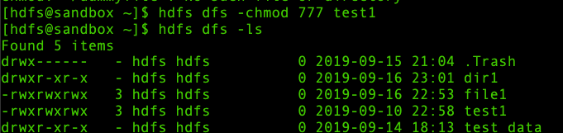

**4.command: hdfs dfs -chown hdfs test1**

**Changes the owner of the test directory from mapred to hdfs**

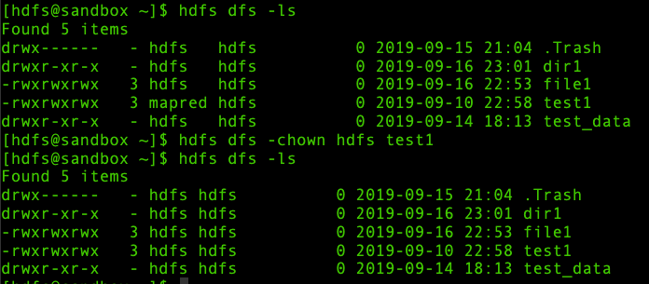

**5.command: hdfs dfs -chgrp mapred test1**

**Changes the group of the test directory from hdfs to mapred**

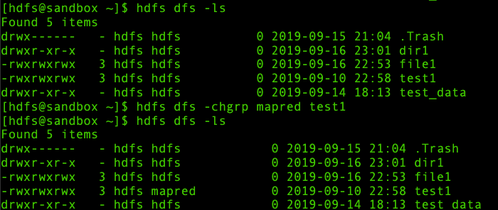

**6.command: hdfs dfs -rm file1**

**Moves the file file1 to trash (-R removes the files recursively which means all the files under the given path)**

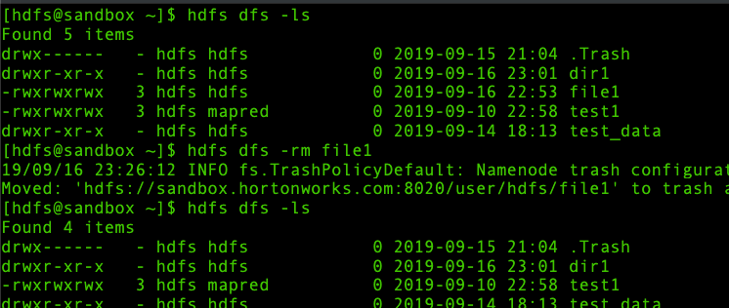

**7.command: hdfs dfs -rmdir dir1**

**Moves the directory to trash**

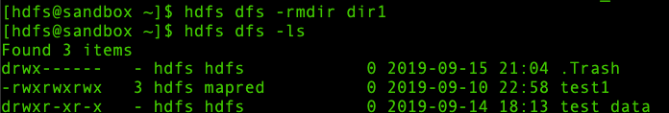

**8.command: hdfs dfs -count /test_data**

**Gives the count of directories, files, bytes and path name of the specified directory**

**9.command: hdfs dfs -df /test_data**

**Gives the disk free space for the given filesystem**

**-h after df gives the human readable format of the size of the file system**

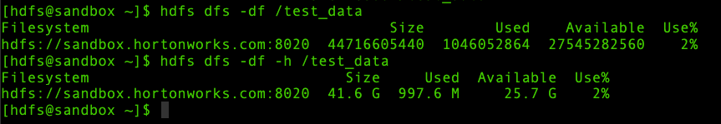

**10.command: hdfs dfs -du /**

**Gives the sizes of the files and directories under the given path.**

**hdfs dfs -du -s /-Gives the summary of the total size of all files**

**hdfs dfs -du -h/-Gives the human readable format of all the sizes of files and directories**

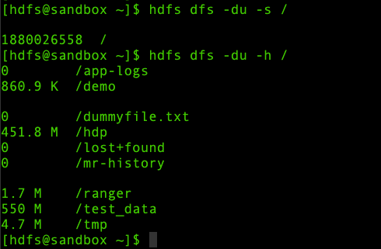

**11.command: hdfs dfs -put dummyfile /test_data**

**-put is used to copy file from local to destination**

**-copyFromLocal works same as put**

**12.command: hdfs dfs -mv dummyfile /test_data**

**Works similar to -put. But moves the file to the destination instead of copying it.**

**13.command: hdfs dfs -stat "%F %u %g %b %y %n" /test_data**

**Gives the statistics about the given file.** **Format accepts file size in blocks (%b), type (%F), group name of owner (%g), name (%n),** **username of owner(%u), and modification date (%y, %Y)**

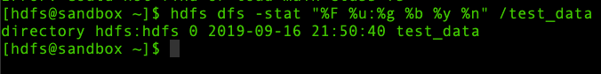

**14.command: hdfs dfs -setrep -w 4 test1**

**Changes the replication factor of the given file test1 to 4. But in this case since the name node is in safe mode it could not change the replication factor of the file test1.**

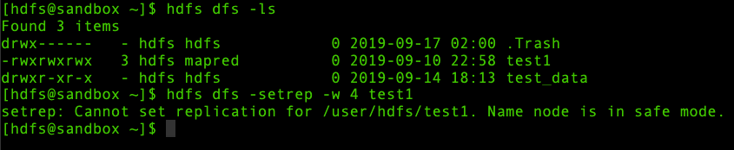

**15.command: hdfs dfs -ls -R /user/hdfs**

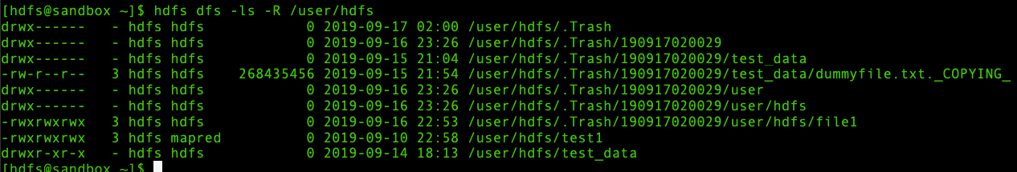**Gives the list of all files and folders under the given path.**

**16.command: hdfs dfs -appendToFile dummyfile.txt /user/hdfs**

**Appends one or more files to the destination. Here dummyfile.txt is the source and /user/hdfs is the destination. But it could not be perform as the node was in safe mode.**

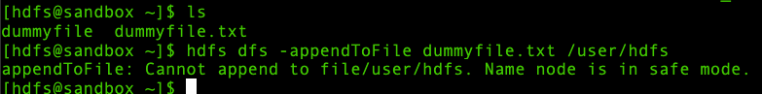

**17.command: hdfs dfs -checksum test1**

**Gives the checksum information about the given file**