Objective – To create partitions on table and execute aggregate queries.

Tried doing partition two ways-

**1.Partition based on gender**

**2.Partition based on education**

**1.Partiton based on gender**

Moved Data1.csv from /home/hdfs to /user/Harshida/ext_table and the permissions of the file were changed using command **hdfs dfs -chmod 777 /user/Harshida/ext_table/Data.csv**

Logged into hive- and created the test_db and created the external_table

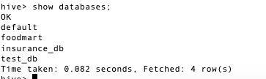

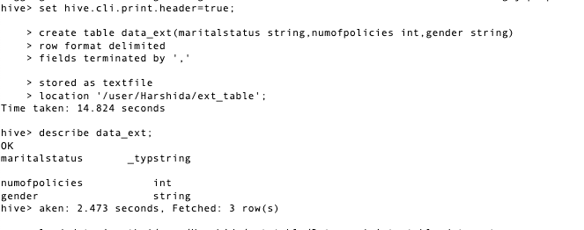

2.Load data from HDFS path into data_ext table by using command

**Load data inpath ‘/user/Harshida/ext_table/Data.csv’ into table data_ext ;**

**Once loaded the table looks like below**

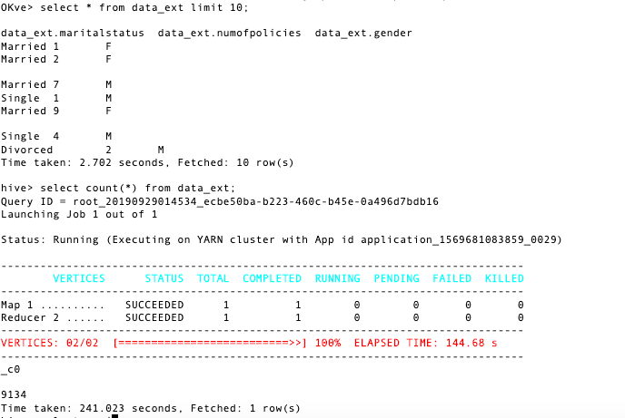

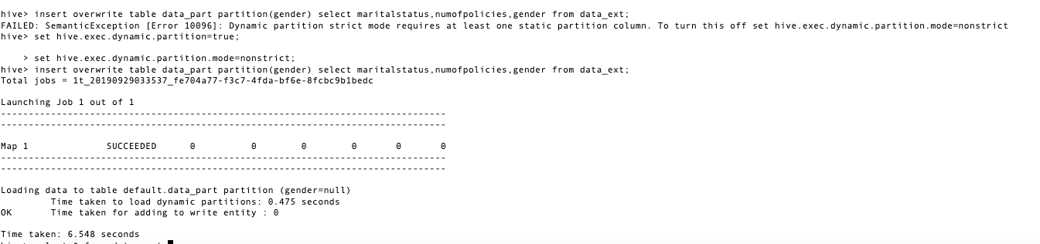3.Creating another table data_part which is partitioned by gender-**Dynamic partitioning**

This query takes data from data_ext and creates a new table data_part with the given partition column.

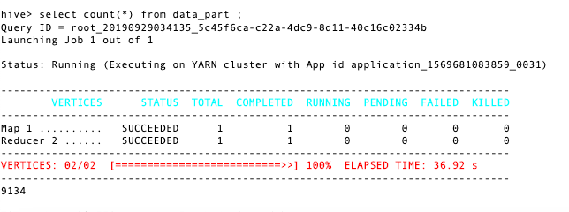4.Applied count (*) aggregate query on the table created which gave successful result.

Select query on the partition-

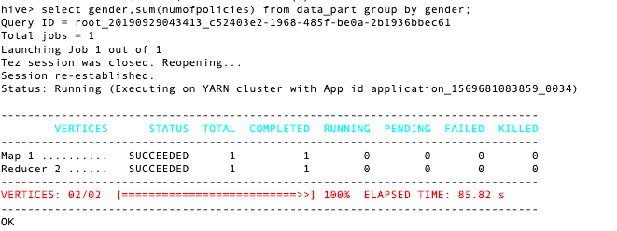



**2.Partition based on education-**

**The Insurance_data1.csv file is moved to HDFS and all the permissions are given.**

**Logged into hive to create external table-**

**Using test_db;**

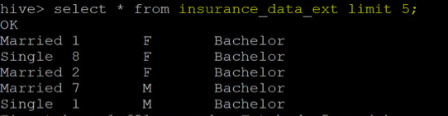

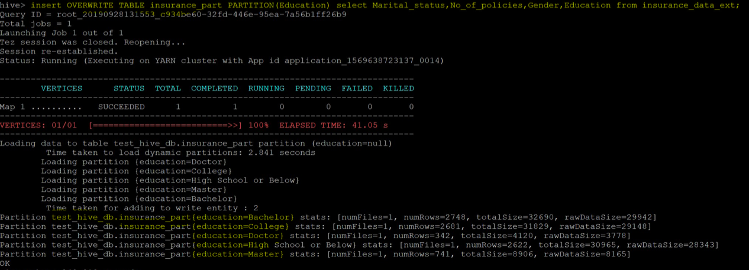 **Creating new table Insurance_part by creating partitioning on education column.**

**Partitions created-**

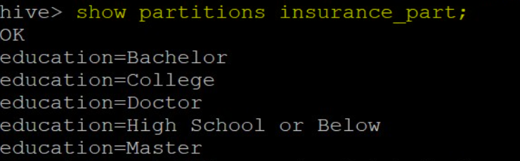

Select query on the partitioned table-

