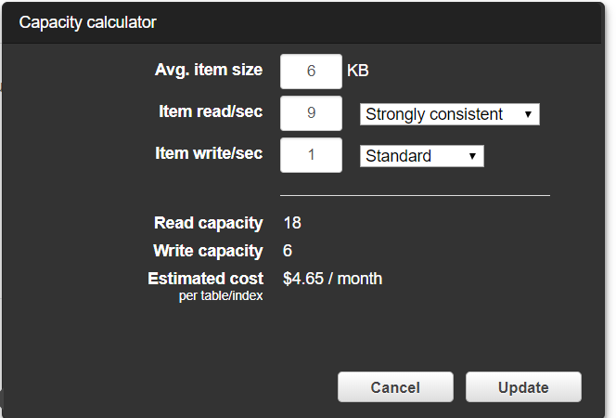

6 Item Size ROUNDED to 8 KB = 2 RCU (1 RCU 4)

9 read/sec = 9

So, 9 \* 2 = 18 Strongly consistent RCU

Eventually means – Strongly consistent/2 = 9 RCU

