THE REAL-TIME CAMPUS GRID
Hackathon Project Paper | Theme B: The Broken College Stack | IIT Jodhpur

1. The Problem — The Broken Allocation Stack
At IIT Jodhpur and most Indian engineering colleges, physical resource management runs on a fragmented, manual, invisible system. Three compounding failures define it:
- Manual Bottlenecks: Booking a room requires emailing the office and waiting hours—or days—for confirmation. No self-service exists.
- Zero Spatial Visibility: There is no portal showing real-time room availability. Students physically walk corridors to find a free classroom.
- Blind Hardware Usage: Lab equipment—multimeters, sensors, kits—is shared with zero tracking. Students waste trips discovering tools are occupied or missing.
- No Data Trail: Zero booking logs means zero utilization data. Infrastructure decisions are made on gut feeling, not evidence.

2. Theme Alignment
Theme B challenges you to identify something fundamentally broken in college life and rethink it as a system—not just add a feature. Campus resource allocation is a textbook case: students have simply adjusted to the friction instead of questioning it. This project replaces the entire manual permission loop with automated, self-service, real-time visibility.

3. Solution & Feature Set

3.1 Problems vs. Solutions

Problem | Solution
Email booking (hours of delay) | Self-service portal — instant confirmation, no human in loop
No real-time room status | Live dashboard: Green (Free) / Red (Occupied) / Yellow (Pending check-in) / Blue (Maintenance)
No equipment tracking | Digital checkout ledger: student ID, due time, condition flag, auto-escalation on overdue
No timetable integration | Automated CSV/API ingestion blocks lecture halls with zero manual entry; delta-sync mid-semester
Ghost bookings / no-shows | Auto-release after 15-min check-in lapse; QR code on-site verification
No admin override mechanism | Master override panel with mandatory reason log + instant displaced-student notification
Zero utilization data | Analytics dashboard: heatmaps, idle rates, no-show reports, peak-hour forecasts

3.2 Key Features
- Live Availability Dashboard — color-coded real-time status for all rooms and equipment
- QR-Based Check-In — on-site scan verifies physical presence; prevents remote ghost check-ins
- Smart Waitlist — auto-notifies next user within 10 min when a slot opens
- Recurring Bookings — clubs book once for the entire semester with admin approval
- Reliability Score — per-user score based on on-time returns and check-ins; affects booking windows
- Interactive Campus Map — SVG floor-plan with live color overlay; book directly from map
- Public Read-Only API — exposes availability for college app, department portals, notice boards

4. System Architecture

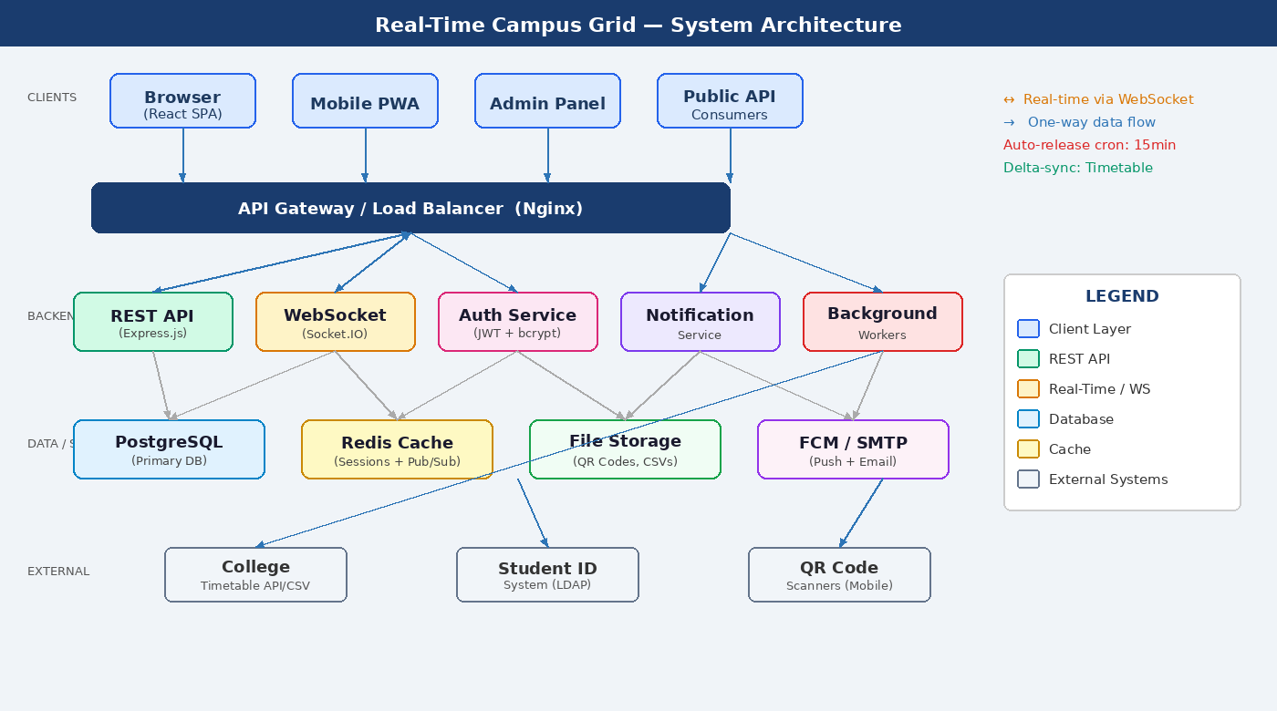

The platform follows a 5-layer architecture. Clients (Browser, Mobile PWA, Admin Panel) connect via HTTPS and WebSocket through an Nginx API Gateway. The backend comprises five services: a REST API (Express.js), a WebSocket engine (Socket.IO) for real-time push, an Auth Service (JWT), a Notification Service (FCM/SMTP), and Background Workers for auto-release and timetable sync. Data is persisted in PostgreSQL, cached in Redis, with external integrations to the college timetable system, LDAP student identity, and QR scanners.

4.1 Tech Stack

Layer | Technology | Purpose
Frontend | React.js + Tailwind | SPA dashboard, map view, booking flows
Real-Time | Socket.IO | Instant status broadcast to all clients
Backend API | Node.js + Express | Business logic, booking rules, auth
Database | PostgreSQL | ACID-compliant persistent storage
Cache | Redis | Sessions, rate-limiting, pub/sub
Auth | JWT + bcrypt | Role-based access (Student/Faculty/Admin)
Notifications | FCM + NodeMailer | Push and email for waitlist, overrides, reminders
Deployment | Docker + Nginx | Container isolation, reverse proxy, scalability

5. Vulnerabilities & Mitigations

Vulnerability | Risk | Mitigation
Ghost booking / no-show | Space locked despite no physical use | Auto-release after 15-min check-in lapse; no-show tracked in reliability score
Remote ghost check-in | QR scanned from photo, not on-site | Time-seeded rotating QR codes (30-min rotation); WiFi SSID proximity check
Mass booking abuse | Single user monopolizes all rooms | Per-role weekly booking caps; advance window limits by role
Equipment non-return | Digital record only; no physical deterrent | Admin escalation after grace period; penalty flag on student ID
Session hijacking | JWT token stolen → account takeover | HTTPS enforced; JWT in httpOnly cookies; 15-min expiry + refresh rotation
Concurrent booking race | Two users book same slot simultaneously | DB-level row locking (SELECT FOR UPDATE); unique constraint on resource+timeslot
Timetable injection | Bad CSV corrupts availability data | Strict schema validation; diff preview before commit; admin-only access
Backend outage | Entire campus loses visibility | Offline fallback: service worker serves cached snapshot with 'last updated' watermark

6. Implementation Roadmap
Phase | Timeline | Deliverables
1 — Foundation | Weeks 1–2 | DB schema, auth (JWT), REST API, basic dashboard
2 — Core | Weeks 3–5 | WebSocket real-time, booking flow, timetable ingestion, equipment ledger, admin override
3 — Enhanced | Weeks 6–8 | QR check-in, auto-release cron, waitlist, reliability score, recurring bookings
4 — Polish | Weeks 9–10 | Campus map view, analytics dashboard, offline fallback, public API, security audit

7. Impact
Metric | Current State | With Campus Grid
Time to book a room | 4–24 hours (email) | < 30 seconds
Room utilization rate | ~40–50% (wasted blocks) | 70–80% (real-time visibility)
Equipment accountability | Zero tracking | Full ledger + condition history
Admin booking overhead | 3–5 hrs/week manual | < 1 hr/week (overrides only)
Double-booking incidents | Frequent (untracked) | Near-zero (DB constraint)

The Core Thesis: Students don't walk corridors hoping to find a free room because they like the exercise. They do it because the information doesn't exist anywhere. The Campus Grid makes that information real-time, universal, and actionable. That is the rethink.

Real-Time Campus Grid | Theme B: The Broken College Stack | IIT Jodhpur Hackathon

