CFSS GLOBAL INTERNSHIP PROGRAM 2026
SOC OPERATIONS & THREAT
DETECTION MASTERY
Final Project Report

Domain | SOC Analyst & Blue Teaming
Submitted By | Harshil Miteshkumar Barot
Project Duration | 4 Weeks
Submission Date | 25th June 2026
Tools Used | Wazuh SIEM/XDR | Windows 11 | Kali Linux | VirtualBox
Project Type | SOC Lab, Log Analysis, Threat Detection & Reporting

Building, Monitoring, Detecting and Reporting Security Events using Wazuh SIEM

Table of Contents
1. Executive Summary | 2
2. Methodology | 2
3. Tools & Technologies Used | 3
4. Lab Architecture | 3
5. Technical Findings & Evidence | 4
6. Top 10 Security Events | 9
7. Recommendations | 14
8. Challenges Faced | 14
9. GitHub Repository | 15
10. Conclusion | 15

1. Executive Summary
During the 4-week CFSS Global Internship Program, a complete Security Operations Center (SOC) environment was deployed and validated in a controlled lab. The project involved Wazuh SIEM/XDR deployment, endpoint agent configuration, Windows and Linux log monitoring, safe attack simulation, command monitoring, custom dashboarding and professional reporting.
The work was performed with a Cyber Investigator's mindset, focusing on evidence-based documentation, clear screenshots and SOC-style analysis of normal versus suspicious activity.

2. Methodology
Four-Week Execution Plan
• Week 1: Deployed the virtualized SOC lab using VirtualBox and configured Wazuh Manager with endpoint agents.
• Week 2: Monitored Windows Event Logs and Linux Syslog/authentication logs to identify normal and suspicious activity.
• Week 3: Simulated attacks using controlled brute-force attempts, EICAR test activity and command monitoring.
• Week 4: Built custom visual dashboards and prepared final technical reporting for SOC presentation.

3. Tools & Technologies Used
Tool / Platform | Purpose
Wazuh Manager | Central SIEM/XDR server for alert analysis and agent management
Wazuh Agent | Endpoint log collection from Windows and Kali Linux
Wazuh Dashboard / OpenSearch Dashboards | Search, visualization and SOC dashboard creation
Windows 11 | Monitored endpoint for Windows Security Event Logs
Kali Linux | Linux endpoint and controlled attack simulation environment
Hydra | Controlled brute-force simulation in a local lab
EICAR Test File | Safe malware simulation string for detection validation
VirtualBox | Virtualized lab environment

4. Lab Architecture
Windows Agent ---> Wazuh Manager VM <--- Kali Linux Agent
Logs and security events were collected by agents, analyzed by Wazuh Manager, stored in the indexer and visualized in Wazuh Dashboard.

5. Technical Findings & Evidence Descriptions

Week 1: Lab Architecture & Deployment
Objective: Build a functional SOC monitoring environment using Wazuh SIEM/XDR and endpoint agents.
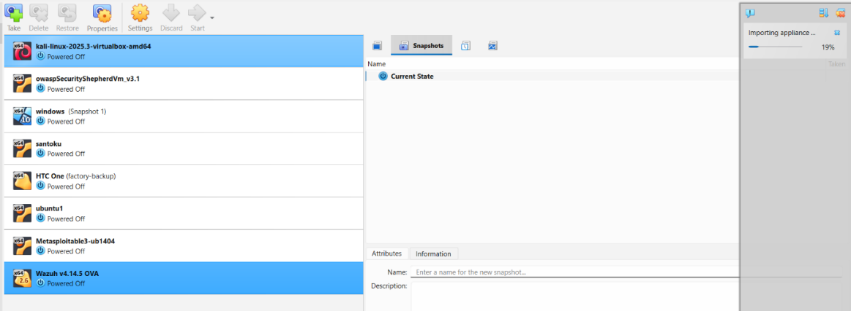
Figure 1: Oracle VirtualBox environment used for the Wazuh SOC lab.
Virtualization Setup: Oracle VirtualBox was configured with multiple VMs, including the Wazuh v4.14.5 OVA instance.
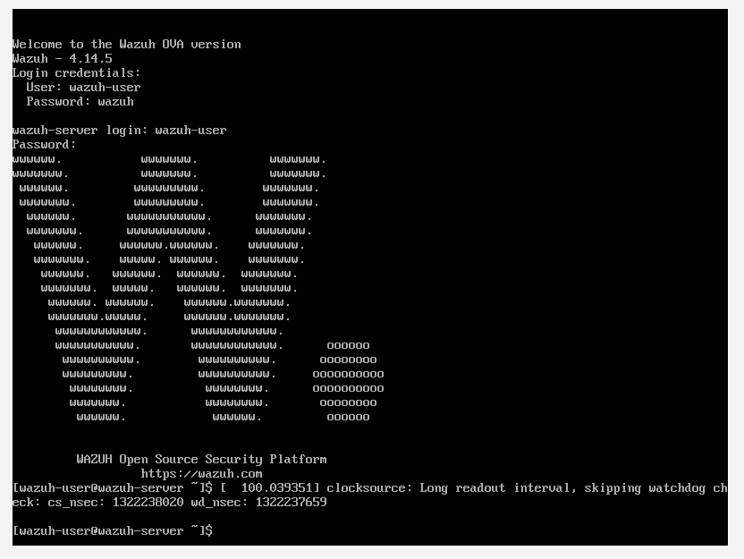
Figure 2: Wazuh server successfully booted in the virtual machine.
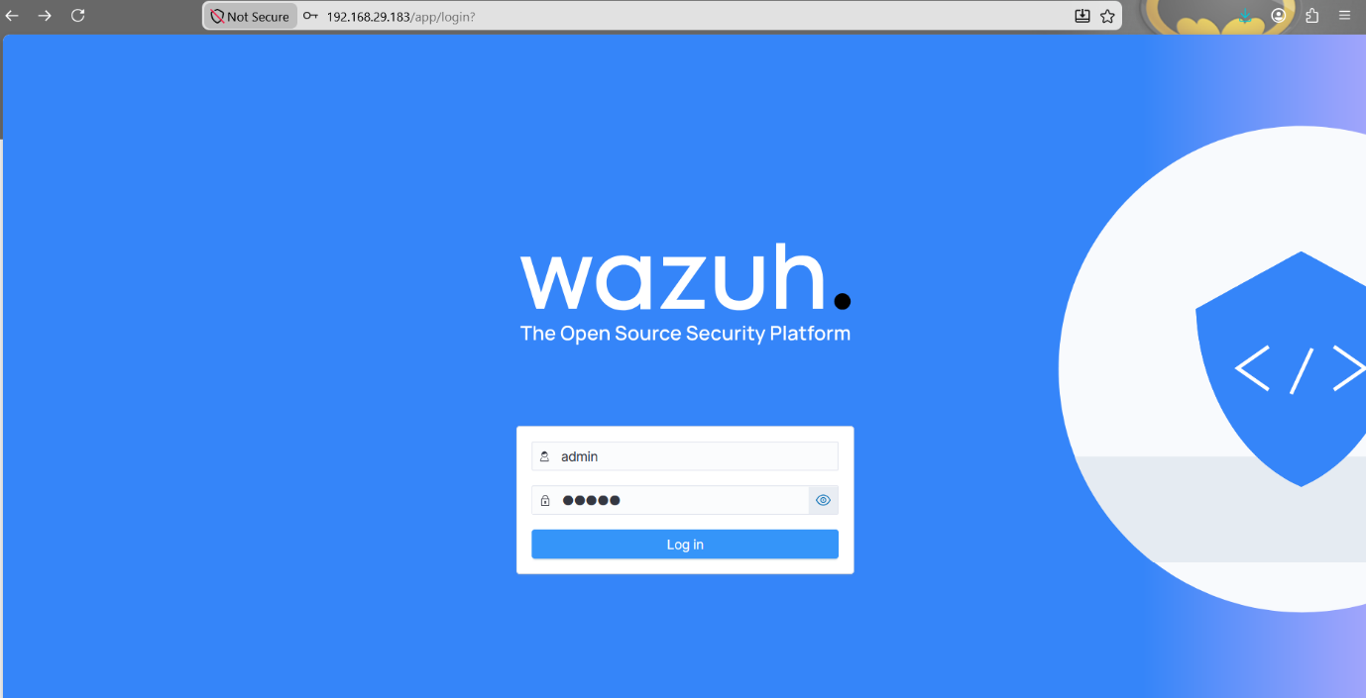
Figure 3: Wazuh web interface accessed using the manager IP address.
Wazuh Initialization: The Wazuh server was booted and the dashboard was accessed at the assigned local IP address.
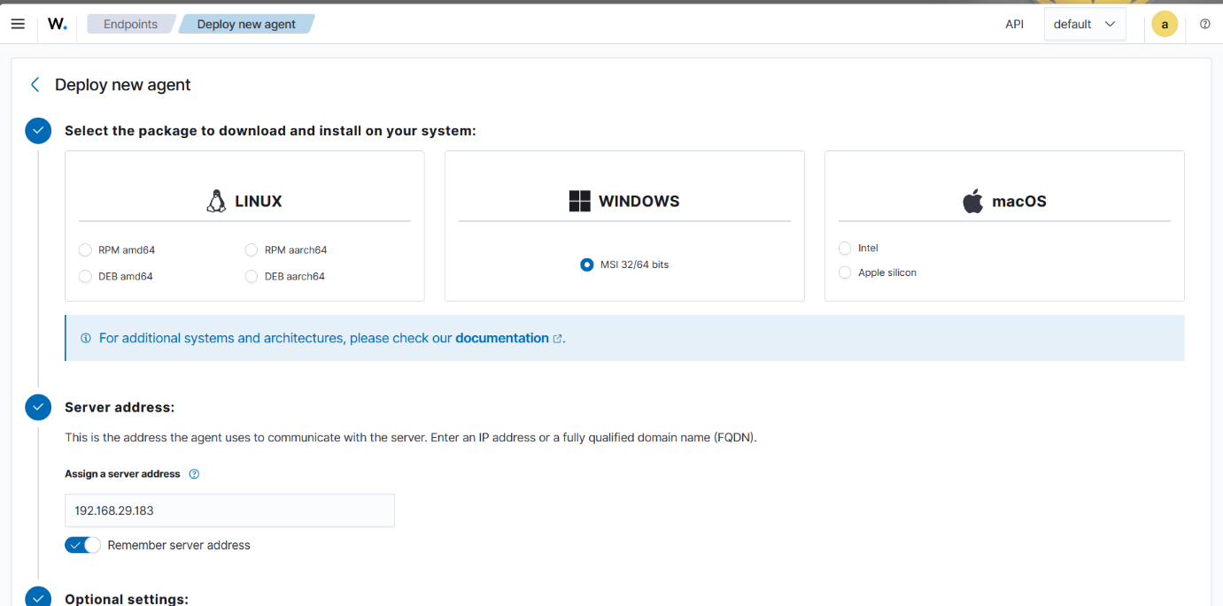
Figure 4: Wazuh agent deployment page for Windows endpoint installation.
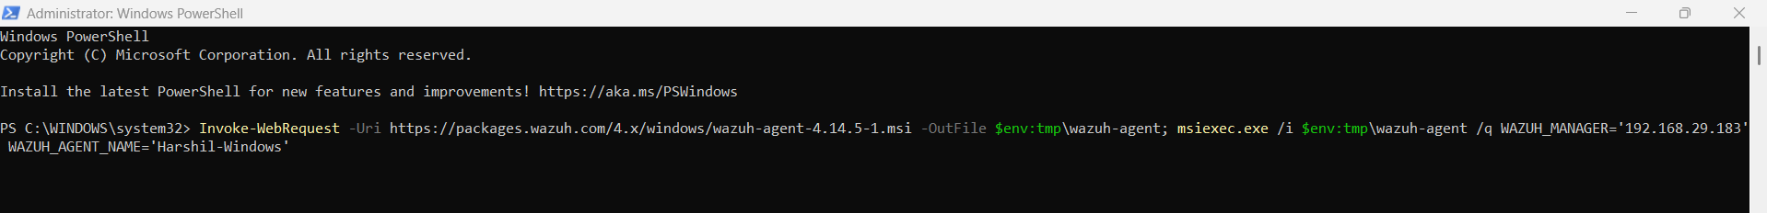
Figure 5: Windows MSI agent installation command executed through administrative PowerShell.
Agent Deployment: A Windows MSI deployment command was generated from the Wazuh UI and executed on the Windows endpoint.
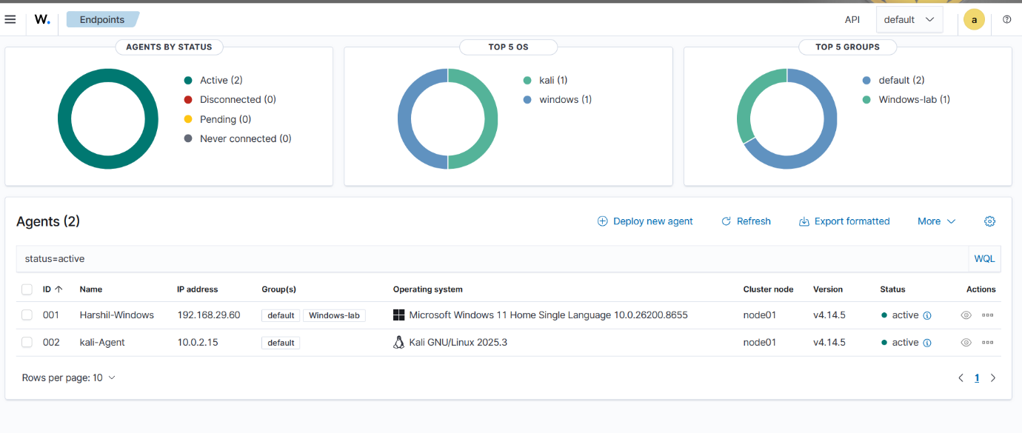
Figure 6: Wazuh dashboard showing two active agents: Windows and Kali Linux.
Endpoint Verification: The Wazuh dashboard verified successful endpoint connectivity with active Windows and Kali agents.

Week 2: Log Analysis & Event Monitoring
Objective: Understand normal versus suspicious events by filtering Windows authentication logs and endpoint telemetry.
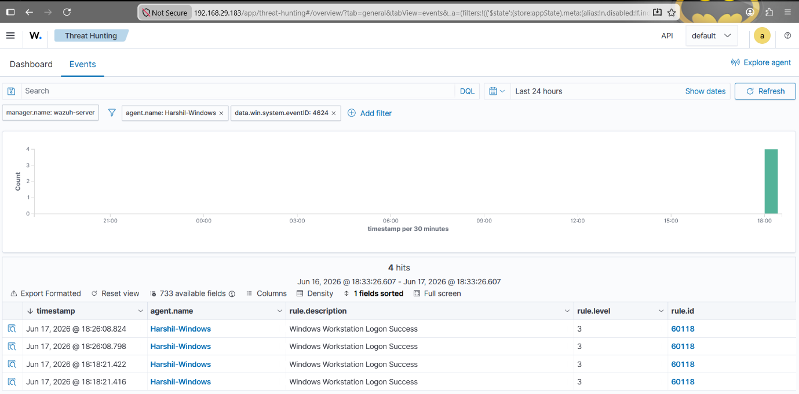
Figure 7: Windows Event ID 4624 / Rule ID 60118 showing successful logon activity.
Log Filtering - Success: The Threat Hunting dashboard was filtered for data.win.system.eventID: 4624, identifying Windows Workstation Logon Success events.
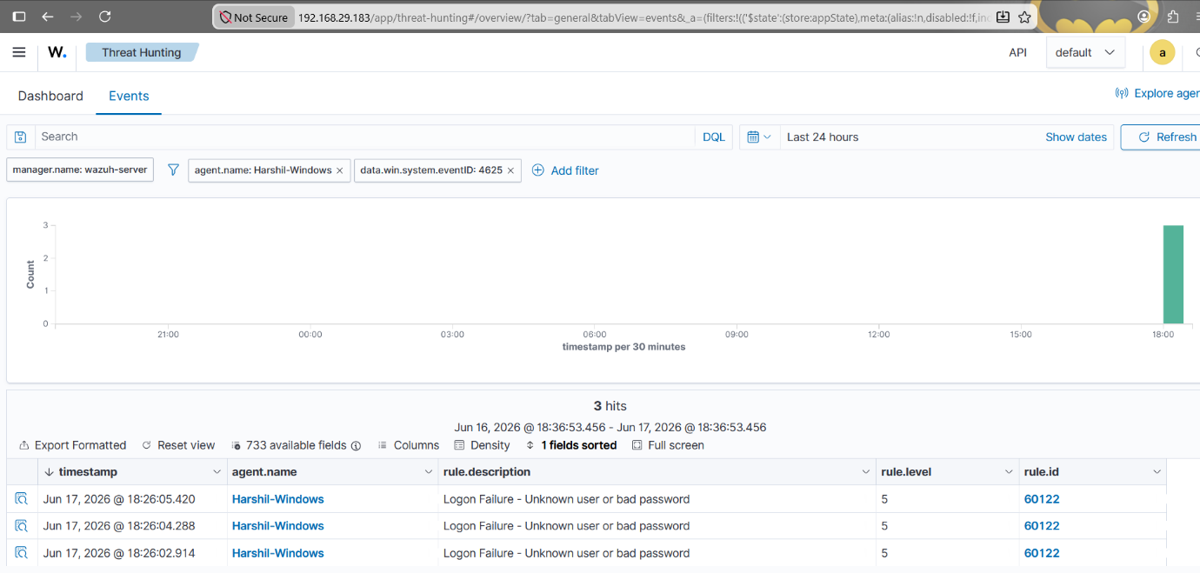
Figure 8: Windows Event ID 4625 / Rule ID 60122 showing failed logon attempts.
Log Filtering - Failure: The dashboard was filtered for data.win.system.eventID: 4625, capturing failed logon events caused by an unknown user or bad password.
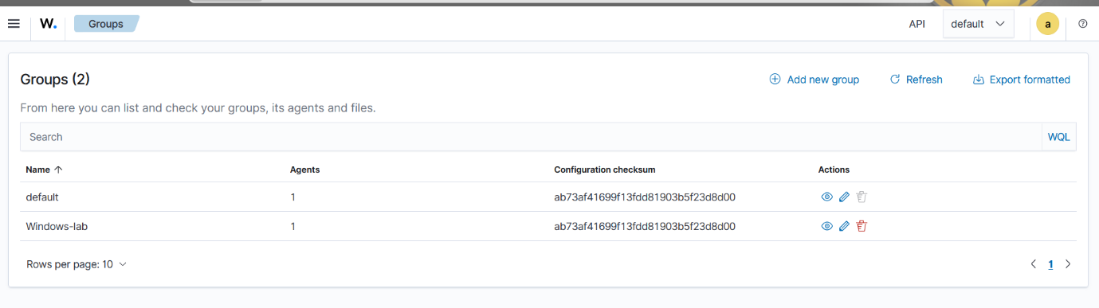
Figure 9: Custom Wazuh group named Windows-lab created for segmented management.
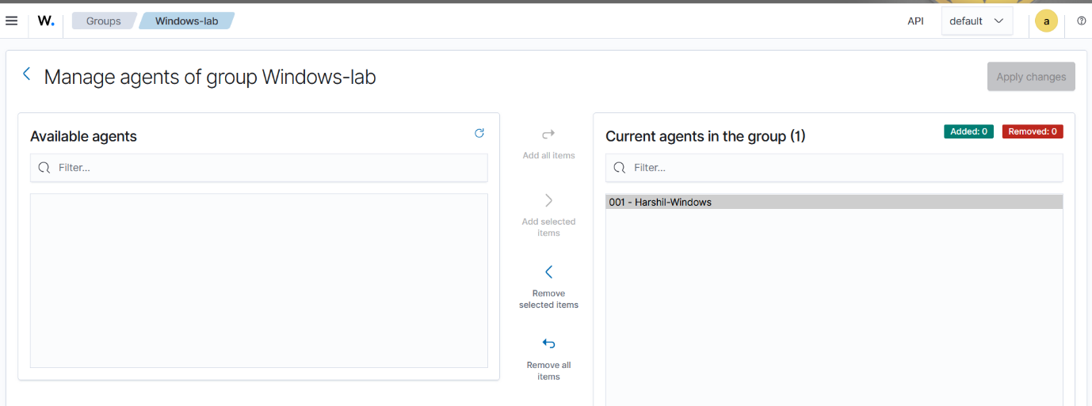
Figure 10: Harshil-Windows agent assigned to the Windows-lab group.
Agent Grouping: A custom group named Windows-lab was created and the Windows endpoint was assigned to it for organized endpoint management.

6. Top 10 Security Events Triggered
No. | Rule Description | Agent | Rule ID | Level | Count | Category
1 | SCA summary: CIS Microsoft Windows 11 Enterprise Benchmark | Harshil-Windows | 19005 | 9 | 1+ | Compliance
2 | CIS Microsoft Windows 11 Enterprise Benchmark check | Harshil-Windows | 19009 | 3 | 1+ | Compliance
3 | CIS Microsoft Windows 11 Enterprise Benchmark password policy check | Harshil-Windows | 19013 | 5 | 1+ | Compliance
4 | Windows Workstation Logon Success | Harshil-Windows | 60118 | 3 | 4 | Normal
5 | Logon Failure - Unknown user or bad password | Harshil-Windows | 60122 | 5 | 3 | Suspicious
6 | The VSS service is shutting down due to idle timeout | Harshil-Windows | 60702 | 5 | 1+ | System Event
7 | sshd: authentication failed | kali-Agent | 5710 | 5 | 470 | Suspicious
8 | sshd: brute force trying to get access to the system | kali-Agent | 5763 | 10 | 1+ | Attack Detection
9 | Anti-virus event detected / EICAR test file activity | kali-Agent | 554 | 7 | 1+ | Malware Simulation
10 | Successful sudo to ROOT executed | kali-Agent | 5402 | 3 | 1 | Privileged Command Monitoring
The events above were collected from Wazuh SIEM during Windows and Kali Linux endpoint monitoring. They include authentication success, authentication failure, brute-force detection, compliance checks, malware simulation and privileged command execution.

Week 3: Attack Simulation & Detection
Objective: Simulate attacker-like behavior in a controlled lab and verify detection through Wazuh alerts.
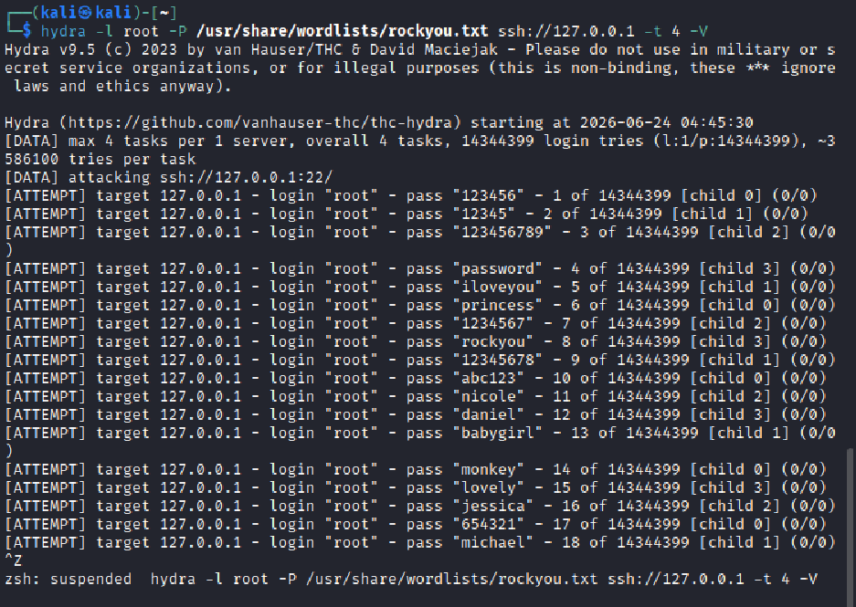
Figure 11: Controlled Hydra brute-force simulation against the local Kali SSH service.
Brute Force Simulation: A controlled brute-force simulation was performed using Hydra against the Kali SSH service. The objective was to generate authentication failure logs and validate Wazuh correlation.
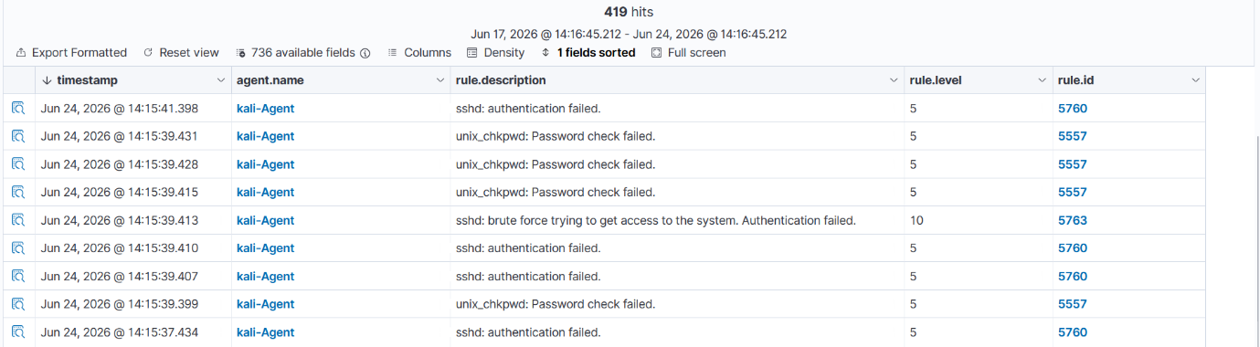
Figure 12: Wazuh detected repeated SSH authentication failures and brute-force activity.
Brute Force Detection: Wazuh detected the activity as a Level 10 brute-force alert for sshd: brute force trying to get access to the system (Rule ID 5763 / MITRE T1110).
Figure 13: Safe EICAR test string written to a local file for malware simulation.
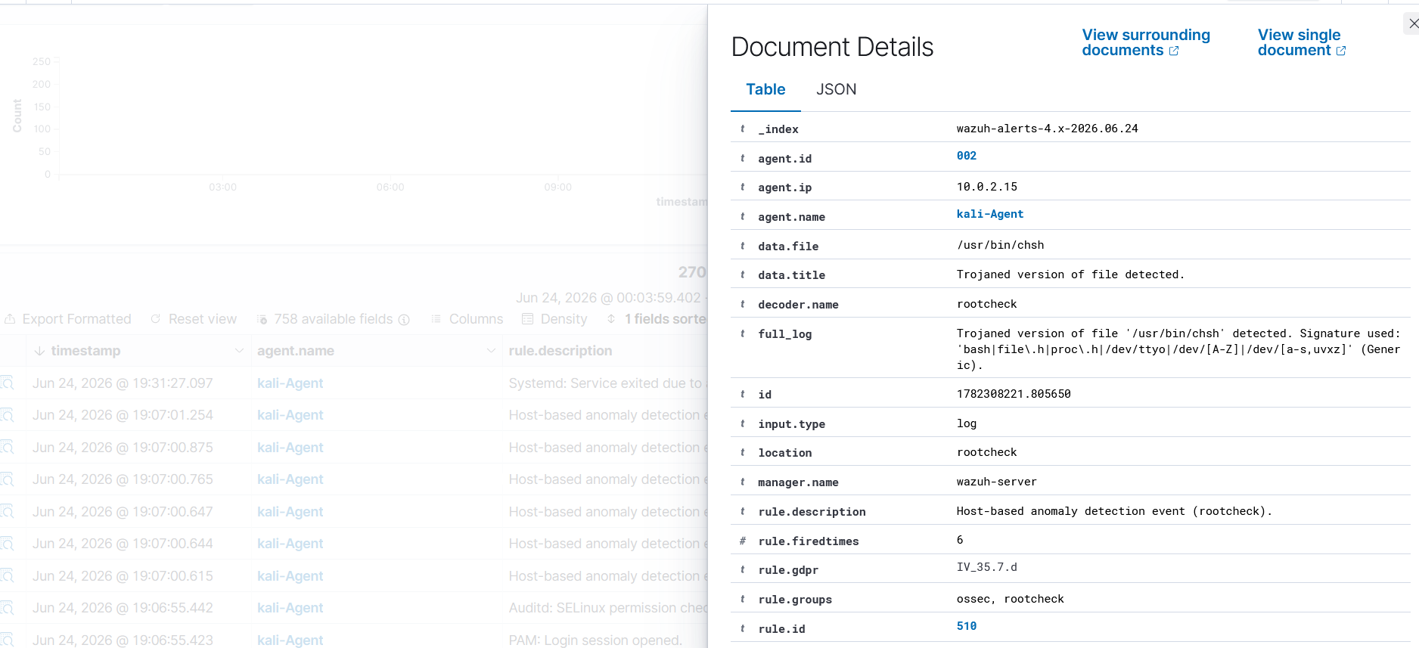
Figure 14: Wazuh event details related to EICAR test activity.
Malware Simulation: A safe EICAR antivirus test string was used to simulate malware detection behavior. This was performed only for security monitoring validation and did not involve real malware.
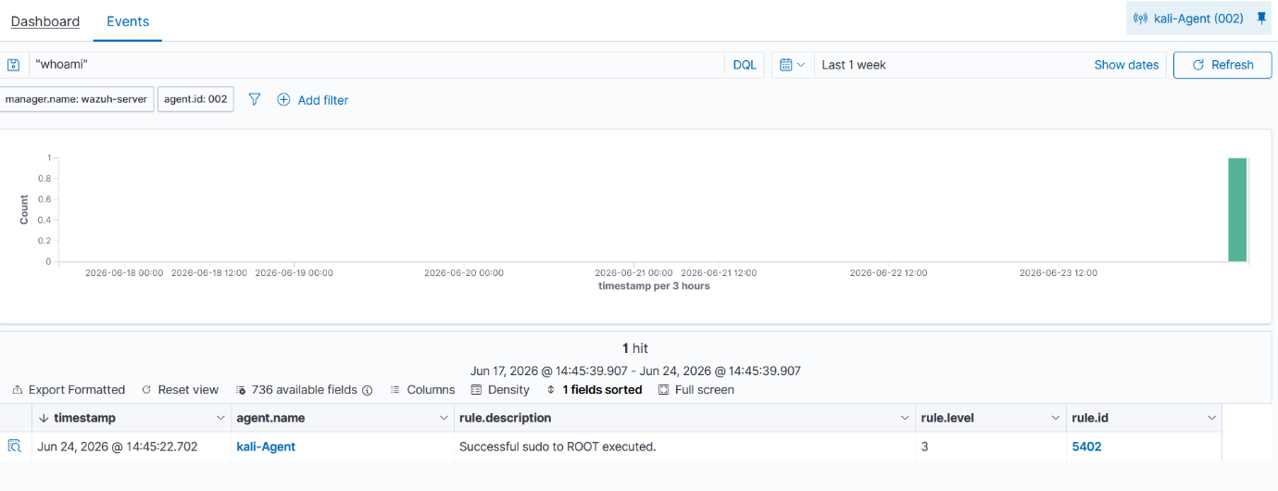
Figure 15: Wazuh event showing successful sudo to ROOT execution.
Command Monitoring: Privileged command execution was captured and verified in Wazuh as Successful sudo to ROOT executed (Rule ID 5402).

Week 4: Dashboarding & Final Reporting
Objective: Present SOC telemetry professionally using custom dashboard visualizations and final reporting.
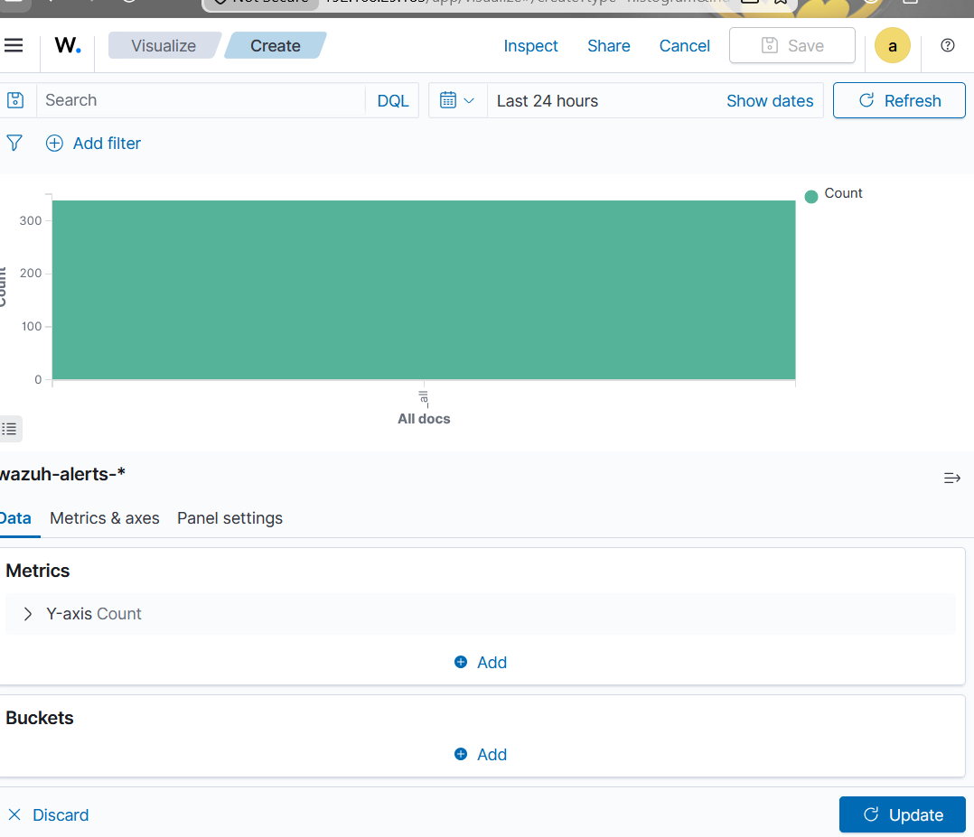
Figure 16: Custom visualization creation in Wazuh/OpenSearch Dashboards.
Visualization Creation: Custom visual metrics were designed for alert tracking, including time-based histograms and rule distribution charts.
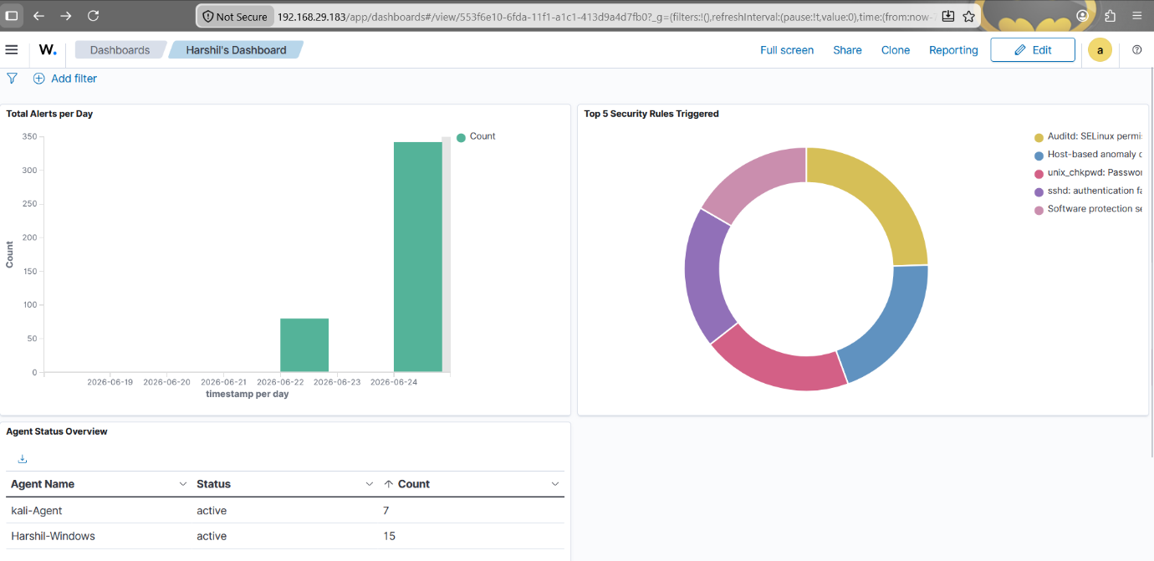
Figure 17: Final custom dashboard showing alert trends, top rules and agent status overview.
Custom Dashboard: A centralized dashboard named Harshil's Dashboard was created with Total Alerts per Day, Top 5 Security Rules Triggered and Agent Status Overview.

7. Recommendations
- Mitigate Brute-Force Attacks: Implement account lockout policies and SSH hardening controls to reduce automated credential guessing.
- Automate Threat Containment: Use Wazuh Active Response or integrate EDR controls to quickly contain known malicious indicators.
- Enforce Least Privilege: Restrict administrative access and monitor sudo/root activity to prevent unauthorized privileged operations.
- Improve Endpoint Telemetry: Integrate Sysmon for Windows and auditd for Linux to improve command and process visibility.
- Strengthen Dashboard Monitoring: Review dashboards regularly for alert spikes, repeated authentication failures and high-severity events.

8. Challenges Faced
Challenge | Resolution
Wazuh API connection issue | Resolved by restarting Wazuh services and validating manager availability.
Agent deployment issues | Resolved by verifying Wazuh Manager IP address, service status and network connectivity.
Brute-force alert timing | Generated repeated SSH failures within a short time window to trigger correlation rules.
EICAR visibility | Validated the safe test file and checked Wazuh event details for SIEM visibility.
Command monitoring limitations | Used sudo/audit-style events to confirm privileged command monitoring.

9. GitHub Repository
The GitHub repository contains configuration notes, dashboard details, detection queries and project documentation. Sensitive logs, passwords and confidential internship data were not uploaded.
Repository Link: https://github.com/your-username/SOC-Wazuh-Threat-Detection-Lab

10. Conclusion
This project successfully demonstrated the deployment of a SOC lab using Wazuh SIEM/XDR. Through Windows and Kali Linux endpoint monitoring, authentication log analysis, attack simulation, malware test detection, command monitoring and dashboard creation, the project provided practical exposure to SOC Analyst and Blue Team workflows.
The project improved understanding of how security events are generated, collected, analyzed, visualized and presented in a professional SOC report.

