Department of Computer Science and Engineering

Laboratory Manual

of

# Programming with C

is submitted to

Mrs. Halak Patel

Assistant Professor



Asha M. Tarsadia Institute of Computer Science and Technology

Uka Tarsadia University, Maliba Campus Bardoli, Gujarat

Semester — 1

(Winter 2024)



CERTIFICATE

This is to certify that Mr. /Ms. , Enrollment

No: of B. Tech. Computer Science and Engineering 1st semester

has satisfactorily completed his/her laboratory work of Programming with C during regular term in academic year 2024-25.

Date of Submission:

Department Authority

Mrs. Halak Patel Subject Teacher Assistant Professor

Department of Computer Science and Engineering

Institute Stamp

# Asha M. Tarsadia Institute of Computer Science and Technology

**Uka Tarsadia University**

**INDEX**

|  |  |  |  |
| --- | --- | --- | --- |
| **Practical No.** | **Title** | **Date** | **Sign** |
| 1 | Write a C program to show the usage of *printf* function. |  |  |
| 2 | Write a C program to print basic student details using library function - *printf()*.  ************************************************ Student Name:  Branch:  Enrollment Number:  ************************************************ |  |  |
| 3 | Write a C program that takes user-entered number and print the same number on a terminal screen. |  |  |
| 4 | Write a C program to take two integers from the user and perform arithmetic operations (addition, subtraction, division and multiplication) of two numbers. |  |  |
| 5 | Write a C program to take temperature from the user in F and display the temperature in C. |  |  |
| 6 | Write a C program to display the area as an output of various shapes (circle and rectangle) to the user. User will enter necessary parameter values. |  |  |
| 7 | Write a C program that scan an integer from the user and check whether the number is divisible by 3 or not. |  |  |
| 8 | Write a C program to take inputs of Month and Year from the user and modify it in such a way that prints month name given the month number by the user. (e.g. Input: Month: 03, Year: 2023 Output: Month: March) |  |  |
| 9 | Write a C program to take three integers from the user and print the largest among them. |  |  |
| 10 | Write a C program that display the grade of the student given the marks. |  |  |
| 11 | Write a C program to basic calculator using switch control structure. |  |  |
| 12 | Write a C program that prints the table of 1, 2 and 3 to user using looping statements. |  |  |
| 13 | Write a C program that scan a number from the terminal and print factorial of the number. |  |  |

|  |  |  |  |
| --- | --- | --- | --- |
| 14 | Write a C program that prints all the prime numbers between 1 to 100. |  |  |
| 15 | Write a C program that prints various patterns using looping statements. |  |  |
| 16 | Write a C program that accept the roll no and marks of twenty students using an array. Display the same array to user in appropriate tabular format. |  |  |
| 17 | Write a program to perform various string operations on user entered string. |  |  |
| 18 | Write a C program to add two user-entered numbers using user defined function named add(). Demonstrate the variations of user defined function. |  |  |
| 19 | Write a C program to swap two user entered numbers using user defined function named *swap()*. |  |  |
| 20 | Write a C program to find factorial of user entered number using recursion. |  |  |
| 21 | Write a simple C program to show the use of a pointer. |  |  |
| 22 | Write a C program using pointer to read an array of integers and print the elements in reverse order. |  |  |
| 23 | Write a C program to store a character string in block of memory space created by *malloc()* and then modify the same to store a large string. |  |  |
| 24 | Define a structure type struct *person* that would contain *person_name*, *date_of_joining* and *salary*. Using this structure, write a C program to read this information for one person from the user and print the same on the screen. |  |  |
| 25 | Write a C program that takes student details (*student_name, student_rool_no, student_address)* for ten students from user. Create a file named *student_data.txt* and store this record in this file. Design a user defined function named *fetch_record* that reads the file and displays the content on a terminal. |  |  |

## Practical 1

**AIM :** Write a C program to show the usage of printf function.

**Code :**

/************************************************ Student Name: Bawaskar Ritesh

Branch: B.Tech ICSE

Enrollment Number: 202403103510077

************************************************/ #include <stdio.h>

int main() { int age = 69;

float height = 5.9;

char name[] = "Bawaskar Ritesh";

printf("Name: %s\n", name); printf("Age: %d\n", age); printf("Height: %.1f feet\n", height);

return 0;

}

**Output :**

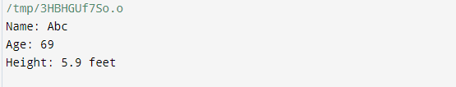

/tmp/B6o5jcddfq.o

Name: Bawaskar Ritesh Age: 69

Height: 5.9 feet

## Practical 2

**AIM :** Write a C program to print basic student details using library function - printf().

************************************************ Student Name: Bawaskar Ritesh

Branch: B.Tech ICSE

Enrollment Number: 202403103510077

************************************************

**Code :**

#include <stdio.h> int main() {

char name[] = "Bawaskar Ritesh"; char branch[] = "B.Tech ICSE";

long enrollment_number = 202403103510077;

printf("************************************************\n"); printf("Student Name: %s\n", name);

printf("Branch: %s\n", branch);

printf("Enrollment Number: %ld\n", enrollment_number); printf("************************************************\n");

return 0;

}

**Output :**

/tmp/B6o5jcddfq.o

************************************* Student Name: Bawaskar Ritesh

Branch: B.Tech ICSE

Enrollment Number: 202403103510077

*************************************

## Practical 3

**AIM :** Write a C program that takes user-entered number and print the same number on a terminal screen

**Code :**

/************************************************ Student Name: Bawaskar Ritesh

Branch: B.Tech ICSE

Enrollment Number: 202403103510077

************************************************/ #include <stdio.h>

int main() {

int number;

printf("Enter a number: "); scanf("%d", &number);

printf("You entered: %d\n", number);

return 0;

}

**Output :**

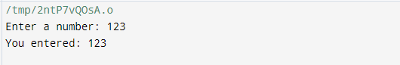

## Practical 4

**AIM :** Write a C program to take two integers from the user and perform arithmetic operations (addition, subtraction, division and multiplication) of two numbers.

**Code :**

/************************************************ Student Name: Bawaskar Ritesh

Branch: B.Tech ICSE

Enrollment Number: 202403103510077

************************************************/ #include <stdio.h>

int main() {

int num1, num2;

int sum, difference, product; float quotient;

printf("Enter first integer: "); scanf("%d", &num1); printf("Enter second integer: "); scanf("%d", &num2);

sum = num1 + num2; difference = num1 - num2; product = num1 * num2; quotient = (float)num1 / num2;

printf("Addition: %d\n", sum); printf("Subtraction: %d\n", difference); printf("Multiplication: %d\n", product);

if (num2 != 0) {

printf("Division: %.2f\n", quotient);

} else {

printf("Division: Cannot divide by zero!\n");

}

return 0;

}

**Output :**

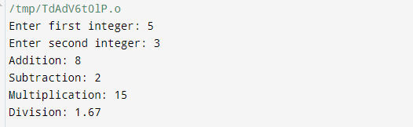

## Practical 5

**AIM :** Write a C program to take temperature from the user in F and display the temperature in C.

**Code :**

/************************************************ Student Name: Bawaskar Ritesh

Branch: B.Tech ICSE

Enrollment Number: 202403103510077

************************************************/ #include <stdio.h>

int main() {

float fahrenheit, celsius;

printf("Enter temperature in Fahrenheit: "); scanf("%f", &fahrenheit);

celsius = (fahrenheit - 32) * 5 / 9; printf("Temperature in Celsius: %.2f\n", celsius);

return 0;

}

**Output :**

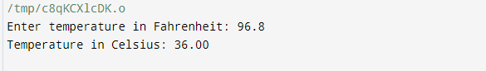

## Practical 6

**AIM :** Write a C program to display the area as an output of various shapes (circle and rectangle) to the user. User will enter necessary parameter values.

**Code :**

/************************************************ Student Name: Bawaskar Ritesh

Branch: B.Tech ICSE

Enrollment Number: 202403103510077

************************************************/

#include <stdio.h> #define PI 3.14159

int main() { int choice; float area;

printf("Select a shape to calculate the area:\n"); printf("1. Circle\n");

printf("2. Rectangle\n"); printf("Enter your choice (1 or 2): "); scanf("%d", &choice);

switch (choice) { case 1: // Circle

{

float radius;

printf("Enter the radius of the circle: "); scanf("%f", &radius);

area = PI * radius * radius;

printf("Area of the circle: %.2f\n", area); break;

}

case 2: // Rectangle

{

float length, width;

printf("Enter the length of the rectangle: "); scanf("%f", &length);

printf("Enter the width of the rectangle: "); scanf("%f", &width);

area = length * width;

printf("Area of the rectangle: %.2f\n", area); break;

}

default:

printf("Invalid choice!\n");

}

return 0;

}

**Output :**

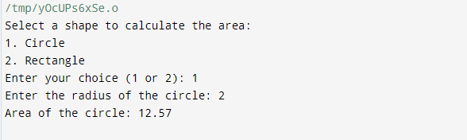

## Practical 7

**AIM :** Write a C program that scan an integer from the user and check whether the number is divisible by 3 or not.

**Code :**

/************************************************ Student Name: Bawaskar Ritesh

Branch: B.Tech ICSE

Enrollment Number: 202403103510077

************************************************/ #include <stdio.h>

int main() {

int number;

printf("Enter an integer: "); scanf("%d", &number);

if (number % 3 == 0) {

printf("%d is divisible by 3.\n", number);

} else {

printf("%d is not divisible by 3.\n", number);

}

return 0;

}

**Output :**

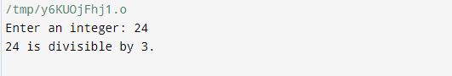

## Practical 8

**AIM :** Write a C program to take inputs of Month and Year from the user and modify it in such a way that prints month name given the month number by the user. (e.g. Input: Month: 03, Year: 2023 Output: Month: March)

**Code :**

/************************************************ Student Name: Bawaskar Ritesh

Branch: B.Tech ICSE

Enrollment Number: 202403103510077

************************************************/ #include <stdio.h>

int main() {

int month, year;

printf("Enter Month (1-12): "); scanf("%d", &month); printf("Enter Year: "); scanf("%d", &year);

printf("Month: "); switch (month) {

case 1:

printf("January\n"); break;

case 2:

printf("February\n"); break;

case 3:

printf("March\n"); break;

case 4:

printf("April\n"); break;

case 5:

printf("May\n"); break;

case 6:

printf("June\n"); break;

case 7:

printf("July\n"); break;

case 8:

printf("August\n"); break;

case 9:

printf("September\n"); break;

case 10:

printf("October\n"); break;

case 11:

printf("November\n"); break;

case 12:

printf("December\n"); break;

default:

printf("Invalid Month!\n");

}

return 0;

}

**Output :**

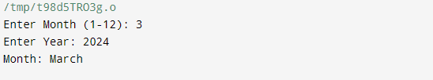

## Practical 9

**AIM :** Write a C program to take three integers from the user and print the largest among them.

**Code :**

/************************************************ Student Name: Bawaskar Ritesh

Branch: B.Tech ICSE

Enrollment Number: 202403103510077

************************************************/ #include <stdio.h>

int main() {

int num1, num2, num3;

// Prompt the user for three integers printf("Enter first integer: "); scanf("%d", &num1); printf("Enter second integer: "); scanf("%d", &num2); printf("Enter third integer: "); scanf("%d", &num3);

// Determine the largest number int largest;

if (num1 >= num2 && num1 >= num3) { largest = num1;

} else if (num2 >= num1 && num2 >= num3) { largest = num2;

} else {

largest = num3;

}

// Print the largest number

printf("The largest number is: %d\n", largest);

return 0;

}

**Output :**

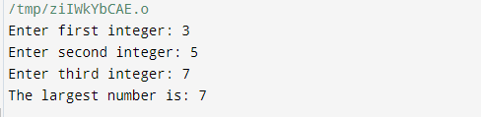

## Practical 10

**AIM :** Write a C program that display the grade of the student given the marks.

**Code :**

/************************************************ Student Name: Bawaskar Ritesh

Branch: B.Tech ICSE

Enrollment Number: 202403103510077

************************************************/ #include <stdio.h>

int main() {

float marks;

// Prompt the user for marks

printf("Enter the marks obtained (0-100): "); scanf("%f", &marks);

// Determine the grade based on marks if (marks >= 90 && marks <= 100) {

printf("Grade: A\n");

} else if (marks >= 80) { printf("Grade: B\n");

} else if (marks >= 70) { printf("Grade: C\n");

} else if (marks >= 60) { printf("Grade: D\n");

} else if (marks >= 0) { printf("Grade: F\n");

} else {

printf("Invalid marks entered! Please enter marks between 0 and 100.\n");

}

return 0;

}

**Output :**

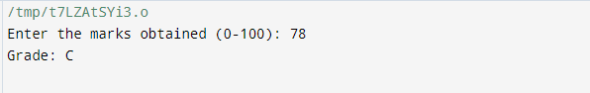

## Practical 11

**AIM : Write a C program to basic calculator using switch control structure. Code :**

/************************************************ Student Name: Bawaskar Ritesh

Branch: B.Tech ICSE

Enrollment Number: 202403103510077

************************************************/

#include <stdio.h> int main() {

char operator; double num1, num2;

// Take user input

printf("Enter an operator (+, -, *, /): "); scanf("%c", &operator);

printf("Enter two operands: "); scanf("%lf %lf", &num1, &num2);

// Switch case to perform operations switch (operator) {

case '+':

printf("%.2lf + %.2lf = %.2lf\n", num1, num2, num1 + num2); break;

case '-':

printf("%.2lf - %.2lf = %.2lf\n", num1, num2, num1 - num2); break;

case '*':

printf("%.2lf * %.2lf = %.2lf\n", num1, num2, num1 * num2); break;

case '/':

if (num2 != 0)

printf("%.2lf / %.2lf = %.2lf\n", num1, num2, num1 / num2); else

printf("Error! Division by zero.\n"); break;

default:

printf("Error! Operator is not correct.\n");

}

return 0;

}

Output:

/tmp/B6o5jcddfq.o

Enter an operator (+, -, *, /): + Enter two operands: 5 6

5.00 + 6.00 = 11.00