AWS Assignment – Customer Management System

Name - Harshil Sheth

1. Admin Dashboard

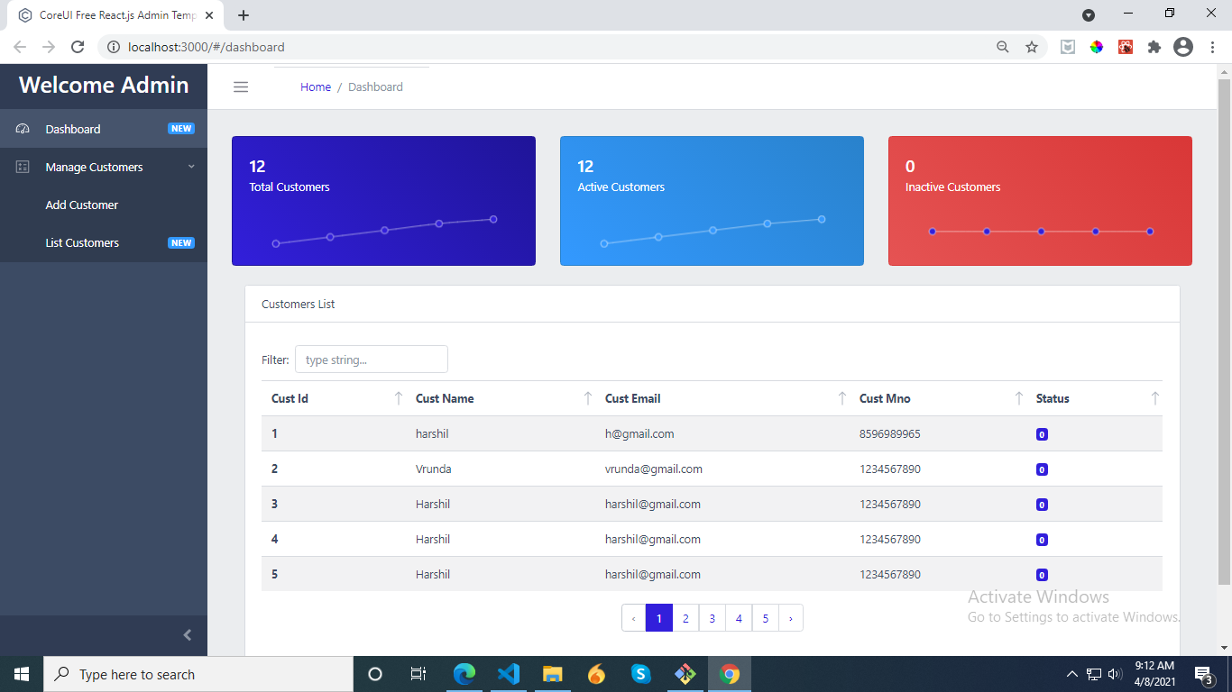
2. Add Customer
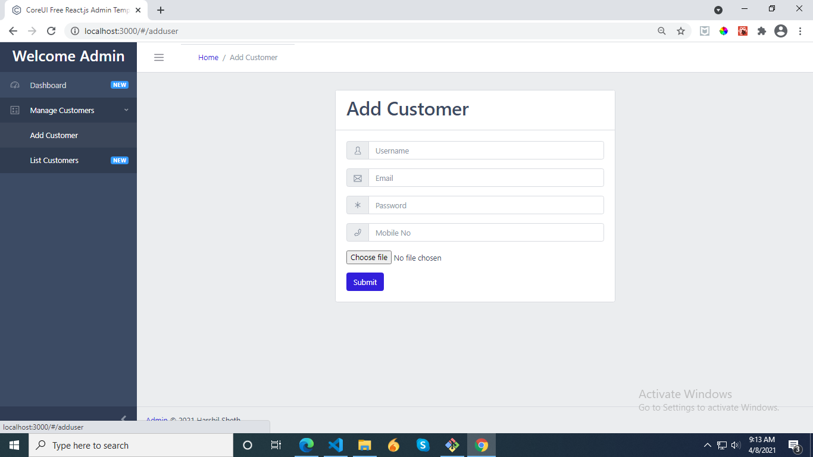
3. List Customers
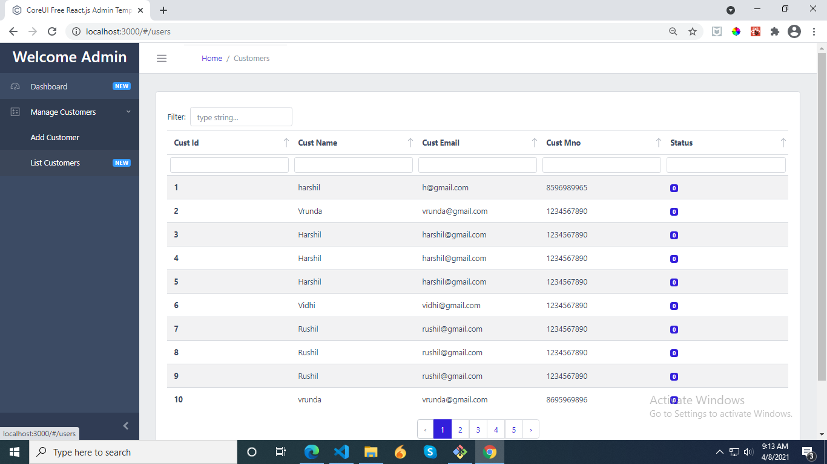
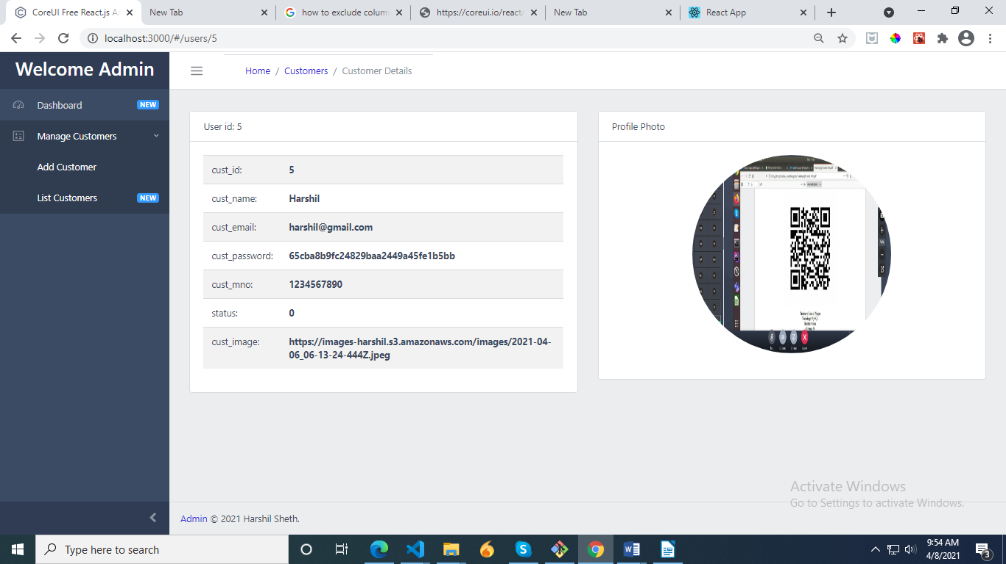
4. Customer Details

