Git Branching, Merging, Reset, and Rebase Using Flask Project

Objective
The objective of this assignment is to understand and implement advanced Git operations including SSH setup, branch creation, merging, conflict resolution, git reset, and rebasing using a Flask-based project.

Tools Used
- Git & Git Bash
- GitHub
- Python (Flask)
- HTML
- Nano Editor
- Windows OS

Step 1: GitHub Repository & SSH Setup
- A new GitHub repository was created.
- SSH key was generated using ssh-keygen command.
- The public SSH key was added to the GitHub account.
- SSH authentication was verified using ssh -T git@github.com.

Step 2: Cloning Repository & Initial Branch
- The repository was cloned using SSH.
- A new branch named Harshil was created.
- Flask project files were added and committed.
- The branch was merged into the main branch.
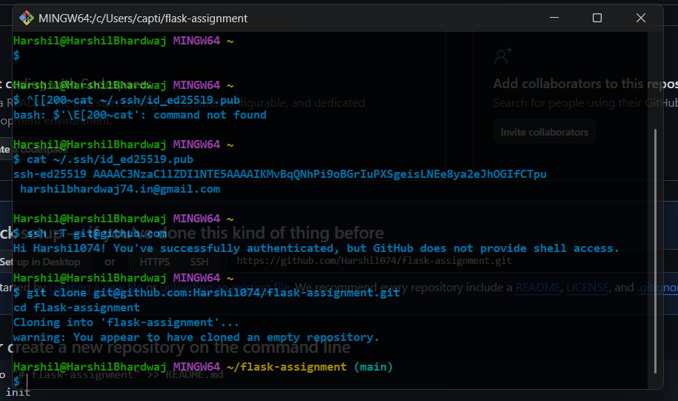

Step 3: JSON API Update Branch
- A new branch named Harshil_new was created.
- A data.json file was created and updated for the /api route.
- Changes were committed and merged into the main branch.
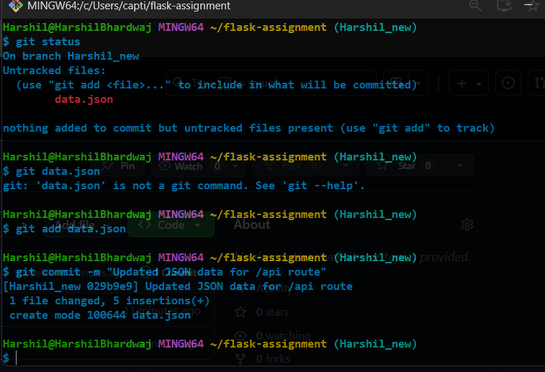

Step 4: Frontend & Backend Separation
- Frontend development was done in master_1 branch by creating a To-Do form page using HTML.
- Backend development was done in master_2 branch by creating a Flask POST API route /submittodoitem.
- Both branches were merged into the main branch.
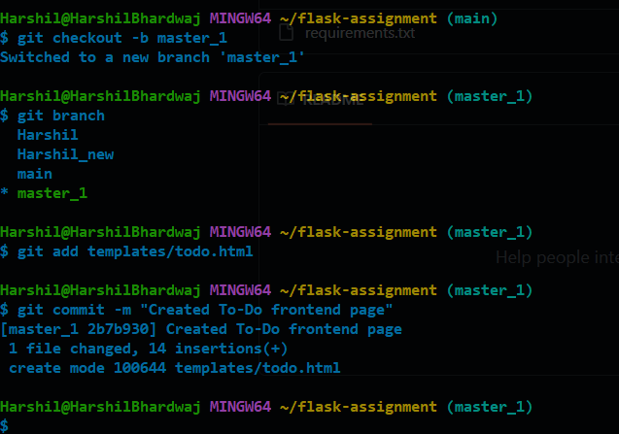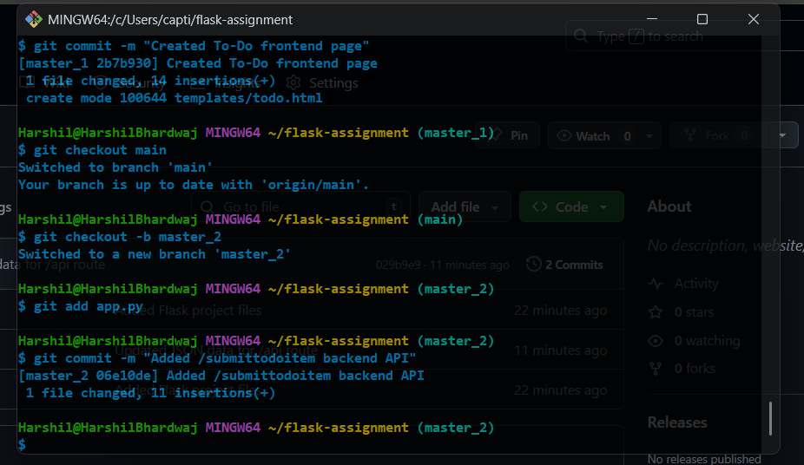

Step 5: Enhancing To-Do Form with Separate Commits
- Item ID field was added and committed.
- Item UUID field was added and committed.
- Item Hash field was added and committed separately.
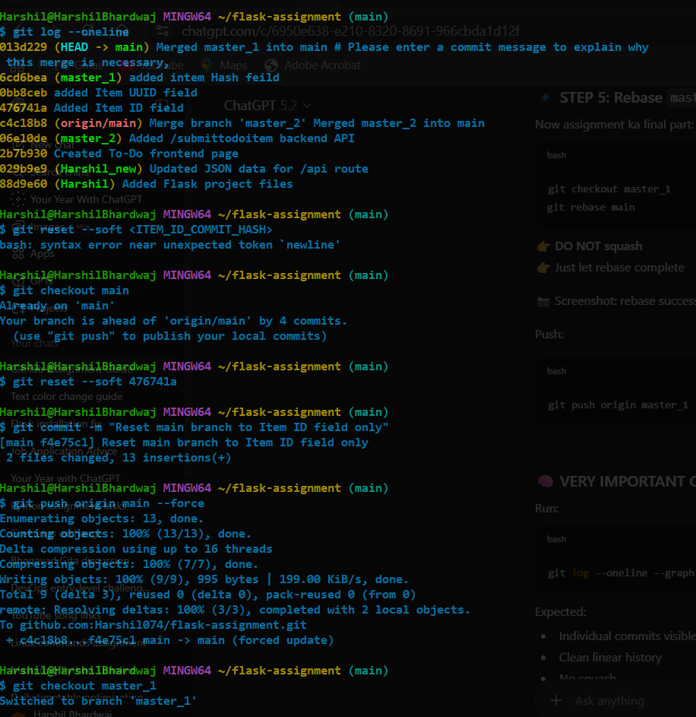

Step 6: Git Reset (Soft)
- The main branch was reset to the commit where only Item ID existed using git reset --soft.
- The state was recommitted and force-pushed to GitHub.
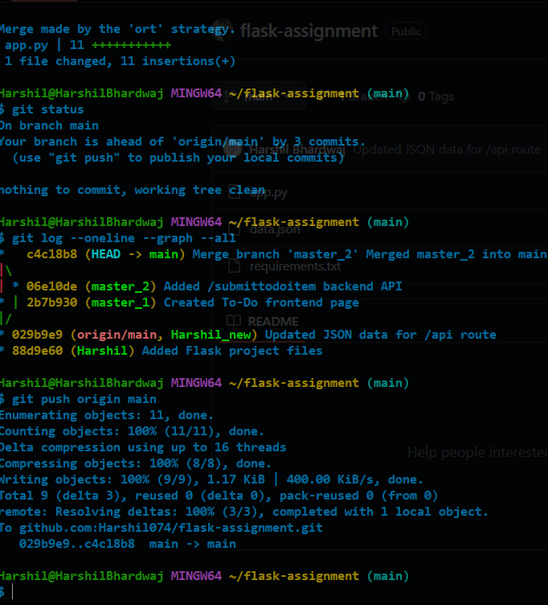

Step 7: Git Rebase with Conflict Resolution
- The updated main branch was rebased into master_1.
- A merge conflict occurred in templates/todo.html.
- The conflict was resolved manually by preserving all required fields.
- Rebase was completed using git rebase --continue.
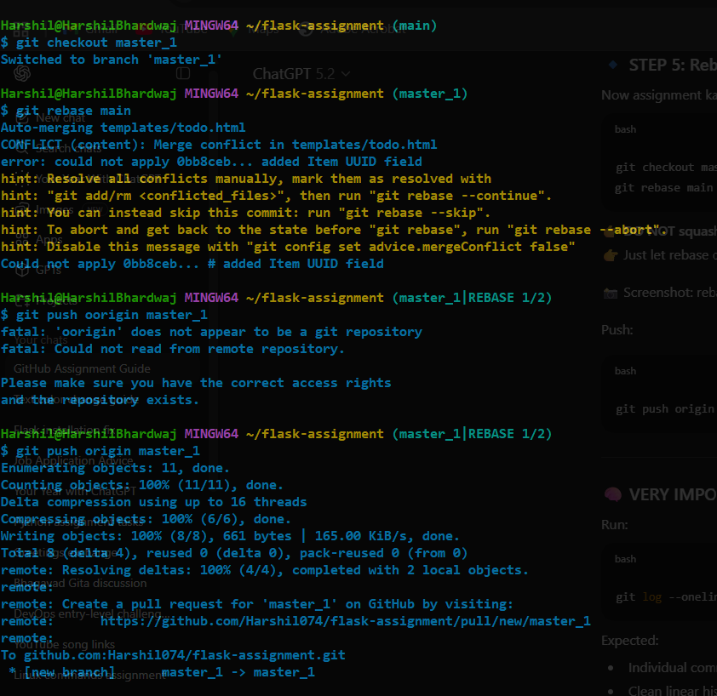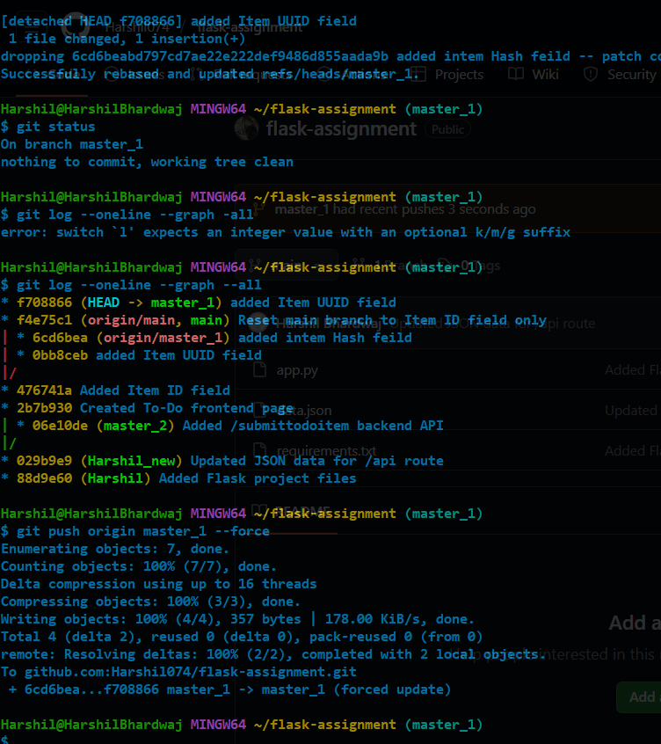

Conclusion
This assignment provided hands-on experience with real-world Git workflows including branching strategies, merge conflict resolution, soft reset, and rebasing without squashing commits. These practices are essential for collaborative software development.

GitHub Repository Link
https://github.com/Harshil074/flask-assignment

