Flask Application with MongoDB Atlas Integration

Objective
The objective of this project is to develop a Flask-based web application that provides a REST API and a frontend form. The application reads data from a backend JSON file and returns it as a JSON response. It also accepts user input from a form and stores the data securely in MongoDB Atlas using PyMongo.

Tools and Technologies Used
- Python
- Flask
- MongoDB Atlas
- PyMongo
- HTML
- JSON
- Visual Studio Code

Project Structure
flask-mongo-assignment/
│
├── app.py
├── data.json
├── requirements.txt
├── .env
├── templates/
│ ├── form.html
│ └── success.html
└── README.md

Project Explanation

Flask Framework
Flask is a lightweight Python web framework used to create the backend of the application. It handles routing, HTTP requests, responses, and template rendering for frontend pages.

API Route (/api)
A backend JSON file is used to store sample data. The /api route reads the contents of this file and returns it as a JSON response using Flask.

MongoDB Atlas Integration
MongoDB Atlas is used as a cloud-based NoSQL database. PyMongo is used to connect Flask with MongoDB Atlas using a secure connection string.

Form Handling and Data Insertion
The frontend form collects user input and submits it to Flask. The submitted data is inserted into MongoDB Atlas using PyMongo. On successful insertion, the user is redirected to a success page.

Screenshot

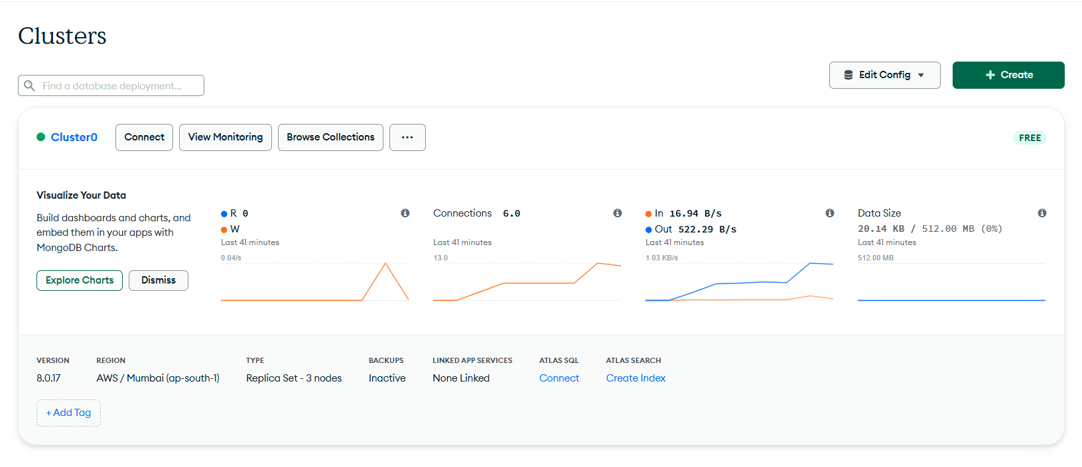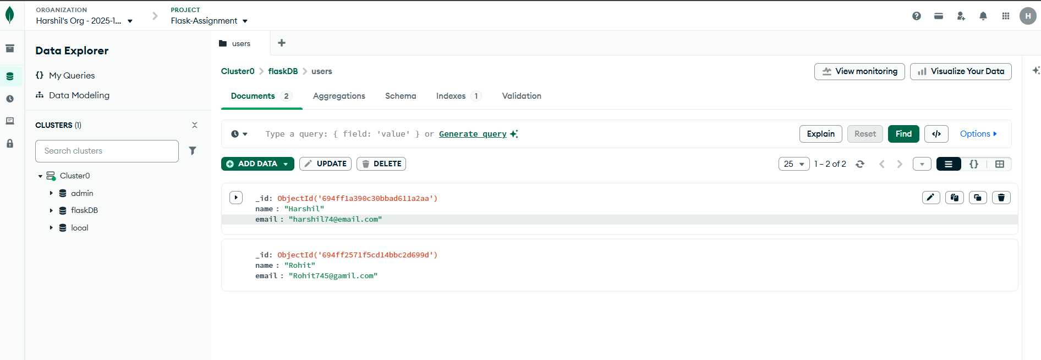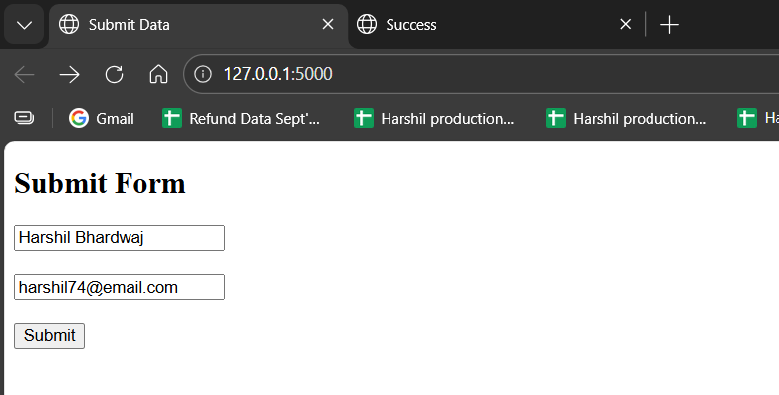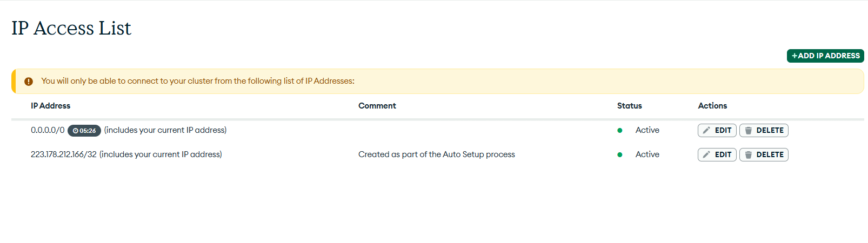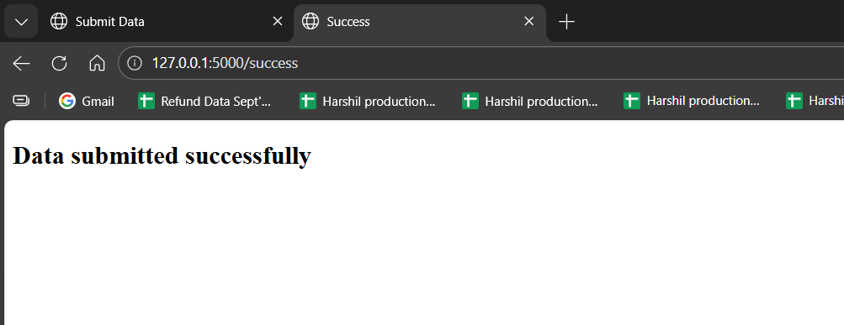

Conclusion
This project demonstrates the integration of Flask with MongoDB Atlas using PyMongo. It showcases REST API creation, form handling, database interaction, and error handling.

