Assignment

Module -3: Understanding And Maintenance Of Networks

Section 1: Multiple Choice

1. What is the primary function of a router in a computer network?

Ans :- Forwarding data packets between networks.

1. What is the purpose of DNS (Domain Name System) in a computer network?

Ans :- Converting domain names to IP addresses

1. What type of network topology uses a centralized hub or switch to connect all device ?

Ans :- Star

1. Which network protocol is commonly used for securely accessing and transferring files over a network?

Ans :- FTP

Section 2: True or False

1. True or False: A firewall is a hardware or software-based security system that monitors and controls incoming and outgoing network traffic based on predetermined security rules.

Ans :- True

1. True or False: DHCP (Dynamic Host Configuration Protocol) assigns static IP addresses to network devices automatically.

Ans :- False

1. True or False: VLANs (Virtual Local Area Networks) enable network segmentation by dividing a single physical network into multiple logical networks.

Ans :- True

Section 3: Short Answer

1. Explain the difference between a hub and a switch in a computer network.

Ans :- 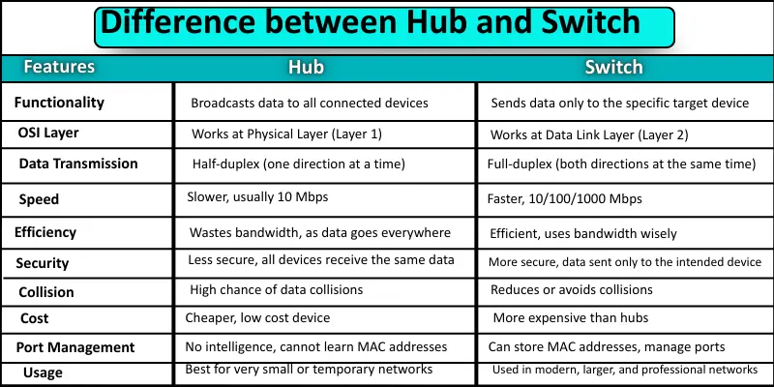

1. Describe the process of troubleshooting network connectivity issues.

Ans :- 1. Identify the problem.

2. Define the scope.

3. Check Physical Connection.

4. Restart Network Connection.

5. Verify Network Setting.

6. Use Diagnostic Tool.

7. Check Firewall & Security Software.

8. Run Built- - in Troubleshooters.

9. Monitor Network Performance.

10. Contact ISP or Escalate.

Section 4: Practical Application

1. Demonstrate how to configure a wireless router's security settings to

enhance network security.

Ans :- log in to the router's admin page and update the firmware. Next,

Next, change the default admin password and the Wi-Fi password

to a strong  unique one, and select WPA3 or WPA2-AES for the

wireless encryption settings. Finally, disable unnecessary features

like remote management and WPS, and enable the built-in

firewall.

1. Discuss the importance of regular maintenance for computer hardware a

and provide examples of maintenance tasks.

Ans :- Network documentation is a cornerstone of effective IT management and cybersecurity. It ensures that your network is understandable, maintainable, and secure—especially in complex environments or during troubleshooting, upgrades, audits, or disaster recovery.