Assignment

Module -1: Understanding of Hardware and

Its Components.

Section 1: Multiple Choice

1. Which of the following is NOT a component of the CPU ?

Ans :- RAM

1. What is the function of RAM in a computer ?

Ans :- The Basic Function of RAM in computer is store

Temporary data and speed up computer.

1. Which of the following is a primary storage device ?

Ans :- HDD / SSD

1. What is the purpose of a GPU ?

Ans :- The basic purpose of GPU is to control graphics

of high resolution photos and make realistic graphics

in high graphical games.

Section 2: True or False

1. True or False: The motherboard is the main circuit board of a computer where other components are attached.

Ans :- True

1. True or False: A UPS (Uninterruptible Power Supply) is a hardware device that provides emergency power to a load when the input power source fails.

Ans :- True

1. True or False: An expansion card is a circuit board that enhances the functionality of a component.

Ans :- True

Section 3: Short Answer

1. Explain the difference between HDD and SSD.

Ans :- HDD: Store data, HDD is Slower then SSD, available in cheaper rate in market.

SSD: Store data, SSD is Faster then HDD, available in expensive rate in market.

1. Describe the function of BIOS in a computer system.

Ans :- BIOS is the different function to boot OS.

1. List and briefly explain three input devices commonly used with

Computers.

Ans :- Keyboard & Mouse.

Section 4: Practical Application

1. Identify and label the following components on a diagram of a

motherboard:

Ans :-

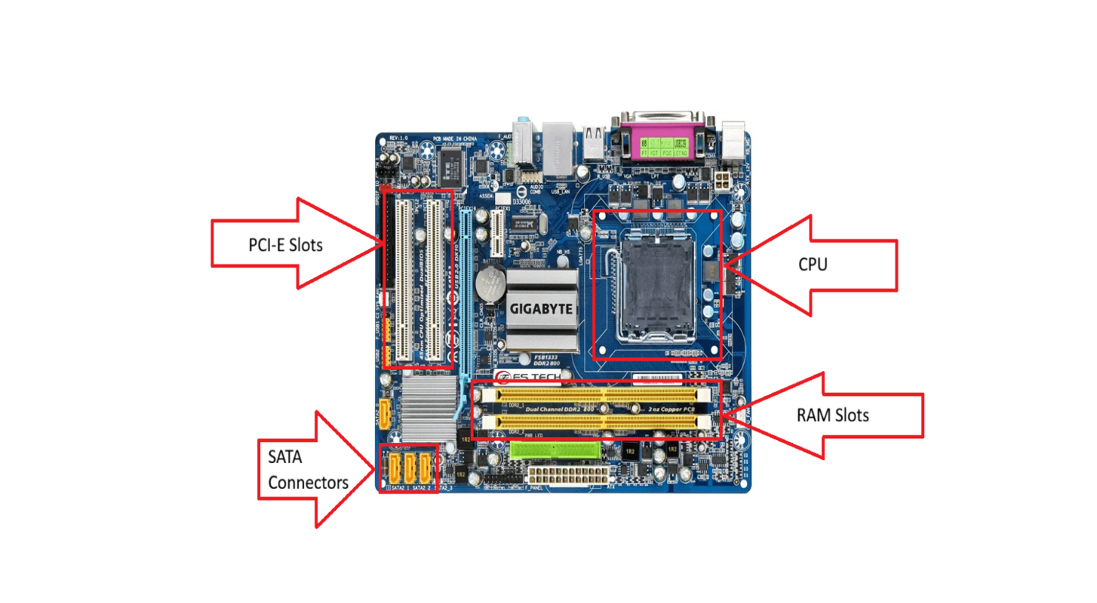

1. Demonstrate how to install a RAM module into a computer.

Ans :- 1. Shut down your device & remove plug.

2. unscrew the covers & find the ram slots.

3. connect ram to it’s right pin spots and

push it down to metal clips.

4. now screw the covers and start device.

1. Discuss the importance of proper cooling mechanisms in a computer

system. Include examples of cooling methods and their effectiveness.

Ans :- 1. Air Cooling :- It uses heatsinks and fans to dissipate heat from

components, air cooling unit is affordable and easy to install.

2. Liquid Cooling :- This unit Circulates coolant through blocks

and radiators to absorb and release heat, it gives high –

performance.

3. Passive Cooling :- This unit Relies on heat spreaders and natural

airflow without fans, this unit is silent.

1. Explain the concept of bus width and its significance in computer architecture.

Ans :- Bus width mentions bits of computer, and bus is communication

pathway & connect components of computer likes CPU, memory.

Bus width is a fundamental concept in computer architecture that

directly shows how efficiently data moves within a computer, it

shows data transfer speed.