EMPLOYEE ATTRITION AND WORKFORCE ANALYTICS
Identifying Drivers of Employee Turnover

Project Report Submitted in fulfillment of the
Requirements for the Award of the Internship of
Summer Training Program by IDRA
Data Science and AI
By:
Name: Patel Harshil Rajubhai
Institute: S.P.B. Patel Engineering College, Saffrony Institute of Technology, Dholasana, Mehsana, Gujarat

Institute Roll No.: 230390116015
Enrollment No.: IDRA-2026-840802
Under the Supervision of
Dr. Shaheena Salam

Through the platform:

India Data Research Academy

DECLARATION
I hereby declare that this project report entitled "Employee Attrition and Workforce Analytics: Identifying Drivers of Employee Turnover" is my original work, submitted in partial fulfillment of the requirements for the award of the Internship of the Summer Training Program by the India Data Research Academy (IDRA). The data preparation, statistical analysis, machine learning modelling and interpretation presented in this report were completed by me as part of the capstone project. All external datasets, tools and sources used have been appropriately acknowledged in the References section. No part of this work has been submitted elsewhere for any other degree, diploma or certificate.
Patel Harshil Rajubhai

ACKNOWLEDGEMENT
I would like to thank the India Data Research Academy (IDRA) for organising the Data Science & AI Training Program and for giving me this capstone project, the assigned dataset and the study material. I am especially thankful to my supervisor, Dr. Shaheena Salam, for her guidance and for the feedback she gave at every stage of this project. I also thank the IDRA faculty and my fellow trainees for the practical sessions, because those sessions are where I actually got comfortable with the Python data science workflow. Finally, I acknowledge the providers of the IBM HR Analytics Employee Attrition & Performance dataset used in this study.

ABSTRACT
Employee attrition is an expensive problem for any company. When an employee leaves, the organisation has to recruit and train someone new, and it often loses experienced staff in the process. This project studies the IBM HR Analytics dataset of 1,470 employees and 35 variables to find out which employees are likely to leave and what makes them leave. The data were cleaned by removing constant columns and the employee ID, then the distributions and relationships were studied through exploratory data analysis, and two classification models were tested: Logistic Regression and Random Forest. The data were split into a stratified 80-20 train-test set. On unseen test data, Logistic Regression gave 76.2 percent accuracy with a ROC-AUC of 0.805 and recalled 63.8 percent of actual leavers, while Random Forest reached 84.4 percent accuracy but missed about 91.5 percent of real leavers and clearly overfitted the training data. Overtime came out as the strongest driver: employees who work overtime leave at 30.5 percent compared with 10.4 percent for others, and low-income employees who also work overtime form the highest-risk group with about 43.1 percent attrition. The main conclusion is that attrition can be predicted well enough to use as an early-warning tool for HR, and that retention effort should focus on overtime, compensation and work-life balance.

Keywords: Employee Attrition; Classification; Logistic Regression; Random Forest; Exploratory Data Analysis; Predictive Analytics

TABLE OF CONTENTS
1. Introduction
2. Problem Statement and Motivation
3. Objectives
4. Research Questions
5. Dataset Description and Data Understanding
6. Data Cleaning
7. Data Preprocessing
8. Exploratory Data Analysis
9. Statistical Analysis
10. Feature Engineering
11. Model Development
12. Model Evaluation
13. Results and Findings
14. Discussion
15. Limitations
16. Conclusion
17. Recommendations and Future Work
18. References
Appendix A. Code
Appendix B. Additional Figures and Tables
After completing the report in Microsoft Word, update the Table of Contents so that the page numbers correspond to the final document. Keep the hierarchy of numbered headings consistent throughout the report.

1. INTRODUCTION

1.1 Background

Employee turnover, or attrition, is the rate at which employees leave an organisation and have to be replaced. Turnover is expensive. The company has to spend money on recruitment, onboarding and training, and while a new employee is still learning, the work either slows down or the team has to cover it. On top of that, the company loses experienced people who knew how things actually work. Most of the time, HR only finds out about a resignation when the notice period starts, which means there is almost no time to react.

Because of this, more and more organisations are looking at the data they already have about their employees - demographics, salary, job role, overtime, satisfaction scores and tenure - and trying to find patterns that show who is likely to leave before they actually resign.

1.2 Context of the Problem

This project works with the IBM HR Analytics Employee Attrition & Performance dataset. It is a widely used employee dataset containing 1,470 employee records and 35 attributes covering personal, professional and satisfaction-related information. The central business question is simple and practical: which employees are most likely to leave, and can a machine learning model flag them early?

A reliable prediction is useful because it lets HR focus its effort - compensation review, workload adjustments or career development - on the employees who actually need attention, instead of applying the same retention plan to the whole workforce.

1.3 Scope of the Study

This study is limited to a supervised classification analysis of the assigned IBM dataset. It covers data cleaning and preprocessing, exploratory data analysis, statistical and probability analysis, and the development and evaluation of two classification models: Logistic Regression and Random Forest. It does not cover external factors like the labour market, salary comparison with other companies, or any employee survey beyond the satisfaction scales that are already inside the dataset. All conclusions are therefore specific to the characteristics captured in this data.

2. PROBLEM STATEMENT AND MOTIVATION

The problem investigated in this project is: can we predict, from routinely collected HR data, whether an employee will leave the organisation, and which factors contribute the most to that decision?

This problem was chosen for a straightforward reason: attrition is costly and, in many cases, preventable if it is detected early. In this dataset only about 16 percent of employees leave, which means the leaver is a minority class that simple models tend to ignore. A data-driven solution has clear value here. It turns a static HR record into an early-warning signal, it quantifies which working conditions (for example overtime or income) carry the highest risk, and it gives decision-makers evidence about which targeted retention actions are likely to help.

3. OBJECTIVES
List 3-6 measurable objectives. Each objective should describe an outcome of the project, not merely a software action.

1. To understand and prepare the IBM HR Analytics dataset for analysis, and to document every cleaning decision properly.

2. To identify the employee factors most strongly associated with attrition, focusing on overtime, income, job role, satisfaction and tenure.

3. To apply descriptive statistics, conditional probability and z-score analysis to quantify attrition risk.

4. To build classification models (Logistic Regression and Random Forest) to predict employee attrition.

5. To evaluate the models on unseen test data using accuracy, precision, recall, F1-score, ROC-AUC and overfitting checks.

6. To translate the findings into specific, evidence-based HR recommendations.

4. RESEARCH QUESTIONS
Write 3-6 questions that your EDA and modelling work will answer. Your questions should guide the analysis rather than simply describe what code you will run.

1. Q1: What are the main characteristics and data-quality issues of the dataset?

2. Q2: Which variables are most strongly associated with employee attrition?

3. Q3: How does attrition vary across departments, job roles, overtime and income segments?

4. Q4: How accurately can the selected models predict attrition, and which model performs better?

5. Q5: Does the better model generalise well, or does it overfit the training data?

5. DATASET DESCRIPTION AND DATA UNDERSTANDING

5.1 Data Source
State where the dataset came from, the access date if relevant, and any licensing or usage information. If the dataset was provided in the LMS, mention that clearly.
The dataset was provided in the IDRA Learning Management System (LMS) for Capstone Project 7. It corresponds to the IBM HR Analytics Employee Attrition & Performance dataset, a well-known dataset that contains anonymised, synthetic employee records of a single organisation. It is used here purely for academic purposes. No real personal information is disclosed beyond the fields in the dataset.

5.2 Dataset Size and Structure
Report the number of rows, columns, and the role of each important variable. Identify the target variable and explain why it is the target.
The raw dataset contains 1,470 employee records (rows) and 35 variables (columns): 26 numeric and 9 categorical. The target variable is Attrition ("Yes"/"No"), which records whether an employee left the company.
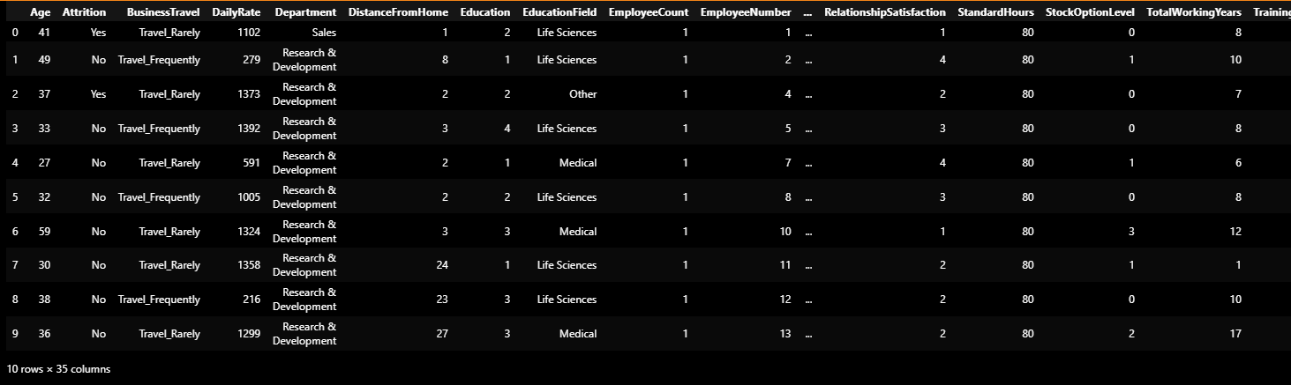

Table 1. Summary of the Dataset
Replace the sample table with your own results. Mention the table in the text before or after it.

Attribute | Value
Source | IDRA LMS - Capstone Project 7 (IBM HR Analytics)
Number of employees (rows) | 1,470
Number of variables (columns) | 35
Numerical variables | 26
Categorical variables | 9
Target variable | Attrition (Yes/No)
Missing values | 0
Duplicate rows | 0

5.3 Data Dictionary
Create a compact data dictionary. Include variable name, meaning, data type, and role (feature/target) for the main variables.
Variable | Meaning | Type | Role
Age | Employee age in years | Numeric | Feature
Attrition | Left company (Yes/No) | Categorical | TARGET
BusinessTravel | Frequency of travel | Categorical | Feature
DailyRate | Daily pay rate | Numeric | Feature
Department | Sales / R&D / HR | Categorical | Feature
DistanceFromHome | Distance from home to work | Numeric | Feature
Education | Education level (1-5) | Ordinal | Feature
EducationField | Field of education | Categorical | Feature
JobRole | Job role | Categorical | Feature
JobSatisfaction | Satisfaction score (1-4) | Ordinal | Feature
MaritalStatus | Single / Married / Divorced | Categorical | Feature
MonthlyIncome | Monthly salary | Numeric | Feature
OverTime | Works overtime (Yes/No) | Categorical | Feature
TotalWorkingYears | Total years of work | Numeric | Feature
WorkLifeBalance | Work-life balance score (1-4) | Ordinal | Feature
YearsAtCompany | Years at this company | Numeric | Feature

Table 2. Data Dictionary
Replace the sample table with your own results. Mention the table in the text before or after it.

6. DATA CLEANING
Document the state of the raw data before cleaning. Explain missing values, duplicates, invalid values, inconsistent categories, incorrect data types, and outliers if present. For every important cleaning decision, explain why you chose that treatment.
The raw data were inspected for missing values, duplicate records, inconsistent categories, data types and outliers before any modelling. The dataset was already tidy in most respects. There were no missing values and no duplicate rows, so no imputation or de-duplication was required. The cleaning decisions below are therefore small but important, and each one is justified.

6.1 Missing Values
Report which columns contain missing values, how many are missing, what proportion this represents, and how you handled them.
None of the 35 columns contain missing values (verified with isnull().sum()). Because the data are complete, no mean/median/mode imputation or forward fill was needed.

6.2 Duplicate Records
State whether duplicates were found, how many were removed, and whether duplicate removal changed the dataset size.
A check with duplicated().sum() found zero duplicate rows, so nothing was removed and the sample size stayed at 1,470.

6.3 Data Types and Inconsistent Values
Describe any data type corrections or inconsistent text/category values you fixed.

The two binary survey answers, Attrition and OverTime, were stored as "Yes"/"No" text, so they were mapped to 1/0 so the models could use them directly. The remaining object columns like Department and JobRole were kept as categories and encoded later in the preprocessing step. No inconsistent spellings or category labels were found.

6.4 Outlier Handling
Explain which variables were checked, which method was used, what was detected, and what decision was made. Do not remove observations without justification.
The numerical variables were checked for outliers using the 1.5 x IQR rule. Outliers were found mainly in salary and tenure variables: MonthlyIncome has 114 outliers (about 7.8 percent of rows), YearsAtCompany has 104, TotalWorkingYears has 63, and YearsInCurrentRole has 21, while Age, DailyRate and DistanceFromHome have none.
A deliberate decision was made to keep these values rather than remove them. High earners are real employees, not data-entry mistakes, and deleting them would have made the relationship between income and attrition look weaker than it really is. Random Forest is not bothered by outliers, and StandardScaler handles them reasonably well for Logistic Regression. The full outlier summary is in Appendix B (Table 8).

6.5 Before vs After Cleaning

Table 3. Data Quality Before and After Cleaning
Replace the sample table with your own results. Mention the table in the text before or after it.
Property | Before Cleaning | After Cleaning
Rows | 1,470 | 1,470
Columns | 35 | 31
Missing values | 0 | 0
Duplicate rows | 0 | 0
Target encoding | Yes/No (text) | 1/0 (binary)
Constant columns | EmployeeCount, Over18, StandardHours | Removed
Unique ID column | EmployeeNumber | Removed

7. DATA PREPROCESSING
Explain how the cleaned dataset was prepared for analysis and modelling. Include encoding, scaling, transformations, feature selection, and train-test splitting where applicable. Make it clear which steps were performed before and after the train-test split.
Preprocessing prepared the cleaned 31-column set for modelling. This was done with the train-test split in mind, so that no information from the test set leaks into the fitted transformations.

7.1 Categorical Encoding
Identify categorical features and explain whether you used one-hot, ordinal, label encoding, or another method, and why.
Six nominal categorical variables - BusinessTravel, Department, EducationField, JobRole, MaritalStatus and Gender - were one-hot encoded using pd.get_dummies with drop_first=True. One-hot encoding converts each category into binary columns, and drop_first=True avoids the dummy-variable trap (keeping k-1 columns instead of k). The ordinal variables such as Education, JobSatisfaction and WorkLifeBalance already carry meaning in their integer ordering, so they were left as they were and not label-encoded.

7.2 Feature Scaling and Transformation
Explain which numerical features were scaled or transformed and why that was appropriate for the selected model.
Logistic Regression needs numerical features on a similar scale to converge well, so a StandardScaler was used. The important detail is that the scaler was fitted on the training data only and then applied to the test data, which avoids data leakage. Random Forest is a tree-based model and does not need scaling, but it was trained on the raw (unscaled) features, since that is how tree models normally work.

7.3 Train-Test Split
State the train-test split ratio, random state if used, and explain why the split is necessary. Mention how you avoided data leakage.
The data were split 80-20 (1,176 training rows and 294 test rows) using train_test_split with random_state = 42 and stratify = y. Stratification keeps the 84:16 attrition ratio identical in both subsets, which matters when the target is imbalanced. The split happened before any model fitting, and the constant columns and ID column were already removed, so there is no obvious target or identity leakage.

7.4 Final Feature Set
List the final input features and target variable used for modelling.
After one-hot encoding, the feature matrix contains 47 input features for the target Attrition. No feature was left that directly reveals the target, and the engineered ratio features (Section 10) are built only from pre-existing information.

8. EXPLORATORY DATA ANALYSIS
Use EDA to understand distributions, group differences, trends, and relationships. Do not add charts only because they were taught in class; each chart should answer a meaningful analytical question.
For the EDA, only the charts that actually help answer the research questions were kept. Each figure below supports a specific conclusion; the rest of the grouped tables are in Appendix B so the main body stays readable.

8.1 Univariate Analysis
plt.figure(figsize=(6, 4))
sns.countplot(data=data, x="Attrition", hue="Attrition",
palette=["Blue", "Red"], legend=False)
plt.title("Figure 1: Employees Who Stayed vs Left")
plt.xlabel("Attrition (0 = Stayed, 1 = Left)")
plt.ylabel("Number of Employees")
plt.show()

print(data["Attrition"].value_counts())
print("Attrition rate = {:.1f}% (84% stay, only 16% leave)".format(data["Attrition"].mean() * 100))

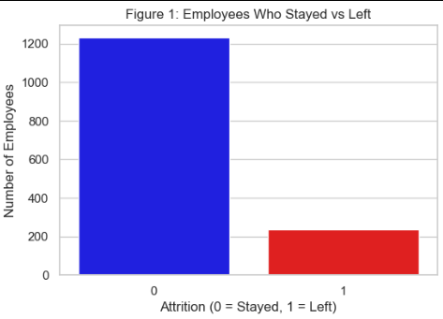
Figure 1. Distribution of [Important Variable]
Insert your chart/graph here. Keep the figure centered and readable.
Explain what the distribution shows, whether it is skewed or approximately symmetric, and whether there are unusual observations.

Figure 1 shows the target distribution. Only 237 of 1,470 employees (16.1 percent) left the company. This confirms a class-imbalanced classification problem, where overall accuracy alone cannot be trusted.
Most of the numerical features are right-skewed. For example MonthlyIncome has a mean of about 6,503 and a median of 4,919 with skewness of about +1.37, which means the median is the more representative measure of the typical employee than the mean.

8.2 Categorical Analysis
plt.figure(figsize=(12, 5))
sns.boxplot(data=data, x="JobRole", y="MonthlyIncome", hue="Attrition",
palette=["Blue", "Red"])
plt.xticks(rotation=45, ha="right")
plt.title("Figure 2: Monthly Income vs Attrition across Job Roles")
plt.ylabel("Monthly Income (USD)")
plt.show()

print("Median income of people who left = {:.0f}".format(data[data["Attrition"] == 1]["MonthlyIncome"].median()))
print("Median income of people who stayed = {:.0f}".format(data[data["Attrition"] == 0]["MonthlyIncome"].median()))

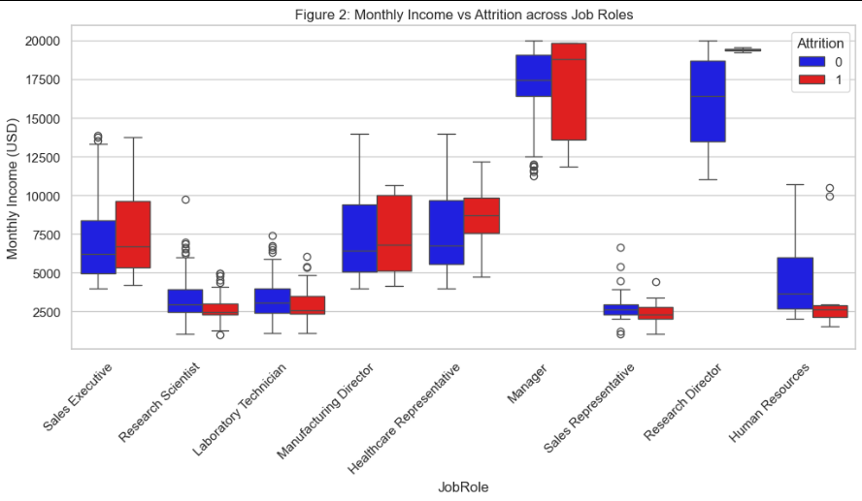
Figure 2. [Category] Compared Across [Outcome/Measure]
Insert your chart/graph here. Keep the figure centered and readable.
Explain the key difference between categories and why it matters.

Figure 2 compares monthly income across job roles for leavers and stayers. Leavers earn clearly less overall (median around 3,202 versus 5,204 for stayers), and the gap shows up in most roles, especially Sales Representative, Laboratory Technician and Human Resources.

8.3 Bivariate / Relationship Analysis
rate = data.groupby("OverTime")["Attrition"].mean().mul(100)

plt.figure(figsize=(6, 4))
ax = rate.plot(kind="bar", color=["Blue","Red"])
plt.title("Figure 3: Attrition Rate by Overtime")
plt.xlabel("OverTime (0 = No, 1 = Yes)")
plt.ylabel("Attrition Rate (%)")
plt.ylim(0, 35)
plt.show()

print("Attrition rate without overtime = {:.1f}%".format(rate[0]))
print("Attrition rate with overtime = {:.1f}%".format(rate[1]))

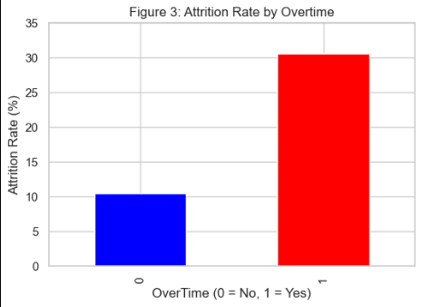
Figure 3. Relationship Between [Feature] and [Target]
Insert your chart/graph here. Keep the figure centered and readable.
Explain the direction, strength, and practical meaning of the relationship. Do not claim causation from correlation alone.
Figure 3 highlights the single strongest practical driver of attrition in this dataset: overtime. Employees who work overtime leave at 30.5 percent, almost three times the 10.4 percent rate of employees who do not work overtime.

8.4 Correlation Analysis
corr = data[num_cols + ["Attrition"]].corr()

plt.figure(figsize=(9, 7))
sns.heatmap(corr, annot=True, fmt=".2f", cmap="coolwarm", square=True,
cbar_kws={"shrink": 0.8})
plt.title("Figure 4: Correlation Heatmap of Key Numerical Features")
plt.show()

print("Features most related to Attrition:")
print(corr["Attrition"].drop("Attrition").abs().sort_values(ascending=False).head(6))

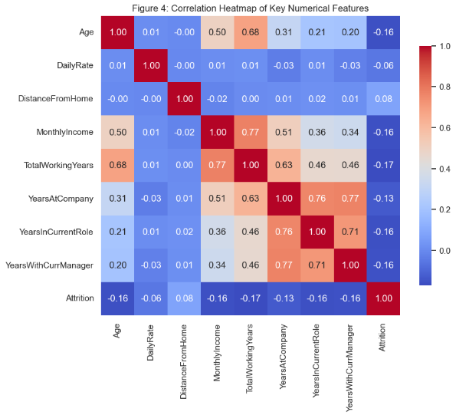
Figure 4. Correlation Heatmap of Numerical Variables
Insert your chart/graph here. Keep the figure centered and readable.
Identify important positive or negative relationships and discuss whether they have implications for modelling.
Figure 4 is the correlation heatmap of the main numerical features with attrition. No feature shows a strong linear correlation with the target (the strongest is TotalWorkingYears at around 0.17). This is typical of attrition data: risk is driven more by combinations of conditions - for example low income plus overtime - and by categorical group membership than by any single linear factor.

8.5 Group Comparisons
The grouped aggregations (by department, job role and overtime) show clear risk patterns, and these patterns directly supported the modelling choices. The highest-risk role-by-overtime combinations are Sales Representative with overtime (66.7 percent attrition), Laboratory Technician with overtime (50.0 percent) and Human Resources with overtime (38.5 percent). A "danger zone" segment was also built: 202 employees with below-median income who also work overtime. That group attrites at 43.1 percent, far above the 16.1 percent company baseline. These numbers are summarised in Appendix B (Tables 9 and 10).

9. STATISTICAL ANALYSIS
Report relevant descriptive statistics and statistical observations. Depending on your project, include mean, median, mode, standard deviation, variance, IQR, group-level summaries, or other statistics covered during the training.
Table 4 reports the descriptive statistics of the key numerical variables. Income and tenure variables are right-skewed (skewness above 1), so the median represents the typical employee better than the mean.

Variable | Mean | Median | Std Dev | Min | Max | Skewness
Age | 36.9 | 36 | 9.1 | 18 | 60 | +0.41
DistanceFromHome | 9.2 | 7 | 8.1 | 1 | 29 | +0.96
MonthlyIncome | 6502.9 | 4919 | 4708.0 | 1009 | 19999 | +1.37
TotalWorkingYears | 11.3 | 10 | 7.8 | 0 | 40 | +1.12
YearsAtCompany | 7.0 | 5 | 6.1 | 0 | 40 | +1.77
WorkLifeBalance | 2.8 | 3 | 0.7 | 1 | 4 | -0.62
JobSatisfaction | 2.7 | 3 | 1.1 | 1 | 4 | -0.30

Table 4. Descriptive Statistics of Key Variables
Conditional probability analysis was used to quantify risk directly. With event A = overtime and event B = attrition, P(Attrition) = 16.1 percent, P(Attrition | OverTime) = 30.5 percent and P(Attrition | No OverTime) = 10.4 percent. So overtime multiplies the baseline risk by about 1.9 times. Applying Bayes’ reasoning the other way round, P(OverTime | Attrition) = 53.6 percent while P(OverTime) = 28.3 percent, which confirms that overtime workers are far more common among leavers than in the company as a whole. For the salary outliers, the highest earner has a z-score of about +2.87 relative to the income mean and standard deviation, which marks it as a genuine outlier under the 68-95-99.7 rule. Such values were retained because they are realistic senior salaries.

Replace the sample table with your own results. Mention the table in the text before or after it.
Interpret the statistics in words. Avoid listing numbers without explaining what they indicate.

10. FEATURE ENGINEERING
Describe any new variables created from the original data. Explain the logic behind each engineered feature and how it may help answer the research question or improve prediction.
Three ratio features were created to capture compound conditions that the raw columns do not express directly. Each one is built only from pre-existing columns, so these features do not introduce target leakage.
These features appeared among the top predictors in the Random Forest importance ranking (for example IncomePerYearWorked and LoyaltyRatio), which supports keeping them in the model.

Feature | Formula | Rationale
IncomePerYearWorked | MonthlyIncome / (TotalWorkingYears + 1) | Earning pace per year of career; a low pace means the employee is paid below what their experience deserves.
LoyaltyRatio | YearsAtCompany / (TotalWorkingYears + 1) | Share of the career spent at this firm; a low value hints the employee has moved around a lot.
PromotionLag | YearsSinceLastPromotion / (YearsAtCompany + 1) | Promotion delay relative to tenure; a high value suggests the employee is stagnating.

Table 5. Engineered Features
Replace the sample table with your own results. Mention the table in the text before or after it.

11. MODEL DEVELOPMENT

11.1 Problem Formulation
Clearly state whether your task is regression or classification. Define the input features and target variable. Explain why the chosen problem formulation makes sense.
The task is a binary classification problem: predict whether an employee leaves (Attrition = 1) or stays (Attrition = 0), using the 47 input features. This matches the business need, where the useful output is a yes/no risk flag rather than a continuous quantity.

11.2 Model Selection
Two models from the scikit-learn curriculum were selected. Logistic Regression was chosen as an interpretable baseline: it gives well-calibrated probabilities and reports a coefficient for each factor, so it is easy to explain to HR. Random Forest was chosen as a more powerful non-linear ensemble that handles interactions between features and does not require scaling. Both use class_weight="balanced" to deal with the 84:16 class imbalance. The choice was deliberately kept limited to the models covered in the training program.
Explain why the chosen model is appropriate. Mention any alternative model you considered, if applicable.

11.3 Training the Model
Include the relevant model-training code in the notebook/report and explain the main parameters. Keep code focused on the important steps. Full code can also be placed in Appendix A.
Both models were trained with the scaler fitted only on the training split, so the transformation never touches the test data.

from sklearn.model_selection import train_test_split
from sklearn.linear_model import LinearRegression
X_train, X_test, y_train, y_test = train_test_split(
X, y, test_size=0.20, random_state=42
)
model = LinearRegression()
model.fit(X_train, y_train)

The code above is only a formatting example. Replace it with the code for your own project.
Key parameters: the Logistic Regression uses the liblinear solver (a good fit for a medium-size dataframe) with up to 1,000 iterations, and the Random Forest uses 200 trees with balanced class weights. The 80-20 stratified split gives 1,176 training rows and 294 test rows.

12. MODEL EVALUATION
Evaluate the trained model on unseen test data. Select metrics appropriate to the problem type and explain what each metric means. Report results clearly and interpret them rather than merely printing metric values.
Both models were evaluated on the 294 unseen test rows using a confusion matrix, accuracy, precision, recall and F1-score for the leaver class, and the ROC-AUC.

12.1 Regression Evaluation
If your project is regression, report the regression metrics covered in training, such as MAE, MSE, RMSE, and R-squared, where appropriate.
Column 1 | Column 2 | Column 3 | Column 4
[Enter value] | [Enter value] | [Enter value] | [Enter value]
[Enter value] | [Enter value] | [Enter value] | [Enter value]
[Enter value] | [Enter value] | [Enter value] | [Enter value]
[Enter value] | [Enter value] | [Enter value] | [Enter value]
Table 6. Regression Model Performance
Replace the sample table with your own results. Mention the table in the text before or after it.

12.2 Classification Evaluation
If your project is classification, report the confusion matrix, accuracy, precision, recall, and F1-score as appropriate.
For this business problem, a false negative (an actual leaver who gets missed) is the most costly error, because that person leaves without any intervention. A false positive simply wastes some retention effort on an employee who would have stayed anyway.
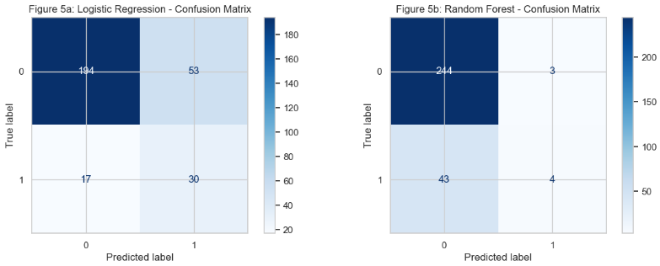
Figure 5. Confusion Matrix
Insert your chart/graph here. Keep the figure centered and readable.
Model | Accuracy | Precision | Recall | F1-Score | ROC-AUC
Logistic Regression | 0.762 | 0.361 | 0.638 | 0.462 | 0.805
Random Forest | 0.844 | 0.571 | 0.085 | 0.148 | 0.756

Table 7. Classification Model Performance
Replace the sample table with your own results. Mention the table in the text before or after it.
Random Forest has the higher overall accuracy (84.4 percent vs 76.2 percent), but that number is misleading. It recalls only about 8.5 percent of real leavers, missing 43 of 47 leavers in the test set. Logistic Regression recalls 63.8 percent of leavers (30 of 47), so for an HR screening use-case it is the more useful model. This comparison shows exactly why accuracy is not enough on imbalanced data, and why recall and ROC-AUC matter more here.

12.3 Overfitting and Underfitting
Compare training and test performance. Explain whether the model appears well-fitted, overfitted, or underfitted, and support your conclusion with evidence.
Table 7 compares each model’s accuracy on the training data against its accuracy on the unseen test data. A large gap between the two means the model has memorised the training data instead of learning a general pattern.
Table 7. Overfitting Check (Train vs Test Accuracy)
Model | Train Accuracy | Test Accuracy | Gap (Train-Test)
Logistic Regression | 78.0% | 76.2% | 1.8 pp
Random Forest | 100.0% | 84.4% | 15.6 pp

Random Forest reaches 100 percent training accuracy but only 84.4 percent on the test data, a gap of about 16 percentage points. That is a clear sign of overfitting: default-depth trees memorise the training sample. Logistic Regression has a small gap of just 1.8 percentage points, so it is well fitted and more likely to generalise to new employees.

13. RESULTS AND FINDINGS
Bring together the most important results from the EDA and model. Highlight the findings that directly answer your research questions.

The most important results, each supported by the tables and figures above, are:

1. Class imbalance. The dataset contains 237 leavers (16.1 percent) and 1,233 stayers. Accuracy is therefore a misleading metric, and class weights plus recall/AUC evaluation were required (Figure 1).

2. Overtime is the strongest driver. Overtime workers leave at 30.5 percent versus 10.4 percent for others; P(Attrition) rises from 16.1 percent to 30.5 percent when overtime is present (Figure 3, Section 9).

3. Low income plus overtime is the danger zone. The 202 employees with below-median income who also work overtime attrite at 43.1 percent, nearly three times the company baseline (Section 8.5).

4. Job role matters. Sales Representative with overtime (66.7 percent), Laboratory Technician with overtime (50.0 percent) and Human Resources with overtime (38.5 percent) are the riskiest role segments (Table 9, Appendix B).

5. Income separates leavers. Leavers have a median monthly income of about 3,202 versus 5,204 for stayers, and monthly income is right-skewed (skewness +1.37), so the median is the better measure of the typical employee (Table 4).

6. Logistic Regression is the better screening model. It reaches 0.805 ROC-AUC and 0.638 leaver recall on unseen data and generalises stably, while Random Forest overfits (100 percent training vs 84.4 percent test) and recalls only about 8.5 percent of leavers (Tables 6 and 7).

Figure 6 shows which features the Random Forest considered most informative for separating leavers from stayers. Income, age, tenure and the engineered earning-pace and loyalty ratios lead the ranking, which reinforces the compensation and career findings above.
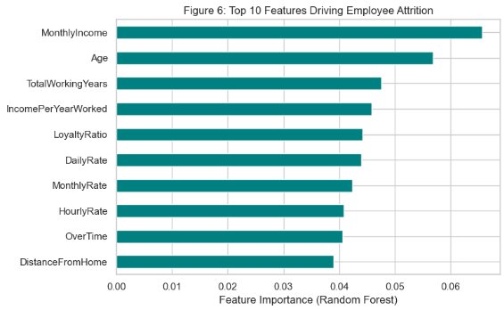
Figure 6. Top 10 Features Driving Employee Attrition (Random Forest).

14. DISCUSSION
Interpret the overall results in context. Discuss why the findings may have occurred, how they relate to the problem, and what a practitioner or decision-maker should take away from them. Distinguish observed relationships from causal claims.
The EDA, statistics and modelling tell a consistent story. Overtime, compensation and satisfaction keep appearing as the conditions under which employees leave: overtime roughly doubles the baseline risk, lower-paid employees leave more, and the low-income-plus-overtime segment concentrates the risk. These patterns show up again in the model, where income, tenure and the engineered ratios rank among the most important features.
One thing that has to be stated honestly is that these are associations, not proof of causation. Overtime might be a proxy for workload pressure, for an unfair compensation structure, or for a manager who demands too many hours, and the dataset simply cannot separate these mechanisms. So the claim here is not that overtime causes attrition - only that it is strongly linked to it in this data.
The modelling lesson is just as important. Random Forest looked better on accuracy, but it is the wrong model for this use-case because it effectively ignores the minority class it was supposed to find. Logistic Regression trades some accuracy for a far higher recall of leavers. For an early-warning system, catching a leaver (recall) matters more than avoiding false alarms, so the balanced Logistic Regression is the recommended choice. The practical way to use it is to turn the predicted probabilities into risk scores and act on a threshold that is calibrated to the cost of each type of error.

15. LIMITATIONS
Be honest about data, methodological, modelling, and scope limitations. Examples include sample bias, missing variables, limited data volume, measurement quality, assumptions of the model, or limits on generalization.

The dataset is a single static snapshot of one company, and the records are synthetic. The results describe association, not causation, and they may not generalise to other firms or industries.

The leaver class is small (16 percent), which limits how much any model can learn about rare attrition and makes the metrics noisier.

Important drivers that are not captured - manager quality, local market salary, commute, and external job offers - may explain attrition better than the available columns can.

The data have no time dimension, so the analysis cannot show when an employee is approaching a departure decision.

Class weighting changes the scale of the predicted probabilities. The model should be treated as a risk score with a carefully chosen threshold, not as an absolute verdict on any employee.

16. CONCLUSION
Provide a concise conclusion that returns to the original problem and objectives. Summarize what the analysis established, how useful the model was, and what the overall project demonstrates. Do not introduce new evidence here.
This project set out to identify the drivers of employee attrition and to predict leavers from the IBM HR Analytics dataset. The analysis established that attrition is driven mainly by overtime, income level, job role and satisfaction/work-life balance, and that a balanced Logistic Regression model predicts leavers with about 76.2 percent accuracy, 0.805 ROC-AUC and a leaver recall of 0.638 on unseen data - while Random Forest, despite higher accuracy, overfits and misses most actual leavers.
The project demonstrates the full data science workflow covered during the internship, from cleaning and statistics through EDA and model evaluation. If there is one lesson from this project, it is that metric choice and interpretation matter as much as a high accuracy number. The practical answer to the research question is that attrition is predictable enough to support an HR early-warning system, and that the overtime and compensation-driven segments deserve the most attention.

17. RECOMMENDATIONS AND FUTURE WORK

17.1 Recommendations
Provide 3-5 practical recommendations based directly on your findings. Each recommendation should be specific enough that a stakeholder could act on it.

1. Reduce forced overtime. Overtime employees leave at 30.5 percent versus 10.4 percent for others (Finding 2). HR should cut mandatory overtime, rotate shifts, or compensate overtime work fairly.

2. Target the low-income-plus-overtime segment. This group of 202 employees attrites at 43.1 percent (Finding 3). A compensation review and a structured career path should prioritise these employees.

3. Run role-specific retention programmes. Sales Representative, Laboratory Technician and Human Resources roles with overtime show the highest attrition (Finding 4), so workload checks and role-specific incentives make sense for them.

4. Strengthen work-life balance and satisfaction. Lower satisfaction and work-life balance scores rank high in the grouped risk table (Finding 5); flexible hours, wellness support and regular pulse surveys are low-cost levers.

5. Deploy the Logistic Regression model as an early-warning risk score. Score the current employees, prioritise recall, and set the decision threshold from the cost of a missed leaver rather than from accuracy (Finding 6).

17.2 Future Work
Explain what could be improved or extended in a future study, such as additional data, alternative models, new variables, better sampling, deployment, or more rigorous validation.
Follow-up work could extend this project in several directions: (i) add time-series or exit-survey data to detect when an employee is approaching departure; (ii) include external benchmark data such as market salary and local commuting conditions; (iii) test additional models from the program such as pruned decision trees, k-nearest neighbours or a tuned gradient-boosting model and compare them properly; (iv) apply threshold tuning to optimise recall under a chosen false-alarm budget; and (v) validate the final model on a held-out year of new employees before actual deployment.

18. REFERENCES
List every external source used in the report, including dataset sources, papers, documentation, articles, and websites. Use one consistent citation style throughout the report. Do not include sources that were not actually used.

[1] IBM HR Analytics Employee Attrition & Performance dataset. Provided in the IDRA LMS for Capstone Project 7. Available at: https://www.kaggle.com/datasets/pavansubhasht/ibm-hr-analytics-attrition-dataset

[2] IDRA Data Science & AI Training Program. Internship course notebooks and study material (Days 1-19): pandas data analysis, cleaning, preprocessing, EDA, visualisation, statistics and probability, and the scikit-learn machine-learning workflow.

APPENDIX A. CODE
Place important code needed to reproduce your analysis here. Keep the main report readable by showing only key code in the methodology/model sections; place longer code listings in the appendix. Use clear subheadings for data loading, cleaning, preprocessing, EDA, and modelling.

The complete, reproducible code is in the accompanying notebook (IDRA_PROJECT_7.ipynb). The key steps are reproduced below.

A.1 Data Loading and Inspection
import pandas as pd
data = pd.read_csv("Capstone7_IBM_HR_Attrition_Dataset.csv")
print("Data loaded successfully!")
data.head(10)
print("How big is the dataset:")
print(data.shape[0], "rows x", data.shape[1], "columns")
print("List of all columns:")
print(list(data.columns))
print("Data types of all columns:")
print(data.dtypes)
print("Basic summary of the numbers:")
data.describe()

A.2 Data Cleaning
data["Attrition"] = data["Attrition"].map({"Yes": 1, "No": 0})
data["OverTime"] = data["OverTime"].map({"Yes": 1, "No": 0})

data = data.drop(columns=["EmployeeCount", "Over18", "StandardHours", "EmployeeNumber"])

A.3 Preprocessing
data["IncomePerYearWorked"] = data["MonthlyIncome"] / (data["TotalWorkingYears"] + 1)
data["LoyaltyRatio"] = data["YearsAtCompany"] / (data["TotalWorkingYears"] + 1)
data["PromotionLag"] = data["YearsSinceLastPromotion"] / (data["YearsAtCompany"] + 1)

print("3 new ratio features created:")
print(data[["IncomePerYearWorked", "LoyaltyRatio", "PromotionLag"]].describe().T.round(3))
cat_cols = ["BusinessTravel", "Department", "EducationField", "JobRole", "MaritalStatus", "Gender"]
data_encoded = pd.get_dummies(data, columns=cat_cols, drop_first=True)

print("Size of the encoded matrix:", data_encoded.shape)

X = data_encoded.drop(columns="Attrition")
y = data_encoded["Attrition"]

X_train, X_test, y_train, y_test = train_test_split(
X, y, test_size=0.20, random_state=42, stratify=y
)

print("Train = {} rows, Test = {} rows".format(X_train.shape[0], X_test.shape[0]))
print("Attrition % train {:.1f}%, test {:.1f}% - same ratio in both.".format(
y_train.mean() * 100, y_test.mean() * 100))

A.4 EDA and Visualization
import matplotlib.pyplot as plt
import seaborn as sns
sns.set_theme(style="whitegrid")
plt.rcParams["figure.facecolor"] = "white

#fig 1
plt.figure(figsize=(6, 4))
sns.countplot(data=data, x="Attrition", hue="Attrition",
palette=["Blue", "Red"], legend=False)
plt.title("Figure 1: Employees Who Stayed vs Left")
plt.xlabel("Attrition (0 = Stayed, 1 = Left)")
plt.ylabel("Number of Employees")
plt.show()

print(data["Attrition"].value_counts())
print("Attrition rate = {:.1f}% (84% stay, only 16% leave)".format(data["Attrition"].mean() * 100))

#fig 2
plt.figure(figsize=(12, 5))
sns.boxplot(data=data, x="JobRole", y="MonthlyIncome", hue="Attrition",
palette=["Blue", "Red"])
plt.xticks(rotation=45, ha="right")
plt.title("Figure 2: Monthly Income vs Attrition across Job Roles")
plt.ylabel("Monthly Income (USD)")
plt.show()

print("Median income of people who left = {:.0f}".format(data[data["Attrition"] == 1]["MonthlyIncome"].median()))
print("Median income of people who stayed = {:.0f}".format(data[data["Attrition"] == 0]["MonthlyIncome"].median()))

#fig 3
rate = data.groupby("OverTime")["Attrition"].mean().mul(100)

plt.figure(figsize=(6, 4))
ax = rate.plot(kind="bar", color=["Blue","Red"])
plt.title("Figure 3: Attrition Rate by Overtime")
plt.xlabel("OverTime (0 = No, 1 = Yes)")
plt.ylabel("Attrition Rate (%)")
plt.ylim(0, 35)
plt.show()

print("Attrition rate without overtime = {:.1f}%".format(rate[0]))
print("Attrition rate with overtime = {:.1f}%".format(rate[1]))

#fig 4
corr = data[num_cols + ["Attrition"]].corr()

plt.figure(figsize=(9, 7))
sns.heatmap(corr, annot=True, fmt=".2f", cmap="coolwarm", square=True,
cbar_kws={"shrink": 0.8})
plt.title("Figure 4: Correlation Heatmap of Key Numerical Features")
plt.show()

print("Features most related to Attrition:")
print(corr["Attrition"].drop("Attrition").abs().sort_values(ascending=False).head(6))

A.5 Model Training and Evaluation
from sklearn.model_selection import train_test_split
from sklearn.preprocessing import StandardScaler
from sklearn.linear_model import LogisticRegression
from sklearn.ensemble import RandomForestClassifier
from sklearn.metrics import (confusion_matrix, classification_report, roc_auc_score,
accuracy_score, precision_score, recall_score, f1_score,
ConfusionMatrixDisplay)

scaler = StandardScaler()
X_train_s = scaler.fit_transform(X_train)
X_test_s = scaler.transform(X_test)

lr = LogisticRegression(class_weight="balanced", solver="liblinear", max_iter=1000, random_state=42)
lr.fit(X_train_s, y_train)

rf = RandomForestClassifier(n_estimators=200, class_weight="balanced", random_state=42)
rf.fit(X_train, y_train)

y_pred_lr = lr.predict(X_test_s)
y_pred_rf = rf.predict(X_test)

print("Both models trained and predictions are ready!")

# Logistic Regression - evaluation
cm_lr = confusion_matrix(y_test, y_pred_lr)
print("Logistic Regression confusion matrix:")
print(cm_lr)
print("TN =", cm_lr[0, 0], ", FP =", cm_lr[0, 1], ", FN =", cm_lr[1, 0], ", TP =", cm_lr[1, 1])

lr_auc = roc_auc_score(y_test, lr.predict_proba(X_test_s)[:, 1])
print()
print(classification_report(y_test, y_pred_lr, digits=3))
print("ROC-AUC = {:.4f}".format(lr_auc))

# Random Forest - evaluation
cm_rf = confusion_matrix(y_test, y_pred_rf)
print("Random Forest confusion matrix:")
print(cm_rf)
print("TN =", cm_rf[0, 0], ", FP =", cm_rf[0, 1], ", FN =", cm_rf[1, 0], ", TP =", cm_rf[1, 1])

rf_auc = roc_auc_score(y_test, rf.predict_proba(X_test)[:, 1])
print()
print(classification_report(y_test, y_pred_rf, digits=3))
print("ROC-AUC = {:.4f}".format(rf_auc))

APPENDIX B. ADDITIONAL FIGURES AND TABLES
Use this section for additional charts, tables, model outputs, or supplementary results that are useful but not essential to the main narrative.
Table 8. IQR Outlier Summary for Key Numerical Variables
Column | Q1 | Q3 | IQR | Lower | Upper | Outliers
MonthlyIncome | 2911 | 8379 | 5468 | -5291 | 16581 | 114 (7.8%)
YearsAtCompany | 3 | 9 | 6 | -6 | 18 | 104
TotalWorkingYears | 6 | 15 | 9 | -8 | 28 | 63
YearsInCurrentRole | 2 | 7 | 5 | -6 | 14 | 21
YearsWithCurrManager | 2 | 7 | 5 | -6 | 14 | 14
DistanceFromHome | 2 | 14 | 12 | -16 | 32 | 0
Age | 30 | 43 | 13 | 10 | 62 | 0
DailyRate | 465 | 1157 | 692 | -573 | 2195 | 0

Table 9. Top 5 Riskiest Job Role x Overtime Combinations
Job Role | Overtime | Attrition Rate % | Employees
Sales Representative | Yes | 66.7 | 24
Laboratory Technician | Yes | 50.0 | 62
Human Resources | Yes | 38.5 | 13
Research Scientist | Yes | 34.0 | 97
Sales Executive | Yes | 33.0 | 94

Table 10. Riskiest JobSatisfaction x WorkLifeBalance Combinations
JobSatisfaction | WorkLifeBalance | Attrition Rate % | Employees
1 | 1 | 47.1 | 17
3 | 1 | 38.1 | 21
2 | 4 | 27.6 | 29
2 | 1 | 22.2 | 18
1 | 3 | 21.4 | 182

