Contents
Introduction 2
Meaning 2
Goals 3
Learning 3
Perception 3
Introduction 3
• C is an imperative procedural language, supporting structured programming, lexical variable scope, and recursion, with a static type system. 3
• It was designed to be compiled to provide low-level access to memory and language constructs that map efficiently to machine instructions, all with minimal runtime support. 3
Characteristics 4
• Free-form source code 4
• Executable code is contained in functions; no script-like syntax 4
History 4
• Thompson wanted a programming language for developing utilities for the new platform. 4
ANSI C and ISO C 4
Introduction 4
• A database is an organised collection of data or type of data store based on the use of a database management system(DBMS.) 5
• Before digital storage and retrieval of data have become widespread. 5
Terminology and overview 5
• Retrieval – Selecting data according to specified criteria (e.g., a query, a position in a hierarchy, or a position in relation to other data) and providing that data either directly to the user. 5
History 5
1960s, navigational DBMS 5
Introduction 5
• Web design encompasses many different skills and disciplines in the production and maintenance of websites. 5
• The different areas of web design include web graphic design; user interface design (UI design). 5
History 6
• Although web design has a fairly recent history, it can be linked to other areas such as graphic design, user experience, and multimedia arts, but is more aptly seen from a technological standpoint. 6
• n 1989, whilst working at CERN in Switzerland, British scientist Tim Berners-Lee proposed to create a global hypertext project, which later became known as the World Wide Web. 6
Tools and technologies 6
UX Design 6

Artificial intelligence

Introduction

Meaning
- Artificial intelligence (AI) is the capability of computational systems to perform tasks typically associated with human intelligence, such as learning, reasoning, problem-solving, perception, and decision-making.
- It is a field of research in computer science that develops and studies methods and software that enable machines to perceive their environment and use learning and intelligence to take actions that maximize their chances of achieving defined goals.

Goals
- The general problem of simulating (or creating) intelligence has been broken into subproblems. These consist of particular traits or capabilities that researchers expect an intelligent system to display. The traits described below have received the most attention and cover the scope of AI research.
- AI's main goals are to mimic human intelligence (learning, reasoning, perception, problem-solving), automate tasks.

Learning
- Machine learning is the study of programs that can improve their performance on a given task automatically.[41] It has been a part of AI from the beginning.

Perception
- Machine perception is the ability to use input from sensors (such as cameras, microphones, wireless signals, active lidar, sonar, radar, and tactile sensors) to deduce aspects of the world. Computer vision is the ability to analyze visual input.

C (programming language)

Introduction

C is an imperative procedural language, supporting structured programming, lexical variable scope, and recursion, with a static type system.

It was designed to be compiled to provide low-level access to memory and language constructs that map efficiently to machine instructions, all with minimal runtime support.

Characteristics

Free-form source code

Executable code is contained in functions; no script-like syntax

History
- The origin of C is closely tied to the development of the Unix operating system, originally implemented in assembly language on a PDP-7 by Dennis Ritchie and Ken Thompson, incorporating several ideas from colleagues.

Thompson wanted a programming language for developing utilities for the new platform.

ANSI C and ISO C
- During the late 1970s and 1980s, versions of C were implemented for a wide variety of mainframe computers, minicomputers, and microcomputers, including the IBM PC, as its popularity increased significantly.
- In 1990 the ANSI C standard (with formatting changes) was adopted by the International Organization for Standardization (ISO) as ISO/IEC 9899:1990, which is sometimes called C9

Database

Introduction

A database is an organised collection of data or type of data store based on the use of a database management system(DBMS.)

Before digital storage and retrieval of data have become widespread.

Terminology and overview
- Data Defination-Creation, modification and removal of definations that detail how the data is to be organized.
- Update-Insertion, modification , and deletion of the data itself.

Retrieval – Selecting data according to specified criteria (e.g., a query, a position in a hierarchy, or a position in relation to other data) and providing that data either directly to the user.

History
- Object databases were developed in the 1980s to overcome the inconvience of object-relational impedance mismatch.
- The next generation of post-relational databases in the late 2000s became known as NoSQL databases.

1960s, navigational DBMS
- The introduction of the term database coincided with the availability of direct-access storage (disks and drums) from the mid-1960s onwards.
- As computers grew in speed and capability, a number of general-purpose database systems emerged.

Web Design

Introduction

Web design encompasses many different skills and disciplines in the production and maintenance of websites.

The different areas of web design include web graphic design; user interface design (UI design).

History

Although web design has a fairly recent history, it can be linked to other areas such as graphic design, user experience, and multimedia arts, but is more aptly seen from a technological standpoint.

n 1989, whilst working at CERN in Switzerland, British scientist Tim Berners-Lee proposed to create a global hypertext project, which later became known as the World Wide Web.

Tools and technologies
- Web designers use a variety of different tools depending on what part of the production process they are involved in.

UX Design
- One popular tool in web design is UX Design. A popular modality of modern web design art, it features a user-friendly interface and appropriate presentation.

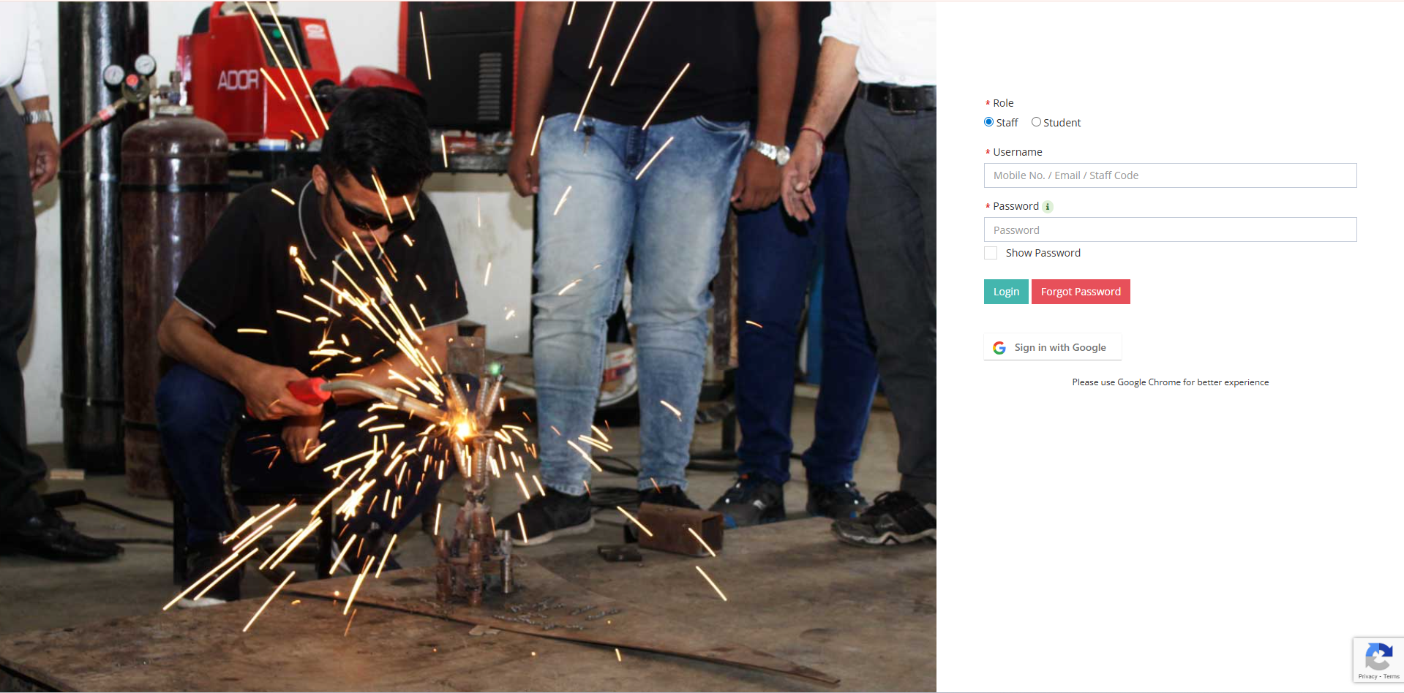

101

