Lab Practical #03:
Practical Assignment #03:

Network Cable Name: Ethernet Cable

Description:

An Ethernet cable is a network cable used to connect computers, switches, routers, and other network devices in a Local Area Network (LAN). It provides reliable and high-speed data communication. Ethernet cables are commonly used in homes, offices, schools, and business networks for stable and secure connections.

Diagram:
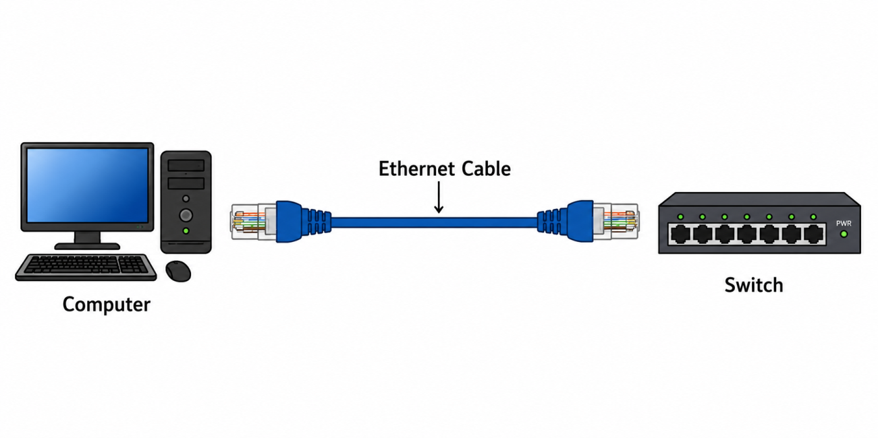

Steps for Crimping:

1) Cut the UTP cable to the required length.
2) Strip about 2–3 cm of the outer insulation.
3) Untwist and arrange the wires according to the T568A or T568B color code.
4) Trim the wires evenly.
5) Insert the wires into the RJ45 connector.
6) Use a crimping tool to crimp the RJ45 connector.
7) Test the cable using a cable tester to ensure it works properly.

Cross-Wired Cable Diagram:
Uses:
- Used to connect two similar devices, such as PC to PC, Switch to Switch.
- Used for direct data transfer between two computers.
- Used in peer-to-peer networking without a switch.
- Used for testing and troubleshooting network connections between compatible devices.
Diagram:

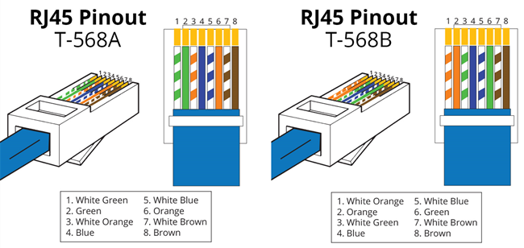

Straight Through Cable Diagram:
Uses:
- Used to connect two different network devices.
- Used to establish a network connection between different devices.
- Used for connecting a host device to a network device.
- Used to connect PC to Switch.
Diagram:
