Lab-9
Question 9:
• Prepare screen list
Solution:

Screen-1: Login form
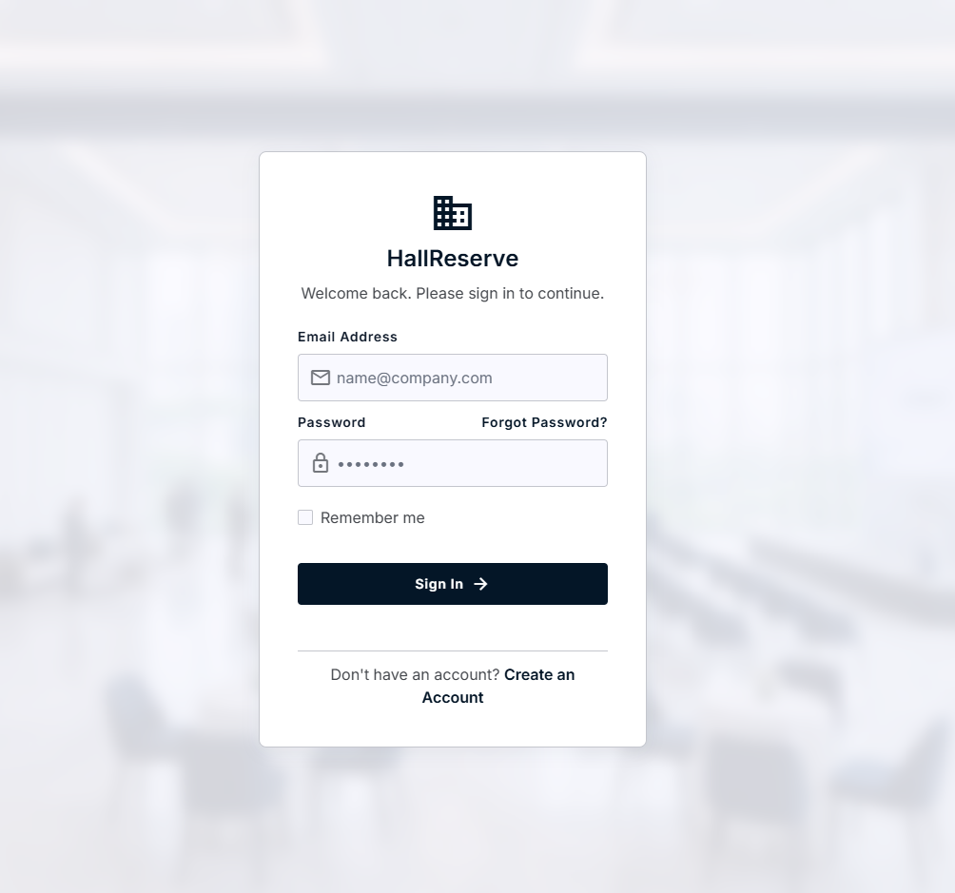

Figure 3.1-1 Screen-1: Patient information Form
Sr. | Screen Element | Input Type | O/M | 1/N | Description
1 | Email address | Textbox | M | 1 | Display Email Address
2 | Password | Textbox | M | 1 | Display Password
3 | Remember me | Check box | M | 1 | Select Remember me
4 | Sign in | button | M | 1 | Press the sign in

Screen-2: Search form

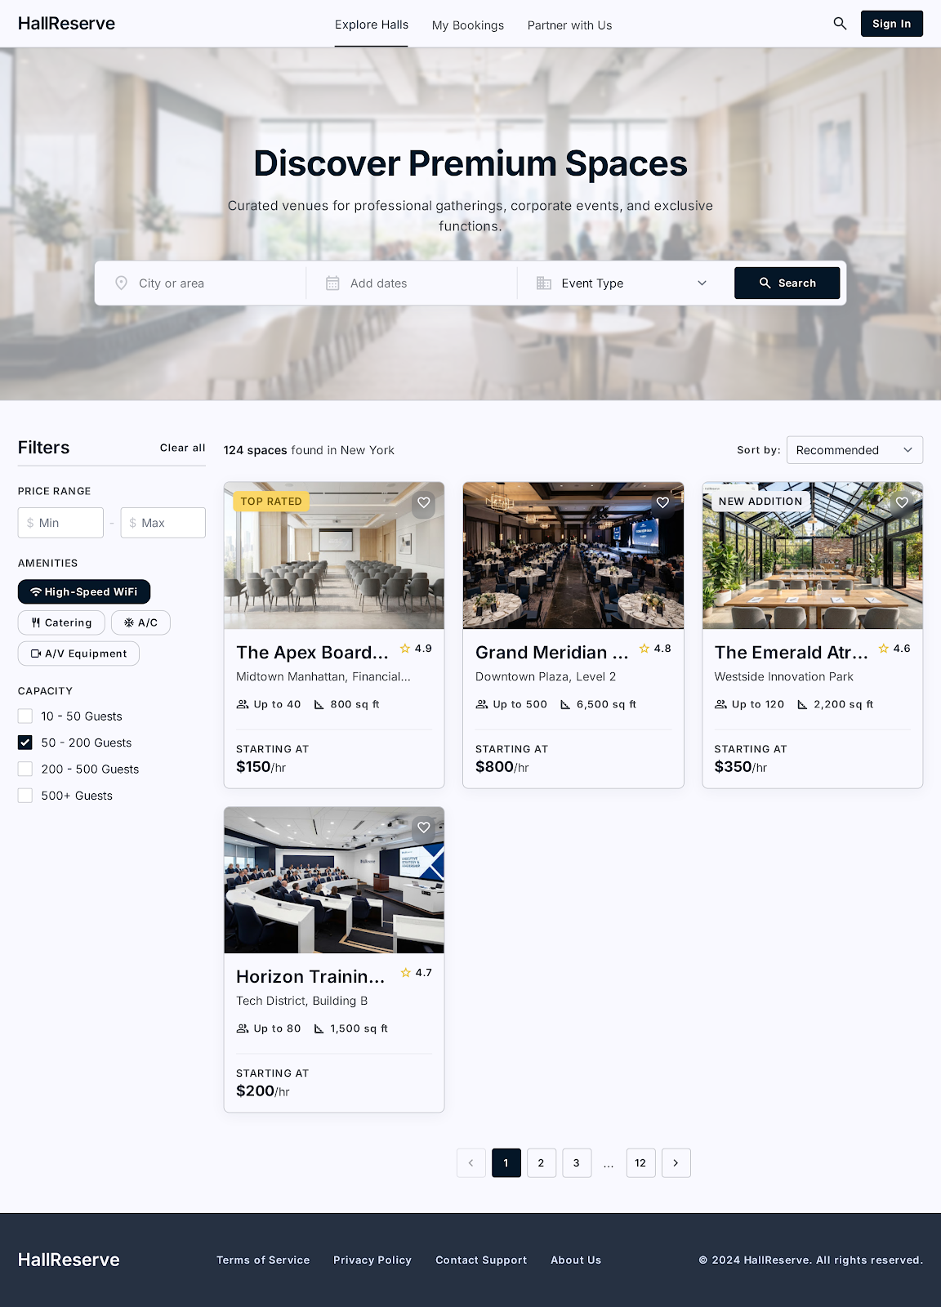

Figure 3.2-1 Screen-2: Doctor detail for

Sr. | Screen Element | Input Type | O/M | 1/N | Description
1 | City or area | Textbox | M | 1 | Select city or area
2 | Add dates | dropdown | M | 1 | Select add dates
3 | Event type | dropdown | M | 1 | Select event type
4 | search | button | M | 1 | Search hall
5 | Price range | TextBox | M | N | Select price range

Screen-3: select form
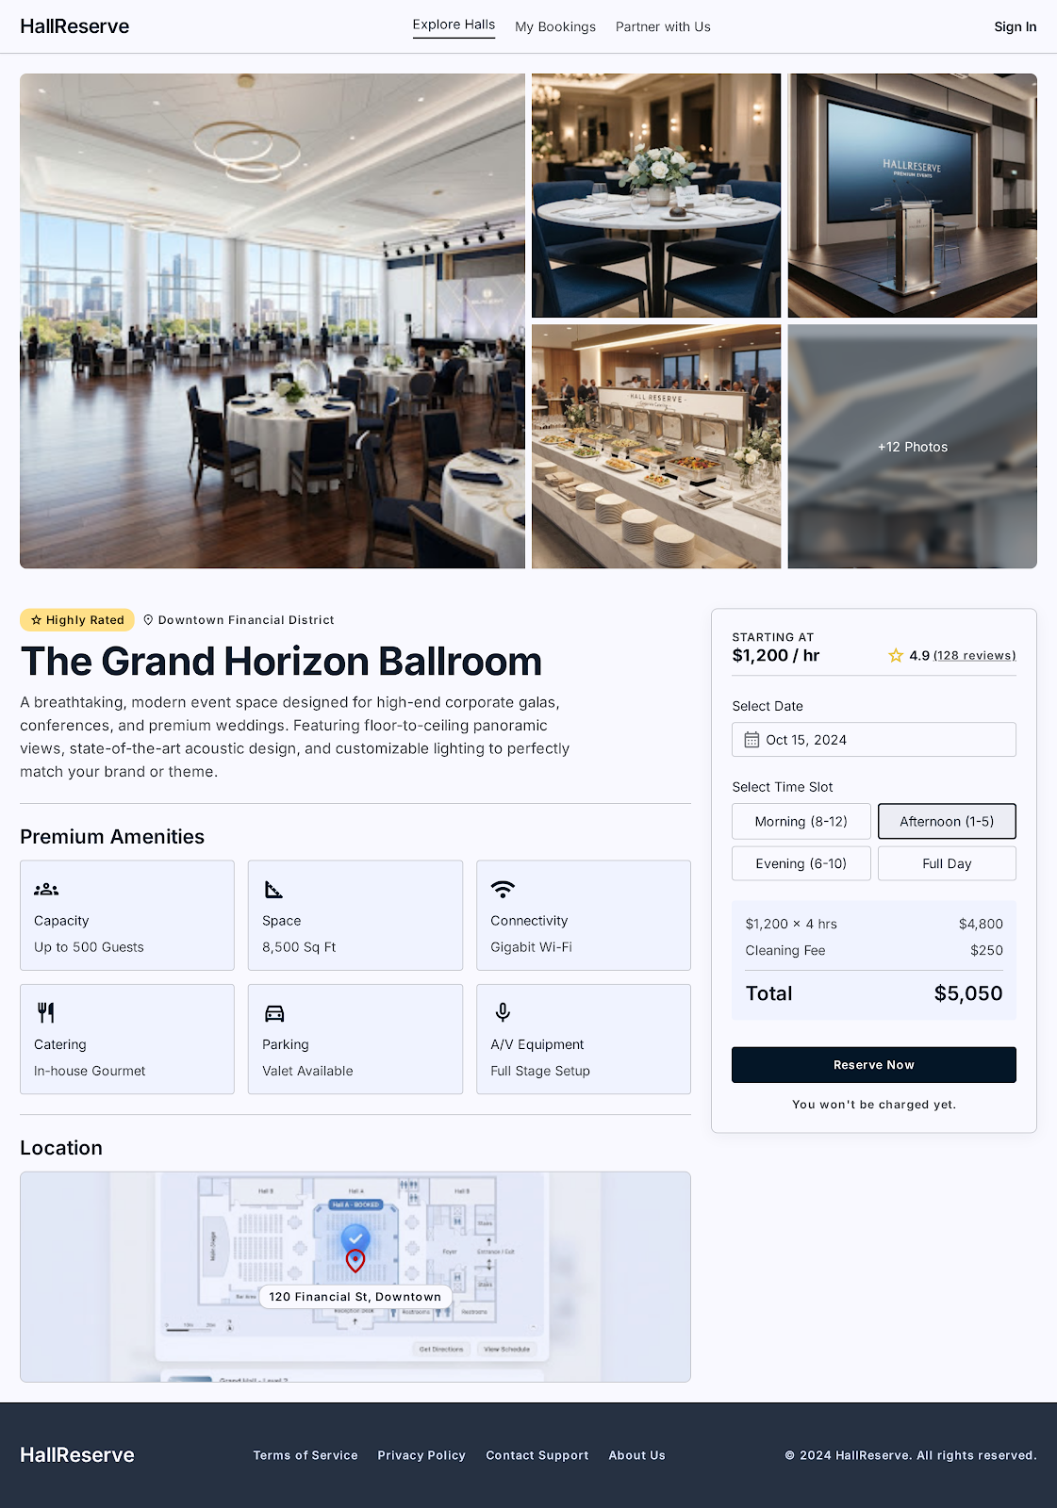

Figure 3.3-1 Screen-3: Appointment booking form

Sr. | Screen Element | Input Type | O/M | 1/N | Description
1 | Select date | Dropdown | M | 1 | Select dayte for hall booking
2 | Select time | Drop down | M | 1 | Select time
3 | Premium amenities | Dropdown | M | 1 | Select premium amenities
4 | location | ---------- | M | 1 | Select location for hall

• Prepare database schema
  - List of Tables

2 Product view Database design

2.1 List of Tables
- UserAccount
- Song
- Playlist
- Artist Profile
Table 4.1-1 Table: UserAccount
Column | Data Type | Null | Keys & Constrains | Default Value & Description
Email address | Varchar(150) | NN | PK (Auto Increment) | Unique user login
Password | varchar(100) | NN
Role | Varchar(50) | NN |  | Account type selector
Display name | Varchar(100) | NN |  | User name shown on screen dashboard
IsRemembered | boolean | NN |  | Maps “Remember me” checkbox state

Table 1.1-2 Table: Song
Column | Data Type | Null | Keys & Constrains | Default Value & Description
SongID | int | NN | PK (Auto Increment) | Unique internal track
SongTitle | Varchar(150) | NN |  | Main title text field
AlbumName | Varchar(150) | AN |  | Optional container album value
Genre | Varchar(50) | NN |  | Dropdown-genre selection
Language | Varchar(50) | NN |  | Dropdown audio language selection
ReleasesDate | Date | NN |  | Calendar publication selector

Table 1.1-3 Table: Playlist
Column | Data Type | Null | Keys & Constrains | Default Value & Description
PlaylistID | int | NN | PK (Auto Increment) | Unique playlist identity code
PlaylistName | varchar(100) | NN |  | User name assignment
PlaylistType | varchar(50) | NN |  | Access selection dropdown
TotalTrack | int | NN |  | Counter tracking total added songs
DateCreated | Date | NN |  | Auto-generated timestamp for folder setup
CreatedEmail | Varchar(150) | NN | FK | References UserAccount

Table 1.1-4 Table: Artist Profile
Column | Data Type | Null | Keys & Constrains | Default Value & Description
ArtistID | int | NN | PK (Auto Increment) | Unique identity code for the creator
UserEmail | Varchar(150) | NN | FK,Unique | Reference UserAccount
ArtistName | Varchar(100) | NN |  | Stage name displayed under tracks
Biography | text | AN |  | Brief text description for the profile page
IsVerified | boolean | NN |  | Maps the blue verification badge state
FollowerCount | int | NN |  | Default: counter tracking total fans

