Lab-9
Question 9:
• Prepare screen list
Solution:

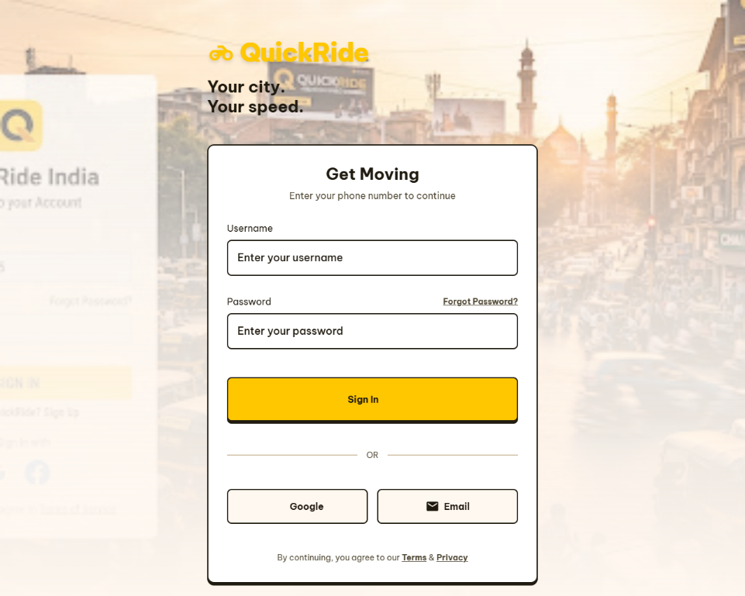
Screen-1: Patient information form

Figure 3.1-1 Screen-1: LOGIN Form

Sr. | Screen Element | Input Type | O/M | 1/N | Description
1 | Username | Textbox | M | 1 | Field for users to enter their unique username.
2 | Password | Textbox | M | 1 | Display Password
3 | Sign In | Submit | M | 1 | Action to authenticate and enter the app
4 | Google | Button | O | 1 | Alternative authentication via Google account
5 | Email | Button | O | 1 | Alternative authentication via personal email.
Screen-2: Search Ride
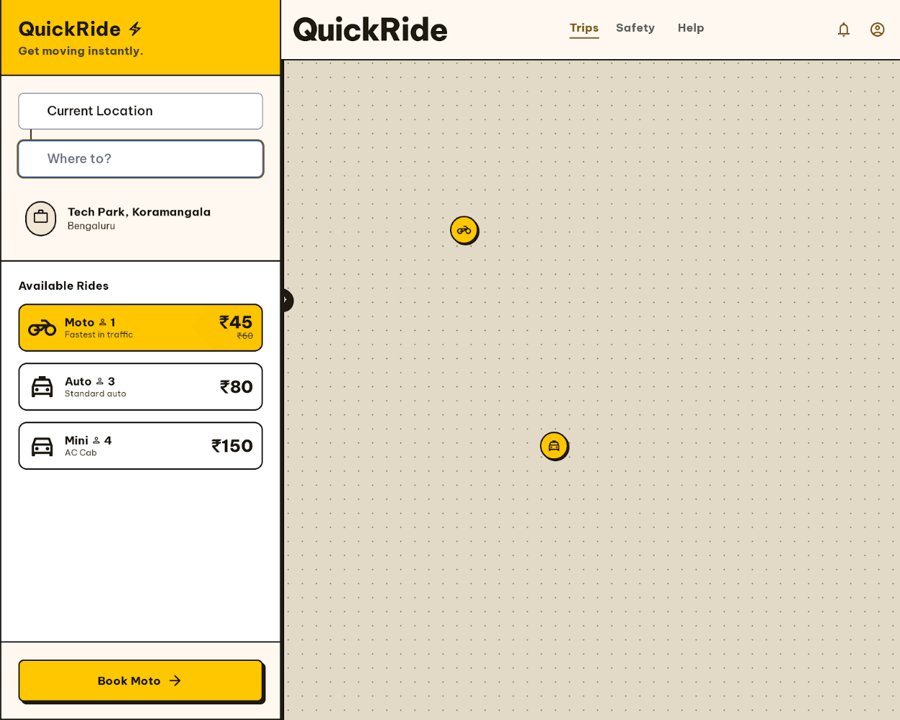

Figure 3.2-1 Screen-2: Search Ride

Sr. | Screen Element | Input Type | O/M | 1/N | Description
1 | Map | - | M | 1 | Full-screen map showing real-time vehicle positions.
2 | Current Location | Textbox | M | 1 | Auto-detected or manual entry for the pickup point.
3 | Destination | Textbox | M | 1 | Search field for the drop-off location ("Where to?").
4 | Available Rides | Radio Button | M | 1 | Filters for Moto, Auto, and Mini vehicles.
5 | Book | Button | M | 1 | Proceeds to the vehicle selection/confirmation phase.

Screen-3: Select Ride

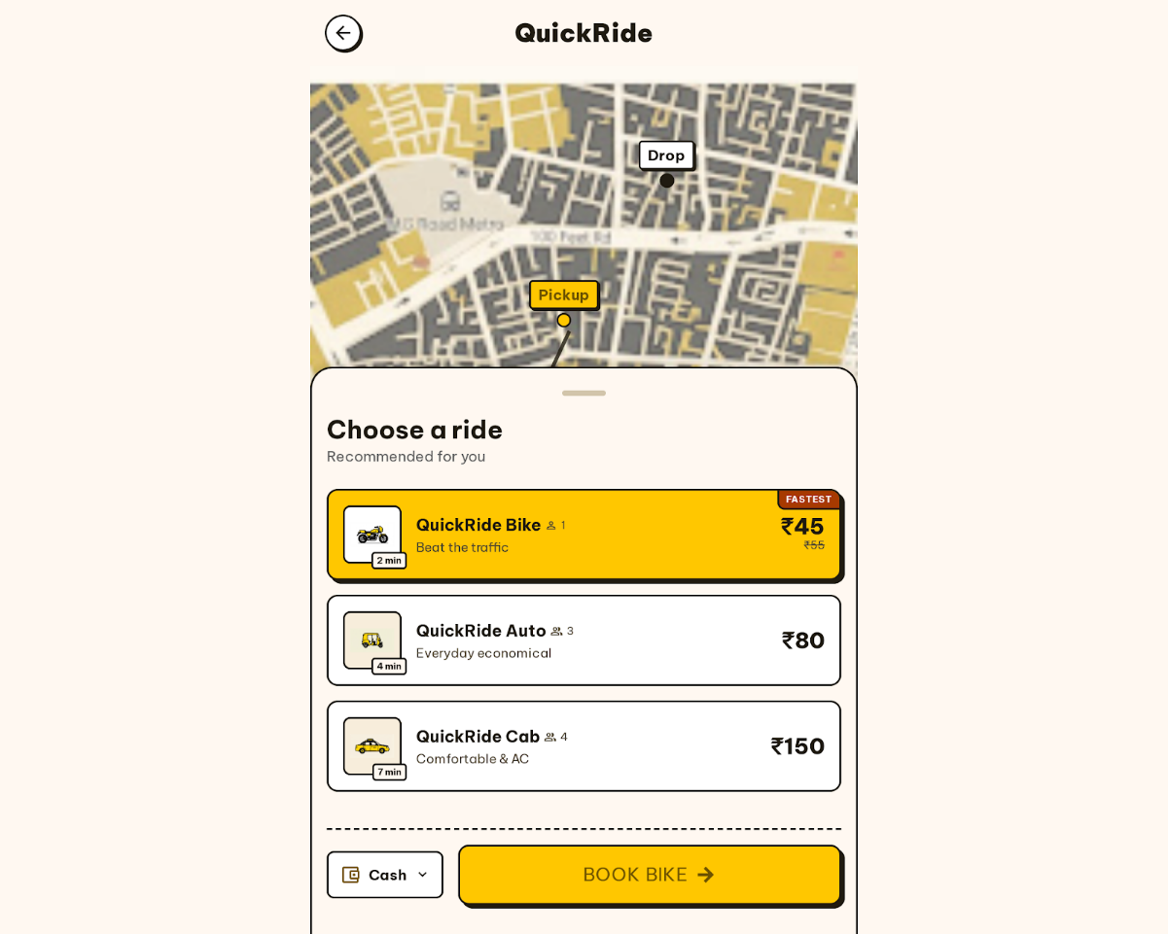

Figure 3.3-1 Screen-3: Select form

Sr. | Screen Element | Input Type | O/M | 1/N | Description
1 | Route Map | - | M | 1 | Visual representation of pickup and drop points.
2 | Vehicle List | - | M | N | Available ride types (Bike, Auto, Cab) with capacity and ETA.
3 | Fare Display | - | M | 1 | Dynamic pricing in Indian Rupees (₹).
4 | Payment Preview | Dropdown | M | 1 | Quick-selector for payment method (e.g., Cash).
5 | Book Vehicle Button | Button | M | 1 | Confirmation button

• Prepare database schema
  - List of Tables

2 Product view Database design

2.1 List of Tables
- UserAccount
- Song
- Playlist
- Artist Profile
Table 4.1-1 Table: UserAccount
Column | Data Type | Null | Keys & Constrains | Default Value & Description
Email address | Varchar(150) | NN | PK (Auto Increment) | Unique user login
Password | varchar(100) | NN
Role | Varchar(50) | NN |  | Account type selector
Display name | Varchar(100) | NN |  | User name shown on screen dashboard
IsRemembered | boolean | NN |  | Maps “Remember me” checkbox state

Table 1.1-2 Table: Song
Column | Data Type | Null | Keys & Constrains | Default Value & Description
SongID | int | NN | PK (Auto Increment) | Unique internal track
SongTitle | Varchar(150) | NN |  | Main title text field
AlbumName | Varchar(150) | AN |  | Optional container album value
Genre | Varchar(50) | NN |  | Dropdown-genre selection
Language | Varchar(50) | NN |  | Dropdown audio language selection
ReleasesDate | Date | NN |  | Calendar publication selector

Table 1.1-3 Table: Playlist
Column | Data Type | Null | Keys & Constrains | Default Value & Description
PlaylistID | int | NN | PK (Auto Increment) | Unique playlist identity code
PlaylistName | varchar(100) | NN |  | User name assignment
PlaylistType | varchar(50) | NN |  | Access selection dropdown
TotalTrack | int | NN |  | Counter tracking total added songs
DateCreated | Date | NN |  | Auto-generated timestamp for folder setup
CreatedEmail | Varchar(150) | NN | FK | References UserAccount

Table 1.1-4 Table: Artist Profile
Column | Data Type | Null | Keys & Constrains | Default Value & Description
ArtistID | int | NN | PK (Auto Increment) | Unique identity code for the creator
UserEmail | Varchar(150) | NN | FK,Unique | Reference UserAccount
ArtistName | Varchar(100) | NN |  | Stage name displayed under tracks
Biography | text | AN |  | Brief text description for the profile page
IsVerified | boolean | NN |  | Maps the blue verification badge state
FollowerCount | int | NN |  | Default: counter tracking total fans

