Module–1(Fundamental)

1. What is SDLC

Ans. The software development life cycle(SDLC) is a process used by the software industry to design, develop, and test high-quality software. It aims to produce software that meets or exceeds customer expectations, reaches completion within times and cost estimates. The SDLC consists of several phases, including:

1). Planning

2). Requirements

3). Design

4). Implementation

5). Testing

6). Deployment

7). Maintenance

2. what is software testing?

Ans. Software testing is the process of evaluating and verifying that a software application or system meets specified requirements and functions correctly. The primary goal is to identify and fix defects to ensure that the software is reliable, secure, and performs as expected.

3. What is SRS?

Ans. A software requirements specification (SRS)

Is a complete description of the behavior of the system to be developed. It includes a set of use cases that describe all of the interactions that the users will have with the software. Use cases are also known as functional requirements. In addition to use cases, the SRS also contains nonfunctional requirements.

4.what is oops?

Ans. OOPS (Object-Oriented Programming System) is a programming paradigm based on the concept of “objects”, which can contain data and code to manipulate that data. Programming is not so easy, because a real good program is not easily programmed. It needs the programmers’ lots of wisdom, lots of knowledge about programming and lots of experience.

5. Write Basic Concepts of oops

Ans. There are 6 concepts oops

1). Class: class is a structure in which we can have member function and member variable are there.

2). Object: object is instant of class.

3). Inheritance: To access properties of one class to another class.

4). Polymorphism: same function name but having different functionalities.

5). Abstraction: hiding internal details and showing essential information to user.

6). Encapsulation: To wrapping data into single unit.

6. What is object

Ans. An object is an entity that can be identified within a context and can be either tangible or intangible. In different fields, ”object” can have specific meanings. An object represents an individual, identifiable item, unit, or either real or abstract, with a well-defined role in the problem domain. That is both data and function that operate on data are bundled as a unit called as object.

7. What is class?

Ans. Class is a structure in which we can have member function and member variable are there. This doesn’t actually define any data, but it does define what the class name means, that is, what an object of the class will consist of and what operations can be performed on such an object.

8. What is encapsulation?

Ans. Encapsulation is a fundamental concept in object-oriented programming. That refers to the bundling of data and methods that operate on the data into a single unit, or class. Encapsulation helps to hide the internal state of the object and protect it from unwanted or unauthorized access and modification.

9. What is inheritance?

Ans. To access properties of one class to another class. That allows a class to inherit properties and methods from another class.

10. What is polymorphism?

Ans. same function name but having different functionalities. That allows object of different classes to be treated as object of a common superclass. It enables a single interface to represent different underlying data types or classes.

11. Draw Use-case on Online book shopping.

Ans.

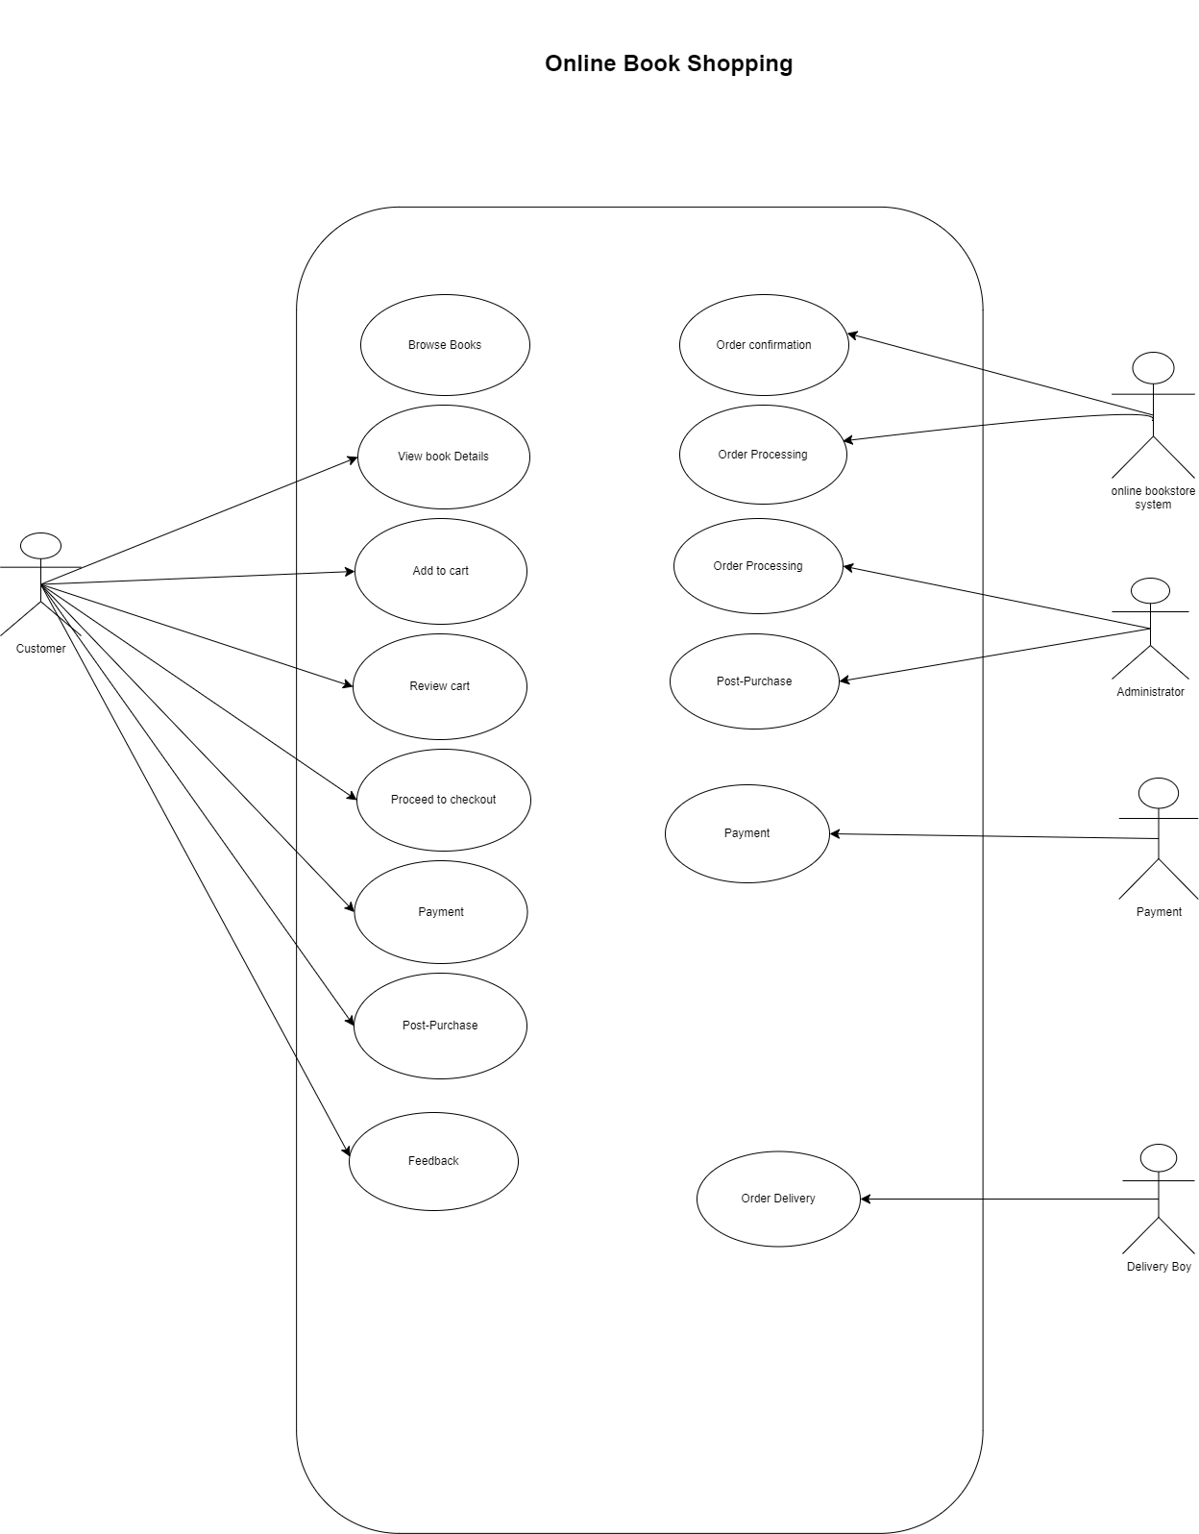

12. Draw Use-case on online bill payment system (paytm)

Ans.