Longitudinal Confidence Modelling for Motor Subtype Classification in Early Parkinson's Disease

1. Introduction
Parkinson's Disease (PD) patients are usually split into two motor types: Tremor-Dominant (TD), where tremor is the main symptom, and Postural Instability and Gait Difficulty (PIGD), where balance and walking problems dominate. A third group, indeterminate, covers patients who do not clearly fit either. This classification, first proposed by Jankovic et al. (1990) and later validated for the modern MDS-UPDRS scale by Stebbins et al. (2013), still guides how doctors treat patients today. PIGD patients tend to be older, respond less well to levodopa, fall more often, and progress faster than TD patients, so knowing a patient's subtype earlier changes how closely they should be monitored.
Right now, a clinician usually needs several visits over months or years to become confident about a patient's subtype. This project asks whether machine learning, applied to the same longitudinal data already collected by registries like the Parkinson's Progression Markers Initiative (PPMI), can reach that confidence sooner.
The contribution here is not simply "classify TD vs. PIGD earlier." Longitudinal studies show that a third to half of patients get reclassified within one to two years, so a subtype prediction is only useful if it also says how reliable it is.
Objective (expanded in Section 3): build a longitudinal, uncertainty-aware framework that, at each visit, predicts a patient's subtype using the established Jankovic/Stebbins formula, attaches a calibrated confidence score using conformal prediction, tracks how that confidence changes across visits to flag unstable or shifting cases, and uses an LLM layer to explain the result in plain language. The goal: tell a clinician not just the likely subtype, but how much to trust it and how soon that trust should firm up.

2. Literature Survey

2.1 Established criteria for motor subtype classification
The TD/PIGD/indeterminate classification began with Jankovic et al. (1990), who split PD patients by predominant symptom using baseline data from the DATATOP cohort. Kang et al. (2005) and Schiess et al. (2000) proposed similar ratio-based variants using slightly different item groupings. Stebbins et al. (2013) then re-derived and validated the ratio for the MDS-UPDRS scale used in PPMI and most modern PD registries. This is why TD/PIGD/indeterminate can be used as ground truth without new clinical sign-off: the label comes from a published, peer-reviewed formula applied to existing UPDRS scores, not a new idea that needs fresh validation.
Gap: these papers define how to label a patient from data that already exists at one visit. None of them predict a label ahead of that visit using earlier data.

2.2 Machine learning for TD/PIGD classification
Several studies use machine learning to tell TD and PIGD apart, but almost all rely on imaging rather than the routine clinical exam data used to define the label in the first place. One PPMI-based study used MRI radiomic features from 135 patients (92 TD, 43 PIGD) with five different classifiers. A smaller study used arterial spin labelling MRI with a support vector machine on 21 patients to find subtype-specific blood-flow differences. A third study combined two MRI types (T1-weighted and diffusion tensor imaging) across 70 TD, 70 PIGD, and 70 healthy controls, reaching 85% three-class accuracy with a gradient-boosting classifier, the strongest reported result in this area, though on an artificially balanced sample.
Gap: these studies classify subtype using imaging from the same visit as the label, not earlier data. None report a calibrated confidence measure, only accuracy or AUC. Imaging is also costly and not routinely available at every visit, unlike the clinical exam data this project plans to use.

2.3 Data-driven subtyping and progression modelling
One study skipped the established TD/PIGD scheme and instead derived new subtypes statistically. It applied Gaussian Mixture Modelling across the PPMI and PDBP cohorts, then trained Random Forest models to predict which subtype a patient would fall into at 12, 24, and 48 months. This showed that data-driven subtyping can generalise across cohorts, and that Random Forest outperformed LASSO-regression and SVM baselines for this task.
Gap: this closely resembles our own earlier clustering approach, and shares the same problem: a subtype discovered by an unsupervised algorithm still needs independent clinical validation before it can be trusted as ground truth. This is an independent confirmation of why this project anchors its label to the published Jankovic/Stebbins formula instead.

2.4 Stability and transition of motor subtype over time
Several studies check whether TD/PIGD/indeterminate labels stay the same once assigned. A three-year study of early PD patients applied the Stebbins criteria at multiple follow-up points and measured how often patients changed category, along with what predicted that change. Other work comparing subtyping methods over shorter windows (one month, twelve months) found similar results: a meaningful share of patients do not stay in their original subtype, and PIGD and indeterminate categories are less stable than TD.
Gap: this work reports cohort-level instability after the fact. It does not build a predictive tool that tells a clinician, for one specific patient, how likely their current label is to hold or change going forward. That is a different and more useful task than reporting overall instability statistics.

2.5 Uncertainty quantification and conformal prediction in neurodegenerative disease
Conformal prediction is a model-agnostic method that turns point predictions into calibrated confidence sets or intervals with formal guarantees. It has recently started appearing in neurodegenerative-disease work. One PD-specific study (CASCADE) used a two-stage conformal framework to forecast medication dosing needs, passing uncertainty from a screening classifier into a downstream dosage prediction. In multiple sclerosis, conformal prediction has been used to generate individualized diagnostic uncertainty for disease-course prediction, where prediction-set size shrinks or grows with model confidence. In Alzheimer's research, conformal methods have bounded uncertainty in biomarker trajectories across irregularly-timed visits, and, closer to our own use case, produced set-valued diagnostic predictions across MCI/AD stages, with one study reporting 93.3% empirical coverage at a 90% target confidence level using an XGBoost classifier.
Gap: conformal prediction is clearly useful for related neurodegenerative conditions, and even for other PD outcomes like dosing. No study found here applies it to longitudinal TD/PIGD/indeterminate motor subtype classification. The MS disease-course paper is the closest match in structure, but for a different disease, and without a stability or transition-risk layer added on top.

2.6 LLM-augmented reasoning and explainability in clinical decision support
A growing body of work pairs traditional ML predictions with large language models to make outputs easier for clinicians to read. Examples include combining SHAP feature-importance values with an LLM to explain ICU mortality risk at the bedside, and a similar hybrid for explaining psychiatric emergency-department return risk. Purpose-built uncertainty-aware LLM systems exist too: ConfidentNeuro uses conformal prediction to score the hallucination risk of LLM answers in Alzheimer's decision support, assigning each answer a LOW/MEDIUM/HIGH trust label. At the same time, recent interpretability research is a caution against trusting LLM clinical reasoning alone: a 2026 study found medical LLMs can shift staging accuracy by over 50% based on prompt format alone, and that some models give confident answers even when the input is not enough to support one.
Gap: LLM-explainability work in this space almost always sits downstream of a separately validated ML or statistical signal (SHAP values, conformal risk scores), rather than generating clinical claims on its own. This project should follow that same pattern. No study found here combines calibrated multi-visit subtype confidence with an LLM reasoning layer for PD. The interpretability-instability findings also confirm that the LLM layer here should explain the conformal model's numeric output, not make independent classification judgments of its own.

2.7 Literature Survey Summary Table
Theme | Paper Title | Link | Description | Main Gap
Established criteria | How to identify tremor dominant and PIGD groups with the MDS-UPDRS (Stebbins et al., 2013) | https://movementdisorders.onlinelibrary.wiley.com/doi/abs/10.1002/mds.25383 | Re-derives and validates the TD/PIGD ratio for the modern MDS-UPDRS scale, replacing the older Jankovic formula. This is the standard used by PPMI and most current PD research. | Defines how to label a patient at one visit. Does not address prediction ahead of that visit.
Established criteria | MDS-sponsored revision of the UPDRS (Goetz et al., 2007) | https://pubmed.ncbi.nlm.nih.gov/17115387/ | Describes the process behind the MDS-UPDRS, the four-part scale that all subtype formulas and this project's features are built from. | Background paper only. No subtyping or prediction content.
ML classification (imaging) | Automatic differentiation of PD motor subtypes via deep learning and radiomics (2025) | https://pmc.ncbi.nlm.nih.gov/articles/PMC12445147/ | Uses MRI-derived radiomic features from 8 brain nuclei across 135 PPMI patients (92 TD, 43 PIGD) and five ML classifiers to distinguish subtype. | Classifies same-visit imaging, not earlier prediction. No confidence measure reported. Imaging is not routinely available every visit.
ML classification (imaging) | Auto-classification of PD motor subtypes using ASL-MRI | https://www.ncbi.nlm.nih.gov/pmc/articles/PMC10670033/ | Applies SVM to arterial spin labelling MRI data from 21 PD patients to distinguish TD from PIGD via brain blood-flow patterns. | Very small sample. Single-visit classification only. No uncertainty quantification.
ML classification (imaging) | Multi-modality radiomics (T1 + DTI) for early-stage PD subtypes | https://pmc.ncbi.nlm.nih.gov/articles/PMC11377437/ | Combines two MRI types with a gradient-boosting classifier across 70 TD / 70 PIGD / 70 healthy controls. Reports 85% three-class accuracy, the strongest result in this space. | Sample is artificially class-balanced. Real cohorts are TD-heavy. No longitudinal or confidence component.
ML classification (imaging) | 7T Quantitative MRI and ML for motor subtype stratification | https://arxiv.org/pdf/2605.24179 | Tests ultra-high-field 7-Tesla MRI features with multiple classifiers (KNN, SVM, RF, XGBoost) for HC vs. PIGD vs. TD classification. | Reports only moderate accuracy (about 0.62). Exploratory. No uncertainty calibration or longitudinal tracking.
Data-driven subtyping | Analysis, Identification and Prediction of PD Sub-Types and Progression through ML | https://arxiv.org/pdf/2306.04748 | Uses Gaussian Mixture Modelling across PPMI and PDBP cohorts to discover progression subtypes, then trains Random Forest to predict them at 12/24/48 months. | Subtypes are self-derived, not clinically validated. Same limitation our research guide flagged for our earlier clustering approach.
Subtype stability | Stability of MDS-UPDRS Motor Subtypes Over Three Years in Early PD | https://www.frontiersin.org/journals/neurology/articles/10.3389/fneur.2021.704906/full | Tracks TD/indeterminate/PIGD assignment across 3 years in an early-PD cohort. Measures how often patients are reclassified and what predicts that instability. | Descriptive and retrospective only. Reports cohort-level statistics, not a per-patient predictive tool.
Subtype stability | Consistency and Stability of Motor Subtype Classifications in de novo PD | https://www.frontiersin.org/journals/neuroscience/articles/10.3389/fnins.2021.637896/full | Compares multiple subtyping formulas (Jankovic, Schiess, Kang) side by side and checks how consistent they are with each other and over time. | Focuses on comparing classification methods, not predicting an individual patient's future stability.
Subtype stability | Efficacy of rehabilitation across PD motor subtypes | https://pmc.ncbi.nlm.nih.gov/articles/PMC8284270/ | Applies the MDS-UPDRS TD/PIGD ratio to split patients (36 PIGD, 19 TD, 14 indeterminate) and compares their response to a 3-month rehabilitation program. | Confirms subtype affects treatment response, but is a treatment-outcome study, not a classification or uncertainty study.
Uncertainty quantification | CASCADE: Conformal Prediction for Two-Stage Clinical Decision Support (PD) | https://arxiv.org/abs/2605.20468 | Applies conformal prediction to forecast Parkinson's medication dosing (LEDD), passing uncertainty from a screening classifier into a downstream dosage prediction. | Applies conformal prediction to PD, but for medication dosing, not motor subtype classification.
Uncertainty quantification | Conformal prediction for disease-course prediction in multiple sclerosis | https://pmc.ncbi.nlm.nih.gov/articles/PMC12022056/ | Uses conformal prediction to generate individualized, calibrated diagnostic uncertainty for MS disease-course classification. Closest structural match to this project's design. | Different disease (MS, not PD). No stability or transition-risk framing across visits.
Uncertainty quantification | Conformal bands for biomarker trajectories in Alzheimer's/MCI | https://arxiv.org/html/2511.13911 | Builds group-conditional conformal prediction bands for irregularly-timed biomarker visits. Uses them to flag high-risk MCI patients earlier than standard scores. | Alzheimer's, not PD. Predicts a continuous biomarker, not a discrete motor subtype label.
Uncertainty quantification | Conformal uncertainty quantification for multi-class Alzheimer's stage prediction | (SSRN preprint) | Applies conformal prediction to an XGBoost classifier across AD/MCI stages. Reports 93.3% empirical coverage at a 90% target confidence level. | Alzheimer's staging, not PD subtype. Single-visit prediction, not longitudinal.
LLM reasoning layer | ConfidentNeuro: conformal hallucination-risk scoring for LLM Alzheimer's support | (ResearchGate preprint) | Assigns a LOW/MEDIUM/HIGH trust label to LLM-generated clinical answers in Alzheimer's care, using conformal prediction on semantic similarity scores. | Alzheimer's Q&A trust-scoring, not PD subtype explanation. Scores the LLM output itself, not a reasoning layer over an ML prediction.
LLM reasoning layer | Enhancing LLM clinical support with ML risk and SHAP explainability (ICU) | https://link.springer.com/article/10.1186/s40635-026-00900-w | Feeds XGBoost mortality-risk predictions and SHAP values into GPT-4o to generate bedside-readable risk explanations in ICU settings. | ICU mortality, not PD. Shows the ML-to-SHAP-to-LLM pattern this project should follow, but not applied to subtype confidence.
LLM reasoning layer | Understanding Clinical Reasoning Variability in Medical LLMs | https://www.medrxiv.org/content/10.64898/2026.01.26.26344845v1 | Shows medical LLMs can shift staging accuracy by over 50% based on prompt format alone, and sometimes give confident answers with insufficient input. | Not PD-related, but a direct caution: this project's LLM layer must explain calibrated model output, not make independent clinical judgments.

Literature synthesis
Together, this literature confirms three things this project can build on directly. First, TD/PIGD/indeterminate is an established, formula-based classification that does not need new clinical validation to use as ground truth. Second, subtype instability over time is a real, well-documented phenomenon in PD, not an assumption this project introduces. Third, conformal prediction is a proven, clinically-validated method for calibrating confidence in adjacent neurodegenerative-disease tasks.
What has not been done, based on the papers reviewed here, is combining these three things into one longitudinal pipeline: predicting a patient's current motor subtype from routine clinical (non-imaging) data, attaching a calibrated, visit-by-visit confidence score to that prediction, flagging patients at risk of subtype transition, and surfacing all of this through an LLM layer that explains rather than overrides the underlying model. Section 3 develops this gap further and how it shapes the project's design.

3. Problem Description
The original approach to this project used K-Means clustering on patients' decline rates (motor, cognitive, and autonomic) to sort them into "slow," "moderate," and "fast" progressor groups. The group boundaries were set entirely by the algorithm, and no clinician outside the project had validated that these three groups correspond to a real, clinically meaningful distinction.
This created a verification problem: any subtype invented by the project needs a clinician to confirm it is a genuine medical category before it can be used as ground truth, and securing that kind of clinical sign-off, particularly from a specialist, was not realistic within the project's timeline.
The data itself supported this concern. Re-running the clustering with HDBSCAN, a density-based method that does not force a fixed number of clusters, failed to recover three well-separated groups; it flagged 39% of patients as unclassifiable. This suggests that "slow/moderate/fast" is not three naturally occurring groups in the data, but a boundary imposed by the choice of algorithm.
To remove this bottleneck, the project now predicts an established clinical category instead of an invented one: TD (tremor-dominant) vs. PIGD (postural instability and gait difficulty) vs. indeterminate, the standard three-way motor subtype used across PD research worldwide. This label is not clustered or guessed; it is computed from a published formula, first proposed by Jankovic et al. (1990) and formally validated for the modern MDS-UPDRS scale by Stebbins et al. (2013), that takes a patient's tremor-related and gait/balance-related exam scores and converts their ratio into a category. Because this is the accepted research-standard method already used in PPMI and most PD subtyping studies, the project only needs to confirm it is applying a peer-reviewed formula and public dataset correctly, not validate a new clinical concept, which may not require live clinician review at all.
The core research question is unchanged: can a confident classification be reached earlier than the year-plus of visits a clinician currently needs? What is new is a second problem the project now also addresses: published research shows that roughly a third to a half of patients get reclassified within one to two years as their disease evolves, yet existing work treats this only as a limitation rather than something to be predicted. No current system tells a clinician, per patient, how likely their current label is to hold versus flip at the next visit. This transition-risk problem is what Sections 3–4 of this paper build toward, using the same conformal-prediction and confidence-tracking tools originally developed for the old target, now pointed at the clinically standard one.

4. Objective
This project aims to build a tool that predicts a Parkinson's patient's motor subtype, tremor-dominant (TD), postural instability and gait difficulty (PIGD), or indeterminate, earlier than a clinician normally could using visit history alone. Alongside each prediction, the tool reports how confident it is and whether that confidence is likely to hold steady or shift at the next visit. The end goal is a decision-support system that helps doctors monitor and treat each patient at the right level of urgency, sooner.

5. Data Analysis

5.1 Data source
All data derive from the Parkinson's Progression Markers Initiative (PPMI), an ongoing observational, multi-centre longitudinal study of Parkinson's disease. Data were obtained from the PPMI repository hosted on the Laboratory of Neuro Imaging Image and Data Archive (LONI IDA, ida.loni.usc.edu); the extract used throughout this work is dated 16 August 2026. No new patient data were collected. Nineteen source tables were used, listed below. These were merged into a single table: 12 by outer join on patient and visit identifier, 5 static per-patient tables by left join on patient identifier, and 2 medication logs by date interval.
Domain | Source tables used
Motor assessment | MDS-UPDRS Part I (rater-completed and self-completed components); Part II; Part III
Cognition | Montreal Cognitive Assessment (MoCA)
Autonomic function | SCOPA-AUT
Mood and anxiety | Geriatric Depression Scale (short form); State-Trait Anxiety Inventory
Sleep | Epworth Sleepiness Scale; REM Sleep Behaviour Disorder Screening
Medical history | PD Diagnosis History; Concomitant Medication Log; LEDD Concomitant Medication Log
Subject characteristics | Demographics; Age at Visit; Subject Cohort History
Imaging | Xing Core Lab Quantitative SBR (DaTscan); Xing Core Lab Visual Read
Genetics | IU Genetic Consensus panel; WGS PD variant status

5.2 Final dataset
Preprocessing is implemented in a single deterministic script, 01_preprocess_tdpigd.py, which produces three artefacts. The analysis dataset used by all downstream modelling is ppmi_tdpigd_long.csv.
Artefact | Description | Size
ppmi_tdpigd_long.csv | Final analysis dataset. One row per patient per scheduled visit, in long format, containing the computed label, the transition target, and all candidate predictors. | 6,922 rows x 75 columns
ppmi_tdpigd_dictionary.csv | Data dictionary. Defines every column, its role, its feature group (permitted, banned or optional), its data type and its completeness. Feature selection is driven from this file. | 75 column definitions
ppmi_tdpigd_runlog.txt | Provenance log. Records row and patient counts at each filtering step, the visit codes dropped, the label distribution, flip rates and the result of the leakage assertions. | one entry per run

- Format. The final dataset is deliberately held in long format. Round-specific analysis tables are derived from it downstream rather than being stored separately, so a single file remains the authoritative source.
- Reproducibility. No random seeds are involved in preprocessing, so re-running the script on the same extract reproduces the dataset byte-for-byte.
- Integrity checks. The script asserts that no duplicate patient-visit key exists and that no label-defining column is present in any permitted feature group; it terminates with an error rather than writing an invalid dataset.

5.3 Column inventory
Table 3 lists every column of the final dataset and its role. Role assignment is stored in ppmi_tdpigd_dictionary.csv and drives feature selection programmatically; no column is chosen by hand at model-fitting time.
Role | n | Meaning
Y (target) | 8 | The label and its components, plus the transition targets
X (predictors) | 27 | Permitted feature set used for all reported models
Excluded — defines Y | 19 | Formula items and columns encoding them indirectly
Excluded — optional | 12 | Imaging and genotyping; reserved for a separate variant
Excluded — keys/admin | 9 | Identifiers, dates and provenance fields
Total | 75 | Columns in ppmi_tdpigd_long.csv

Column | Role | Source table | Description
LABEL | Y — target | Computed (Stebbins formula) | TD / PIGD / Indeterminate — the target (Y)
LABEL_FLIPPED_NEXT | Y — target | Computed (next-visit shift) | Whether the label changes at the next visit (transition target)
MONTHS_TO_NEXT_VISIT | Y — target | Computed (next-visit shift) | Interval to next visit
NEXT_LABEL | Y — target | Computed (next-visit shift) | Label at the following visit (transition target)
NEXT_VISIT_MONTH | Y — target | Computed (next-visit shift) | Month of the following visit
PIGD_SCORE | Y — target | Computed (Stebbins formula) | Mean of the 5 gait/balance items (Y component)
TD_PIGD_RATIO | Y — target | Computed (Stebbins formula) | Tremor / PIGD ratio (Y component)
TREMOR_SCORE | Y — target | Computed (Stebbins formula) | Mean of the 11 tremor items (Y component)
AGE_AT_VISIT | X — predictor | Age at Visit | Age at visit
ESS_TOTAL | X — predictor | Epworth (item sum) | Epworth Sleepiness Scale item sum
GDS_TOTAL | X — predictor | GDS-15 (item sum) | Geriatric Depression Scale item sum
GENETIC_COHORT | X — predictor | Derived (Subject Cohort History) | Recruited into the genetic cohort (see limitation below)
HANDED | X — predictor | Demographics | Handedness
LEDD_TOTAL_MG | X — predictor | LEDD Med Log (date interval) | Levodopa-equivalent daily dose (date-interval join)
MCATOT | X — predictor | MoCA | MoCA total
NP1PTOT | X — predictor | MDS-UPDRS Part I (self-completed) | MDS-UPDRS Part I total (self-completed)
NP1RTOT | X — predictor | MDS-UPDRS Part I | MDS-UPDRS Part I total (rater-completed)
NP2DRES | X — predictor | MDS-UPDRS Part II | Dressing
NP2EAT | X — predictor | MDS-UPDRS Part II | Eating tasks
NP2HOBB | X — predictor | MDS-UPDRS Part II | Hobbies and other activities
NP2HWRT | X — predictor | MDS-UPDRS Part II | Handwriting
NP2HYGN | X — predictor | MDS-UPDRS Part II | Hygiene
NP2RISE | X — predictor | MDS-UPDRS Part II | Getting out of a bed, car or deep chair
NP2SALV | X — predictor | MDS-UPDRS Part II | Saliva and drooling
NP2SPCH | X — predictor | MDS-UPDRS Part II | Speech
NP2SWAL | X — predictor | MDS-UPDRS Part II | Chewing and swallowing
NP2TURN | X — predictor | MDS-UPDRS Part II | Turning in bed
N_CONMEDS | X — predictor | Concomitant Med Log (date interval) | Count of active concomitant medications
PDTRTMNT | X — predictor | MDS-UPDRS Part III | On PD treatment at this visit
RBDSQ_TOTAL | X — predictor | RBD Screening (item sum) | REM Sleep Behaviour Disorder screening item sum
SCOPA_AUT_TOTAL | X — predictor | SCOPA-AUT (item sum) | SCOPA-AUT item sum
SEX | X — predictor | Demographics | Sex
STAI_TOTAL | X — predictor | STAI (item sum) | State-Trait Anxiety Inventory item sum
YRS_SINCE_DIAGNOSIS | X — predictor | Derived (PD Diagnosis History + visit date) | Years since diagnosis (derived)
YRS_SINCE_SYMPTOM_ONSET | X — predictor | Derived (PD Diagnosis History + visit date) | Years since symptom onset (derived)
NHY | Excluded — defines Y | MDS-UPDRS Part III | Hoehn & Yahr stage — stage 3 is defined by postural instability
NP2FREZ | Excluded — defines Y | MDS-UPDRS Part II | Freezing (self-reported)
NP2PTOT | Excluded — defines Y | MDS-UPDRS Part II | Part II total — contains the 3 items above
NP2TRMR | Excluded — defines Y | MDS-UPDRS Part II | Tremor (self-reported)
NP2WALK | Excluded — defines Y | MDS-UPDRS Part II | Walking and balance (self-reported)
NP3FRZGT | Excluded — defines Y | MDS-UPDRS Part III | Freezing of gait
NP3GAIT | Excluded — defines Y | MDS-UPDRS Part III | Gait
NP3KTRML | Excluded — defines Y | MDS-UPDRS Part III | Kinetic tremor, left hand
NP3KTRMR | Excluded — defines Y | MDS-UPDRS Part III | Kinetic tremor, right hand
NP3PSTBL | Excluded — defines Y | MDS-UPDRS Part III | Postural stability
NP3PTRML | Excluded — defines Y | MDS-UPDRS Part III | Postural tremor, left hand
NP3PTRMR | Excluded — defines Y | MDS-UPDRS Part III | Postural tremor, right hand
NP3RTALJ | Excluded — defines Y | MDS-UPDRS Part III | Rest tremor amplitude, lip/jaw
NP3RTALL | Excluded — defines Y | MDS-UPDRS Part III | Rest tremor amplitude, left lower limb
NP3RTALU | Excluded — defines Y | MDS-UPDRS Part III | Rest tremor amplitude, left upper limb
NP3RTARL | Excluded — defines Y | MDS-UPDRS Part III | Rest tremor amplitude, right lower limb
NP3RTARU | Excluded — defines Y | MDS-UPDRS Part III | Rest tremor amplitude, right upper limb
NP3RTCON | Excluded — defines Y | MDS-UPDRS Part III | Constancy of rest tremor
NP3TOT | Excluded — defines Y | MDS-UPDRS Part III | Part III total — contains the 13 items above
APOE | Excluded — optional | IU Genetic Consensus | APOE genotype
CAUDATE_REF_CWM | Excluded — optional | Xing Core Lab Quant SBR | DaTscan caudate binding ratio
DATSCAN_VISINTRP | Excluded — optional | Xing Core Lab Visual Read | DaTscan visual read
GBA | Excluded — optional | IU Genetic Consensus | GBA variant status
LRRK2 | Excluded — optional | IU Genetic Consensus | LRRK2 variant status
PARK7 | Excluded — optional | IU Genetic Consensus | PARK7 variant status
PINK1 | Excluded — optional | IU Genetic Consensus | PINK1 variant status
PRKN | Excluded — optional | IU Genetic Consensus | PRKN variant status
PUTAMEN_REF_CWM | Excluded — optional | Xing Core Lab Quant SBR | DaTscan putamen binding ratio
SNCA | Excluded — optional | IU Genetic Consensus | SNCA variant status
STRIATUM_REF_CWM | Excluded — optional | Xing Core Lab Quant SBR | DaTscan striatum binding ratio
VPS35 | Excluded — optional | IU Genetic Consensus | VPS35 variant status
EVENT_ID | Excluded — key | Join key (all tables) | PPMI visit code
INFODT | Excluded — key | MDS-UPDRS Part III | Visit date
PATNO | Excluded — key | Join key (all tables) | Patient identifier
VISIT_MONTH | Excluded — key | Derived (EVENT_ID) | Months since baseline (derived)
APPRDX | Excluded — admin | Subject Cohort History | PPMI diagnostic sub-code
COHORT | Excluded — admin | Subject Cohort History | PPMI cohort code
PDDXDT | Excluded — admin | PD Diagnosis History | Diagnosis date (source)
PDSTATE_USED | Excluded — admin | MDS-UPDRS Part III | Medication state of the retained Part III record
SXDT | Excluded — admin | PD Diagnosis History | Symptom onset date (source)

Table 3. Complete column inventory of ppmi_tdpigd_long.csv (75 columns), with the source table each column was drawn from.
- Why the three Part II formula items are excluded. NP2TRMR, NP2WALK and NP2FREZ are self-reported and inexpensive to collect, but they are inputs to the label formula. Under the strict policy adopted here, any column participating in the computation of Y is excluded from X regardless of collection cost.
- Why the remaining Part III items are absent entirely. Only the 13 Part III items required by the formula were extracted; the other examination items were not carried into the dataset.
- GENETIC_COHORT caveat. This flag records the PPMI recruitment arm rather than a clinical measurement, and the arms differ in class balance (52% TD in the genetic arm against 78% in the sporadic arm). It is retained in the dataset for stratification, but results should be reported with it removed from X, and stratified by arm.

5.4 Dataset overview
The project uses the PPMI cohort throughout. Figure 1 summarises the cohort funnel, the resulting class balance, and the measured instability of the label.
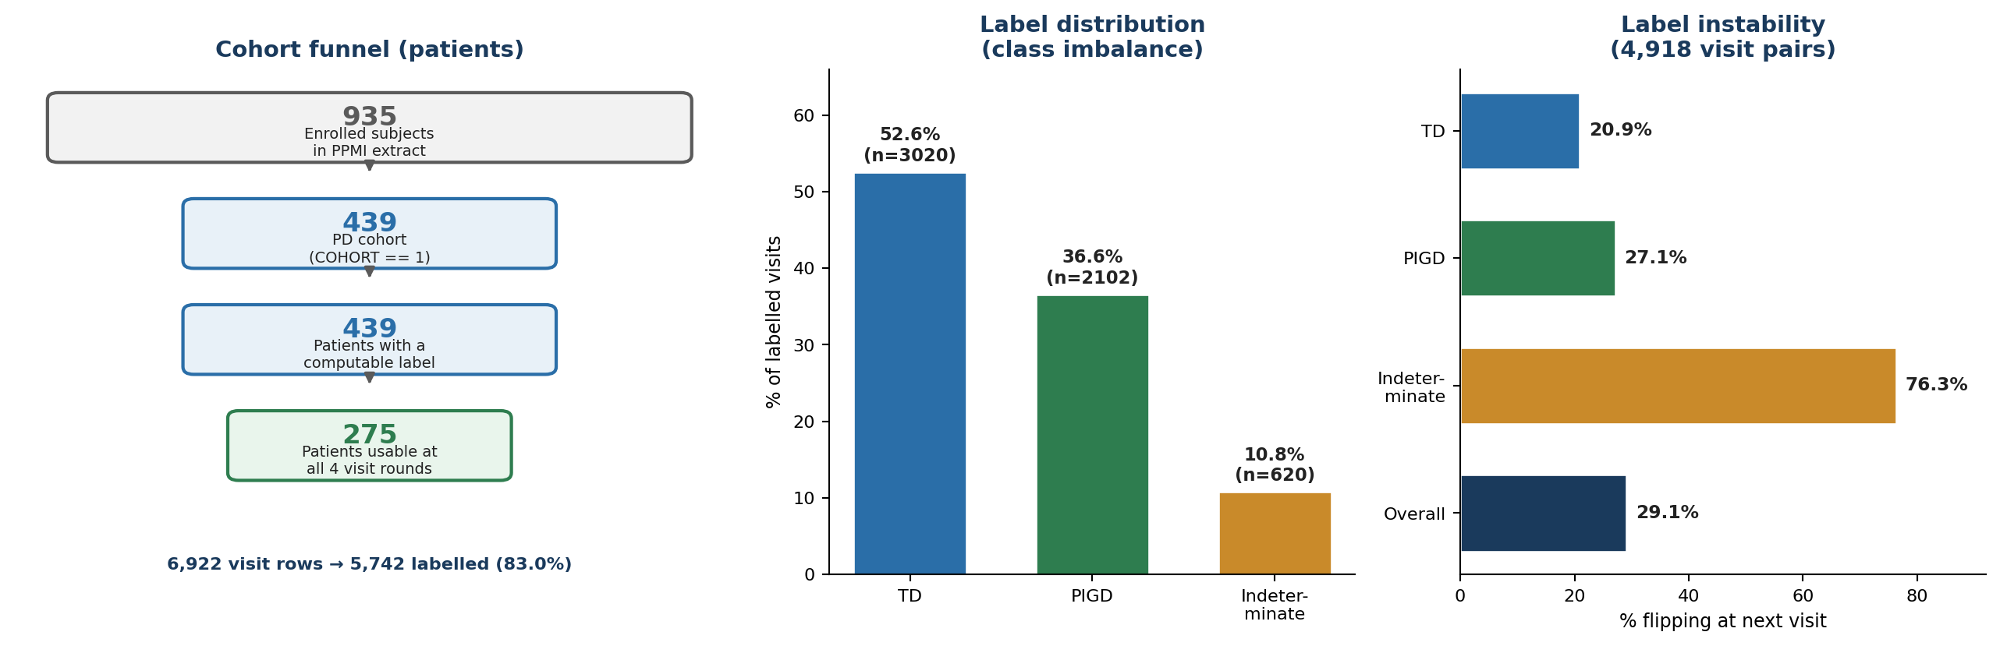
Figure 1. Cohort funnel, label distribution, and label instability across consecutive visits.
Property | Value
Patients (PD cohort, COHORT == 1) | 439
Sporadic PD (APPRDX == 1) | 242
Genetic-cohort PD (APPRDX == 5) | 197
Patient-visits after filtering | 6,922
Visits with a fully computable label | 5,742 (83.0%)
Columns in the analysis table | 75
Duplicate patient-visit keys | 0 (asserted in code)

5.5 Why the target was changed
- Original target. K-Means on per-patient decline rates (motor, cognitive, autonomic) produced 'slow', 'moderate' and 'fast' progressor groups.
- Structural problem. K-Means returns exactly three groups by construction, whether or not three groups exist in the data.
- Evidence against it. Re-clustering the same features with HDBSCAN, which does not fix the cluster count, failed to recover three separated groups and labelled 39% of patients unclassifiable.
- Verification problem. A self-derived subtype needs independent clinical sign-off before it can serve as ground truth, which was not achievable within the project timeline.
- Resolution. The target is now TD / PIGD / indeterminate, computed from the published Jankovic (1990) and Stebbins et al. (2013) formula. Only correct application of a peer-reviewed formula needs to be demonstrated, not a new clinical concept.

5.6 Preprocessing pipeline
Preprocessing is performed by a single deterministic script that emits the analysis table, a machine-readable data dictionary, and a provenance log recording counts at every step. Figure 2 shows the pipeline and, critically, the point at which columns are split so that label-defining data cannot reach the model.
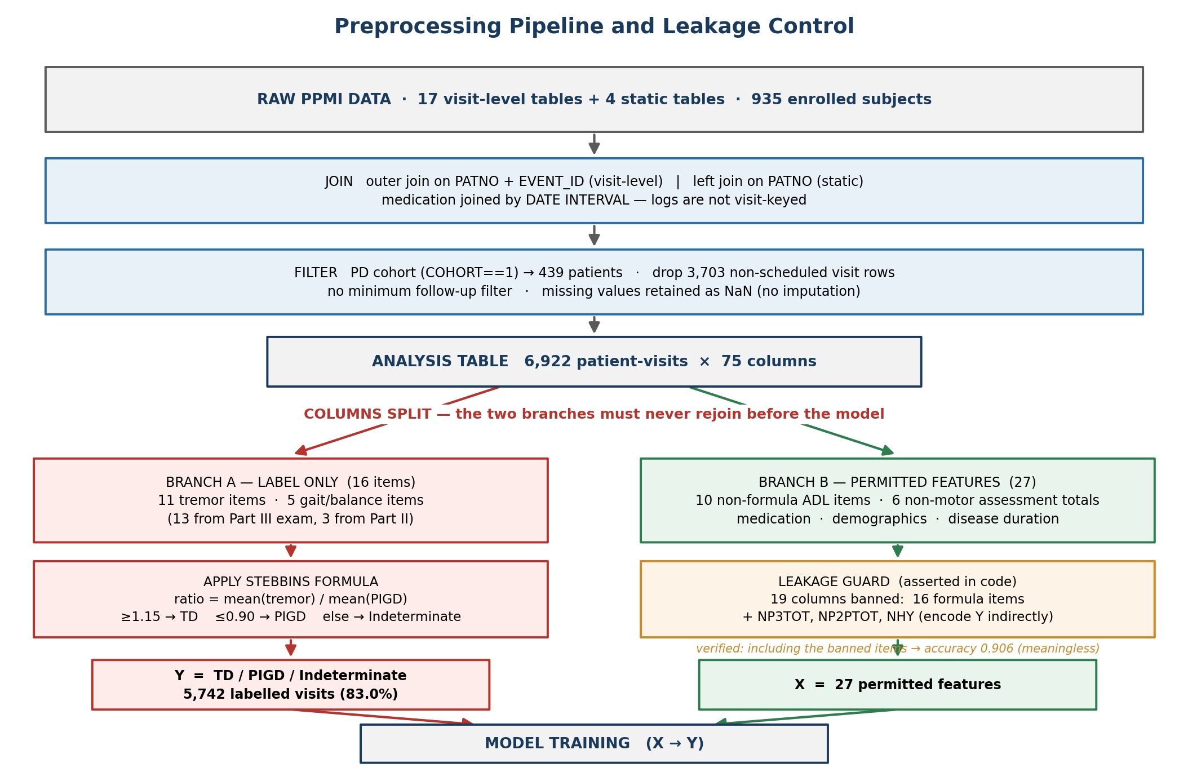
Figure 2. Preprocessing pipeline and leakage control. Branch A computes the label; Branch B supplies the permitted features. The branches converge only at model training.
Step-by-step:
- Cohort. Select COHORT == 1 (PPMI Parkinson's disease cohort) → 439 patients, comprising sporadic PD (n = 242) and genetic-cohort PD (n = 197). A flag retains the distinction, since the genetic arm is enriched for LRRK2, GBA and SNCA carriers by recruitment design.
- Join. Nineteen source tables merged in total: 12 visit-level tables by outer join on PATNO + EVENT_ID, 5 static per-patient tables by left join on PATNO, and 2 medication logs by date interval.
- Medication. Joined by date interval, not visit code: the LEDD and concomitant-medication logs are running records whose visit field only takes the values LOG, ED or SC, so a conventional key join silently returns an empty column.
- Item-level extraction. The 3 required Part II items (99.9-100% present) and 13 required Part III items (94.1-94.2% present) are extracted individually, because the formula operates on items rather than part totals.
- Medication state. One record per patient-visit is kept, preferring the OFF-medication assessment, since dopaminergic treatment suppresses tremor and can shift the ratio.
- Visits. Visit codes mapped to months (BL = 0 … V20 = 96); 3,703 rows with non-scheduled codes dropped. No minimum follow-up filter is applied, as the label is computed independently at each visit.
- Missing data. Retained as NaN. Blanket median imputation previously flattened DaTscan binding ratio to a constant and destroyed a real signal; imputing before splitting also leaks test-fold information. Gradient-boosted trees handle NaN natively.
Validation of the medication join. Median levodopa-equivalent daily dose by visit month confirms the interval logic: 0 mg at baseline is expected, because PPMI recruits de novo, drug-naive patients.
Visit month | 0 | 6 | 12 | 18 | 24
Median LEDD (mg) | 0 | 179 | 300 | 400 | 500

5.7 Label definition and verification
- Tremor score = mean of 11 items (1 patient-reported, 10 examiner-scored).
- PIGD score = mean of 5 items (2 patient-reported, 3 examiner-scored).
- Classification. ratio = tremor / PIGD; ≥ 1.15 → TD, ≤ 0.90 → PIGD, otherwise indeterminate.
- Completeness rule. A label is assigned only when all 16 items are present, so no label derives from a partial mean; 17% of rows therefore remain unlabelled, concentrated at later visits where the motor exam was not administered.
- Undefined ratio. Where the PIGD score is zero, the row is assigned TD if the tremor score is positive and indeterminate if both are zero. This affects 845 rows (14.7% of labelled rows) and warrants a sensitivity analysis.
- Verification. Every label was recomputed independently from its two component scores: 0 mismatches across all 5,742 labelled rows.

5.8 Leakage control
The label is a deterministic function of 16 MDS-UPDRS items, so a model permitted to see them would re-derive arithmetic rather than learn. Supplying them raises accuracy to 0.906 while measuring nothing of interest. Feature eligibility is therefore enforced programmatically, and the script aborts if a banned column reaches a feature group.
Group | Count | Contents | Model input?
Label-defining (Part III) | 13 | 10 tremor items + gait, freezing of gait, postural stability | Never
Label-defining (Part II) | 3 | NP2TRMR, NP2WALK, NP2FREZ (patient-reported) | Never
Indirect encoders | 3 | NP3TOT, NP2PTOT (sums containing the above), NHY (stage 3 is defined by postural instability) | Never
Permitted features | 27 | 10 non-formula MDS-UPDRS Part II items, 6 non-motor instrument totals, medication, demographics, disease duration | Yes
Resource-dependent | 12 | DaTscan measures and gene columns | Optional variant

5.9 Label instability
Each visit is paired with the following scheduled visit to derive the transition target (4,918 consecutive pairs with both labels known).
Current label | Flip rate at next visit | Visit pairs
TD | 20.9% | 2,744
PIGD | 27.1% | 1,629
Indeterminate | 76.3% | 545
Overall | 29.1% | 4,918

- 355 of 439 patients (80.9%) change label at least once.
- The overall rate independently corroborates the 33-50% reclassification range reported in the literature, supporting correct implementation of the formula.
- Indeterminate is markedly unstable, consistent with it being a narrow boundary band (0.90 < ratio < 1.15) rather than a distinct clinical entity.

5.10 Consequences for modelling
- Class imbalance. 52.6% TD, 36.6% PIGD, 10.8% indeterminate at visit level, requiring class weighting and per-class reporting rather than aggregate accuracy.
- Grouped validation is mandatory. Each patient contributes roughly 16 rows, so a row-wise split would place the same patient in both training and test partitions; all cross-validation is grouped by patient identifier.
- Structural missingness. PPMI administers a full battery at annual visits but a subset at interim visits, so MoCA is 52.3% present and the autonomic, mood, anxiety and sleep instrument totals approximately 67% present. This is missing-by-design, not corruption.
- Round structure. Round-specific datasets are produced downstream by appending a suffixed copy of the time-varying features per included visit plus between-visit differences.
Round | Visits included | Patients available | Approx. feature count
1 | Baseline | 438 | 41
2 | Baseline + 6 months | 349 | 83
3 | Baseline + 6 + 12 months | 323 | 125
4 | Baseline + 6 + 12 + 24 months | 275 | 167
Alt. | Annual only (BL + 12 + 24) | 343 | 125

6. System Architecture
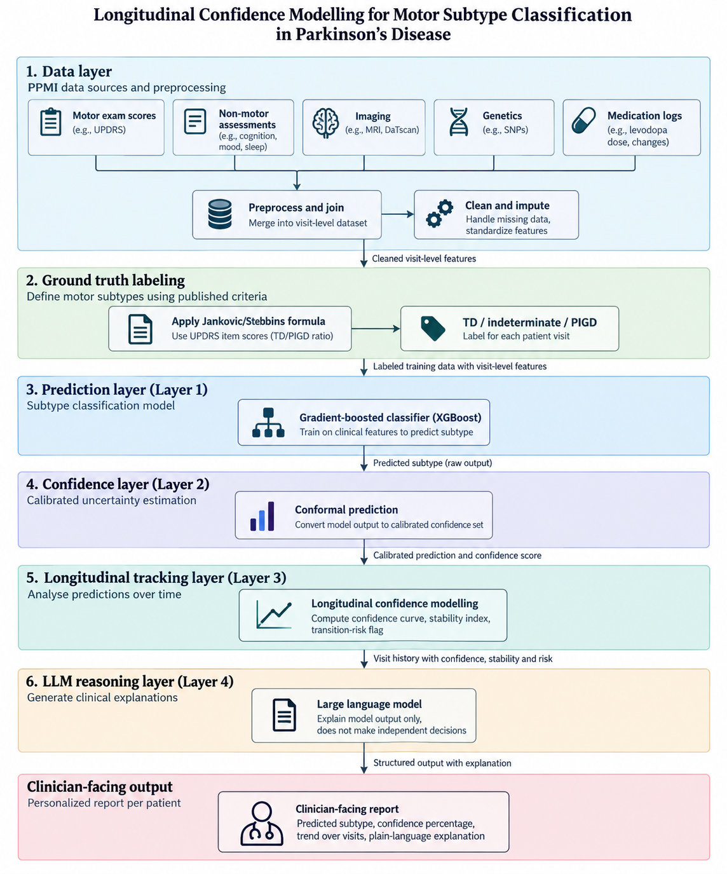
Figure 2. Proposed system architecture, from PPMI data ingestion through the LLM reasoning layer to the clinician-facing report.

The proposed system is organized as a layered pipeline that takes raw PPMI data through to a clinician-facing report, shown in Figure 2. Each layer builds on the output of the one before it, so a prediction is never presented without the calibration and context needed to interpret it.
Data layer. The pipeline draws on five PPMI data sources per patient visit: motor exam scores (UPDRS), non-motor assessments (cognition, mood, sleep), imaging (MRI, DaTscan), genetics (SNPs), and medication logs (levodopa dose and changes). These sources are merged into a single visit-level dataset, then cleaned and imputed to handle missing values and standardize features across visits.
Ground truth labeling. Each visit is labeled TD, PIGD, or indeterminate by applying the Jankovic/Stebbins formula to the relevant UPDRS item scores, producing the TD/PIGD ratio used throughout the rest of the pipeline as the training target.
Prediction layer (Layer 1). A gradient-boosted classifier (XGBoost) is trained on the cleaned, visit-level clinical features to predict motor subtype.
Confidence layer (Layer 2). The classifier's raw output is passed through conformal prediction, which converts it into a calibrated confidence set rather than a single point estimate, giving each prediction a statistically grounded measure of certainty.
Longitudinal tracking layer (Layer 3). Because a single visit's prediction can be unreliable, this layer analyzes predictions across a patient's full visit history. It computes a confidence curve showing how certainty evolves over time, a stability index summarizing how consistent the predicted subtype has been, and a transition-risk flag identifying patients whose subtype may be about to shift.
LLM reasoning layer (Layer 4). A large language model takes the calibrated prediction, confidence score, and longitudinal trend and generates a plain-language explanation of the result. This layer is restricted to explaining the upstream model's output — it does not make or alter any classification or clinical decision independently.
Clinician-facing output. The pipeline terminates in a personalized report for each patient, presenting the predicted subtype, confidence percentage, trend across visits, and the LLM-generated plain-language explanation, giving the clinician both the prediction and the context needed to act on it.

7. References
- Stebbins, G. T., Goetz, C. G., Burn, D. J., Jankovic, J., Khoo, T. K., & Tilley, B. C. (2013). How to identify tremor dominant and postural instability/gait difficulty groups with the movement disorder society unified Parkinson's disease rating scale: Comparison with the unified Parkinson's disease rating scale. Movement Disorders. https://movementdisorders.onlinelibrary.wiley.com/doi/abs/10.1002/mds.25383
- Goetz, C. G., et al. (2007). Movement Disorder Society-sponsored revision of the Unified Parkinson's Disease Rating Scale (MDS-UPDRS): Process, format, and clinimetric testing plan. Movement Disorders. https://pubmed.ncbi.nlm.nih.gov/17115387/
- Author(s) not specified (2025). Automatic differentiation of Parkinson's disease motor subtypes via deep learning and radiomics. https://pmc.ncbi.nlm.nih.gov/articles/PMC12445147/
- Author(s) not specified. Auto-classification of Parkinson's disease motor subtypes using ASL-MRI. https://www.ncbi.nlm.nih.gov/pmc/articles/PMC10670033/
- Author(s) not specified. Multi-modality radiomics (T1 + DTI) for early-stage Parkinson's disease subtypes. https://pmc.ncbi.nlm.nih.gov/articles/PMC11377437/
- Author(s) not specified (2026). 7T quantitative MRI and machine learning for motor subtype stratification. arXiv. https://arxiv.org/pdf/2605.24179
- Author(s) not specified. Analysis, identification and prediction of Parkinson's disease sub-types and progression through machine learning. arXiv. https://arxiv.org/pdf/2306.04748
- Author(s) not specified (2021). Stability of MDS-UPDRS motor subtypes over three years in early Parkinson's disease. Frontiers in Neurology. https://www.frontiersin.org/journals/neurology/articles/10.3389/fneur.2021.704906/full
- Author(s) not specified (2021). Consistency and stability of motor subtype classifications in de novo Parkinson's disease. Frontiers in Neuroscience. https://www.frontiersin.org/journals/neuroscience/articles/10.3389/fnins.2021.637896/full
- Author(s) not specified. Efficacy of rehabilitation across Parkinson's disease motor subtypes. https://pmc.ncbi.nlm.nih.gov/articles/PMC8284270/
- Author(s) not specified (2026). CASCADE: Conformal prediction for two-stage clinical decision support in Parkinson's disease. arXiv. https://arxiv.org/abs/2605.20468
- Author(s) not specified. Conformal prediction for disease-course prediction in multiple sclerosis. https://pmc.ncbi.nlm.nih.gov/articles/PMC12022056/
- Author(s) not specified (2025). Conformal bands for biomarker trajectories in Alzheimer's disease/mild cognitive impairment. arXiv. https://arxiv.org/html/2511.13911
- Author(s) not specified (2026). Enhancing LLM clinical support with machine learning risk scores and SHAP explainability in the ICU. Intensive Care Medicine Experimental. https://link.springer.com/article/10.1186/s40635-026-00900-w
- Author(s) not specified (2026). Understanding clinical reasoning variability in medical large language models. medRxiv. https://www.medrxiv.org/content/10.64898/2026.01.26.26344845v1

